Steps:

1.

2.

3.

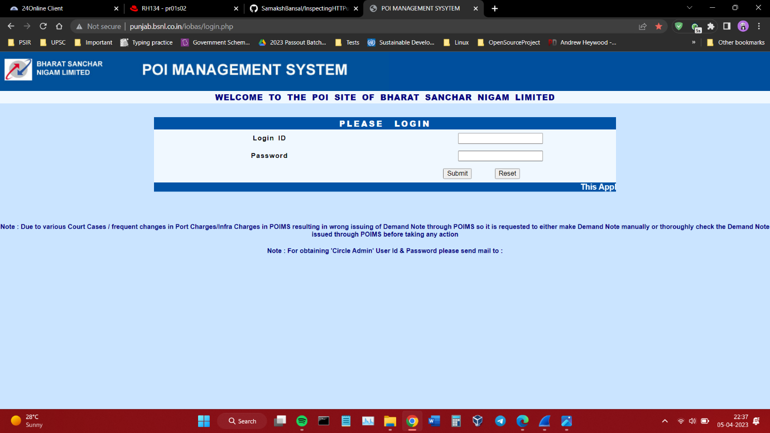

4.

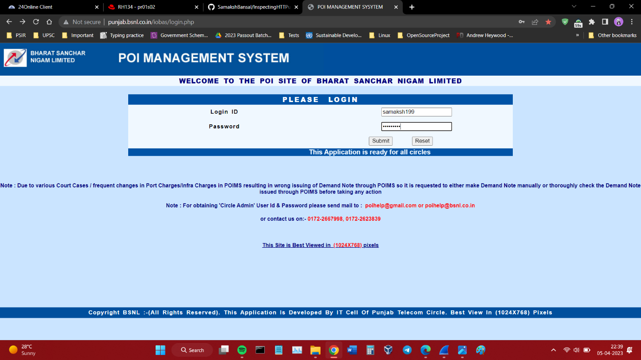

5.

6.

7.

8.

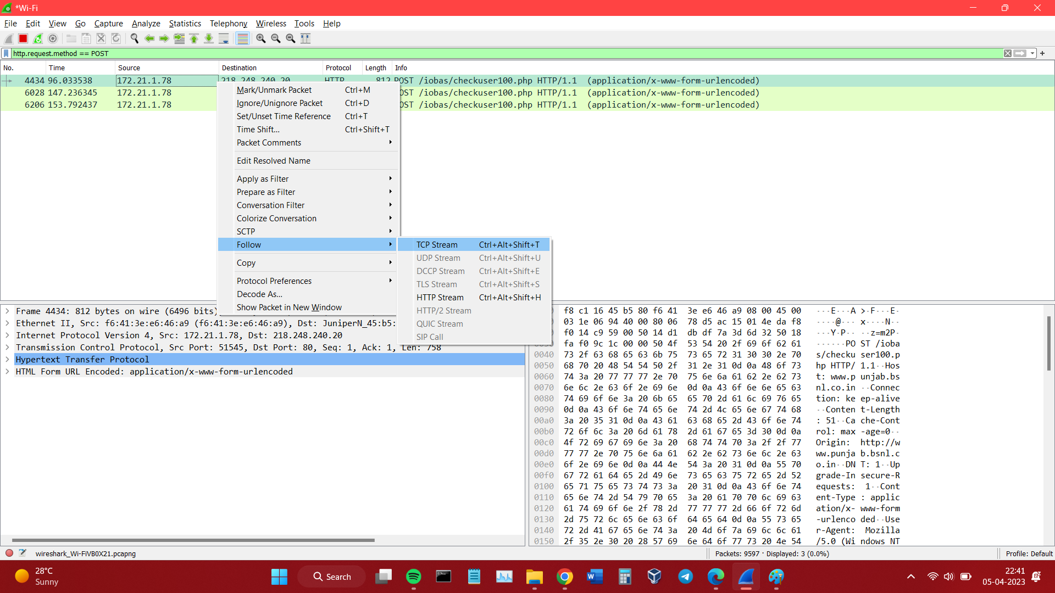

9.

10.

