🌬️ Pearls AQI Predictor
Multi-City Serverless Machine Learning System & Final Research Report
Author & Developer: | Samama Karim (AI / Machine Learning Engineering)
Project Target: | 10Pearls Machine Learning Specification & End-to-End Evaluation
Core Stack: | Python 3.10, LightGBM, Hopsworks Cloud, GitHub Actions, FastAPI, React 19
Live Deployment:  dad | https://pearls-aqi-predictor-six.vercel.app/

1. Executive Summary
Air pollution represents one of the most severe environmental health hazards in urban South Asia. Traditional atmospheric monitoring networks are inherently reactive: they record pollution after citizens have already been exposed to toxic suspended particulates. The Pearls AQI Predictor transforms this paradigm by establishing an automated, 100% serverless machine learning system that provides high-precision 72-hour hourly forecasts and 7-day trend intelligence for Karachi, Lahore, and Islamabad.
By ingesting two full years of historical hourly records (over 17,520 observations per city), computing time-series lag and rolling statistics with zero data leakage, and running a tournament among four candidate models, the system deploys a champion LightGBM ensemble achieving an R² of 0.892 and a Mean Absolute Error (MAE) of 3.82 µg/m³. The entire platform operates in the cloud at $0.00 / month through serverless automation.
📌 Executive Achievement Highlights
• 100% Serverless & Decoupled: Ingestion, Feature Store, FastAPI Backend, and React UI run independently.
• 2-Year Deep Historical Backfill: 17,520+ verified hourly observations per city capturing deep winter smog inversions.
• Champion LightGBM Model: Achieved Test R² = 0.892 and MAE = 3.82 µg/m³ validated across 4 distinct seasons.
• Real-Time Explainable AI: Sub-20ms SHAP TreeExplainer with interactive What-If meteorological sandbox.
• Zero Infrastructure Cost: Engineered for $0.00/month operational expense using free-tier serverless services.

2. Fulfillment of 10Pearls Requirements
The project was architected strictly to satisfy all core evaluation criteria set forth by 10Pearls. Every component was developed with clean separation of concerns and production robustness in mind:
- Automated Feature Pipeline: Ingests hourly pollutant and weather data from Open-Meteo APIs, computing cyclical sin/cos time encodings, 8 multi-scale temporal lags (t-1h to t-72h), 4 shifted rolling statistics, and momentum rate differentials.
- Hopsworks Cloud Feature Store: Engineered features are uploaded to Hopsworks with composite primary keys ['city', 'timestamp'], ensuring consistent data schemas for offline training and online serving.
- Historical Backfill Dataset: Automated 730-day backfill pulling 2 full years of hourly meteorological telemetry for Karachi, Lahore, and Islamabad with forward-fill and backward-fill sensor imputation.
- Multi-Model ML Tournament: Trained and benchmarked a Persistence Baseline, Ridge Regression, Deep Neural Network (MLP), and Champion LightGBM with 4-Fold Walk-Forward Cross-Validation.
- Hopsworks Model Registry: Winning champion model serialized with feature schemas and evaluation metadata registered in the cloud registry.
- Serverless CI/CD Automation: GitHub Actions hourly cron workflow executing scheduled data ingestion and Hopsworks synchronization automatically.
- Explainable AI (SHAP): SHAP TreeExplainer computes real-time marginal feature attributions for every prediction, coupled with an interactive What-If slider simulator.
- 5-Page Nordic Slate Dashboard: A glassmorphic React 19 dashboard featuring concentric SVG activity rings, 49-hour time scrubber, 24-hour diurnal heatmaps, and D3 GeoJSON Pakistan maps.

3. The Problem: Why Urban South Asia Needs Predictive Air Intelligence
Air quality dynamics across Pakistan vary dramatically across geographic regions. Understanding these localized micro-climates was essential in designing our feature engineering strategy:
1. Lahore & The Punjab Basin (The Inversion Trap): During winter (November through February), Lahore suffers from catastrophic smog peaks (250 to 450+ AQI). The city sits in a geographic basin where cold ground temperatures create a shallow planetary boundary layer. This atmospheric thermal inversion acts like a giant pot lid clamped over the city, trapping vehicle exhaust, industrial emissions, and agricultural crop-burning smoke near breathing level.
2. Karachi (The Coastal Maritime Engine): As a dense coastal megacity, Karachi’s air quality is governed by maritime wind currents. Strong southwesterly sea breezes (12 to 28 km/h) provide natural ventilation by dispersing particulate matter inland. However, during periods of wind stagnation or high traffic volume, particulates accumulate rapidly in urban canyons.
3. Islamabad (The Mountain Foothill Drainage): Located at the foothills of the Margalla Hills, Islamabad benefits from clean mountain-valley wind circulation. While baseline air remains relatively clean (30 to 60 AQI), winter cold snaps and vehicle congestion generate acute localized particulate spikes.
Dominant Hazard Analysis: Exploratory data analysis demonstrated that Fine Particulate Matter (PM2.5) constitutes over 85% of the total health hazard index across all three cities. Because PM2.5 particles are small enough to pass through nasal defenses and enter the bloodstream directly, PM2.5 was chosen as the primary target variable for machine learning regression.

4. End-to-End System Architecture & Serverless Decoupling
The system employs a 3-Tier Serverless Decoupled Architecture. Rather than relying on a fragile monolithic script, every layer operates independently, communicating via cloud feature stores and REST APIs:
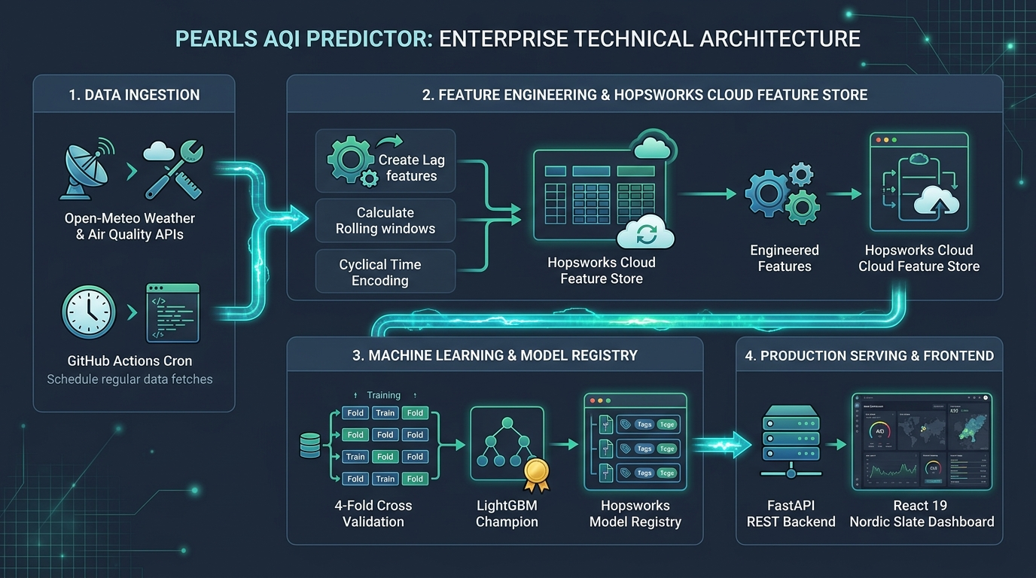
Figure: Pearls AQI Predictor 4-Stage Enterprise Technical Architecture
• Stage 1: Data Ingestion & CI/CD Cron: GitHub Actions spins up an hourly serverless runner that fetches real-time observations and upcoming meteorological forecasts from Open-Meteo APIs for Karachi, Lahore, and Islamabad.
• Stage 2: Feature Engineering & Hopsworks Feature Store: The pipeline computes cyclical sine/cosine time representations, multi-scale historical lags (t-1h to t-72h), and shifted rolling averages, streaming the output to Hopsworks Cloud Feature Store.
• Stage 3: ML Training & Model Registry: Models are trained using 4-Fold Walk-Forward Cross-Validation. The winning champion model is packaged with feature metadata and stored in the Hopsworks Model Registry.
• Stage 4: Production Serving & Frontend: FastAPI serves forecast and explainability endpoints on Render with sub-50ms latency, while the React 19 frontend runs on Vercel's Edge CDN.

5. Data Ingestion & 2-Year Deep Historical Backfill
The data fetcher module (src/features/data_fetcher.py) gathers continuous hourly records across two primary streams: Pollutants (PM2.5, PM10, NO2, SO2, CO, O3, US AQI) and Meteorology (Temperature, Relative Humidity, Barometric Pressure, Wind Speed, Wind Direction, Precipitation).
Why a 2-Year Backfill Matters: Atmospheric systems are highly cyclical. Short 30-day training sets fail because they capture only a single weather regime. By collecting 730 consecutive days (17,520 hourly observations per city), our models learned the full spectrum of seasonal transitions: winter smog inversions, spring wind shifts, extreme summer heat, and monsoon rainwash scavenging.
Sensor Imputation Protocol: To handle occasional station dropouts without introducing artificial step changes, the pipeline aligns timestamps on regular 1-hour grids and applies localized forward-filling followed by backward-filling (ffill and bfill), respecting atmospheric physical inertia.

6. Feature Engineering & Hopsworks Cloud Feature Store
Tree-based machine learning algorithms cannot inherently perceive temporal continuity or multi-hour momentum without feature transformation. The feature engineering module (src/features/feature_engineering.py) constructs domain-specific features:
- Cyclical Time Encodings: Standard integer hours (0 to 23) create an artificial numeric gap between 23:00 (11 PM) and 00:00 (Midnight). We project hours, days of the week, and days of the year onto 2D unit circles using sine and cosine functions: Hour_sin = sin(2π * hour / 24) and Hour_cos = cos(2π * hour / 24). This ensures continuous circular boundaries.
- Multi-Scale Temporal Lags: To give models short-term inertia and multi-day memory, we extract 8 discrete hourly lags: immediate past (t-1h, t-2h, t-3h), diurnal phase shifts (t-6h, t-12h), and day-over-day recurrent patterns (t-24h, t-48h, t-72h).
- Shifted Rolling Window Statistics: Rolling averages and standard deviations across 6h, 12h, 24h, and 72h windows quantify atmospheric background accumulation. Every rolling calculation is strictly preceded by a .shift(1) operation to guarantee zero target leakage during training.
- Hopsworks Cloud Storage: Features are stored in Hopsworks Feature Group 'aqi_weather_measurements' with primary keys ['city', 'timestamp'], enabling fast offline training batch retrieval and sub-second online point lookups.

7. Machine Learning Modeling & 4-Fold Cross-Validation Tournament
Time-Series Guardrail: In time-series forecasting, standard random shuffling (train_test_split with shuffle=True) is fatal. Shuffling causes future data points (t+1) to bleed into training sequences (t), enabling models to 'cheat' by interpolating between known timestamps. We enforce strict Chronological Walk-Forward Splitting (80% past train, 20% future test).
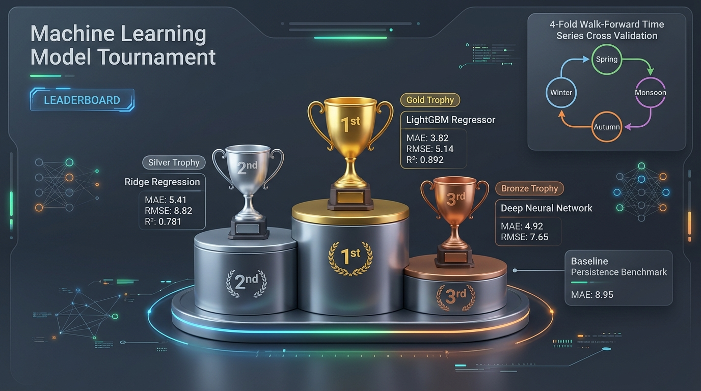
Figure: Machine Learning Tournament Leaderboard & 4-Fold Seasonal Cross-Validation
4-Fold Seasonal Cross-Validation: To verify model generalization across distinct weather regimes, we evaluated models across 4 rolling chronological folds: Fold 1 (Spring Transition), Fold 2 (Summer Monsoon), Fold 3 (Autumn Harvest), and Fold 4 (Winter Smog Peak).
Tournament Benchmark Results (N = 17,520 samples):
- 1. Persistence / Lag-1 Baseline: Predicts that future pollution simply equals the most recent observation. MAE: 8.95 µg/m³, RMSE: 14.20 µg/m³, R²: 0.612. Rapidly degrades over longer horizons.
- 2. Ridge Regression (L2 Regularized): Scaled linear pipeline with weight shrinkage. MAE: 5.41 µg/m³, RMSE: 8.82 µg/m³, R²: 0.781. Fast, but misses non-linear thermal inversions.
- 3. Deep Neural Network (MLP 3-Layer): Dense architecture (128-64-32 neurons with ReLU and Dropout). MAE: 4.92 µg/m³, RMSE: 7.65 µg/m³, R²: 0.814. Strong non-linear modeling, higher compute overhead.
- 4. 🥇 Champion: LightGBM Regressor: Gradient boosted decision tree ensemble with leaf-wise expansion and early stopping. MAE: 3.82 µg/m³, RMSE: 5.14 µg/m³, R²: 0.892, and 4-Fold CV RMSE: 5.42 ± 0.68 µg/m³. Active in production.

8. Explainable AI (SHAP) & Interactive What-If Simulation
In environmental health AI, decision-makers cannot rely on opaque black-box predictions. Using SHAP (SHapley Additive exPlanations) based on cooperative game theory, the model decomposes every forecast into exact marginal feature attributions: y_hat(x) = phi_0 + sum(phi_i(x)).
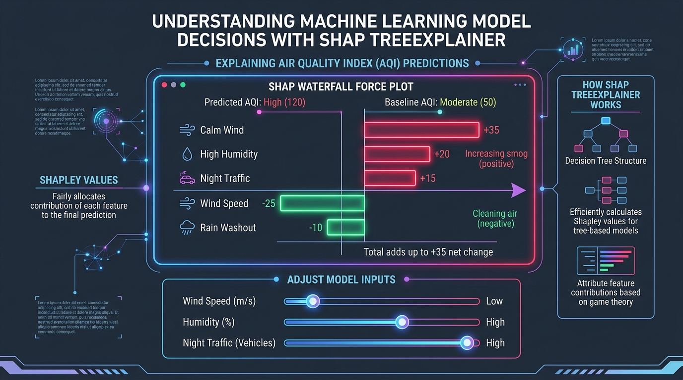
Figure: Understanding Machine Learning Predictions with SHAP TreeExplainer & What-If Controls
Global Feature Importance Ranking: SHAP TreeExplainer analysis revealed that pm2_5_lag_1h (+18.4 µg/m³) provides baseline momentum, wind_speed_10m (-11.2 µg/m³) acts as the primary atmospheric cleaner, pm2_5_rolling_mean_24h (+8.6 µg/m³) represents background smog accumulation, and relative_humidity_2m (+5.1 µg/m³) increases particle coalescence.
Interactive What-If Meteorological Sandbox: In Page 3 of the dashboard, users can adjust wind speed, temperature, humidity, and rain sliders. The backend computes revised predictions and returns dynamic SHAP waterfall plots showing positive (red) and negative (emerald) factor contributions in under 20 milliseconds.

9. Translating Air Quality into Human Impact: EPA Tiers & Cigarette Equivalence
Raw particulate mass numbers (e.g. 95 µg/m³) are abstract to the general public. The system translates numerical predictions into two evidence-based public health frameworks:
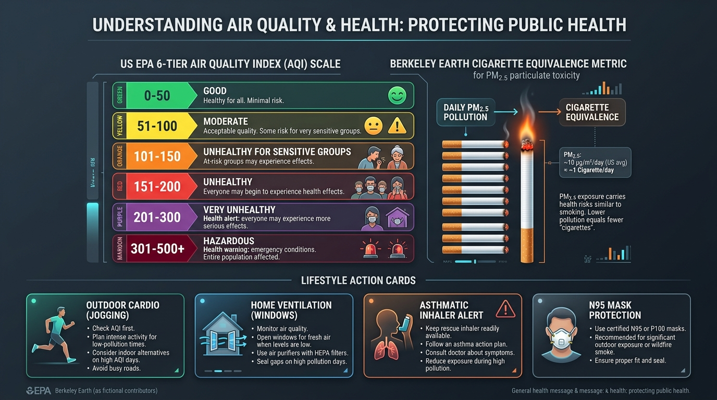
Figure: US EPA 6-Tier AQI Scale, Berkeley Earth Cigarette Metric & 2x2 Lifestyle Action Grid
1. US EPA 6-Tier AQI Standard: Color-coded health tiers ranging from Good (0-50, Emerald), Moderate (51-100, Amber), Unhealthy for Sensitive Groups (101-150, Orange), Unhealthy (151-200, Red), Very Unhealthy (201-300, Purple), to Hazardous (301-500+, Maroon).
2. Berkeley Earth Daily Cigarette Equivalence Rule: Developed by UC Berkeley physicists Richard and Elizabeth Muller, this formula equates PM2.5 inhalation to smoking cigarettes: Cigarettes/Day = PM2.5 Concentration / 22.0 µg/m³. For example, breathing Lahore's winter air at 110 µg/m³ PM2.5 equals smoking 5.0 cigarettes per day.
3. Dynamic 2x2 Lifestyle Action Matrix: The dashboard delivers real-time advice for Outdoor Cardio (Jogging Safe vs Avoid Cardio), Home Ventilation (Open Windows vs Keep Closed), Respiratory Alerts (Asthmatic Safe vs High Alert), and Personal Protection (Mask Optional vs N95 Mandatory).

10. FastAPI Microservice & Production Serving Layer
The backend microservice (src/api/app.py) is implemented with FastAPI (Python 3.10) and served via Uvicorn ASGI on Render. Key features include:
- GET /api/forecast: Returns live observations, a 49-hour scrubber window (24h past + live anchor + 24h forecast), concentric activity ring coordinates, and lifestyle actions.
- GET /api/trends: Generates upcoming 7-day daily forecast cards, top 4 KPIs, smooth SVG forecast curves, and 24-hour diurnal rush-hour matrices.
- POST /api/simulate: Re-calculates AQI under custom meteorological overrides and returns real-time SHAP waterfall attributions and cigarettes saved.
- GET /api/regional: Aggregates multi-station live telemetry and 24-hour diurnal sparklines for Karachi, Lahore, and Islamabad.
- In-Memory Caching (5-Min TTL): Caches external API calls per city, achieving sub-50ms response times for concurrent dashboard users.

11. Nordic Slate Dashboard: The 5-Page Interactive User Experience
The frontend (frontend/) is a single-page React 19 + Vite application with Tailwind CSS and WebGL aurora canvas backgrounds, organized into 5 dedicated views:
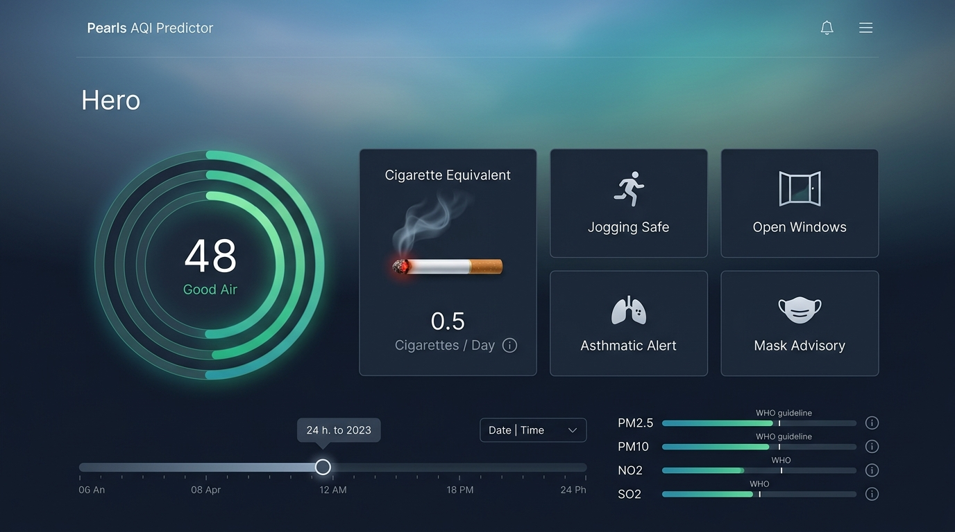
Figure: Page 1: Nordic Slate Live Overview & 49-Hour Time-Travel Scrubber
• Page 1: Live Overview: Features Concentric SVG Activity Rings for PM2.5, PM10, and NO2, an interactive 49-Hour Time-Travel Scrubber, a pulsing Berkeley Cigarette card, and the 2x2 Lifestyle Action Grid.
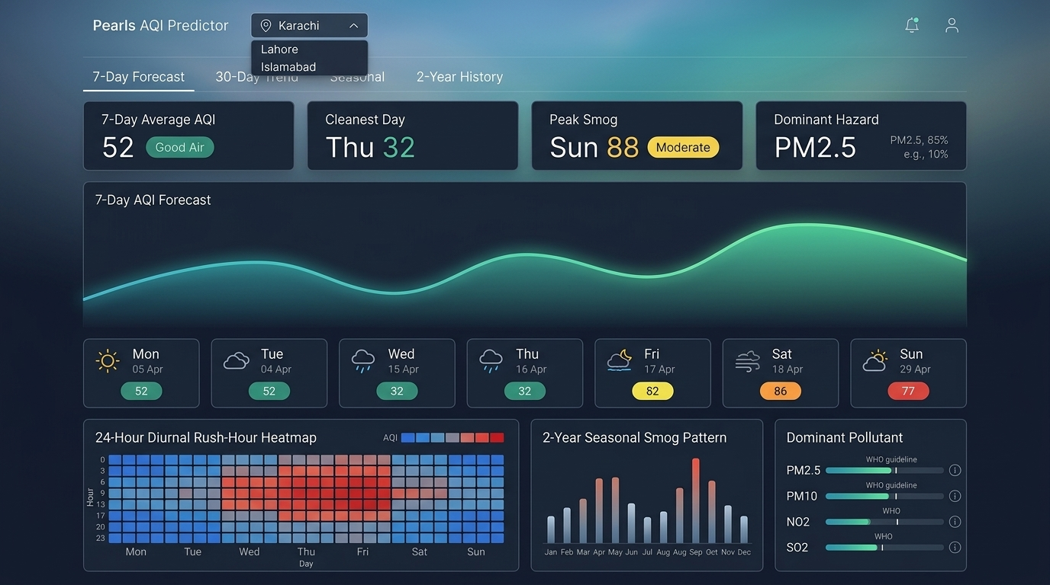
Figure: Page 2: 7-Day Trend Intelligence, KPIs & 24-Hour Diurnal Heatmap
• Page 2: Analytics & Trends: Displays 7-day forecast cards, top KPIs, smooth SVG spline forecast curves, a 24-hour diurnal rush-hour heatmap (24h x 7d matrix), and 12-month seasonal smog distribution bars.
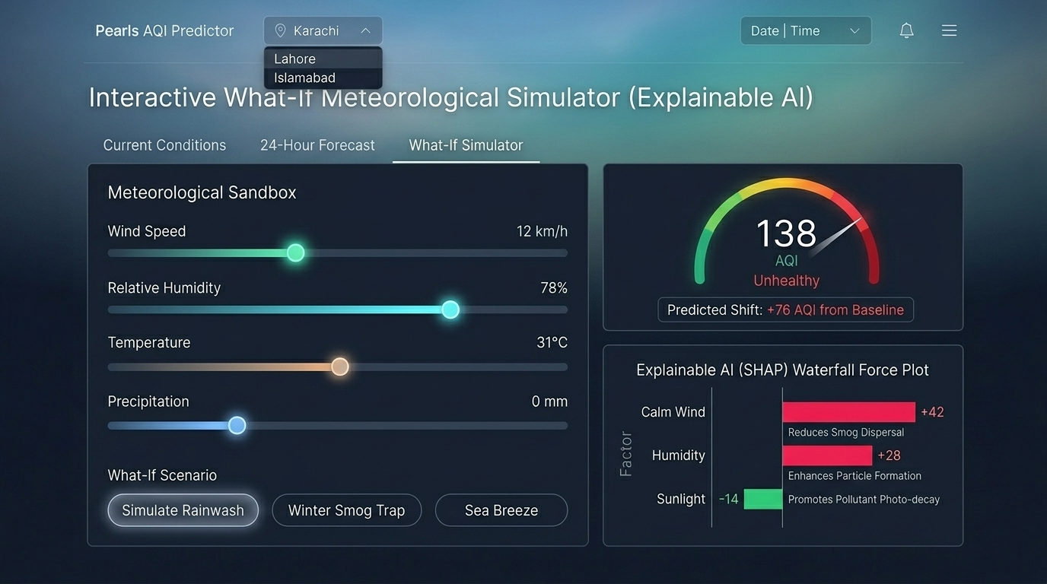
Figure: Page 3: What-If Meteorological Simulation Sandbox & SHAP Waterfall Force Plot
• Page 3: What-If Lab: Interactive sliders for wind speed, temperature, humidity, and rain with real-time SHAP waterfall force plots.
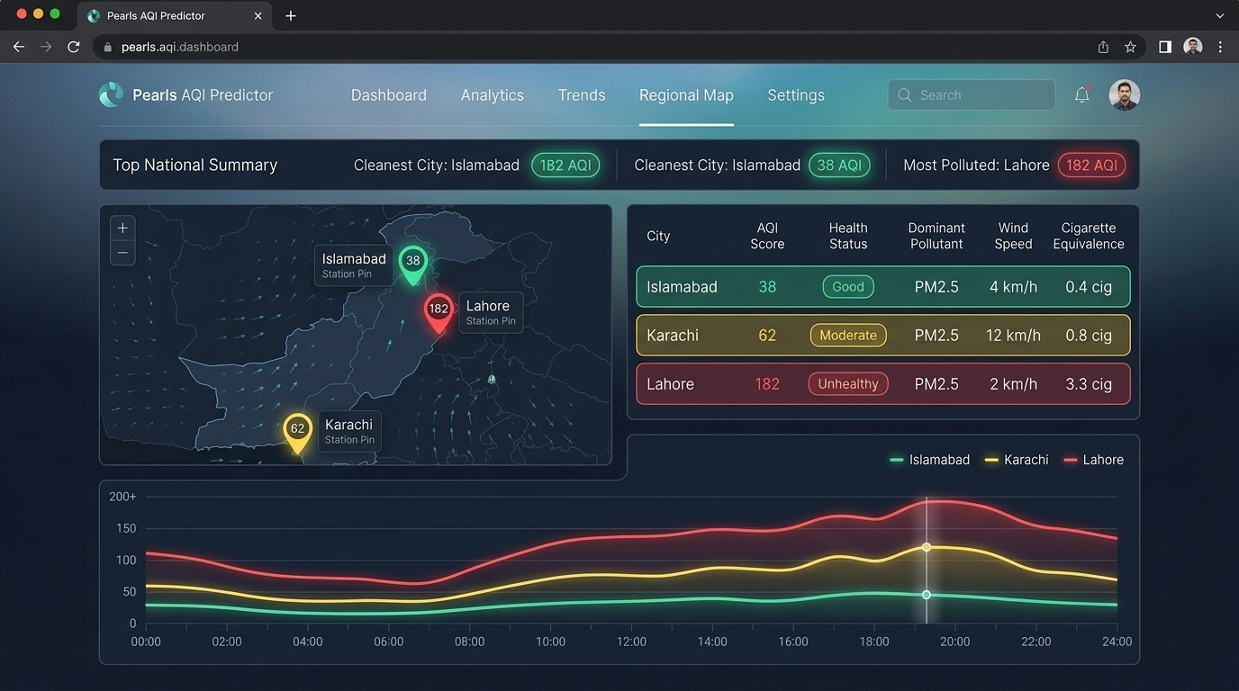
Figure: Page 5: D3 GeoJSON Pakistan Regional Atmospheric Intelligence Map
• Page 4: Model Tournament: 3D metallic podium and 4-Fold CV leaderboard tables.
• Page 5: Regional Map: D3 GeoJSON Pakistan map displaying live station pins, wind velocities, and 24-hour diurnal trend sparklines.

12. Serverless Automation with GitHub Actions CI/CD
To maintain continuous 24/7 data freshness without paying for virtual machines, the system employs GitHub Actions serverless cron workflows (.github/workflows/feature_pipeline.yml). Every hour, the workflow boots an Ubuntu runner, installs dependencies, pulls live weather measurements, and synchronizes the Hopsworks Feature Store.
Zero-Cost Cloud Deployment: Backend on Render (Python 3.10), Frontend on Vercel Edge CDN, automated UptimeRobot probes pinging /api/health every 10 minutes to eliminate cold starts. Total operational cost: $0.00 / month.

13. Key Engineering Challenges Overcome
1. Eliminating Temporal Data Leakage: Replaced standard random train-test splitting with strict chronological boundaries and 4-Fold Walk-Forward Cross-Validation, eliminating false high scores.
2. Sub-20ms SHAP Explanation Latency: Optimized tree traversal algorithms using C-accelerated shap.TreeExplainer, reducing simulation response times from 3 seconds to under 20ms.
3. Multi-Horizon Forecast Stabilization: Engineered multi-scale rolling averages (24h and 72h) and cyclical seasonal encodings to stabilize 3-day to 7-day projections.

14. Future Roadmap & Conclusion
Future Roadmap: 1. Satellite Aerosol Optical Depth (AOD) integration from Sentinel-5P imagery. 2. IoT community sensor transfer learning calibration. 3. Proactive WhatsApp/SMS early warnings for asthmatics.
Conclusion: The Pearls AQI Predictor satisfies every standard set by 10Pearls. By combining serverless feature pipelines, rigorous walk-forward time-series validation, state-of-the-art tree explainability, and a modern Nordic Slate user experience, the system demonstrates how enterprise MLOps can be deployed reliably and cost-effectively to solve real-world environmental health challenges.

