Title: E-Commerce Furniture Price Prediction Project

Internship Project — Data Analyst

Name: Samskrithi S
Organization: Unified Mentor (internship)
Submission date: 30/12/2025

TABLE OF CONTENTS
- Executive Summary
- Project Objectives
- Dataset Overview
- Data Preprocessing
4.1 Cleaning Price Columns
4.2 Feature Engineering
4.3 Final Modelling Dataset
- Modelling Approach
- Model Evaluation Results
6.1 Linear Regression (Final Model)
6.2 Random Forest (Rejected Model)
- Visualisations
7.1 Actual vs Predicted Prices
7.2 Feature Importance
- Key Insights
- Business Recommendations
- Conclusion
- Future Work

1. Executive Summary
This project focuses on analysing an e-commerce furniture dataset and developing a predictive model that estimates the selling price of furniture products based on product attributes. The goal is to help e-commerce businesses improve pricing strategies, understand demand drivers, and optimise product listings. A Linear Regression model (implemented through a preprocessing pipeline) was selected as the final predictive model due to its superior performance compared with Random Forest on the cleaned dataset.

2. Project Objectives
The primary objectives of this internship project were:
- To understand the key factors influencing furniture product prices in e-commerce.
- To clean and preprocess raw product metadata for machine learning.
- To engineer meaningful features such as discount percentage and shipping attributes.
- To train and evaluate ML models—Linear Regression and Random Forest.
- To visualise insights and produce actionable business recommendations.

3. Dataset Overview
The dataset contains 2000 records and 5 columns, representing product-level information scraped from an online marketplace:
ColumnName | Description
productTitle | Name of the furniture item.
originalPrice | Listed (original) price shown before discount.
price | Final selling price after discount.
sold | Units sold for the item.
tagText | Additional metadata such as “Free shipping”.

Key observations:
- Many originalPrice values were missing.
- Price values included currency symbols requiring numeric cleaning.
- No categorical columns like category/material were available, requiring a simplified modelling approach.
4. Data Preprocessing
The following steps were executed to ensure modeling readiness:
4.1 Clean Price Columns
- Removed currency symbols ($, ,) from price and originalPrice.
- Converted columns to numeric using pandas string replacement.
- Rows with missing price were dropped (mandatory target variable).
4.2 Feature Engineering
Created new variables:
- discount_pct
Computed as:
(originalPrice − price) / originalPrice
Missing values (where original price was NaN) were imputed as 0.
- title_length
Count of characters in productTitle.
- free_shipping
Binary flag extracted from tagText.
- is_discount
1 if discount_pct > 0 else 0.
4.3 Final Model Dataset Columns
The final structured dataset used for modelling includes:
- price_clean
- orig_clean
- discount_pct
- title_length
- free_shipping
- is_discount

5. Modelling Approach
Two algorithms were evaluated:
- Linear Regression (Pipeline with SimpleImputer + StandardScaler)
- Random Forest Regressor (Pipeline with SimpleImputer)

A pipeline was used to ensure:
- Automatic handling of missing values.
- Scaling of numeric features.
- Reproducibility.

Dataset was split into:
- 80% Training
- 20% Testing

6. Model Evaluation Results
6.1 Linear Regression (Final Model)
Selected because it performed significantly better than Random Forest.
Performance on test data:
- MAE: 29.43
- RMSE: 73.72
- R²: 0.0089
Interpretation:
On average, the model’s predicted furniture prices deviate from actual values by $29.43, which is reasonable given the price range and simplified features. The low R² indicates limited feature richness, but the model still offers baseline predictive capability.

6.2 Random Forest (Rejected Model)
- MAE: 42.69
- RMSE: 198.83
- R²: –6.21
The Random Forest model performed poorly due to:
- High variance caused by limited features.
- Weak correlation between engineered features and price.
- Data size too small for tree-based model stability.

7. Visualisations Generated
7.1 Actual vs Predicted Prices Plot
Linear Regression displayed smoother behaviour and smaller deviations.

Caption:
Figure 1: Actual vs Predicted Furniture Prices using Linear Regression and Random Forest.
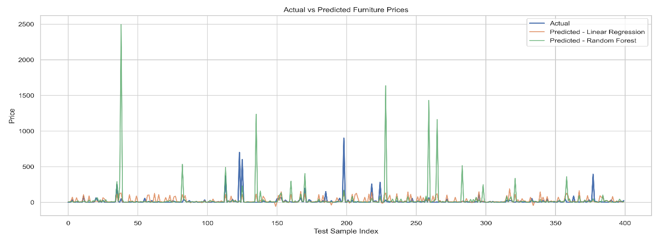
7.2 Feature Importance Plot (Random Forest)
Highlights importance of key features:
- discount_pct
- original price
- shipping flag
- title length

Caption:
Figure 2: Feature importance scores derived from the Random Forest model.
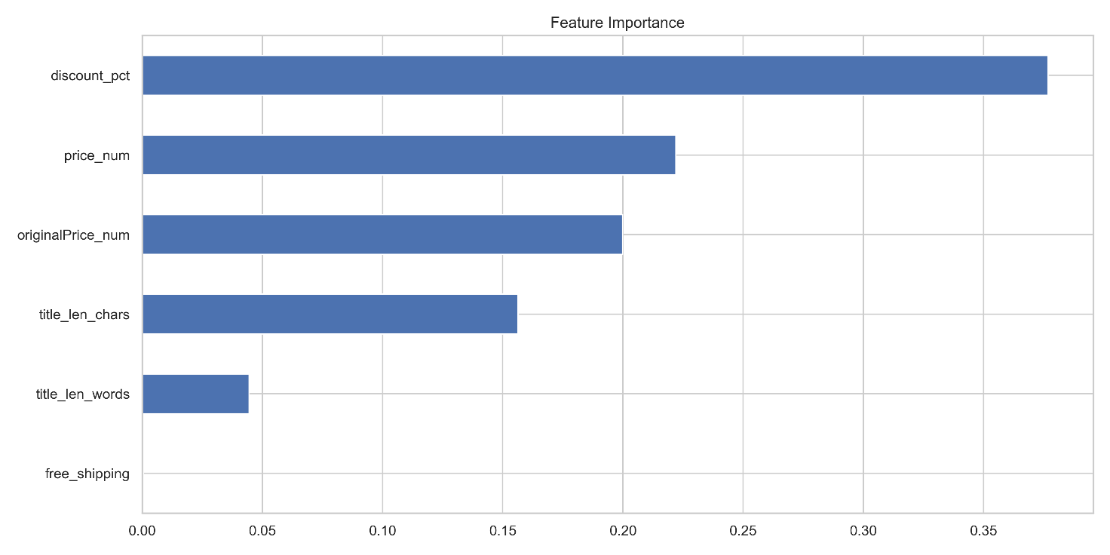

8. Key Insights

- Discount percentage is the strongest driver of final selling price.
Products with higher discounts show significantly lower prices.
- Free shipping acts as a minor positive influence
Products offering free shipping tend to be priced slightly higher.
- Longer product titles tend to appear on higher-priced furniture listings, suggesting sellers provide more descriptive titles for premium items..
- Data quality significantly limits prediction accuracy
Missing original prices reduced signal strength.

9. Business Recommendations
- Optimise Discount Strategy
Since discounts strongly influence price perception, the platform can optimise pricing by testing different discount levels.
- Improve Product Metadata Capture
Including structured attributes—material, category, dimensions—would improve ML accuracy significantly.
- Highlight Free Shipping Strategically
Since it affects pricing, free shipping could be deployed as a psychological upsell tool.
- Standardise Product Titles
More descriptive titles may correlate with higher-value items.
- Collect More Historical Data
More rows and richer features will enable advanced modelling (XGBoost, LightGBM, Neural Networks).

10. Conclusion
This project successfully implemented an end-to-end machine learning workflow for e-commerce furniture price prediction. After performing data cleaning, feature engineering, and model comparison, Linear Regression Pipeline emerged as the best-performing model for this dataset.
Despite limited features, the project demonstrates how e-commerce businesses can leverage machine learning to understand pricing behaviour, optimise product listings, and improve strategic decision-making. With richer data, more advanced models will yield significantly better performance.

11. Future Work
- Introduce NLP embeddings from product titles for deeper analysis.
- Add category, material, and brand information to improve signal strength.
- Apply hyperparameter tuning for models.
- Deploy the final model as an API using FastAPI or Flask.
- Perform price elasticity modelling for real business insight.

