Resume Analyzer and Job Role Recommendation System

1. Introduction
In today’s competitive job market, recruiters receive a large volume of resumes for every job opening. To efficiently shortlist candidates, many organizations rely on Applicant Tracking Systems (ATS) that automatically analyze resumes based on keyword relevance and job requirements. However, this often leads to capable candidates being rejected due to poor keyword alignment rather than lack of skills.
This project, titled “Resume Analyzer and Job Role Recommendation System”, aims to simulate a simplified ATS-based screening system. The application analyzes the compatibility between a candidate’s resume and a given job description and further recommends the most suitable job role based on resume content using Natural Language Processing (NLP) techniques.

2. Objectives of the Project
The main objectives of this project are:
- To analyze how well a resume matches a given job description
- To identify matching and missing keywords between resume and job requirements
- To calculate a resume–job compatibility score
- To recommend the most suitable job role based on resume content
- To demonstrate the limitations of automated screening systems

3. System Overview
The system is implemented as a web-based application using Python and Streamlit. It accepts a resume in PDF format and a job description as input. The application processes both inputs using NLP techniques and provides analytical insights along with role recommendations.
User Flow:
- User uploads resume (PDF)
- User pastes job description
- System analyzes resume–job compatibility
- Results are displayed
- User optionally requests best-fit job role recommendation

4. Technology Stack

Component |  | Technology used
Frontend |  | Streamlit
Backend |  | Python
NLP |  | TF-IDF Vectorization
Similarity Measure |  | Cosine Similarity
PDF Processing |  | PyPDF2
Data Handling |  | Scikit-learn

5. Methodology
5.1 Resume Text Extraction
The resume is uploaded in PDF format and text is extracted using the PyPDF2 library. This allows the system to convert unstructured resume content into analyzable text.
5.2 Text Preprocessing
Both resume text and job description are cleaned using:
- Lowercasing
- Removal of special characters
- Removal of extra whitespace
This preprocessing ensures uniformity in text comparison.
5.3 Resume–Job Matching
TF-IDF (Term Frequency–Inverse Document Frequency) is used to convert text into numerical vectors. Cosine similarity is then calculated to determine how closely the resume matches the job description.
The result is expressed as a percentage match score.

6. Keyword Analysis
The system identifies:
- Matching keywords: present in both resume and job description
- Missing keywords: present in job description but absent in resume
This helps candidates understand skill gaps and improve their resumes.

7. Job Role Recommendation Module
Apart from job-specific matching, the system also performs role-based recommendation. Predefined role profiles (Data Analyst, Business Analyst, HR, Web Developer, Operations) are compared against the resume using TF-IDF similarity.
Key Features:
- Role recommendation is optional and user-controlled
- Confidence threshold is applied to avoid misleading suggestions
- If confidence is low, the system warns instead of recommending
This reflects real-world ATS behavior and avoids false positives.

8. Results and Discussion
Observations:
- When job descriptions closely align with resume skills, higher match scores are obtained
- Keyword mismatch significantly affects ATS-style screening
- Role recommendation works effectively when resume content aligns with predefined role profiles
- Low confidence scenarios are handled responsibly by displaying warnings
Important Insight:
The system highlights the gap between human evaluation and automated screening, demonstrating why qualified candidates may not always pass ATS filters.

9. Limitations of the System
- Role profiles are keyword-based and do not capture full semantic meaning
- No deep contextual understanding of projects or experience
- ATS logic is simplified compared to enterprise systems
- Accuracy depends heavily on resume wording

11. Conclusion
The Resume Analyzer and Job Role Recommendation System successfully demonstrates how automated systems analyze resumes and make hiring-related decisions. By combining resume–job matching with role recommendation and confidence thresholds, the system provides realistic insights into modern recruitment processes.
The project not only serves as a practical application of NLP techniques but also educates users about the limitations of ATS-based screening, making it a valuable decision-support tool for job seekers.

12. How to Run the Application
A. Running the Application Locally
Prerequisites
- Python version 3.9 or higher
- Internet connection (for installing dependencies)
- Any code editor (VS Code recommended)

Step 1: Clone or Download the Project
Download the project source code or clone it from GitHub:
git clone https://github.comSamamin1810/resume-analyzer.git
cd resume-analyzer
Step 2: Install Required Dependencies
Install all required Python libraries using the requirements.txt file:
pip install -r requirements.txt
Step 3: Run the Application
Start the Streamlit application using the following command:
python -m streamlit run app.py
Step 4: Access the Application
Once the application starts, open a web browser and navigate to:
http://localhost:8501
The Resume Analyzer interface will be displayed.
Step 5: Use the Application
- Upload a resume in PDF format
- Paste a job description
- Click Analyze Resume
- View match score, keyword analysis, and interpretation
- Optionally enable Best-Fit Job Role Recommendation

12. Screenshots
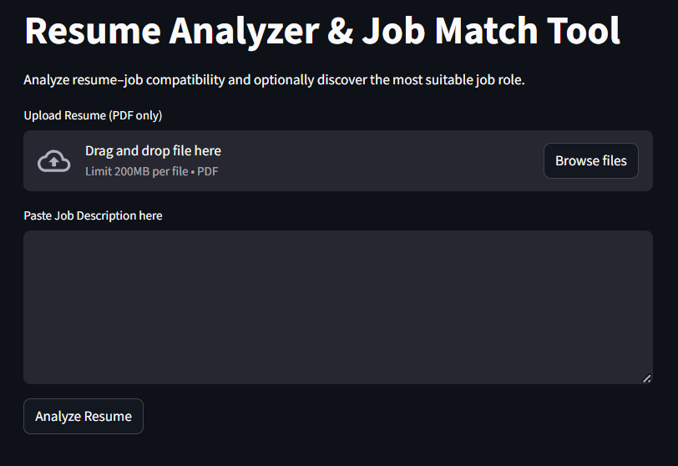
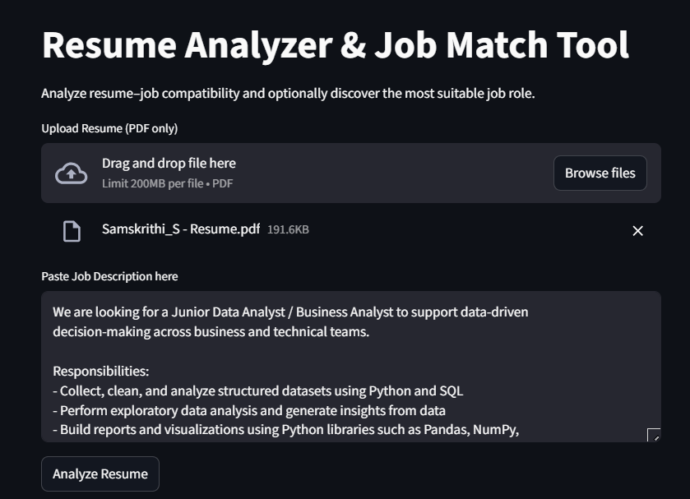
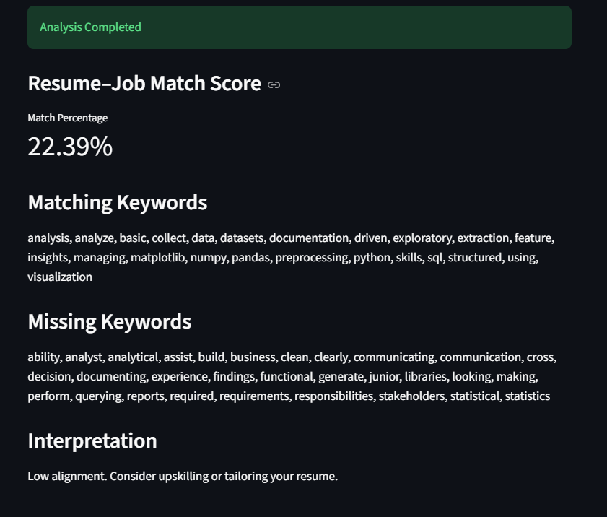

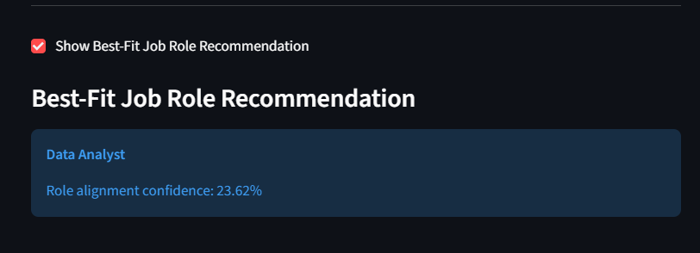

13. References
- Scikit-learn Documentation
- Streamlit Documentation
- PyPDF2 Documentation

