Test Specification

Using whatever WPF technology, you like, produce a vending machine application that allows users to choose from a list of beverage recipes (see below) from a menu, and for the machine to feedback to the user, the progress while it prepares the selection.

**Vending Machine Recipes**

Hot Chocolate

* Boil water
* Add drinking chocolate to cup
* Add water

White Coffee with 1 sugar

* Boil water
* Add sugar
* Add coffee granules to cup
* Add water
* Add milk

Lemon Tea

* Boil water
* Add water
* Steep tea bag in hot water
* Add lemon

Iced Coffee

* Crush Ice
* Add ice to blender
* Add coffee syrup to blender
* Blend ingredients
* Add ingredients

**The application has two views, Main and Order.**

The Shell contains **two regions**: a **header** and a **body**. For this test, only the body will change and the header contains the application’s title (E-Corp Vending Machine) and the current logged-in user info (full username and avatar) which should be bound to the appropriated model.

The Main View of the application should look like the following:

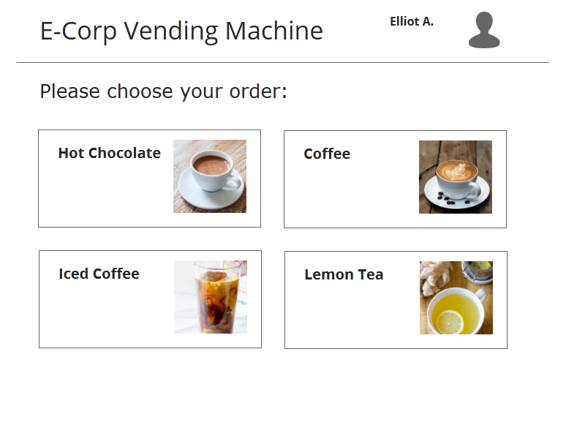

You can see that header is separated from body by a line in the above picture.

After choosing the desired beverage, user is navigated to the order view, in which the application will show the progress of the beverage being prepared. In this view, user can cancel the order at any time before the order is complete. User should also be able to navigate back to the main view via the back button, but this button should remain inactive while the order is in progress.

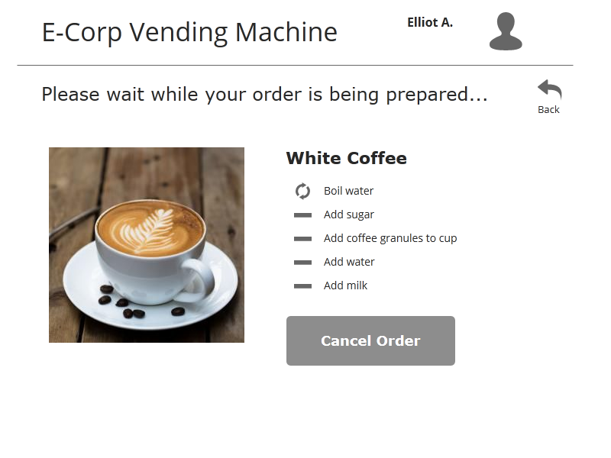

You can find out more about different states of this view in the pictures provided with this test.

# Objectives:

Emphasis should be placed on creating a good C# object model, making use of class inheritance, interfaces and other common object oriented (OOP) concepts and MVVM concept.

Following strict coding conventions and commenting your code is not necessary unless it will aid you in the code review.