BDA2

Rabnawaz jansher & Saman Zahid

5/21/2018

# BDA2 - Spark Sql - Exercises

# Question 1

## Part A

#sql spark imports  
from pyspark import SparkContext  
from pyspark.sql import SQLContext, Row  
from pyspark.sql import functions as F  
#create a spark objec  
sc = SparkContext(appName = "Lab2 Q1")  
#create a sql context  
sqlContext = SQLContext(sc)  
#read a temperatue data from file  
temperatureFile = sc.textFile("/user/x_rabsh/data/temperature-readings.csv")  
lines = temperatureFile.map(lambda line: line.split(";"))  
#create temperature dataframe   
tempReadingsRows = lines.map(lambda x: (x[0],x[1],int(x[1][0:4]),float(x[3])))  
dataFrameString = ["station","date","year","temp"]  
df = sqlContext.createDataFrame(tempReadingsRows,dataFrameString)  
df.registerTempTable("tempReadingTable")  
#group by year and find max temperature  
df_filter = df.groupBy('year').agg(F.max('temp').alias('max_temp'))  
output = df.join(df_filter,df_filter.year == df.year ,'inner').select('station' , df_filter.year,df_filter.max_temp , df.temp)  
#filter data by year   
output = output.where('temp = max_temp').select('station','year','max_temp').where( 'year >= 1950 and year <= 2014' )  
#order dataframe in descending order  
output = output.orderBy('max_temp', ascending=False)  
#convert dataframe into Rdd  
output = output.rdd  
#repartion result and save into file  
output = output.coalesce(1)  
output.saveAsTextFile("lab2_1a")

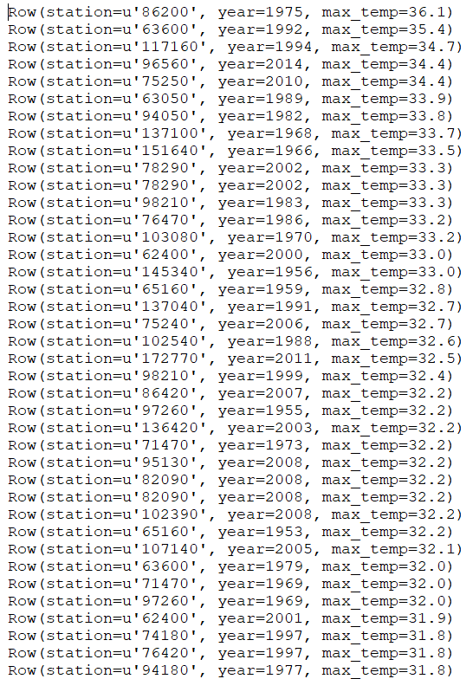

## Part B

#import spark libraries  
from pyspark import SparkContext  
from operator import add  
#spark sql context  
from pyspark.sql import SQLContext, Row  
from pyspark.sql import functions as F  
from pyspark.sql.functions import broadcast  
   
#spark context object  
sc = SparkContext(appName = "Lab2 Q5")  
#create a sql context  
sqlContext = SQLContext(sc)  
#temperature dataframe  
#read temperature data   
temperature_file = sc.textFile("/user/x_rabsh/data/temperature-readings.csv")  
temp_lines = temperature_file.map(lambda line: line.split(";"))  
#temperature dataframe  
tempRows = temp_lines.map(lambda x: (x[0], x[1][0:10],int(x[1][0:4]),int(x[1][5:7]),int(x[1][8:10]), float(x[3]) ))  
tempDataString = ["station", "date", "year","month","day","temp"]  
#register temperature table  
dfTemp = sqlContext.createDataFrame(tempRows,tempDataString)  
dfTemp.registerTempTable("tempReadingTable")  
#filter stations by using broadcast Join  
dfTemp_filter = dfTemp.where('year >= 1960 and year <= 2014')   
maxTemp = dfTemp_filter.groupBy('date','station').agg(F.max('temp').alias('max_temp'),F.min('temp').alias('min_temp'))  
output = maxTemp.rdd  
#for now  
#output = output.coalesce(1)  
output.saveAsTextFile("ppp")

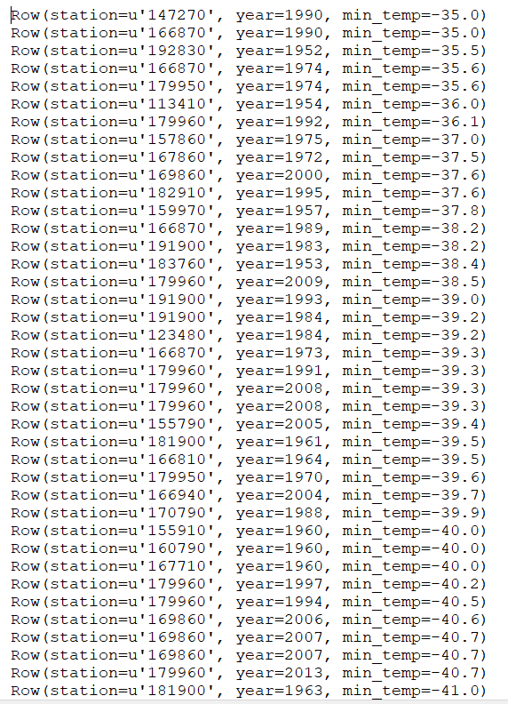

# Quesrion 2

## Part A

#import spark libraries  
from pyspark import SparkContext  
from operator import add  
#spark sql context  
from pyspark.sql import SQLContext, Row  
from pyspark.sql import functions as F  
#spark context object  
sc = SparkContext(appName = "Lab1 Q2-count-records")  
#create a sql context  
sqlContext = SQLContext(sc)  
#read temperature data from file  
temperature_file = sc.textFile("/user/x_rabsh/data/temperature-readings.csv")  
lines = temperature_file.map(lambda line: line.split(";"))  
#create a temperature datafreame  
tempReadingsRows = lines.map(lambda p: (p[0], p[1], int(p[1].split("-")[0]), int(p[1].split("-")[1]), float(p[3]),1))  
dataFrameString = ["station", "date", "year", "month", "temp","counter"]   
df = sqlContext.createDataFrame(tempReadingsRows,dataFrameString)  
df.registerTempTable("tempReadingTable")  
#select and filter data on year  
df_select = df.select('year','month','counter','year','temp').where( 'year >= 1950 and year <= 2014 and temp > 10' )  
#count records  
output = df_select.groupBy('year','month').agg(F.count('counter').alias('count')).orderBy('count', ascending=False)  
#convert dataframe into rdd  
output = output.rdd  
#repartion data and save  
output = output.coalesce(1)  
output.saveAsTextFile("lab2_2a")

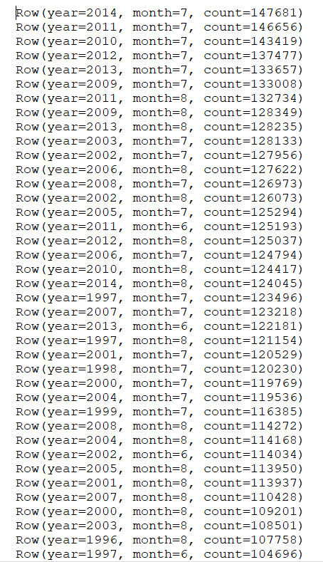

## Part B

#import spark libraries  
from pyspark import SparkContext  
from operator import add  
#spark sql context  
from pyspark.sql import SQLContext, Row  
from pyspark.sql import functions as F  
#spark context object  
sc = SparkContext(appName = "Lab1 Q2b-count-distinct-records")  
#create a sql context  
sqlContext = SQLContext(sc)  
#read temperature from file  
temperature_file = sc.textFile("/user/x_rabsh/data/temperature-readings.csv")  
lines = temperature_file.map(lambda line: line.split(";"))  
#create a data frame  
tempReadingsRows = lines.map(lambda p: (p[0], p[1], int(p[1].split("-")[0]), int(p[1].split("-")[1]), float(p[3])))  
dataFrameString = ["station", "date", "year", "month", "temp"]  
df = sqlContext.createDataFrame(tempReadingsRows,dataFrameString)  
df.registerTempTable("tempReadingTable")  
#filter data year wise  
output = df.where(df.year >= 1950)\  
 .where(df.year <= 2014)\  
 .where(df.temp >= 10)  
#groupby data count distinct count   
output = output.groupBy(output.year, output.month).agg(F.countDistinct(output.station).alias('count_record'))\  
 .orderBy('count_record', ascending = False)  
#convert dataframe into rdd  
output = output.rdd  
#repartion data and save  
output = output.coalesce(1)  
output.saveAsTextFile("lab2_2b")

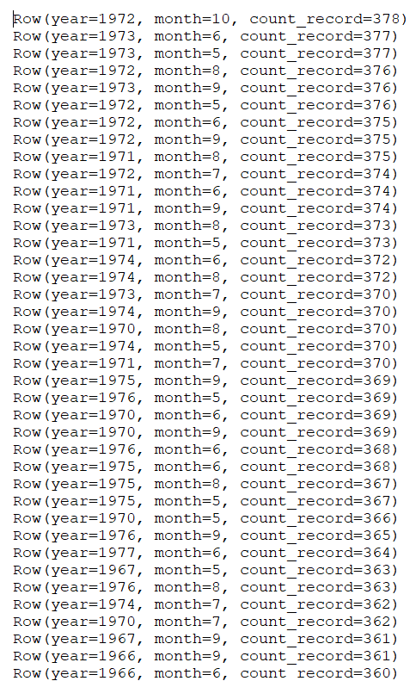

# Quesrion 3

#sql spark imports  
from pyspark import SparkContext  
from pyspark.sql import SQLContext, Row  
from pyspark.sql import functions as F  
sc = SparkContext(appName = "Lab2 Q3")  
# create a sql context  
sqlContext = SQLContext(sc)  
# reading data  
temperatureFile = sc.textFile("/user/x_samza/data/temperature-readings.csv")  
lines = temperatureFile.map(lambda line: line.split(";"))  
# creating dataframe of temperatures data   
tempReadingsRows = lines.map(lambda x: (x[0], int(x[1][8:10]) ,int(x[1][0:4]) ,int(x[1][5:7]) , float(x[3]) ))  
dataFrameString = ["station","date","year","month","temp"]  
df = sqlContext.createDataFrame(tempReadingsRows,dataFrameString)  
df.registerTempTable("tempReadingTable")  
# filtering data within the period 1950 and 2014  
df = df.where('year >= 1950 and year <= 2014')  
# finding max temperature  
df_groupby_df = df.groupBy('year','month','date','station').agg(F.max('temp').alias('max_temperature'))  
# finding min temperature  
df_groupby = df.groupBy('year','month','date','station').agg(F.min('temp').alias('min_temperature'))  
# joining dataframes containing min and max temperature and selecting required attributes  
df_join = df_groupby_df.join(df_groupby,(df_groupby_df.year == df_groupby.year) & (df_groupby_df.month == df_groupby.month) &   
 (df_groupby_df.date == df_groupby.date) & (df_groupby_df.station == df_groupby.station))\  
 .select(df_groupby.year,df_groupby.month,df_groupby.date,df_groupby.station,  
 df_groupby.min_temperature,df_groupby_df.max_temperature)   
# determining daily avg i-e (daily_max + daily_min)/2  
daily_average = df_join.withColumn('sum_min_max', (df_join.min_temperature + df_join.max_temperature)/2)  
# determining monthly avg by avg daily avg over stations  
monthly_avg = daily_average.groupBy('year','month','station').agg(F.avg(daily_average.sum_min_max).alias('average'))  
# sorting in descending order  
monthly_avg = monthly_avg.orderBy('average',ascending = False)  
output = monthly_avg.rdd  
output = output.coalesce(1)  
# saving output  
output.saveAsTextFile("lab_q2")

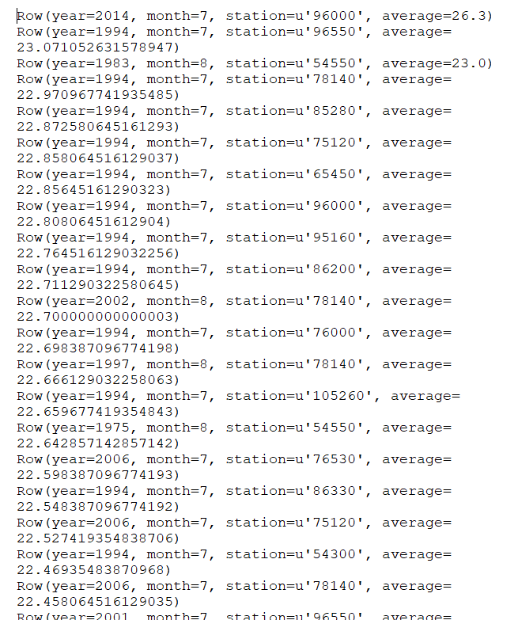

# Quesrion 4

#import spark libraries  
from pyspark import SparkContext  
from operator import add  
#spark sql context  
from pyspark.sql import SQLContext, Row  
from pyspark.sql import functions as F  
   
#spark context object  
sc = SparkContext(appName = "Lab1 Q4")  
#create a sql context  
sqlContext = SQLContext(sc)  
#read preciptate data   
precipitation_file = sc.textFile("/user/x_rabsh/data/precipitation-readings.csv")  
precipt_lines = precipitation_file.map(lambda line: line.split(";"))  
#preciptiate dataframe  
preciptRows = precipt_lines.map(lambda x: (x[0], x[1][0:10], float(x[3]) ))  
preciptDataString = ["station", "date", "value"]  
#register temperature table  
dfPrecipt = sqlContext.createDataFrame(preciptRows,preciptDataString)  
dfPrecipt.registerTempTable("tempReadingTable")  
#sum preciptate  
precipt_filter = dfPrecipt.groupBy('station','date') \  
 .agg(F.sum('value').alias('pvalue'))  
output_2 = precipt_filter.groupBy(precipt_filter.station)\  
 .agg(F.max(precipt_filter.pvalue).alias('max_precipt'))   
max_precipt_r = output_2.where('max_precipt >= 100 and max_precipt <= 200')  
#temperature file reading  
temperature_file = sc.textFile("/user/x_rabsh/data/temperature-readings.csv")  
temp_lines = temperature_file.map(lambda line: line.split(";"))  
#temperature dataframe   
tempReadingsRows = temp_lines.map(lambda p: (p[0], p[1], int(p[1].split("-")[0]), int(p[1].split("-")[1]), float(p[3])))  
dataFrameString = ["station", "date", "year", "month", "temp"]  
#register temperature table  
dfTemperature = sqlContext.createDataFrame(tempReadingsRows,dataFrameString)  
dfTemperature.registerTempTable("tempReadingTable")  
#max temperature  
df_filter = dfTemperature.groupBy(dfTemperature.station).agg(F.max('temp').alias('max_temp'))  
output = dfTemperature.join(df_filter,df_filter.station == dfTemperature.station ,'inner')\  
 .select(dfTemperature.station , df_filter.max_temp , dfTemperature.temp)  
output = output.where('temp = max_temp')  
output = output.where('max_temp >= 20 and max_temp <= 30')  
combine_result = max_precipt_r.join(output, output.station == max_precipt_r.station)\  
 .select(output.station,output.max_temp,max_precipt_r.max_precipt)  
output = combine_result.orderBy('station', ascending=False)  
output = output.rdd  
#for now  
output = output.coalesce(1)  
output.saveAsTextFile("lab2_q4")

Because there is no matching between 2 Rdd, so result will be null.

# Quesrion 5

#import spark libraries  
from pyspark import SparkContext  
from operator import add  
#spark sql context  
from pyspark.sql import SQLContext, Row  
from pyspark.sql import functions as F  
from pyspark.sql.functions import broadcast  
   
#spark context object  
sc = SparkContext(appName = "Lab2 Q5")  
#create a sql context  
sqlContext = SQLContext(sc)  
#reading data  
ostergotland_file = sc.textFile("/user/x_rabsh/data/stations-Ostergotland.csv")  
#partition data  
stations = ostergotland_file.map(lambda line: line.split(";"))  
#station data frame   
stationRow = stations.map(lambda x: (x[0],x[1]) )  
stationDataFrameString = ["station","name"]  
stations = sqlContext.createDataFrame(stationRow,stationDataFrameString)  
stations.registerTempTable("tempReadingTable")  
#boradcast stations  
#stations = stations.distinct().collect()  
#Os_stations = sc.broadcast(stations)  
#preciptiate dataframe  
#read preciptate data   
precipitation_file = sc.textFile("/user/x_rabsh/data/precipitation-readings.csv")  
precipt_lines = precipitation_file.map(lambda line: line.split(";"))  
#preciptiate dataframe  
preciptRows = precipt_lines.map(lambda x: (x[0], x[1][0:10],int(x[1][0:4]),int(x[1][5:7]),int(x[1][8:10]), float(x[3]) ))  
preciptDataString = ["station", "date", "year","month","day","value"]  
#register temperature table  
dfPrecipt = sqlContext.createDataFrame(preciptRows,preciptDataString)  
dfPrecipt.registerTempTable("tempReadingTable")  
#filter stations by using broadcast Join  
filter_stations = stations.join(dfPrecipt , dfPrecipt.station == stations.station)\  
 .select(stations.station,dfPrecipt.value,dfPrecipt.date,dfPrecipt.year,dfPrecipt.month,dfPrecipt.day)  
#groupby year,month and day and add precpitate values  
filter_stations = filter_stations.groupBy('year','month','day') \  
 .agg(F.sum('value').alias('pvalue'))  
filter_stations = filter_stations.groupBy(filter_stations.year,filter_stations.month).agg(F.avg('pvalue').alias('avgvalue'))  
#sort data by year and month in Descending order  
filter_stations = filter_stations.orderBy(['year', 'month'], ascending=False)  
#convert datafream into Rdd  
output = filter_stations.rdd  
#parartion data and save  
output = output.coalesce(1)  
output.saveAsTextFile("lab2_q5")

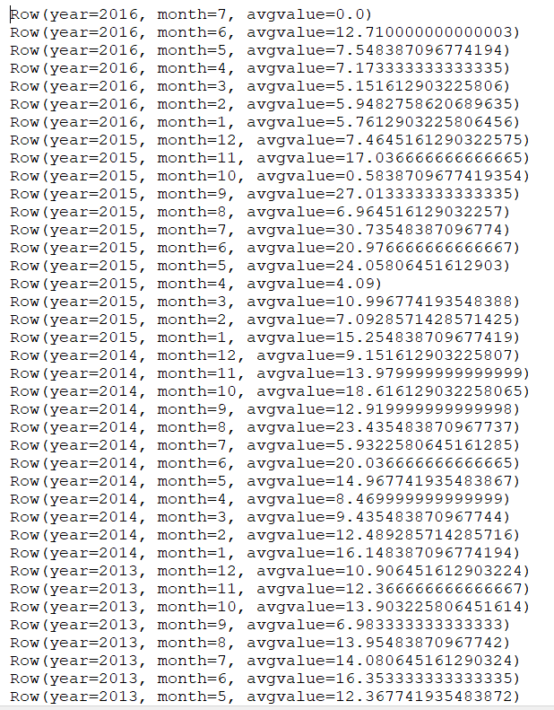

# Quesrion 6

#sql spark imports  
from pyspark import SparkContext  
from pyspark.sql import SQLContext, Row  
from pyspark.sql import functions as F  
#spark object   
sc = SparkContext(appName = "Lab2 Q6")  
#create a sql context  
sqlContext = SQLContext(sc)  
#reading station data  
ostergotland_file = sc.textFile("/user/x_rabsh/data/stations-Ostergotland.csv")  
#partition data  
stations = ostergotland_file.map(lambda line: line.split(";"))  
#station data frame   
stationRow = stations.map(lambda x: (x[0],x[1]) )  
stationDataFrameString = ["station","name"]  
stations = sqlContext.createDataFrame(stationRow,stationDataFrameString)  
stations.registerTempTable("stationReadingTable")  
# reading temperature data from file  
temperatureFile = sc.textFile("/user/x_rabsh/data/temperature-readings.csv")  
lines = temperatureFile.map(lambda line: line.split(";"))  
#create a temperature dataframe  
tempReadingsRows = lines.map(lambda x: (x[0], int(x[1][8:10]) ,int(x[1][0:4]) ,int(x[1][5:7]) , float(x[3]) ))  
dataFrameString = ["station","date","year","month","temp"]  
df = sqlContext.createDataFrame(tempReadingsRows,dataFrameString)  
df.registerTempTable("tempReadingTable")  
#filter stations from temeperature dataframe  
station_filter = df.join(stations, df.station == stations.station)\  
 .select(stations.station,df.date,df.month,df.year,df.temp)  
#monthly average temperature  
max_temp = station_filter.groupBy('year','month','date','station').agg(F.max('temp').alias('max_temperature'))  
min_temp = station_filter.groupBy('year','month','date','station').agg(F.min('temp').alias('min_temperature'))  
df_join = max_temp.join(min_temp,(min_temp.year == max_temp.year) & (min_temp.month == max_temp.month) & (min_temp.date == max_temp.date) & (min_temp.station == max_temp.station))\  
 .select(min_temp.year,min_temp.month,min_temp.date,min_temp.station,min_temp.min_temperature,max_temp.max_temperature)   
daily_average = df_join.withColumn('sum_min_max', (df_join.min_temperature + df_join.max_temperature)/2)  
monthly_avg = daily_average.groupBy('year','month','station').agg(F.avg(daily_average.sum_min_max).alias('average'))  
#average by year  
year_average_r = monthly_avg.groupBy('year','month').agg(F.avg(monthly_avg.average).alias('year_average'))  
#filter year  
year_average_r = year_average_r.where('year >= 1950 and year <= 1980')  
#long term average   
long_term_average_r = year_average_r.groupBy(year_average_r.month).agg(F.avg(year_average_r.year_average).alias('long_term_average'))  
long_term_average_r = year_average_r.join(long_term_average_r, long_term_average_r.month == year_average_r.month,'left_outer')\  
 .select(year_average_r.year,year_average_r.year_average,year_average_r.month,long_term_average_r.long_term_average)  
#find a difference in temperature  
difference_temp = long_term_average_r.withColumn('difference_temp', (long_term_average_r.year_average - long_term_average_r.long_term_average))  
difference_temp = difference_temp.select('year','month','difference_temp').orderBy(['year', 'month'], ascending=False)   
output = difference_temp.rdd  
output = output.coalesce(1)  
output.saveAsTextFile("lab2_q6")

