MAIN MENU:1.START:Click this button, the game will be start

2.STORYBOARD:We use the story 1 at the class

3.TUTORIAL:Teach players how to control role, up - ↑, down - ↓, left -←, right - → ,and maybe can add some function for collection and fight etc.

4.SETTING:Like whether have a background music and control volume

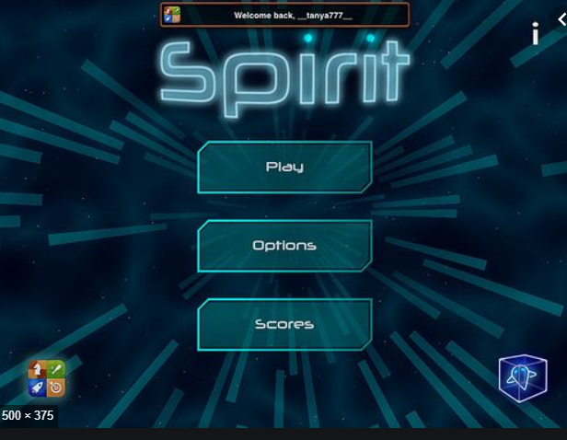

(main menu maybe like this kind of picture)

BACKGROUND: