Tutorial text: Control the characters movement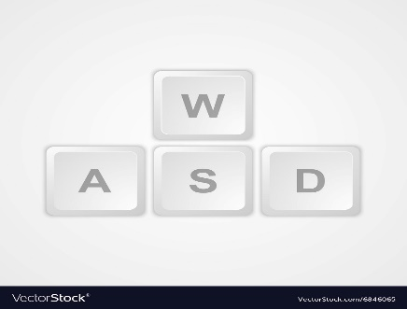

The left mouse button: control the character movement

The right mouse button: collect the entity

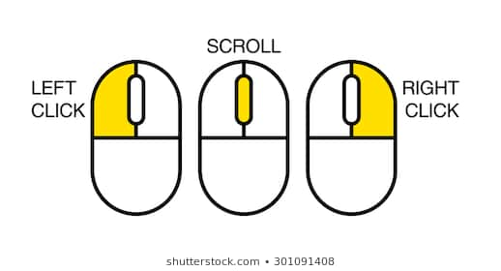

When we start the game, the main character has the full health and the full strength value.

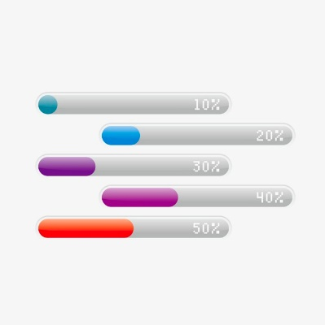

Arsenal: we need the box to load weapons and different weapons have different damage

So in this game, we need to get the food and collection to produce weapons (different material can make different weapons).

 Menu bar: like the bottom of the pictures this kind of menu bar could hide the text and the left side of that we could make the strength and health value.

The right side of: several icons on it like arsenal bag, material bag, food bag, medical bag and manufacturer (through collect material to produce weapon).