**Answer 1**

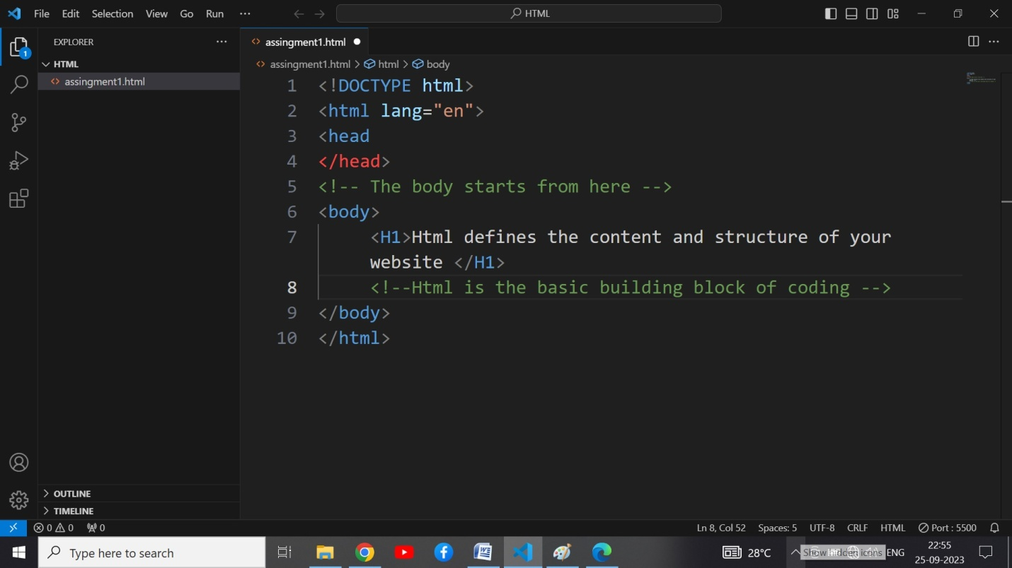

**Answer 2:**

The purpose of comments is not to render that particular text to the webpage . The information inscribed within them is not rendered or displayed on the web page .Moreover,they are used to give a insight of our code to the coders .Also,it is used to hide certain lines of code which can be rendered later as we wish.

For example:

Output:

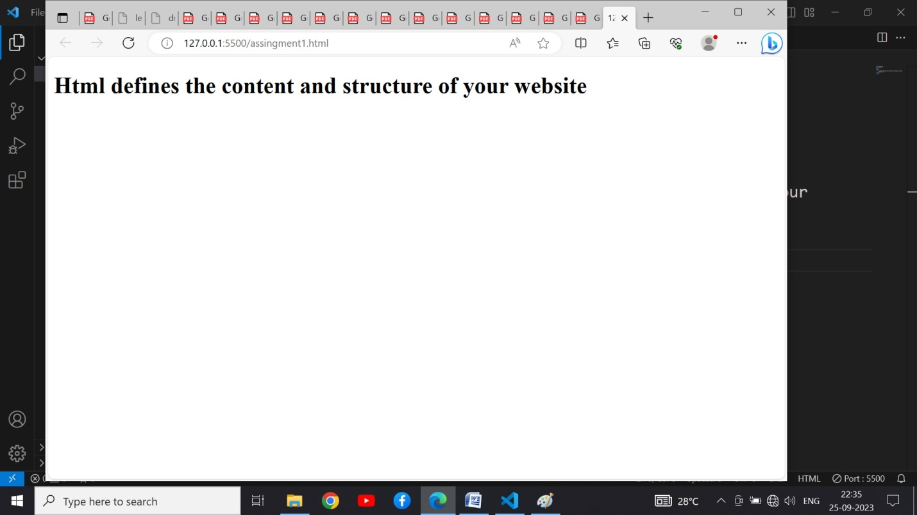

**Answer 3:**

Input:

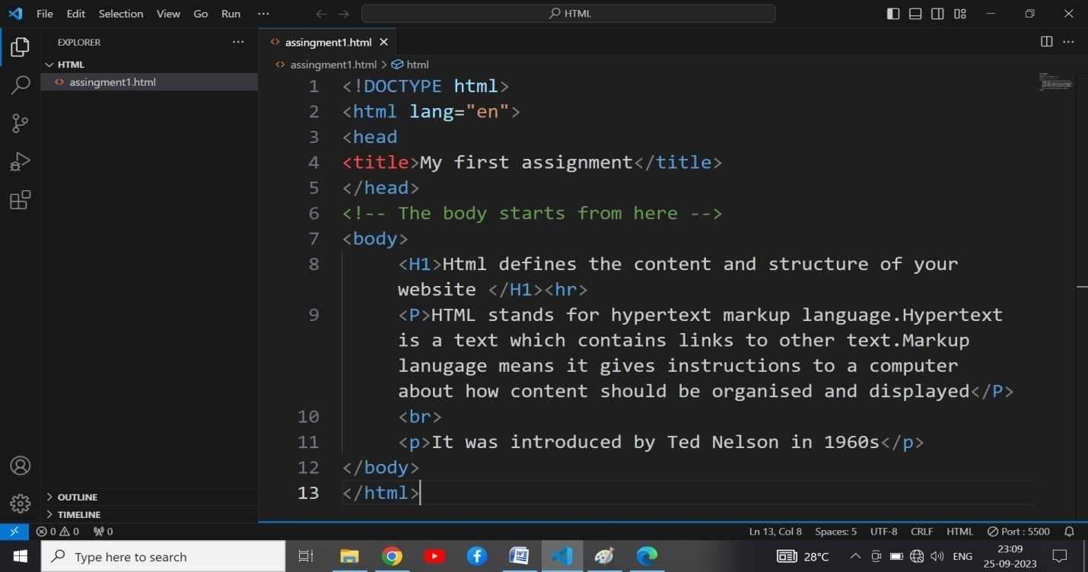

**Answer 4:**

HTML Tags : These are the instructions to the web browser that instructs browser how to format and display text . HTML tags are consist of two types of tags

1. Opening tag
2. Closing tag ( it has a forward slash )

These both tags are enclosed in angular brackets

HTML element : It can be defined as opening tag + content+closing tag

For eg : <H1> HTML is a forgiving language </H1>

This whole is reffered as a element.

**Answer:5**

The doctype declaration in html is used to tell the browser about the document type that what to expect from document . For eg : doctype declaration for HTML 5 is < doctype html>.

----------------------------------------DONE-----------------------------------------