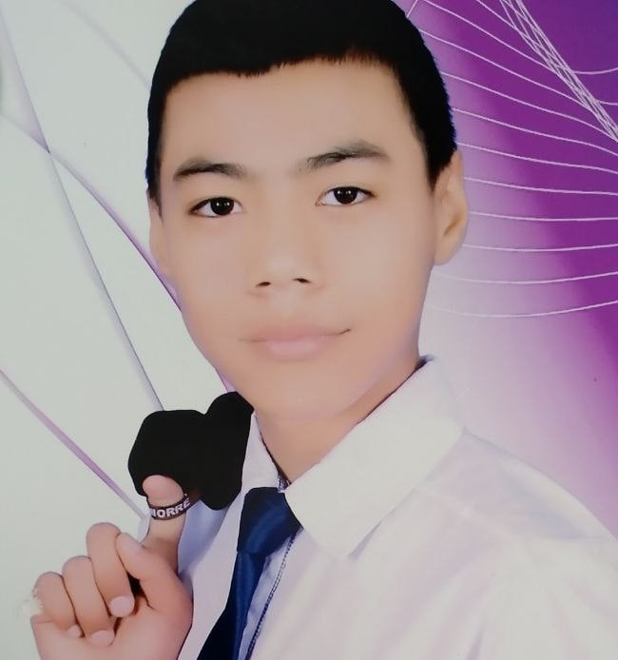

|  |  |  |  |
| --- | --- | --- | --- |
| Samandar | Bo'riyev | 17 | Direktor |