Final Year Project Report

ThreadCraft: Design, Development and Evaluation of an AI-Powered Custom Clothing Design and Ordering Web Platform for Sri Lanka.
Submitted by: Samandee Galagoda
Student number: CL/BSCSD/33/79

Supervisor: Ms. Upeka Wijesinghe
BSc(Hons) Software Engineering
ICBT Campus, Colombo
Academic Year 2025/2026

Table of Contents
Table of Contents 2
Chapter 1: Introduction 5
1.1 Background 5
1.2 Global Context 5
1.3 The Sri Lankan Apparel Industry and the Digital Gap 6
1.4 Research Gap 6
1.5 Problem Statement 7
1.6 Research Question 7
1.7 Aims and Objectives 7
1.8 Scope 8
1.8.1 In Scope 8
1.8.2 Out of Scope 9
Chapter 2: Literature Review 11
2.1 Introduction 11
2.2 Mass Customisation and the E-Commerce Context 11
2.3 Generative AI in Fashion Design 12
2.3.1 Diffusion Models and Latent Diffusion 12
2.3.2 Garment-Focused and Fashion-Specific Diffusion 12
2.3.3 Prompt Engineering and Attribute-Based Interfaces for Fashion Generation 13
2.4 Machine Learning for Body Measurement, Sizing, and Fit 14
2.4.1 Anthropometric Data 14
2.4.2 Gradient-Boosted Trees for Tabular Prediction 14
2.4.3 Fit and Size Recommendation 15
2.5 Vision Transformers for Garment Image Classification 15
2.6 Technology Acceptance and Trust in AI-Assisted Commerce 16
2.7 Configurable Catalogues and the Systems-Integration Gap 17
2.8 Summary 17
Chapter 3: Planning 19
3.1 Feasibility Study 19
3.1.1 Technical Feasibility 19
3.1.2 Operational Feasibility 20
3.1.3 Economic Feasibility 20
3.1.4 Legal and Ethical Feasibility 21
3.2 Risk Management 21
3.2.1 Risk Identification 21
3.2.2 Risk Assessment and Mitigation 22
3.3 Software Development Life Cycle — Agile Methodology 23
3.3.1 Rationale for Agile 23
3.3.2 Agile Sprint Structure 23
Chapter 4: Requirement Gathering and Analysis 25
4.1 Requirement Gathering 25
4.1.1 Approach: Dataset Analysis in Place of Primary Survey Research 25
4.1.2 Why Dataset Analysis Was Sufficient for This Project's Requirements 25
4.1.3 Requirements Derived Directly from Dataset Analysis 26
4.2 Functional Requirements 27
4.3 Non-Functional Requirements 28
Chapter 5: System Design 30
5.1 Architectural Overview 30
5.2 Architecture Diagram 31
5.3 Use Case Diagram 32
5.4 Domain Model 33
5.5 Entity-Relationship Diagram and Normalisation 35
5.6 Sequence Diagram: Order Placement and AI Mockup Generation 36
5.7 Wireframes 37
5.8 API Design 43
5.9 Design Rationale Summary 43
Chapter 6: Implementation 45
6.1 Implementation Overview 45
6.2 The Dynamic Pricing Engine (`pricing.py`) 45
6.3 The AI Prompt-Engineering Pipeline (`prompt.py`) 46
6.4 AI Mockup Generation and the Three-Tier Provider Fallback (`mockup.py`) 47
6.5 Measurement Prediction and Deterministic Sizing (`ml.py`, `sizing.py`) 47
6.6 Machine-Learning Evaluation Methodology 48
6.6.1 Baseline evaluation of the fit recommender 49
6.6.2 Framing A — direct size recommendation — rejected as non-monotonic 49
6.6.3 Framing B — fit-risk advisory — also rejected, inverted direction 50
6.6.4 Root cause and decision 50
6.7 The Garment Classifier: A Hosting Constraint, Not a Modelling Failure 50
6.8 What This Cost, and What It Bought 51
Chapter 7: Testing and Validation 53
7.1 Testing Strategy and Scope 53
7.2 Test Environment and Tooling 53
7.3 Test Plan 54
7.4 Unit-Level Testing: Pure Service Functions 56
7.5 Integration Testing: API and Database Layer 57
7.6 Representative Test Cases 58
7.7 Continuous Integration and Regression Testing 62
7.8 Relationship to ML Model Evaluation 62
7.9 Summary 62
Chapter 8: Conclusion 63
8.1 Overview 63
8.2 Evaluation Against Aims and Objectives 63
8.3 Answering the Research Question 64
8.4 Contributions 65
8.5 Limitations 65
8.6 Future Work 66
8.7 Reflection 66
8.8 Concluding Remarks 67
References 68

Chapter 1: Introduction

1.1 Background
The global apparel industry has moved decisively toward e-commerce over the past decade, with worldwide online apparel revenue reaching approximately US$628.5 billion in 2024 and an online share of 35–40% of total apparel sales (ECDB, 2024). Within this broader shift, a distinct segment has emerged around personalisation: consumers increasingly expect to influence the fit, fabric, and styling of the garments they buy rather than choosing only from fixed, pre-manufactured sizes. Mass customisation producing individually configured goods at close to mass-production cost has therefore become a competitive differentiator for apparel retailers rather than a niche offering confined to bespoke tailoring.
At the same time, two independent strands of applied machine learning have matured to the point where they can plausibly support this kind of personalisation inside an ordinary web application rather than a specialist design studio. The first is text-to-image generation: diffusion models such as Latent Diffusion (Rombach et al., 2022) made high-fidelity image synthesis from a text prompt computationally tractable, and garment-focused variants (Wan et al., 2024; Liu and Wang, 2024) have since demonstrated that such models can be conditioned specifically on clothing attributes rather than generic scenes. The second is predictive modelling over structured, tabular human-body data: gradient-boosted tree ensembles (Friedman, 2001; Ke et al., 2017) trained on large anthropometric datasets can estimate a person's likely measurements from a handful of easily supplied inputs such as height, weight, age, and sex a capability with an obvious application to reducing the friction of specifying a custom-fit garment online.
ThreadCraft, the system built for this project, sits at the intersection of these two trends. It is a full-stack web platform through which a customer selects a garment type, expresses a design intent through a combination of structured tags (fit, neckline, sleeve, pattern) and free text, supplies or receives an estimate of their body measurements, and receives both a computed price and an AI-generated visual mockup of the finished garment before an order is placed. An administrator-facing side of the same platform allows the garment catalogue, materials, pricing rules, and inventory to be configured without a code change, and exposes order-management and analytics views over the resulting data.

1.2 Global Context
Interest in applying generative AI to fashion design specifically as opposed to general-purpose image generation has grown quickly in the research literature since 2023. Zhang and Liu (2024) evaluated Midjourney directly against the Functional, Expressive, and Aesthetic (FEA) Consumer Needs Model for fashion e-commerce use, concluding that diffusion-based image generation shows genuine promise for streamlining ideation but requires careful integration with a retailer's existing product and commerce logic rather than being used as a standalone creative tool. Davis et al. (2024) reached a related but distinct conclusion from the design-tooling side: novice users supported by a graphical, attribute-based interface produced better design outcomes than users working from free-text prompts alone, because translating an abstract design intent into the vocabulary a diffusion model responds well to is itself a skill most consumers do not have. Khleborodova and Kim (2026) formalised this observation into a taxonomy-driven framework that replaces free-form prompting with structured attribute selection across six core design variables, converting user choices into prompts through a rule-based translation layer. Architecturally, this is close to what ThreadCraft's own design-tag system and prompt-construction service attempt to do, independently arrived at for a production e-commerce context rather than a research prototype.
Fit and sizing present a parallel but separate strand of research. Misra, Wan and McAuley (2018) framed the problem of predicting whether a specific item will fit a specific customer as a metric-learning problem over a large real-world marketplace dataset (RentTheRunway), establishing that fit prediction from purchase history and stated body measurements is tractable at scale but also that a poorly calibrated model actively misleads the customer rather than merely being unhelpful a finding directly relevant to the evaluation carried out on ThreadCraft's own fit-recommendation experiment, discussed in Chapter 6. Anthropometric survey data of the kind compiled in ANSUR II (Gordon et al., 2014) has separately underpinned a great deal of applied ergonomics and sizing research by providing large-sample, precisely measured human body dimensions that are otherwise prohibitively expensive for an individual project to collect.

1.3 The Sri Lankan Apparel Industry and the Digital Gap
Sri Lanka's apparel sector is one of the country's largest export industries and employs a substantial share of its manufacturing workforce, built historically around contract manufacturing for large international retail brands. Direct-to-consumer, made-to-order apparel businesses the tailors, boutique designers, and small-batch clothing brands that operate closer to the end customer form a different, less studied segment of the same industry. These businesses typically take custom orders through in-person consultation, phone calls, or unstructured social-media messaging: a customer describes what they want, sends reference photographs, and waits for the tailor to interpret the request, often without seeing anything resembling the finished garment until a physical sample is produced.
This is the digital gap that motivates ThreadCraft: the underlying tools that make structured, AI-assisted, self-service custom-apparel ordering possible (diffusion-based mockup generation, tabular ML for measurement estimation, configurable e-commerce catalogues) already exist and are individually well studied, but they are rarely combined into a single, coherent, small-business-affordable ordering platform aimed specifically at the made-to-order segment. Large international mass-customization platforms exist, but they are generally built around a single retailer's fixed catalogue and infrastructure budget; the tooling gap is sharpest for a smaller operation that wants the same customer experience without an enterprise engineering team behind it.

1.4 Research Gap
Three specific gaps motivate the project's scope:
First, the literature on diffusion-based fashion image generation is overwhelmingly evaluated on virtual try-on and image-editing benchmarks (Rombach et al., 2022; Wan et al., 2024) rather than on the harder practical problem of generating a mockup from a structured specification with no source photograph of the customer or garment at all the situation a made-to-order platform actually faces at the point an order is placed, before anything has been cut or sewn.
Second, published work on measurement or fit prediction (Misra, Wan and McAuley, 2018) is generally evaluated as a pure modelling exercise, reporting accuracy or ranking metrics, rather than as a deployed component inside a live ordering flow where a wrong prediction has a direct cost (wasted fabric, a returned order, a dissatisfied customer) and where the honest, defensible engineering response to a model that fails validation is not to force it into production regardless.
Third, existing academic treatments of configurable e-commerce catalogues and generative AI in fashion tend to address the two areas separately a recommender-systems or catalogue-architecture paper on one side (Deldjoo et al., 2023), a generative-image paper on the other (Rombach et al., 2022; Wan et al., 2024) with comparatively little written about the systems-integration problem of combining an admin-configurable product catalogue, a dynamic pricing engine, an ML measurement pipeline, and a generative mockup pipeline into one coherent, maintainable application.
ThreadCraft is positioned to address this combination directly, and Chapter 6 in particular documents both the design decisions made and, importantly, a case where a trained model was evaluated rigorously and deliberately withdrawn rather than shipped, which is exactly the kind of practical judgement the research gap above identifies as under-documented.

1.5 Problem Statement
Small and medium-sized made-to-order apparel businesses lack an affordable, self-service platform that lets a customer specify a custom garment (type, design details, material, colour, and body measurements), see a realistic visual preview of the result, and receive a transparent price all without a human intermediary while giving the business owner the tools to configure their catalogue, manage inventory, and track orders through production.

1.6 Research Question
Can a web-based ordering platform that combines an admin-configurable garment catalogue, a deterministic pricing engine, a machine-learning-assisted measurement pipeline, and a generative-AI mockup pipeline deliver a coherent, trustworthy self-service custom-apparel ordering experience, and where specifically do machine-learning components in that pipeline earn their place in production versus where does a simpler, non-ML approach perform better and deserve to be used instead?

1.7 Aims and Objectives
The aim of the project is to design, build, and evaluate ThreadCraft: a full-stack custom-apparel ordering and management platform that demonstrates where generative AI and applied machine learning genuinely improve a self-service ordering experience, and where they do not.
The specific objectives are:
- To design and implement an admin-configurable garment catalogue cloth types, per-garment measurement fields, design-option groups, and materials so that new products can be added by an administrator without a code change.
- To design and implement a deterministic, transparent pricing engine that produces an itemized price breakdown from the garment, selected options, material, colour, and computed fabric requirement.
- To train and integrate a measurement-prediction model, using anthropometric survey data, that estimates a customer's missing body measurements from the few fields they are willing to supply, and to validate submitted measurements against the same model to catch likely input errors.
- To train and evaluate a fit or size-recommendation model, and to make an explicit, evidence-based decision rather than a default one about whether it is fit for production use.
- To design and integrate an AI mockup-generation pipeline that converts a customer's structured and free-text design specification into a realistic product image, with a resilient multi-provider fallback strategy suited to a free-tier hosting budget.
- To build an administrator dashboard covering catalogue, pricing, inventory, and order-status management, together with basic operational analytics.
- To evaluate the resulting system against the research question above, documenting specifically which machine-learning components were retained, which were withdrawn, and why.

1.8 Scope
The scope of the project is defined below as a set of explicit in-scope capabilities and explicit exclusions, so that the boundary of what ThreadCraft does and does not attempt to solve is unambiguous going into the requirement, design, and evaluation chapters that follow.

1.8.1 In Scope
The ThreadCraft system, as built and evaluated for this project, encompasses the following capabilities:
- A consumer-facing web portal built with React 19 and Vite, responsive across desktop and mobile browsers, covering the full customer journey from account registration/guest checkout through to post-order tracking.
- A six-step guided ordering wizard: garment (cloth type) selection; design-tag selection, free-text description, and optional reference-image upload; material and colourway selection; body-measurement entry (with prediction and validation support); an itemised, server-computed price breakdown; and an AI-generated mockup preview of the finished garment.
- An admin-configurable garment catalogue cloth types, per-garment measurement fields, design-option groups and options, materials and colourways editable by an administrator without any code change (ADR 0003), together with per-item stock tracking and low-stock thresholds.
- A deterministic, transparent server-side pricing engine that computes an itemised total (base price, stitching premium, material cost, delivery fee) from the garment, selected options, material, colour, and computed fabric requirement.
- Three trained machine-learning models developed and evaluated as part of the project a measurement predictor, a garment-image classifier, and a fit/size recommender together with the deterministic UK size-band lookup that was shipped in the fit recommender's place, and the documented evaluation methodology (Chapter 6) that produced that decision.
- An AI mockup-generation pipeline with a three-tier provider fallback chain: Cloudflare Workers AI (FLUX.1-schnell) as the primary provider, the Hugging Face Inference API as a fallback, and a deterministic, locally rendered SVG placeholder as a last resort, so that a provider outage degrades the feature rather than failing the surrounding order-placement request.
- Payment processing integrated against Stripe in test mode, and an order-status production workflow (received to fabric cut to stitching to quality control to dispatched, or cancelled) with a complete, auditable status-change history.
- A customer account portal (order history, saved measurements, saved design drafts, and order tracking by order number, including for guest orders).
- An administrator dashboard covering catalogue and pricing configuration, inventory management, order-status management, and basic operational analytics.
- Evaluation of the system through its own automated backend test suite (pytest) and the ML evaluation methodology documented in Chapter 6, both of which are described in full in Chapter 7.

1.8.2 Out of Scope
The following are explicitly excluded from the ThreadCraft system as defined for this project:
- Live production deployment and the processing of real-money payments; Stripe is integrated and evaluated in test mode only throughout the project.
- Native mobile applications for iOS or Android; the system is a responsive web application only.
- Physical garment manufacturing, fabric cutting, or logistics/courier automation beyond the digital order-status workflow described above.
- Integration with a real supplier network or an actual tailoring business's live operations; the catalogue and inventory data used for development and evaluation are seeded, illustrative data.
- 3D garment modelling or augmented-reality try-on; the AI mockup component uses 2D text-to-image generation only.
- Training or fine-tuning the underlying diffusion model itself; FLUX.1-schnell is used as a pre-trained model via hosted inference (Cloudflare Workers AI and Hugging Face), not trained or fine-tuned as part of this project.
- A production-grade recommendation engine for cross-selling or upselling, which is a distinct research problem from the one posed in section 1.6.
- Formal usability testing with external human participants; the system was evaluated through its automated test suite, the documented ML evaluation methodology of Chapter 6, and internal review against the objectives of section 1.7, rather than through a moderated user study.

Chapter 2: Literature Review

2.1 Introduction
This chapter reviews the bodies of work that inform ThreadCraft's four technical pillars: generative AI for garment image synthesis, machine learning for body measurement and fit, configurable e-commerce catalogue and recommendation architecture, and user acceptance of AI-assisted commerce. Each section works from foundational technique toward the specific, fashion-domain applications closest to this project, deliberately interleaving general computer-science and information-systems literature with fashion-specific studies so that a claim about, for example, diffusion models is always followed by evidence of how that claim behaves once it is applied to clothing rather than generic photography. Each section closes by relating the literature directly to a design decision taken in ThreadCraft, and the chapter closes with a summary table that maps every reviewed source onto the specific ThreadCraft component it justifies.

2.2 Mass Customisation and the E-Commerce Context
Apparel e-commerce has continued to grow as a share of total retail even as growth in some adjacent retail categories has slowed; ECDB (2024) records worldwide apparel e-commerce revenue of approximately US$628.5 billion in 2024, with an online share of 35–40% of total apparel sales and continued year-on-year growth in the 5–10% range. Within that broader market, personalisation and made-to-order production have shifted from a bespoke-tailoring niche toward a mainstream expectation (ECDB, 2024). Mass customisation as a strategy depends on being able to configure a product per order without a proportional increase in operating cost, and this is not a purely technical claim: Lee and Chang (2011), applying an extended Technology Acceptance Model to 749 South Korean online shoppers using apparel mass-customisation configurators, found that perceived control over the design process and perceived enjoyment of the configuration task were significant, independent predictors of purchase intention over and above the conventional TAM constructs of perceived usefulness and ease of use meaning a mass-customisation storefront has to be evaluated not just on whether it works, but on whether the configuration experience itself feels engaging rather than merely functional. This finding shaped an explicit design choice in ThreadCraft's six-step wizard: each step is presented as a distinct, visually confirmed stage with an itemised price that updates as choices are made, rather than as a single long form, precisely so the customer experiences configuring the garment as an activity rather than as data entry.
Deldjoo et al. (2023), in their systematic review of fashion recommender systems, note that most existing recommendation and personalisation research in the fashion vertical still assumes a fixed catalogue of pre-manufactured SKUs rather than a per-order configurable product precisely the gap a configurable garment catalogue, as opposed to a static one, is intended to close. Deldjoo et al. (2023) further observe that fashion recommendation research has been slower than other verticals (such as media or grocery) to incorporate generative components, which motivates treating catalogue configuration and generative mockup production as connected problems in this project rather than building them independently. Ding et al. (2023), surveying computational technologies for fashion recommendation more broadly across more than one hundred and fifty studies, arrive at a closely related conclusion from a different angle: they classify the great majority of published fashion-recommendation work into personalised product recommendation, complementary (mix-and-match) recommendation, and outfit recommendation, and note that comparatively little of this literature addresses configuration-time personalisation a customer shaping the product itself before it exists as opposed to recommendation over an already-fixed inventory. Read together, Deldjoo et al. (2023) and Ding et al. (2023) describe the same structural gap from the recommender-systems side that Lee and Chang (2011) describe from the consumer-acceptance side: the fashion-technology literature is comparatively rich in both "recommend from what already exists" and "is a customer satisfied with the interface", but comparatively thin on the combination ThreadCraft attempts, where the product itself is configured per order and the configuration interface is the product experience.

2.3 Generative AI in Fashion Design

2.3.1 Diffusion Models and Latent Diffusion
The technical foundation for nearly all recent progress in text-to-image generation is the diffusion model, and specifically the latent diffusion architecture introduced by Rombach et al. (2022), which performs the iterative denoising process in a learned, compressed latent space rather than directly on pixels. A diffusion model is trained to reverse a fixed, gradual noising process: starting from a clean image, Gaussian noise is added over many timesteps until the image is indistinguishable from pure noise, and the network is trained to predict and remove a small increment of that noise at each step, so that at inference time the same network can start from pure noise and iteratively denoise its way to a coherent image conditioned on a text prompt. Rombach et al. (2022) showed that performing this process in a compressed latent space rather than at full pixel resolution reduces the computational cost of high-resolution image synthesis by an order of magnitude relative to earlier pixel-space diffusion models while retaining comparable output fidelity, which is the property that makes running a diffusion model economically viable on a free or low-cost inference tier rather than requiring dedicated GPU infrastructure. This cost profile is directly relevant to ThreadCraft, whose mockup-generation service is built around Cloudflare Workers AI's free-tier neuron allowance specifically because latent diffusion made a small operator's use of the technology financially realistic (Rombach et al., 2022). FLUX.1-schnell, the specific model ThreadCraft calls first in its provider chain, is a more recent open-weights diffusion model released under an Apache-2.0 licence and optimised for very low step counts (Black Forest Labs, 2024), a design choice that trades a small amount of output fidelity for latency low enough to fit inside an interactive ordering wizard rather than a batch job where Rombach et al. (2022) made diffusion computationally affordable in the first place, Black Forest Labs (2024) made a specific variant of it fast enough for a synchronous request-response cycle, which is the exact constraint ThreadCraft's wizard operates under.

2.3.2 Garment-Focused and Fashion-Specific Diffusion
General-purpose diffusion models are not, by default, well suited to preserving the specific visual identity of a garment through the generation process, and a distinct sub-literature has emerged to address this. Wan et al. (2024) introduced GarDiff, a garment-focused diffusion architecture that adds an adapter conditioned on CLIP and VAE encodings of a reference garment image directly into the diffusion U-Net, together with an explicit appearance loss over the synthesized garment region, and demonstrated on the VITON-HD and DressCode benchmarks that this materially improves texture and detail fidelity relative to unconditioned diffusion. Choi et al. (2024), publishing IDM-VTON at ECCV 2024, tackle the same underlying problem preserving a garment's identity, rather than merely its rough shape, through the diffusion process with a different architectural split: high-level garment semantics (cut and structure) are fed into the model's cross-attention layers while low-level texture detail (weave, print, fine pattern) is fed separately into its self-attention layers via a parallel UNet, and the authors report that this decomposition measurably improves garment fidelity over prior virtual try-on systems that treated garment conditioning as a single, undifferentiated signal. The pattern across both GarDiff (Wan et al., 2024) and IDM-VTON (Choi et al., 2024) is instructive for ThreadCraft even though neither system is used directly: both papers assume a photographic reference of the actual garment already exists and treat generation as compositing that garment onto a body, whereas ThreadCraft's mockup problem is the harder, unconditioned case of generating a garment from a structured specification and no source photograph at all a distinction returned to in section 2.4 of this chapter, and addressed directly in the research gap set out in Chapter 1.
Liu and Wang (2024) approached a closely related problem online, interactive T-shirt customisation with MYCloth, a system that lets a consumer iteratively adjust a garment design and receive an updated generated preview, which is architecturally the closest published analogue to ThreadCraft's own step-by-step wizard-plus-mockup flow, albeit scoped to a single garment type rather than a full catalogue. Wan et al. (2024), Choi et al. (2024), and Liu and Wang (2024) all evaluate primarily on photographic fidelity metrics, which is one reason ThreadCraft's own mockup pipeline was designed with a deterministic SVG placeholder fallback (see Chapter 6) rather than assuming generation will always succeed or always look photorealistic the published literature itself does not claim that guarantee, and none of these three systems report a fallback behaviour for generation failure at all.

2.3.3 Prompt Engineering and Attribute-Based Interfaces for Fashion Generation
A separate strand of research addresses not the diffusion architecture itself but the interface problem of getting a useful prompt out of a non-expert user. Davis et al. (2024) ran a comparative study of fashion-design apprentices using a graphical, attribute-based design-space-exploration tool against a conventional text-prompt interface built on Stable Diffusion, and found that participants using the graphical interface produced designs judged more creative and expressed a stronger preference for the tool, concluding that free-text prompting specifically disadvantages novice users who lack a stable design vocabulary the same population, in effect, as ThreadCraft's target customer, who is assumed to want a custom garment without being expected to already know how to write an effective diffusion prompt. Khleborodova and Kim (2026) generalised this finding into a taxonomy-driven framework that organises fashion design intent into six core attributes and translates structured selections into prompts through a rule-based pipeline rather than asking the user to write natural language at all. ThreadCraft's own design step four structured option groups (fit, neckline, sleeve, pattern) combined with an optional free-text field, assembled server-side into a templated prompt was arrived at independently for a production e-commerce context, but is consistent with the direction both Davis et al. (2024) and Khleborodova and Kim (2026) argue for on separate empirical grounds, and it deliberately keeps the free-text field optional rather than mandatory so that a customer who does have specific extra detail in mind is not blocked from supplying it, while a customer who does not is never required to invent one. Zhang and Liu (2024), evaluating Midjourney specifically against the Functional, Expressive, and Aesthetic (FEA) Consumer Needs Model for fashion e-commerce, reached a compatible conclusion from the commerce side: diffusion-generated imagery streamlines ideation and can support a purchase decision, but only when the generation step is integrated into the surrounding commerce workflow rather than treated as a standalone creative exercise precisely the integration problem this project addresses by embedding mockup generation as one step inside a pricing-and-ordering wizard rather than a separate tool.

2.4 Machine Learning for Body Measurement, Sizing, and Fit

2.4.1 Anthropometric Data
Any measurement-prediction model is only as good as the population data it is trained on, and the anthropometric-survey literature is the standard source for such data at a scale no individual e-commerce project could collect itself. Gordon et al. (2014) published ANSUR II, a survey of over 6,000 U.S. Army personnel recording more than ninety precisely measured body dimensions per subject using standardised anthropometric protocols. ANSUR II is used widely outside its original military-equipment-design purpose, including in apparel and ergonomics research, precisely because Gordon et al. (2014) documented their measurement protocol rigorously enough that the resulting dimensions are considered reliable ground truth by later work; ThreadCraft's own measurement-prediction model, discussed in Chapter 6, is trained on this dataset for exactly that reason. A recurring caveat in any use of ANSUR II outside its original context, which ThreadCraft's own documentation (Chapter 6) makes explicit rather than glossing over, is a population-mismatch risk: a dataset of U.S. military personnel is not a representative sample of ThreadCraft's actual customer population, and predictions for body types underrepresented in the source survey should be expected to be less reliable than predictions near the centre of that survey's own distribution.

2.4.2 Gradient-Boosted Trees for Tabular Prediction
Anthropometric prediction from a handful of known measurements is fundamentally a tabular regression problem, and gradient-boosted decision tree ensembles remain, empirically, the strongest general-purpose method for this problem class. Friedman (2001) introduced the gradient boosting framework itself, formalising the idea of fitting each new tree to the negative gradient of the loss with respect to the current ensemble's predictions, which underlies essentially every gradient boosting implementation used in applied machine learning since. Ke et al. (2017) subsequently introduced LightGBM, a histogram-based gradient boosting implementation that discretises continuous features into bins before splitting, trading a small amount of split precision for a large reduction in training time and memory use; scikit-learn's HistGradientBoostingRegressor and HistGradientBoostingClassifier, the model classes used throughout ThreadCraft's ML services, are a direct implementation of the histogram-based approach Ke et al. (2017) popularised. This lineage Friedman (2001) to Ke et al. (2017) to the histogram-based estimators used in this project is why gradient boosting rather than a neural regressor was the appropriate choice for a tabular problem with only a few thousand training rows: neural approaches typically need substantially more data to outperform a well-tuned tree ensemble on this problem class, a general finding in applied tabular machine learning that this project's own dataset size (drawn from ANSUR II) falls well inside.

2.4.3 Fit and Size Recommendation
Fit prediction will a specific item, in a specific size, fit a specific customer has its own dedicated literature, distinct from raw measurement prediction. Misra, Wan and McAuley (2018) formulated fit prediction as a metric-learning problem over a large real-world marketplace dataset from RentTheRunway, learning a joint embedding space in which customer and product "fit" vectors could be compared, and reported that even a well-fitted model has clear limits: fit is highly individual, garment-dependent, and only partially explainable from stated body measurements alone. Sheikh et al. (2019), working with a comparable industrial fashion e-commerce dataset, developed a deep learning system that jointly modelled a customer's latent size and a product's latent size against the same embedding space, and reported that the dominant practical difficulty was not model capacity but label quality: a customer's own record of "true to size", "ran small", or "ran large" reflects that customer's subjective satisfaction with the item they chose to keep, which is systematically different from an objective measurement of size-to-body correspondence, because customers who suspect an item runs small tend to compensate by ordering a larger size in the first place, biasing the very feedback signal the model is trained to predict. This specific finding a selection bias baked directly into the fit label itself, rather than a modelling shortfall correctable by more data or a better architecture is the single most directly relevant piece of literature to Chapter 6 of this dissertation: ThreadCraft's own fit/size recommender was trained on a comparable RentTheRunway-derived dataset, evaluated under two different framings (a direct size recommendation and a fit-risk advisory), and found in both cases to produce predictions that did not behave monotonically or directionally as expected, and Chapter 6 traces that failure to precisely the same selection-bias mechanism Sheikh et al. (2019) describe the target variable measured a customer's own sizing compensation, not an objective body-to-garment relationship, and no amount of additional feature engineering at inference time could correct a bias baked into the label itself. Read alongside Misra, Wan and McAuley's (2018) broader observation that fit is a harder, noisier target than raw body measurement, these two papers jointly support the decision documented in Chapter 6 to withhold the model from production rather than ship it regardless of the technique being fashionable.

2.5 Vision Transformers for Garment Image Classification
ThreadCraft's garment classifier used to sanity-check an uploaded reference image against the customer's selected garment type is a fine-tuned Vision Transformer, and the architecture's suitability for this task rests on Dosovitskiy et al. (2020), who showed that a pure transformer architecture applied directly to fixed-size image patches, with no convolutional inductive bias at all, could match or exceed convolutional networks on image classification benchmarks provided sufficient training data was available. Dosovitskiy et al.'s (2020) central finding that the transformer's lack of built-in translation-equivariance is a disadvantage on small datasets but disappears once the model is pretrained on a sufficiently large corpus and fine-tuned on the target task is the reason ThreadCraft's classifier is built by fine-tuning a google/vit-base-patch16-224-in21k checkpoint (itself pretrained on ImageNet-21k) rather than training a vision transformer from scratch on the comparatively small fashion-product-image dataset used for fine-tuning. The fashion-specific image-classification literature independently supports the choice of a large, richly annotated pretraining-adjacent corpus: Liu et al. (2016), introducing the DeepFashion dataset of more than 800,000 clothing images with attribute, landmark, and cross-domain annotations, demonstrated that clothing recognition and retrieval models trained or evaluated only on small, narrowly sourced image sets generalise poorly to the range of photography conditions (studio product shots, street photographs, and informal consumer photos) a real deployment actually encounters. This is directly relevant to ThreadCraft's own classifier, which is trained on the ashraq/fashion-product-images-small dataset of catalogue-style product photography but is applied in production to informal, customer-supplied reference photographs a distribution shift of exactly the kind Liu et al. (2016) document, and one that Chapter 6 shows measurably degrades classifier accuracy relative to its held-out validation performance, motivating the guard-rail behaviour described there rather than trusting the classifier's raw output unconditionally.

2.6 Technology Acceptance and Trust in AI-Assisted Commerce
Building a technically capable ML or generative pipeline does not, by itself, guarantee a customer will trust or use it, and the Technology Acceptance Model (TAM) remains the standard theoretical lens for that gap. Davis (1989) proposed that a user's intention to use a system is predicted primarily by two beliefs: perceived usefulness and perceived ease of use, and that these beliefs mediate the effect of any objective system characteristic on actual adoption. Lee and Chang (2011), already discussed in section 2.2 in the context of mass customisation specifically, extended this exact model to an apparel-configuration context and found that perceived control and enjoyment sit alongside rather than replace Davis's (1989) original two constructs, which together give ThreadCraft's design two independent theoretical anchors rather than one: TAM's original constructs argue for a feature being genuinely useful and easy to use, while Lee and Chang's (2011) extension argues additionally for the configuration process itself feeling engaging. Applied to ThreadCraft, this combined lens shaped several decisions documented in Chapter 6: a measurement-prediction feature is only useful to a customer if it is also easy to use, which is why the wizard treats predicted measurements as pre-filled suggestions the customer can accept or override rather than a mandatory step, and why a validation warning is phrased as a plain-language explanation rather than a raw statistical deviation; and the wizard's step-by-step visual confirmation of each choice (cloth, design, material, measurements, price, mockup) is a direct, if independently arrived at, design response to Lee and Chang's (2011) enjoyment-and-control finding.

2.7 Configurable Catalogues and the Systems-Integration Gap
Finally, Deldjoo et al. (2023) and Ding et al. (2023), both already discussed in section 2.2, make a point that connects most of the preceding sections together: Deldjoo et al. (2023) explicitly identify the combination of generative components (image synthesis, attribute-based design) with the practical, unglamorous infrastructure of a real catalogue configurable product attributes, pricing, inventory as an under-addressed area relative to either topic studied alone, and Ding et al. (2023) independently corroborate this by finding that the great majority of the more than 150 studies in their survey address recommendation over an existing catalogue rather than configuration of the product itself. Majumdar (2025), writing about the architecture of integrated AI platforms for the apparel industry more broadly, describes a similar three-part decomposition an AI-powered design layer, a production and supply-chain layer, and a customer-engagement layer and argues that the design layer only delivers value once it is wired into the operational layers beneath it, rather than existing as an isolated demo. Between them, Deldjoo et al. (2023), Ding et al. (2023), and Majumdar (2025) describe, from three different angles, exactly the systems-integration problem ThreadCraft's architecture is built to solve: an admin-configurable catalogue (Chapter 4/5), a deterministic pricing engine, and a generative mockup pipeline connected into one ordering flow rather than three separate research prototypes.

2.8 Summary
The literature reviewed in this chapter supports five specific design choices that recur through the rest of this document: using a garment-aware, low-latency diffusion model (Rombach et al., 2022; Black Forest Labs, 2024; Wan et al., 2024; Choi et al., 2024) rather than a generic image generator; using structured, attribute-based design input rather than free-text prompting alone (Davis et al., 2024; Khleborodova and Kim, 2026); using gradient-boosted trees rather than a neural regressor for tabular measurement prediction, given the dataset size available (Friedman, 2001; Ke et al., 2017; Gordon et al., 2014); treating fit/size recommendation as a claim that must be validated before shipping rather than assumed to work because the underlying technique is fashionable (Misra, Wan and McAuley, 2018; Sheikh et al., 2019); and designing the ordering wizard around perceived control, enjoyment, and ease of use rather than functionality alone (Davis, 1989; Lee and Chang, 2011). Chapters 4 through 6 return to each of these points with the specific implementation evidence from ThreadCraft.

Theme | Key sources | ThreadCraft component justified
Mass customisation & TAM | Lee and Chang (2011); Davis (1989); ECDB (2024) | Step-by-step wizard design; perceived control and enjoyment as design goals
Fashion recommendation & catalogues | Deldjoo et al. (2023); Ding et al. (2023); Majumdar (2025) | Admin-configurable catalogue (ADR 0003); systems-integration architecture
Diffusion & garment-focused generation | Rombach et al. (2022); Black Forest Labs (2024); Wan et al. (2024); Choi et al. (2024); Liu and Wang (2024) | AI mockup pipeline; FLUX.1-schnell provider choice
Prompt interface design | Davis et al. (2024); Khleborodova and Kim (2026); Zhang and Liu (2024) | Structured design-tag step with optional free text
Anthropometrics & tabular ML | Gordon et al. (2014); Friedman (2001); Ke et al. (2017) | Measurement-prediction model (threadcraft-measurement-predictor)
Fit/size recommendation | Misra, Wan and McAuley (2018); Sheikh et al. (2019) | Fit-recommender evaluation and withdrawal (Chapter 6)
Garment image classification | Dosovitskiy et al. (2020); Liu et al. (2016) | Garment classifier and its distribution-shift guard-rails (Chapter 6)

Chapter 3: Planning

3.1 Feasibility Study

3.1.1 Technical Feasibility
Every technology used to build ThreadCraft is mature, well-documented, and either free or available on a free tier suitable for a student project, so that no proprietary hardware, paid licenses, or specialized facilities are required at any stage. The researcher's existing coursework experience with Python and modern web frameworks covers the great majority of the skills the build required. Table 3.1 sets out the technology chosen for each layer of the system alongside the reason it was selected over the available alternatives.

Table 3.1 - Technology stack and feasibility rationale
Layer / Concern | Technology chosen | Feasibility rationale
Backend framework | FastAPI + Pydantic v2 | Automatic request/response validation and OpenAPI docs; async-capable; free and open source
ORM / migrations | SQLAlchemy 2.0 + Alembic | Dialect-agnostic engine allows the same models to run against SQLite and PostgreSQL; every schema change is version-controlled rather than applied ad hoc
Production database | PostgreSQL (Neon, free tier) | No fixed expiry on Neon's free tier (autosuspends, does not delete), unlike time-boxed free-tier alternatives (ADR 0001)
Development / CI database | SQLite | Zero-configuration, file-based, fast enough for the automated pytest suite
Frontend framework | React 19 + Vite | Fast dev-server rebuilds; large ecosystem; free and open source
Frontend hosting | Vercel | Free tier sufficient for a prototype-scale static/SPA deployment
AI mockup generation (primary) | Cloudflare Workers AI FLUX.1-schnell | Apache-2.0 licensed model (Black Forest Labs, 2024); free tier of 10,000 neurons/day covers prototype-scale traffic; low step count keeps latency acceptable
AI mockup generation (fallback) | Hugging Face Inference API | Free-tier hosted inference used only when Cloudflare is unreachable or times out, so the feature degrades gracefully rather than failing outright
AI mockup generation (last resort) | Deterministic local SVG placeholder | Guarantees the wizard never hard-fails even if both remote providers are unavailable
Object storage | Cloudflare R2 (with local filesystem fallback) | S3-compatible API; free monthly allowance; pay-for-what-you-use beyond that, so cost tracks actual usage
Payments | Stripe (test mode) | Card data never touches ThreadCraft's own servers; free to integrate and test
Transactional email | Resend (free tier) | Sufficient send volume for prototype-scale order notifications
ML training compute | Kaggle notebooks | Free GPU/CPU compute time, sufficient to train all three models used in the project
ML model hosting | Hugging Face Hub | Free public model hosting; models are downloaded and cached in-process at first use

Technical feasibility is confirmed.

3.1.2 Operational Feasibility
ThreadCraft's target operator is a small or medium-sized made-to-order apparel business the kind that currently takes custom orders by phone, in person, or through unstructured social-media messages and its target customer is any adult comfortable using a web browser to shop online, a population that continues to grow as apparel e-commerce expands globally (ECDB, 2024). The six-step ordering wizard (cloth selection; design tags, description, and reference image; material and colour; measurements; pricing; AI mockup) mirrors the structure of a conventional online storefront checkout, which keeps the learning curve low for a customer already familiar with shopping online. The admin dashboard's order-status workflow received, fabric cut, stitching, quality control, dispatched, or cancelled mirrors the physical production stages a small tailoring operation already works through, so the digital tool tracks an existing process rather than imposing an unfamiliar one. Operational feasibility is confirmed.

3.1.3 Economic Feasibility
The project was designed around a minimal-cost infrastructure footprint so that it remains viable both as a student project and, beyond that, as a low-overhead tool a small business could afford to run. Development cost is limited to the researcher's own time; no paid software licenses, cloud credits, or external contractors were used at any stage. Table 3.2 breaks down the cost of each service or model used, distinguishing the free allowance available at prototype scale from the usage-based cost that would apply beyond it in a live deployment.

Table 3.2 - Cost breakdown by service / model
Service / Model | Free-tier allowance (prototype scale) | Cost beyond free tier | Cost driver
Vercel (frontend hosting) | Free hobby tier unlimited for low-traffic static/SPA deployment | Usage-based paid plan | Bandwidth / build minutes
Backend host (FastAPI) | Free-tier compute (sleeps when idle) | Usage-based paid plan | Always-on compute hours
Neon PostgreSQL | Free tier, no fixed expiry (autosuspends after 5 min idle) | Usage-based paid plan | Storage / compute time
Cloudflare Workers AI FLUX.1-schnell | 10,000 neurons/day free | Pay-per-neuron beyond daily allowance | Number of mockup generations
Hugging Face Inference API (fallback) | Limited free-tier inference requests | Pay-per-request | Frequency of Cloudflare fallback events (comparatively rare)
Cloudflare R2 (object storage) | Free monthly storage + egress allowance | Pay-for-what-you-use beyond allowance | Volume of stored reference/mockup images
Stripe | No cost in test mode | Standard per-transaction fee in live mode | Not applicable during this project (test mode only)
Resend (transactional email) | Free tier, sufficient send volume for prototype traffic | Paid plan at higher send volume | Number of order-status emails sent
Kaggle notebooks (ML training) | Free GPU/CPU compute time | Not applicable training is a one-off, not a recurring cost | One-off model training only
Hugging Face Hub (model hosting) | Free public model hosting | Not applicable | Not usage-metered for public models

The only genuinely variable costs that would appear in a live deployment Hugging Face Inference usage during a Cloudflare fallback, and R2 storage once its free allowance is exceeded are both usage-based rather than fixed, so cost scales with actual order volume rather than being paid upfront. Economic feasibility is confirmed for both the academic prototype and a plausible future small-business deployment.

3.1.4 Legal and Ethical Feasibility
ThreadCraft collects only the personal data necessary to fulfil an order: account email, delivery details, and body measurements. Card payment data is never handled or stored by the application itself; Stripe's hosted checkout handles all card data on its own PCI-DSS-compliant infrastructure, so ThreadCraft's own database never contains a card number. Body measurements are stored against the account holder's user record and are accessible only to that account holder and to an administrator through the authenticated admin API there is no public endpoint that exposes another customer's measurements. The AI mockup pipeline uses FLUX.1-schnell, released by Black Forest Labs (2024) under an Apache-2.0 licence that permits this kind of use, with the Hugging Face-hosted fallback governed by the same model's licence terms. No data belonging to minors is knowingly collected, and the project does not process any special category of personal data beyond body measurements, which are used solely for fit estimation and are not shared with any third party. Legal and ethical feasibility is confirmed.

3.2 Risk Management
Risk management for ThreadCraft followed three stages: identification, assessment on a 1–5 likelihood/impact scale, and mitigation planning for each identified risk.

3.2.1 Risk Identification
ID | Category | Risk Description | Potential Consequences
R1 | Technical | Both Cloudflare Workers AI and the Hugging Face fallback are unavailable at once during mockup generation | Customer cannot view an AI mockup at Step 6 of the wizard
R2 | Technical | The diffusion model generates a low-quality or irrelevant garment image from the constructed prompt | Reduced customer confidence in the mockup step; possible drop-off before checkout
R3 | Technical | Stripe webhook delivery fails after a successful payment | Customer is charged but no order record is created; reconciliation required
R4 | Technical | An Alembic migration is applied incorrectly against the production database | Data loss, corrupted tables, or a failed deploy
R5 | Project Management | A feature (particularly the ML pipelines) takes longer than its sprint estimate | Delayed delivery; scope must be reduced against the original plan
R6 | Technical | The fit/size-recommendation model, once trained, does not pass evaluation | A planned feature cannot ship as originally scoped
R7 | Security | SQL injection, XSS, or a similar injection attack against the API | Customer data (including measurements) exposed; reputational damage
R8 | Security | Unauthorized access to the admin dashboard or its API routes | Order data exposed; pricing, inventory, or catalogue data manipulated
R9 | Business | Customers find the AI-generated mockup unconvincing or unhelpful | Core value proposition undermined
R10 | External | Hugging Face Hub or Cloudflare Workers AI change pricing or rate limits | Running cost increases; provider chain needs revisiting
R11 | Technical | The garment classifier, trained on catalogue-style images, performs poorly on real customer photographs | Classifier feature becomes unreliable in the exact case (a customer's own photo) it exists to help with
R12 | Technical | Cloudflare R2 or the local upload storage fallback runs out of the configured quota | Reference image uploads fail

3.2.2 Risk Assessment and Mitigation
Risk | Likelihood | Impact | Score | Mitigation Strategy | Priority
R1 | 2 | 4 | 8 | Multi-provider fallback chain (Cloudflare to Hugging Face to deterministic SVG placeholder) implemented in app/services/ml.py/mockup.py so the wizard never hard-fails; failed loads are cached for a bounded retry window rather than retried on every request | HIGH
R2 | 3 | 4 | 12 | Structured four-part prompt template (cloth type, design options, colour, material) plus a fixed negative prompt built in app/services/prompt.py, customer can regenerate the mockup | HIGH
R3 | 2 | 5 | 10 | Idempotent webhook handling; payment status stored and reconciled against Stripe's own status before order confirmation is shown | HIGH
R4 | 2 | 3 | 6 | All schema changes go through Alembic migrations, reviewed and applied to a local SQLite/Postgres copy before being applied against the real database; migrations are committed to Git alongside the model change that required them | MEDIUM
R5 | 3 | 3 | 9 | MoSCoW-style prioritization per sprint; the fit-recommendation model (R6) was treated as a Should-Have specifically so that its removal, if evaluation failed, would not block the release | HIGH
R6 | 3 | 3 | 9 | Rigorous, two-framing evaluation methodology defined up front (documented in docs/testing/ml-evaluation.md) with an explicit accept/reject threshold, so a negative result is a planned outcome with a fallback (the deterministic sizing chart in app/services/sizing.py), not a project failure | HIGH
R7 | 2 | 5 | 10 | SQLAlchemy's parameterized query interface used exclusively (no raw string-interpolated SQL), Pydantic schemas validate and coerce all inbound request data server-side; React escapes rendered content by default | HIGH
R8 | 1 | 5 | 5 | Role-based access control (role column on User, checked via FastAPI dependency injection) restricting every /api/admin/* route to authenticated admin accounts; JWT-based auth with a bounded token lifetime | MEDIUM
R9 | 3 | 4 | 12 | The mockup step is framed in the UI as an AI-generated visual guide rather than a photographic guarantee; regeneration is free; classifier and mockup failures degrade to a clear status message rather than a silent blank state | HIGH
R10 | 2 | 3 | 6 | Provider chain is model-agnostic by construction the model name is a configuration value (cf_image_model, hf_image_model), not a hardcoded call, so a provider swap does not require an application redeploy | MEDIUM
R11 | 3 | 3 | 9 | Documented and measured directly rather than assumed: the classifier's real-world accuracy drop was quantified (see Chapter 6) and guarded against with a confidence floor and a restriction to only the garment labels ThreadCraft actually sells | HIGH
R12 | 1 | 3 | 3 | Local filesystem fallback when R2 credentials are absent, upload size and count are capped per order (max_upload_bytes, max_reference_images) to bound storage growth | LOW

Risk Priority Level | Count | Risks | Action
CRITICAL (Score 15–25) | 0 | - | Immediate escalation
HIGH (Score 8–14) | 7 | R1, R2, R3, R5, R6, R9, R11 | Active monitoring and mitigation
MEDIUM (Score 4–7) | 4 | R4, R8, R10, R12 | Mitigation plan in place
LOW (Score 1–3) | 1 | R12 | Monitor periodically

3.3 Software Development Life Cycle — Agile Methodology

3.3.1 Rationale for Agile
ThreadCraft was developed using an Agile methodology in preference to a sequential Waterfall approach, for reasons specific to the nature of this project rather than as a default choice:
The AI prompt-construction pipeline and the shape of the per-garment measurement schema could only be refined by generating real mockups and reviewing real output quality an iterative process that a Waterfall approach, which defers testing to a single final phase, is not well suited to.
Whether the trained fit/size-recommendation model was viable for production could not be known at the planning stage; it depended on an empirical evaluation carried out during development (Chapter 6), and the plan needed to accommodate a negative outcome without treating it as project failure.
As a single-developer project, Agile's lighter-weight reprioritisation between sprints avoided the overhead of formal change-request processes that make sense for larger teams but add friction without benefit for one person.

3.3.2 Agile Sprint Structure
Development was organised into four sprints, each corresponding to a logical layer of the system, following standard Agile ceremonies (sprint planning, regular progress check-ins, a sprint review against working software, and a short retrospective).
Sprint | Focus | Key Deliverables | Success Criteria
Sprint 1 | Foundation and data model | FastAPI project scaffold; SQLAlchemy models for User, ClothType, MeasurementField, DesignOptionGroup/DesignOption, Material/MaterialColor; Alembic migration baseline; idempotent seed script; JWT-based auth (register/login/me) | All models migrate cleanly; seed script populates all eight cloth types with their measurement fields, design options, and materials; register/login endpoints functional
Sprint 2 | Ordering wizard and pricing | Steps 1–4 of the wizard (cloth selection; design tags, description, reference image upload; material/colour selection; measurement entry with per-garment validated ranges); the dynamic pricing engine (app/services/pricing.py) | Customer can complete Steps 1–4 end-to-end; pricing breakdown matches manual calculation for a set of test cases; measurement validation rejects out-of-range values
Sprint 3 | ML pipelines and AI mockup | Measurement-predictor and garment-classifier training in Kaggle, published to Hugging Face; app/services/ml.py integration with lazy loading and failure caching; fit/size-recommender training and evaluation (with the eventual decision to withhold it); prompt-construction and mockup-generation services; Stripe checkout integration | Measurement prediction and validation endpoints return sensible output; mockup generation succeeds via at least one provider in the fallback chain for a representative prompt set; Stripe test-mode payment creates an order record
Sprint 4 | Admin dashboard and hardening | Admin dashboard (catalogue, pricing configuration, inventory, order management with status workflow, analytics); customer account portal (order history, saved measurements, reordering); automated test suite; bug fixes; documentation (ADRs, ML evaluation report) | Admin dashboard covers catalogue/inventory/order management end-to-end; automated test suite passes; ML evaluation methodology and outcome documented

Chapter 4: Requirement Gathering and Analysis

4.1 Requirement Gathering

4.1.1 Approach: Dataset Analysis in Place of Primary Survey Research
Requirement gathering for ThreadCraft was carried out through structured analysis of three public, well-documented datasets, rather than through questionnaires or interviews with prospective users. This was a deliberate choice rather than a fallback: the requirements that matter most for this project what range of body measurements a measurement form must accept, what a measurement-prediction model can realistically promise a customer, what garment categories and article types a classifier needs to distinguish, and whether a fit/size-recommendation feature is trustworthy enough to expose to a customer at all are empirical questions about data and model behavior, not questions of stated user preference that a questionnaire is well suited to answer. A prospective customer asked in a survey whether they would like an "AI size predictor" will very reliably say yes; the harder and more useful question, which only dataset analysis and model evaluation can answer, is whether the prediction that feature would produce is accurate enough to trust with a customer's money and fabric.
Three datasets were therefore treated as the project's primary requirement source, each mapped directly onto a functional area of the system:
- ANSUR II (Gordon et al., 2014) a U.S. Army anthropometric survey of 6,068 individuals across 93 measurements each, released as unrestricted U.S. Government work was analysed to derive the valid ranges, units, and correlational structure for ThreadCraft's measurement fields, and to train the measurement-prediction and validation model described in Chapter 6.
- `ashraq/fashion-product-images-small` (Hugging Face Hub, MIT licence, 44,072 rows) was analysed, after filtering to the Apparel master category, to derive the garment-type taxonomy the classifier needed to distinguish and to confirm that taxonomy mapped cleanly onto ThreadCraft's own catalogue of cloth types.
- The Clothing Fit dataset (Misra, Wan and McAuley, 2018; RentTheRunway split, 192,544 rows, CC BY 4.0) was analysed to determine whether a fit/size-recommendation feature was viable given the data actually available to a made-to-order platform with no purchase history and no catalogue of repeat items a question addressed directly in section 4.1.3 below and revisited with full evaluation evidence in Chapter 6.

4.1.2 Why Dataset Analysis Was Sufficient for This Project's Requirements
Two properties of these datasets made them a stronger requirement source, for the specific questions ThreadCraft needed answered, than a small-sample survey would have been. First, scale: a student-run questionnaire or interview round realistically reaches a few dozen respondents, which is enough to gauge sentiment but not enough to characterise the distribution of human body measurements precisely enough to set a validated min/max range on a form field ANSUR II's 6,068 subjects, each measured to a documented protocol (Gordon et al., 2014), gives a defensible statistical basis a 30-person survey cannot. Second, the requirement in question was frequently a modelling question, not a preference question for example, "can body measurements be predicted accurately enough from a handful of known ones to be useful" is answered by training a model and measuring R² and mean absolute error against held-out data (Friedman, 2001; Ke et al., 2017), not by asking people whether they would find such a feature useful in principle.

4.1.3 Requirements Derived Directly from Dataset Analysis
1. Analysis of ANSUR II established that a measurement-prediction model trained on height, weight, age, and sex alone achieves a mean R² of 0.818 and mean absolute error of 1.62 cm across the thirteen predicted measurements; adding chest and waist as known inputs improves this to R² 0.819 and MAE 1.33 cm, and adding chest, waist, hip, and shoulder further improves it to R² 0.826 and MAE 1.21 cm. This directly generated the requirement that the measurement step must let a customer supply as many or as few measurements as they know and receive predictions for the rest, rather than treating measurement entry as all-or-nothing, since even the minimal four-input case is accurate enough to be useful. The same analysis established a validator threshold (flagging a supplied measurement if it deviates from its 99th-percentile expected range) that catches 98.6% of 20%-magnitude entry errors and 100% of 2×-magnitude errors (for example, inches entered where centimetres were expected) at a 2.1% false-positive rate this generated the specific functional requirement for a measurement-validation warning, and its exact sensitivity, described in section 4.2 below. It also generated an explicit non-functional caveat carried into the UI copy: ANSUR II is a U.S. Army population, and Sri Lankan body proportions are not guaranteed to match it, so predictions had to be presented as an editable starting point rather than an authoritative value.
2. Analysis of ashraq/fashion-product-images-small established that the raw dataset's 141 product categories (which include watches, handbags, and personal-care items) are not a usable classification target for a garment-only classifier a model trained across all categories mostly predicts the majority classes, which are not clothing at all. This generated the requirement to restrict the classifier's label set to the Apparel master category's articleType values and to map that restricted label set explicitly onto ThreadCraft's own cloth-type catalogue, together with the requirement (addressed in Chapter 6) that the classifier's confidence must be checked against a floor before its output is surfaced to a customer, since a wrongly confident prediction outside the sellable-garment label set is worse than no prediction.
3. Analysis of the Clothing Fit dataset (Misra, Wan and McAuley, 2018) established both a positive and a negative requirement. Positively, it confirmed the dataset was large and clean enough (192,544 rows, after dropping post-purchase leakage columns such as rating and review_text that would not be available at prediction time) to support training a fit/size classifier, which generated the requirement to attempt this as a system feature. Negatively, it also surfaced the specific limitation that ultimately shaped the requirement's outcome: the analysis showed that the single strongest predictor of fit in the source data is the specific catalogue item being reviewed two dresses in the same nominal size fit differently, and the dataset's own modelling approach (Misra, Wan and McAuley, 2018) relies on a latent per-item factor learned from repeat purchases of that exact item. ThreadCraft manufactures bespoke garments to order, so there is no repeat-purchase catalogue item for a new model to key on. This generated an explicit, evidence-based non-functional requirement: any fit/size-recommendation feature must be evaluated against a defined acceptance threshold before being exposed to a customer, and must be capable of being withheld from the shipped product if it fails that evaluation which is precisely what happened, and is documented with full results in Chapter 6.

4.2 Functional Requirements
The functional requirements below are grouped by the part of the ordering journey or administrative function they support.
- Account and authentication.
A visitor shall be able to register an account with an email address and password, log in to receive a bearer token, view their own profile, and update their profile details. Guest checkout shall also be supported for a customer who does not wish to create an account.
- Catalogue browsing.
A customer shall be able to browse the list of active cloth types, view a specific cloth type's detail (including its measurement fields and available design options), and browse available materials and their colourways, stock levels being reflected in what is shown as available.
- Ordering wizard.
A customer shall be able to select a cloth type; choose design options across the fit, neckline, sleeve, and pattern option groups, add a free-text design description, and optionally upload up to three reference images; select a material and colour; enter body measurements, optionally request a measurement prediction for fields they leave blank, and receive a validation warning for any entered measurement that appears inconsistent with the rest of their profile; view an itemised price breakdown before confirming; and request an AI-generated mockup image of the finished garment, with the option to regenerate it.
- Checkout and payment.
A customer shall be able to check out through a Stripe-hosted payment flow, have their order created and its payment status verified server-side rather than trusted from the client, and receive a confirmation once payment succeeds.
- Order tracking and history.
A customer shall be able to track an order by its order number without needing to be logged in, and a logged-in customer shall be able to view their own order history, reorder a previous design (where the underlying material and options are still available), and cancel an order that has not yet progressed past an early production stage.
- Design saving.
A logged-in customer shall be able to save a design in progress, retrieve their saved designs, and delete a saved design.
- AI-assisted features.
The system shall offer measurement suggestion and validation, garment-image classification for an uploaded reference photo, and AI mockup generation, each of which shall report itself as unavailable rather than failing the surrounding request if its underlying model cannot be loaded.
- Administration, catalogue and pricing.
An administrator shall be able to create, update, and deactivate cloth types, measurement fields, design option groups and options, and materials and colours, and to configure pricing-relevant settings (delivery fee, free-delivery threshold, and the fabric size-factor sensitivity and clamp bounds) without a code change or redeploy.
- Administration, inventory.
An administrator shall be able to view and update stock levels per material and per colourway, and shall be able to see which colourways are below their configured low-stock threshold.
- Administration, order management.
An administrator shall be able to view all orders, filter and search them, and move an order through its status workflow (received, fabric cut, stitching, quality control, dispatched, or cancelled), with each transition recorded in an order status history.
- Administration, analytics.
An administrator shall be able to view summary analytics (order volume, revenue, and status distribution over time) derived from real order data.

4.3 Non-Functional Requirements
- Performance.
The AI mockup generation step should complete within a bounded, user-visible timeout (30 seconds, per the configured mockup_timeout_seconds), after which the system shall fall back to the next provider in the chain rather than leaving the customer without a response.
- Reliability and graceful degradation.
No AI or ML feature (mockup generation, measurement suggestion, classification) shall be capable of taking down an unrelated part of the application if its underlying model is unreachable, unconfigured, or fails to load; each shall report its own availability rather than raising an unhandled error into the request path.
- Security.
All state-changing requests shall require authentication where the action is user- or account-specific; all administrative routes shall require the authenticated user to hold the admin role; passwords shall be stored as salted hashes, never in plain text; and card payment data shall never pass through or be stored by ThreadCraft's own servers.
- Configurability.
The garment catalogue, its measurement fields, its design options, and pricing-relevant settings shall be modifiable by an administrator through the application itself, without a source-code change or redeploy, satisfying the project's founding requirement that new products be addable without engineering involvement.
- Data integrity and auditability.
Every order status change shall be recorded with a timestamp and the preceding status, so that an order's full production history can be reconstructed; every database schema change shall be captured as a versioned Alembic migration rather than an ad hoc schema edit.
- Maintainability.
Business logic that is reused across multiple entry points pricing calculation, prompt construction, and measurement prediction shall be implemented as pure, independently testable service functions rather than embedded in route handlers, and shall be covered by the automated test suite.
- Portability and cost.
The application shall be deployable using only free-tier or low-cost infrastructure (Vercel, a free-tier API host, Neon Postgres, Cloudflare Workers AI, Stripe test mode) suitable for a student project budget and a plausible future small-business deployment, per the feasibility analysis in Chapter 3.
- Transparency to the end user.
Wherever an AI or ML-derived value is shown to a customer (a predicted measurement, a validation warning, a generated mockup), the interface shall make clear that the value is AI-assisted rather than presenting it indistinguishably from customer-entered or definitive data.

Chapter 5: System Design

5.1 Architectural Overview
ThreadCraft is built as a conventional three-tier web application rather than a monolith with embedded business logic in its route handlers, a structural choice made specifically so that pricing, prompt construction, and measurement prediction could be unit-tested independently of any HTTP request-response cycle (a non-functional requirement established in section 4.3). The frontend is a React 19 single-page application built with Vite, organised into an api/ layer of typed request wrappers, a components/wizard/ directory holding the six-step ordering wizard, pages/ and pages/admin//pages/account/ route-level views, and a context/ layer for cross-cutting concerns such as the authenticated user session. The backend is a FastAPI application whose route handlers (app/routers/*.py — auth, catalog, orders, measurements, mockup, ml, payments, designs, quote, uploads, dashboard, plus an admin/ sub-package) are deliberately thin: each handler validates a request against a Pydantic v2 schema, delegates to a corresponding pure function in app/services/*.py (pricing.py, prompt.py, sizing.py, ml.py, mockup.py, storage.py, orders.py, catalog.py, analytics.py, email.py), and returns a serialised response. Persistence is handled through SQLAlchemy 2.0 models (app/models/*.py) against PostgreSQL in production (Neon's free tier) or SQLite for local development and continuous integration, with every schema change captured as a versioned Alembic migration rather than an ad hoc edit — a data-integrity requirement carried over directly from section 4.3.
Three external services are integrated at the edges of this backend rather than embedded within it. Image generation calls Cloudflare Workers AI first (running FLUX.1-schnell, chosen for its low step count and Apache-2.0 licence — see section 2.3.1), falls back to a Hugging Face Inference endpoint if Cloudflare is unreachable or exceeds its configured timeout, and falls back a second time to a deterministic, locally rendered SVG placeholder if both remote providers fail; this three-tier fallback chain is documented in full as Figure 5.5 below and its rationale — that no AI feature may be allowed to break the surrounding request, per the reliability requirement in section 4.3 — is discussed again with implementation detail in Chapter 6. Payment is handled entirely through Stripe's hosted checkout in test mode, so that card data never touches ThreadCraft's own servers (a security requirement stated in section 4.3), with the payment status subsequently verified server-side via Stripe's API rather than trusted from a client-side redirect. Generated mockup images and uploaded reference photographs are stored in Cloudflare R2 object storage rather than on the application server's own filesystem, keeping the backend process itself stateless and consistent with the portability requirement (section 4.3) that the whole system run on free-tier infrastructure suitable for a small business.
Two architectural decisions were taken deliberately against the original project proposal and are recorded here as they materially shaped this design. First, PostgreSQL was chosen over the MySQL specified in the original proposal (ADR 0001): a survey of free-tier hosting options found that Neon's Postgres free tier has no fixed expiry (it autosuspends after around five minutes of inactivity and wakes in under a second), whereas the closest free MySQL-adjacent option available expires thirty days after creation regardless of activity — unsuitable for a project that needs a stable demo URL across a multi-week grading period. Because SQLAlchemy's engine abstraction isolates the application code from the specific database dialect, this substitution required no application-level compromise beyond using plain sqlalchemy.JSON columns and plain string status fields (rather than Postgres-specific JSONB or native enum types), so that the identical model definitions run unmodified against SQLite in tests and Postgres in production. Second, and more fundamentally, the catalogue itself was made entirely configuration-driven rather than hardcoded (ADR 0003): the original prototype hardcoded its eight cloth types and their prices directly inside a wizard component, and covered measurement fields for only five of nine garments in a separate hardcoded object. Every garment-specific fact — cloth types, their measurement fields, design-option groups and options, materials and colourways — was moved into the database and exposed through an admin API, with the pricing engine and prompt builder implemented as pure functions that take these values as plain inputs and contain no per-garment logic of their own. This directly satisfies the project's founding non-functional requirement (section 4.3) that a new product be addable by an administrator without a code change, and is demonstrated concretely by an automated test (test_admin_can_add_cloth_type_without_code_changes) rather than asserted only in prose.

5.2 Architecture Diagram
Figure 5.1 presents a component-and-deployment view of ThreadCraft that section 5.1 describes only in prose, making explicit where each piece of the system actually runs and how it communicates with the pieces around it. The Client box at the top — the React 19 / Vite single-page application, deployed to Vercel — talks to the backend over HTTPS/REST using JSON payloads and a bearer token, and nothing else in the diagram is reachable directly from the browser: every downstream call is proxied through the backend, which is the single point at which authentication, validation, and business rules are enforced. Inside the backend boundary, the routers and services boxes are drawn as separate components specifically to make the thin-router/pure-service separation from section 5.1 visible rather than asserted, with the ORM box underneath services showing that persistence is reached only through that layer, never directly from a router. The AI mockup provider chain is drawn as its own component beneath services rather than folded into it, both because it is the one part of the request path that leaves the backend's own infrastructure and because its internal fallback behaviour is significant enough to warrant its own sequence diagram (Figure 5.5).
The right-hand column of external services shows the four third-party systems the backend depends on and, importantly, the direction and purpose of each dependency: Cloudflare Workers AI is called first for mockup generation (labelled "1. primary"), Hugging Face Inference is called only if Cloudflare fails or times out (labelled "2. fallback" and drawn with a dashed line to mark it as a conditional path rather than one that executes on every request), Cloudflare R2 receives both generated mockups and customer-uploaded reference images, Stripe is called for checkout session creation and subsequently polled to verify payment status server-side, and Resend delivers transactional order-status emails. A separate, dashed Kaggle notebooks box at the lower left represents the offline, one-off model-training environment described in section 3.1.1 and Chapter 6: it is drawn outside the backend boundary and connected to Hugging Face Hub with a "publish model" edge and back to the services layer with a "load cached model (inference only)" edge, making explicit that training happens independently of and prior to any live request, and that the backend only ever consumes an already-trained, already-published model artefact at inference time rather than training anything itself in the request path — a distinction that matters directly to the reliability and cost arguments made in Chapter 6.
(Figure 5.1 — Architecture Diagram: ThreadCraft Deployment & Component View — embedded below; editable source: architecture.drawio.)
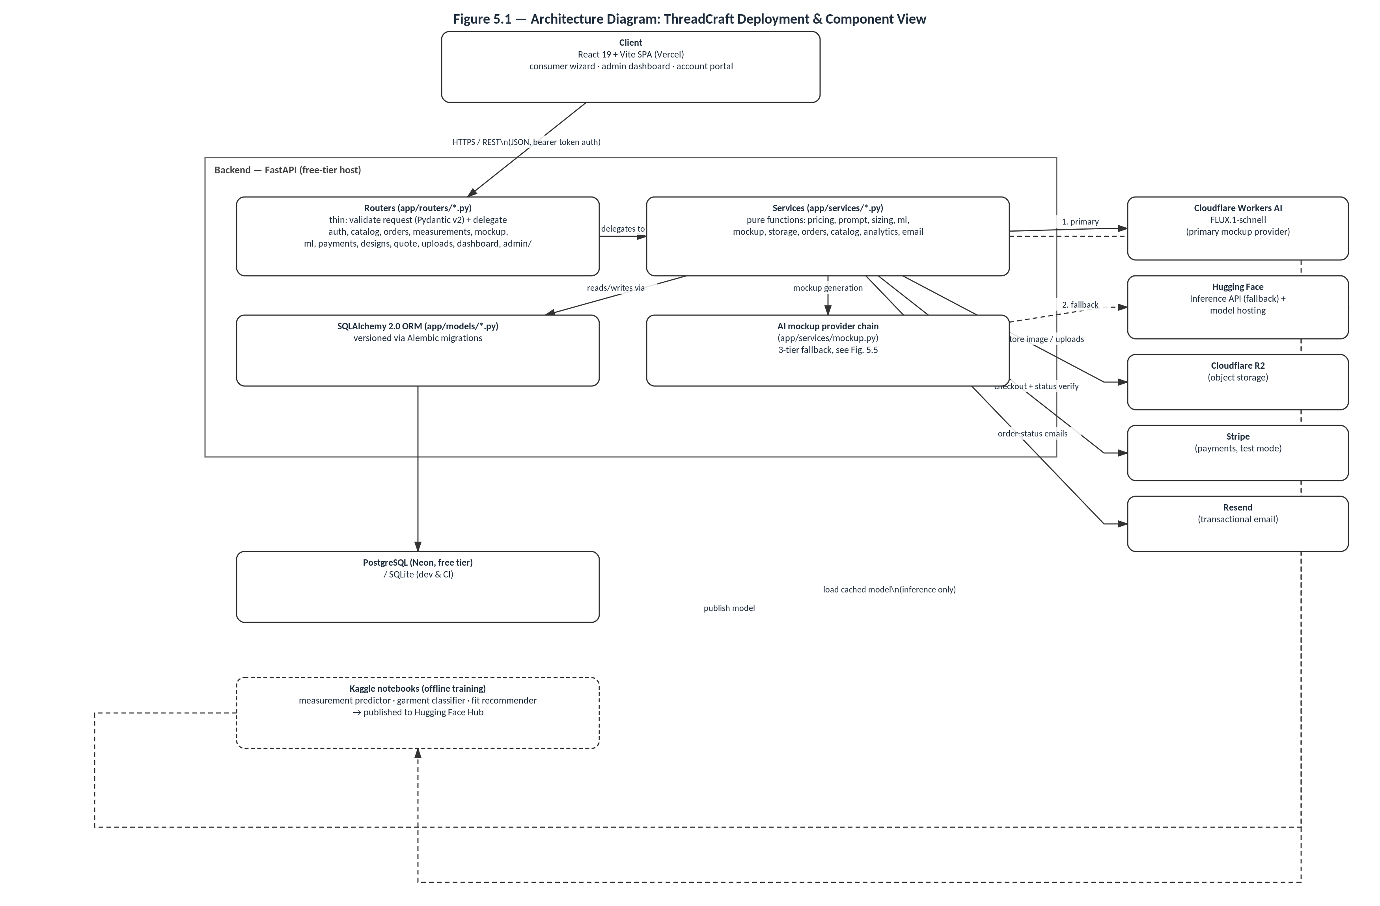

5.3 Use Case Diagram
Figure 5.2 sets out the system's functional boundary from the perspective of its three human and machine actors: a Customer (who may act as a guest or a registered, logged-in user), an Administrator, and two external systems — Stripe as the payment gateway and the AI mockup provider chain (Cloudflare Workers AI, with Hugging Face as its fallback) — modelled as actors because the system depends on them but does not control their internal behaviour. The customer-facing use cases map directly onto the six-step ordering wizard and account area described in section 4.2: registering or logging in, browsing the catalogue, configuring a garment's design, selecting material and colour, entering measurements, viewing a price breakdown, checking out, and tracking or managing orders and saved designs. Two <<include>> relationships are shown deliberately rather than left implicit, because they correspond to functional requirements with measurable acceptance criteria established in Chapter 4: entering measurements includes both predicting missing measurements and validating supplied ones (the ANSUR II-derived requirement from section 4.1.3), and configuring a garment's design includes generating an AI mockup. An <<extend>> relationship from checkout to order tracking reflects that tracking is an optional continuation of an order rather than a mandatory step in the same transaction. The administrator's use cases — managing the catalogue and pricing, managing inventory, managing the order-status workflow, and viewing analytics — correspond directly to the administrative functional requirements in section 4.2 and to ADR 0003's configuration-driven catalogue.
(Figure 5.2 — Use Case Diagram: ThreadCraft Platform — embedded below; editable source: usecase.drawio.)
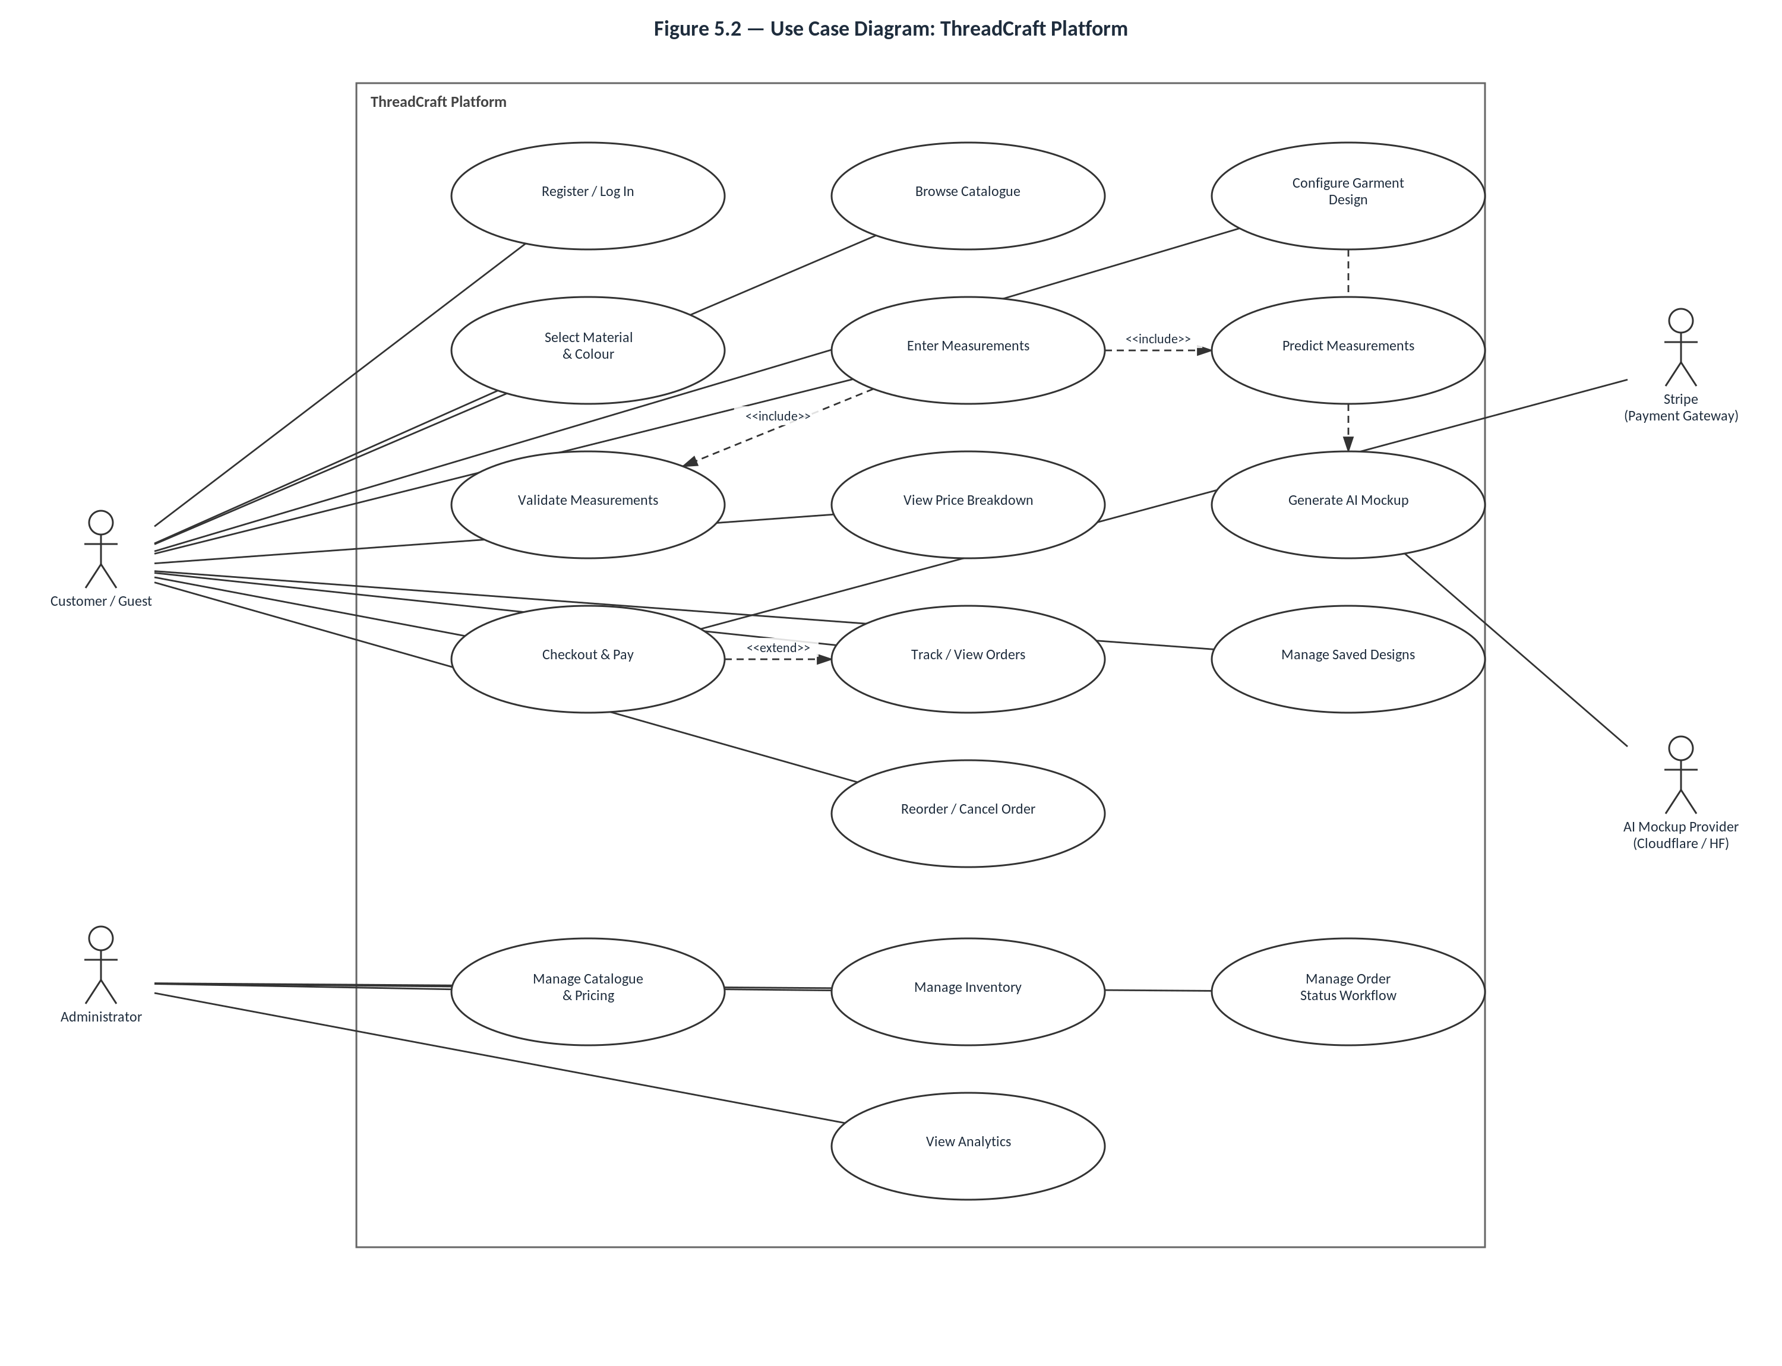

5.4 Domain Model
Figure 5.3 shows the domain model underlying ThreadCraft's relational schema, derived directly from the SQLAlchemy models in app/models/. Four functional clusters are visible in the diagram's layout. The user cluster (User, UserMeasurement) separates account identity from body measurements, held as a flexible JSON map of field_key to a value in centimetres rather than a fixed set of columns, so that the measurement set can vary by garment type (per MeasurementField) without a schema migration for every new garment. The catalogue cluster (ClothType, MeasurementField, DesignOptionGroup, DesignOption) is the direct schema realisation of ADR 0003: every one of these tables is administrator-editable, and DesignOption.ai_prompt_term explicitly decouples the customer-facing label (for example, "Puff sleeve") from the vocabulary the prompt builder feeds to the diffusion model, so that changing UI copy never requires changing a generation prompt and vice versa. The materials cluster (Material, MaterialColor) similarly separates a fabric from its purchasable colourways, each with independent stock tracking against the low-stock-threshold requirement in section 4.2. The order cluster (Order and its dependents OrderStatusHistory, OrderReferenceImage, SavedDesign, MockupGeneration) is deliberately the most self-contained: Order stores cloth_type_name, material_name, and color_name as immutable string snapshots alongside a JSON snapshot of the selected design options and measurements, rather than only holding foreign keys to the live catalogue rows. This is shown in the diagram as a dashed, nullable association back to ClothType and Material labelled "snapshot of" precisely because it is a deliberate design decision, not an oversight: if an administrator later renames, reprices, or deactivates a cloth type or material, previously placed orders must continue to display exactly what the customer originally ordered, satisfying the data-integrity and auditability requirement from section 4.3. OrderStatusHistory gives the same auditability guarantee to the production workflow itself, recording every status transition (the received - fabric_cut – stitching - qc - dispatched/cancelled sequence from section 4.2) with its preceding status and a timestamp, so that an order's full production history can be reconstructed rather than only its current state being visible.
(Figure 5.3 — Class Diagram: ThreadCraft Domain Model — embedded below; editable source: classdiagram.drawio.)
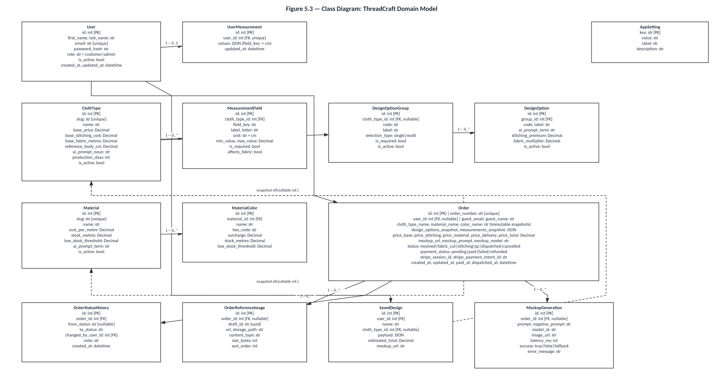

5.5 Entity-Relationship Diagram and Normalisation
Figure 5.4 re-expresses the same underlying schema as Figure 5.3 in a deliberately different notation — primary and foreign keys listed explicitly per entity, and crow's-foot-style cardinality text (e.g. "1 : 0..N", "1 : 0..1") on every relationship line — because a class diagram and an entity-relationship diagram answer two different questions about the same database: the class diagram in section 5.4 communicates the object-oriented shape of the domain (attributes, types, and behaviourally meaningful groupings), while the ER diagram here communicates the relational shape actually enforced by the database engine (keys, foreign-key direction, and cardinality). The fourteen entities are laid out in the same four functional clusters as the class diagram — user, catalogue, materials/order, and order-detail — so that a reader moving between the two figures can map an entity in one directly onto the equivalent box in the other.
Normalisation was applied to this schema up to third normal form (3NF) for every table except the two places where it is deliberately relaxed, and both the applied normalisation and the two exceptions are discussed here explicitly rather than left for the reader to infer from the diagram alone. First normal form is satisfied throughout: every column in every table (USER, CLOTH_TYPE, MATERIAL, ORDER, and so on) holds a single atomic value per row, with no repeating groups — for example, a cloth type's design-option groups are not stored as a delimited string or array column on CLOTH_TYPE itself but as separate rows in the child table DESIGN_OPTION_GROUP, each referencing its parent by foreign key, and likewise DESIGN_OPTION rows reference their parent DESIGN_OPTION_GROUP rather than being embedded within it. Second normal form is satisfied because every table uses a single-column surrogate primary key (id, or key for APP_SETTING) rather than a composite key, which means the question 2NF asks — whether a non-key attribute depends on only part of a composite key — cannot arise: every non-key attribute in, for instance, MEASUREMENT_FIELD (field_key, label, unit, min_value, max_value) depends on the whole of id, not on some subset of a multi-column key. Third normal form is satisfied because non-key attributes depend only on their own table's primary key and not transitively on another table's attributes reached through a foreign key: MATERIAL_COLOR.surcharge, for example, is stored on MATERIAL_COLOR itself rather than being derivable only through a join back to MATERIAL, and ORDER_STATUS_HISTORY.from_status/to_status are stored directly on the history row rather than requiring a second lookup against ORDER's current status to reconstruct what changed.
Two deliberate departures from strict normalisation exist in the schema, and both are treated in this project as considered engineering trade-offs rather than as normalisation errors, consistent with the same evidence-based design discipline documented for the fit-recommendation model in Chapter 6. The first is UserMeasurement.values and Order.measurements_snapshot/design_options_snapshot, which are stored as JSON columns mapping a field key to a value rather than as a fully normalised child table with one row per measurement field per user or order. A strictly normalised alternative — a USER_MEASUREMENT_VALUE(user_id, field_key, value) table — was considered and rejected because the set of applicable fields is itself dynamic (it is defined per cloth type by the administrator-editable MEASUREMENT_FIELD table from section 5.4), so a rigid relational representation would need to either union together every possible field across every garment type or introduce an additional join for every single read of a customer's measurements, for no benefit given that the value set is never queried or aggregated across users at the field level. The second is the immutable snapshot fields on ORDER itself (cloth_type_name, material_name, color_name, and the JSON snapshots), which duplicate data already held in CLOTH_TYPE and MATERIAL and would, in a strictly normalised design, be reachable only via foreign key. This duplication is intentional and is shown on the diagram as a dashed "snapshot of" relationship specifically to flag it as such: because CLOTH_TYPE and MATERIAL rows can be edited or deactivated by an administrator after an order is placed (ADR 0003), a live foreign-key-only design would silently change the historical record of what a customer ordered whenever the catalogue changed underneath it, which directly violates the auditability and data-integrity requirement established in section 4.3. Denormalising these specific fields onto ORDER trades a small, bounded amount of data duplication for a correctness guarantee that a fully normalised design cannot provide without additional versioning machinery of its own, and was judged the simpler and more defensible choice for a system of this scale.
(Figure 5.4 — Entity-Relationship Diagram: ThreadCraft Relational Schema — embedded below; editable source: erdiagram.drawio.)
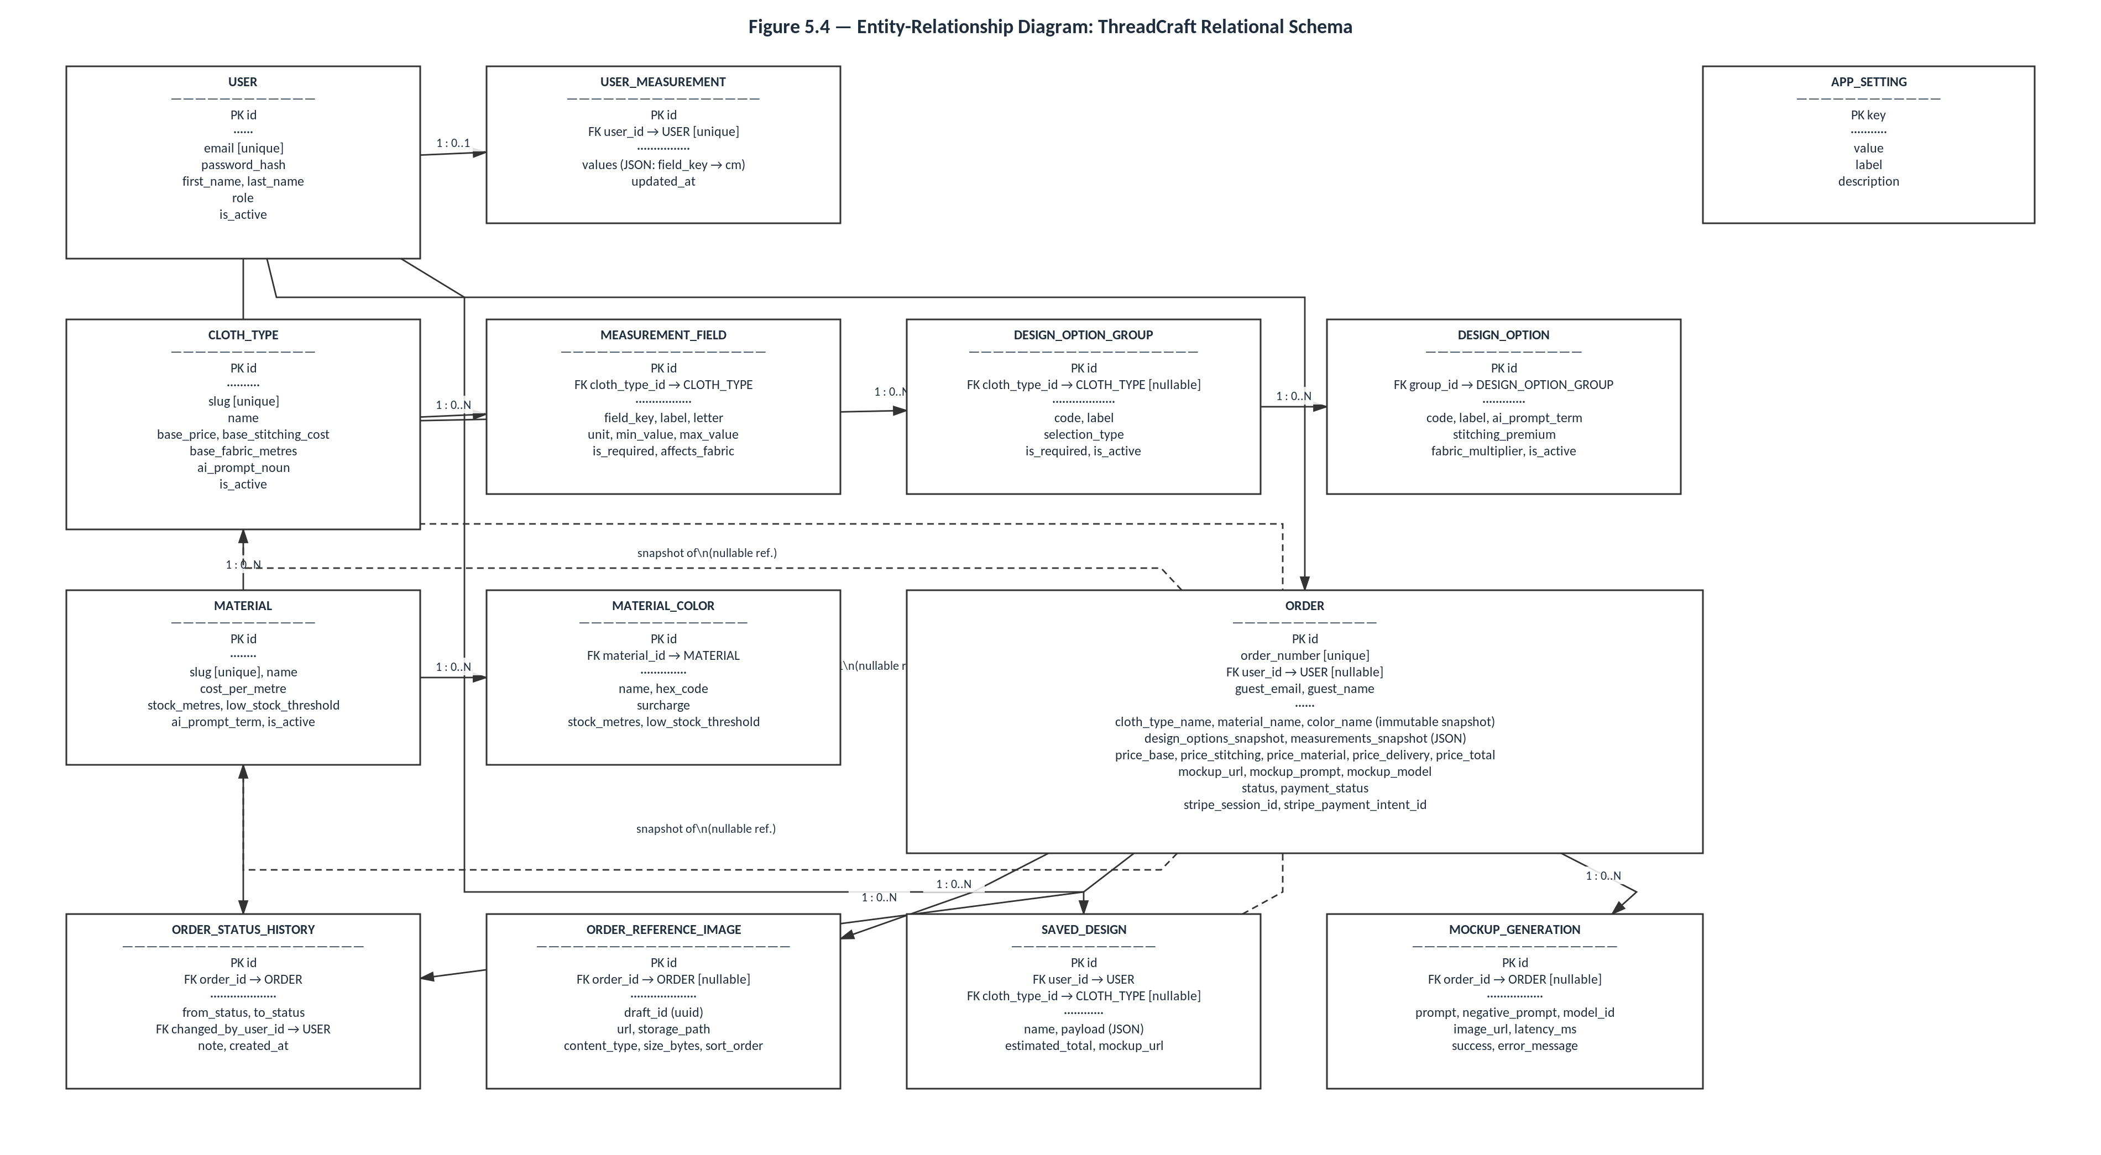

5.6 Sequence Diagram: Order Placement and AI Mockup Generation
Figure 5.5 traces the single interaction that most directly exercises the system's reliability requirement: the point in the ordering wizard where a customer's finalised design and measurements are turned into a priced, mocked-up order. After the frontend posts the draft order to the backend, the backend first calls two of its own pure service functions in-process — pricing.py to compute the itemised price breakdown and prompt.py to assemble the diffusion-model prompt from the selected design options' ai_prompt_term values — shown as self-messages on the Backend API's own lifeline rather than as calls to a separate service, since both are plain Python functions within the same process, not network calls. The mockup-generation step is then modelled as an alt fragment with two else branches, corresponding exactly to the three-tier fallback chain described in section 5.1 and implemented in app/services/mockup.py: the primary branch calls Cloudflare Workers AI and succeeds if a response arrives within the configured mockup_timeout_seconds; the first else branch calls Hugging Face Inference if Cloudflare times out or is unreachable; and the second else branch renders a deterministic SVG placeholder locally if Hugging Face also fails, guaranteeing that mockup generation always returns something to the customer rather than allowing a failure in an external AI provider to fail the entire order-placement request — precisely the reliability and graceful-degradation requirement from section 4.3. Once an image is available from whichever branch executed, it is stored in R2 object storage keyed by a content hash (so identical prompts are not regenerated and re-stored), the order and a MockupGeneration log entry (recording which provider served the request, its latency, and whether it succeeded or fell back) are written to the database, and a single confirmation response — containing the order, its price breakdown, and the mockup URL — is returned to the frontend and displayed to the customer.
(Figure 5.5 — Sequence Diagram: Order Placement & AI Mockup Generation — embedded below; editable source: sequence.drawio.)
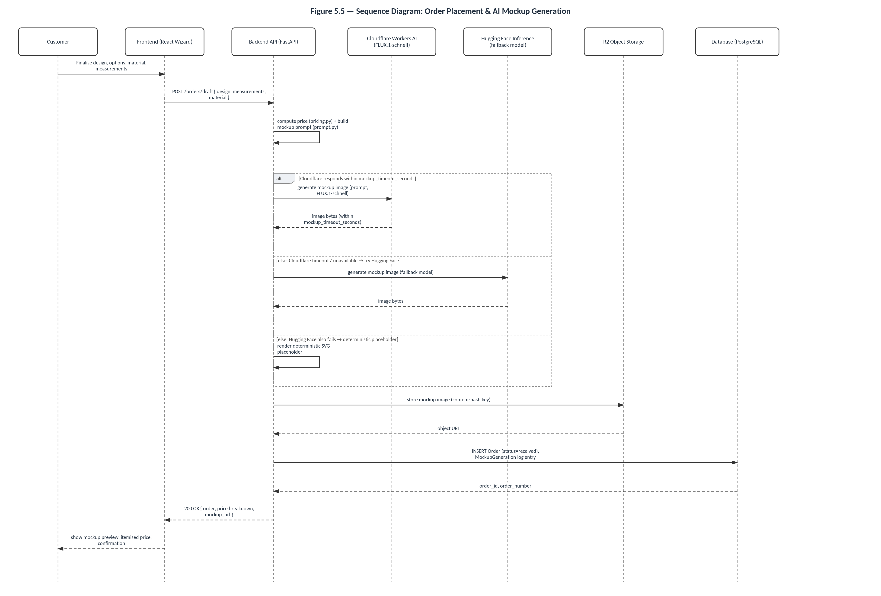

5.7 Wireframes
Figures 5.6a–5.6h present low-fidelity wireframes of eight representative pages, chosen to cover every distinct page template in the real frontend (frontend/src/pages/) rather than all twenty-three individual routes, since many routes (for example, the six wizard steps) share a single layout pattern that only one or two representative wireframes need to illustrate. Each wireframe was built directly from the corresponding .jsx component's actual copy, field labels, and layout structure rather than from a generic template, so that the wireframes function as an accurate low-fidelity record of the real, implemented UI rather than an idealised or aspirational one.
Figure 5.6a (Home) reproduces Home.jsx's real structure: the announcement bar, hero section with its call-to-action buttons, the six-step "how it works" strip, the cloth-type card grid, and the AI-mockup banner. Figure 5.6b (Sign In / Create Account) reproduces Auth.jsx's split-screen layout, including the perks list on the left panel and the tabbed create-account/sign-in form with its guest-checkout fallback on the right. Figure 5.6c (Browse Catalogue) shows the searchable, filterable card grid through which a customer selects a garment, the first step of the six-step ordering wizard from section 4.2. Figures 5.6d and 5.6e show two representative wizard steps in detail — StepDesign.jsx (design-tag groups, free-text description, reference-image upload with thumbnails, and the AI-classifier hint) and StepMeasurements.jsx (the profile-based measurement-prediction flow, the resulting size-estimate hint, and the per-field measurement inputs with validation) — since these two steps carry the majority of the wizard's functional complexity discussed in section 4.2 and Chapter 6. Figure 5.6f (Order Tracking) reproduces OrderTracking.jsx's order-lookup field and five-stage production timeline (received → fabric cut → stitching → quality control → dispatched), matching the OrderStatusHistory workflow modelled in Figure 5.4. Figure 5.6g (Account — My Orders) is representative of the customer account portal, showing order cards with their status badges and progress indicators as implemented in AccountOrders.jsx. Figure 5.6h (Admin — Catalogue Management) is representative of the administrator dashboard, showing the configuration-driven garment-type list, its per-row measurement and deactivate actions, and the "no code change" callout that reflects ADR 0003 directly in the interface copy, as implemented in AdminCatalogue.jsx.
(Figures 5.6a–5.6h — Wireframes: Home, Sign In / Create Account, Browse Catalogue, Ordering Wizard (Design), Ordering Wizard (Measurements), Order Tracking, Account – My Orders, Admin – Catalogue Management — embedded below; editable sources: wf_home.drawio, wf_auth.drawio, wf_catalogue.drawio, wf_wizard_design.drawio, wf_wizard_measurements.drawio, wf_tracking.drawio, wf_account_orders.drawio, wf_admin_catalogue.drawio.)
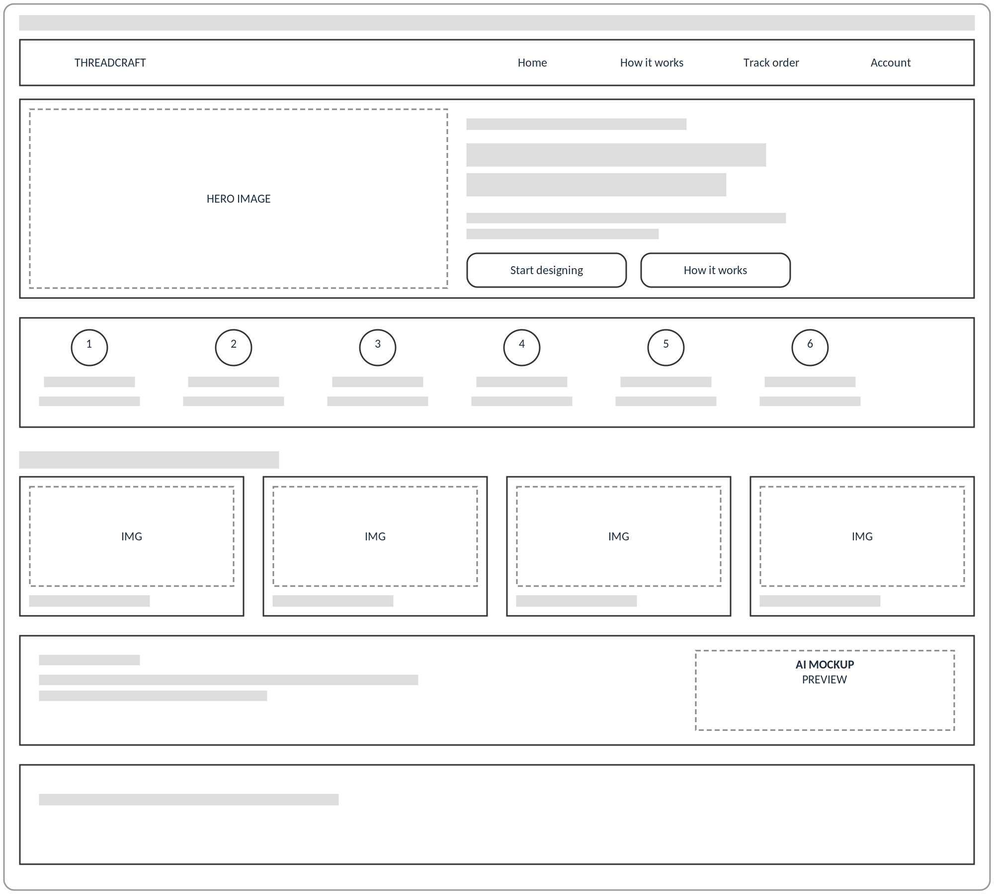
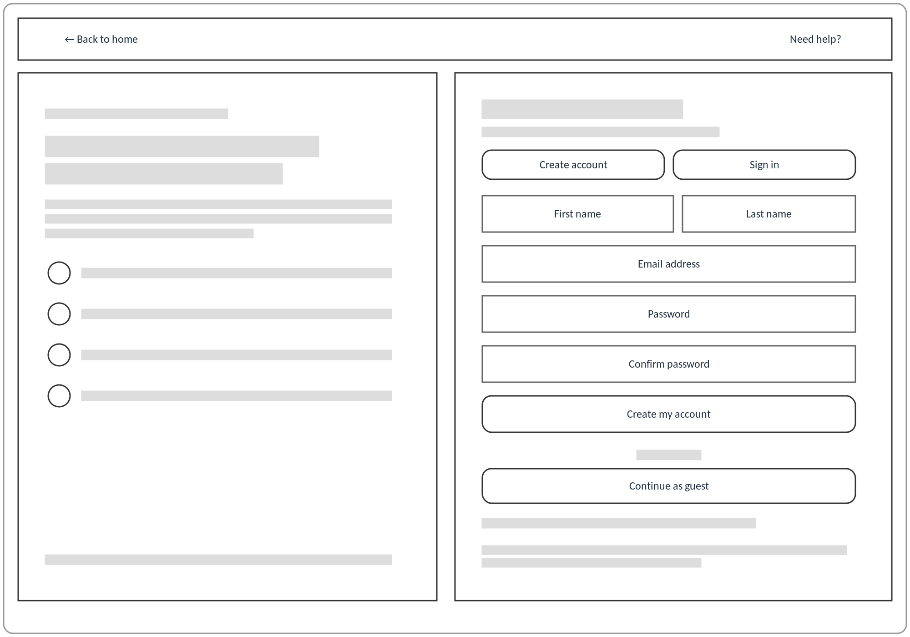
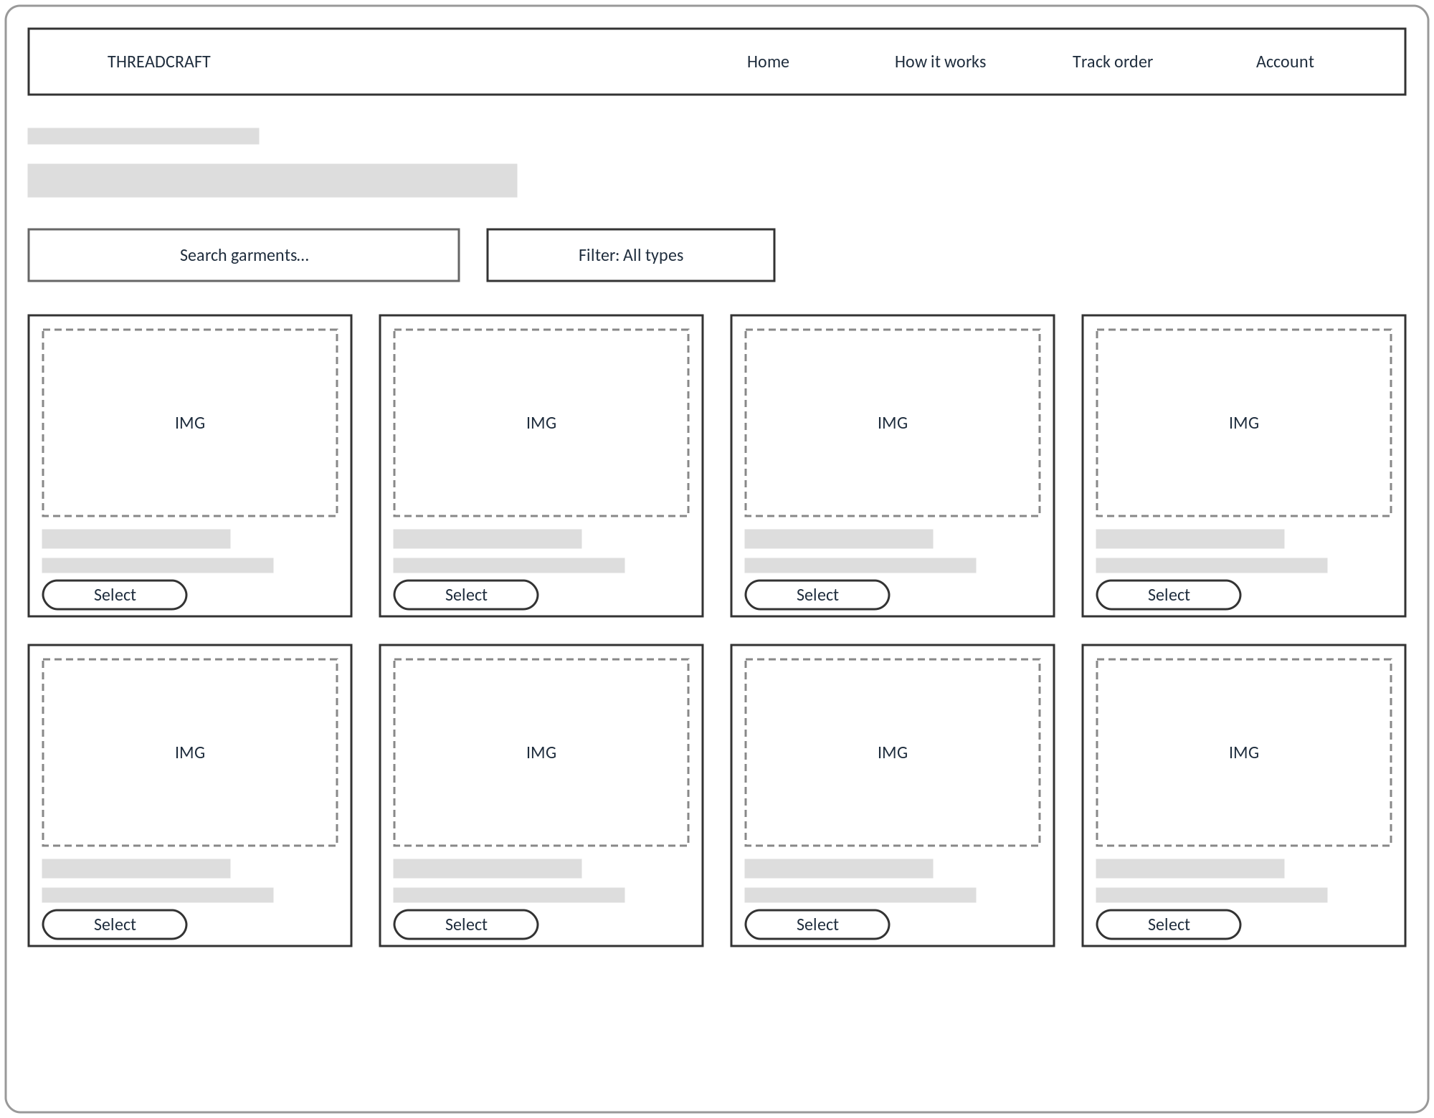
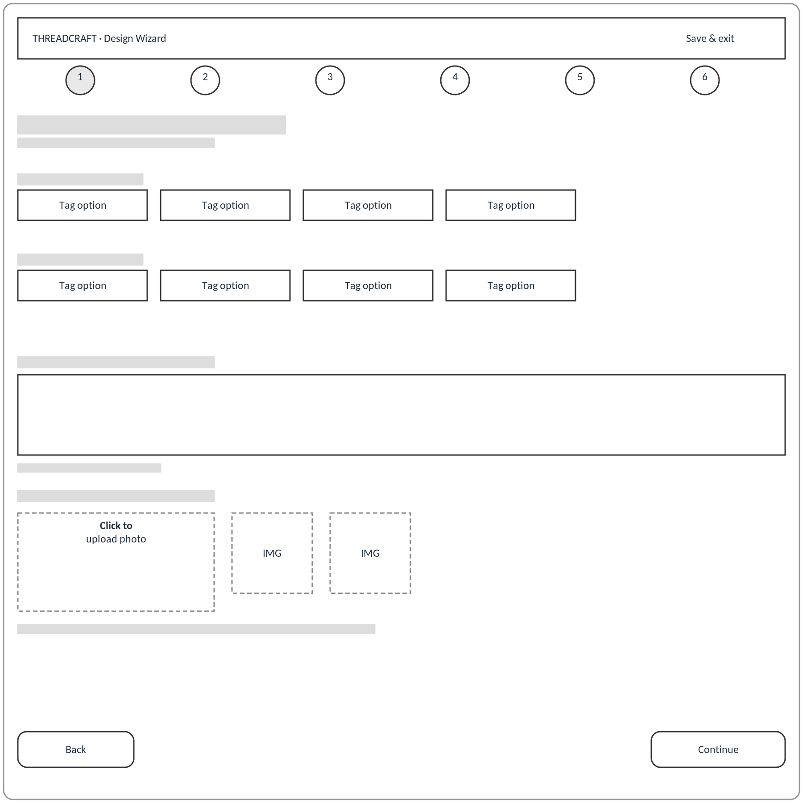
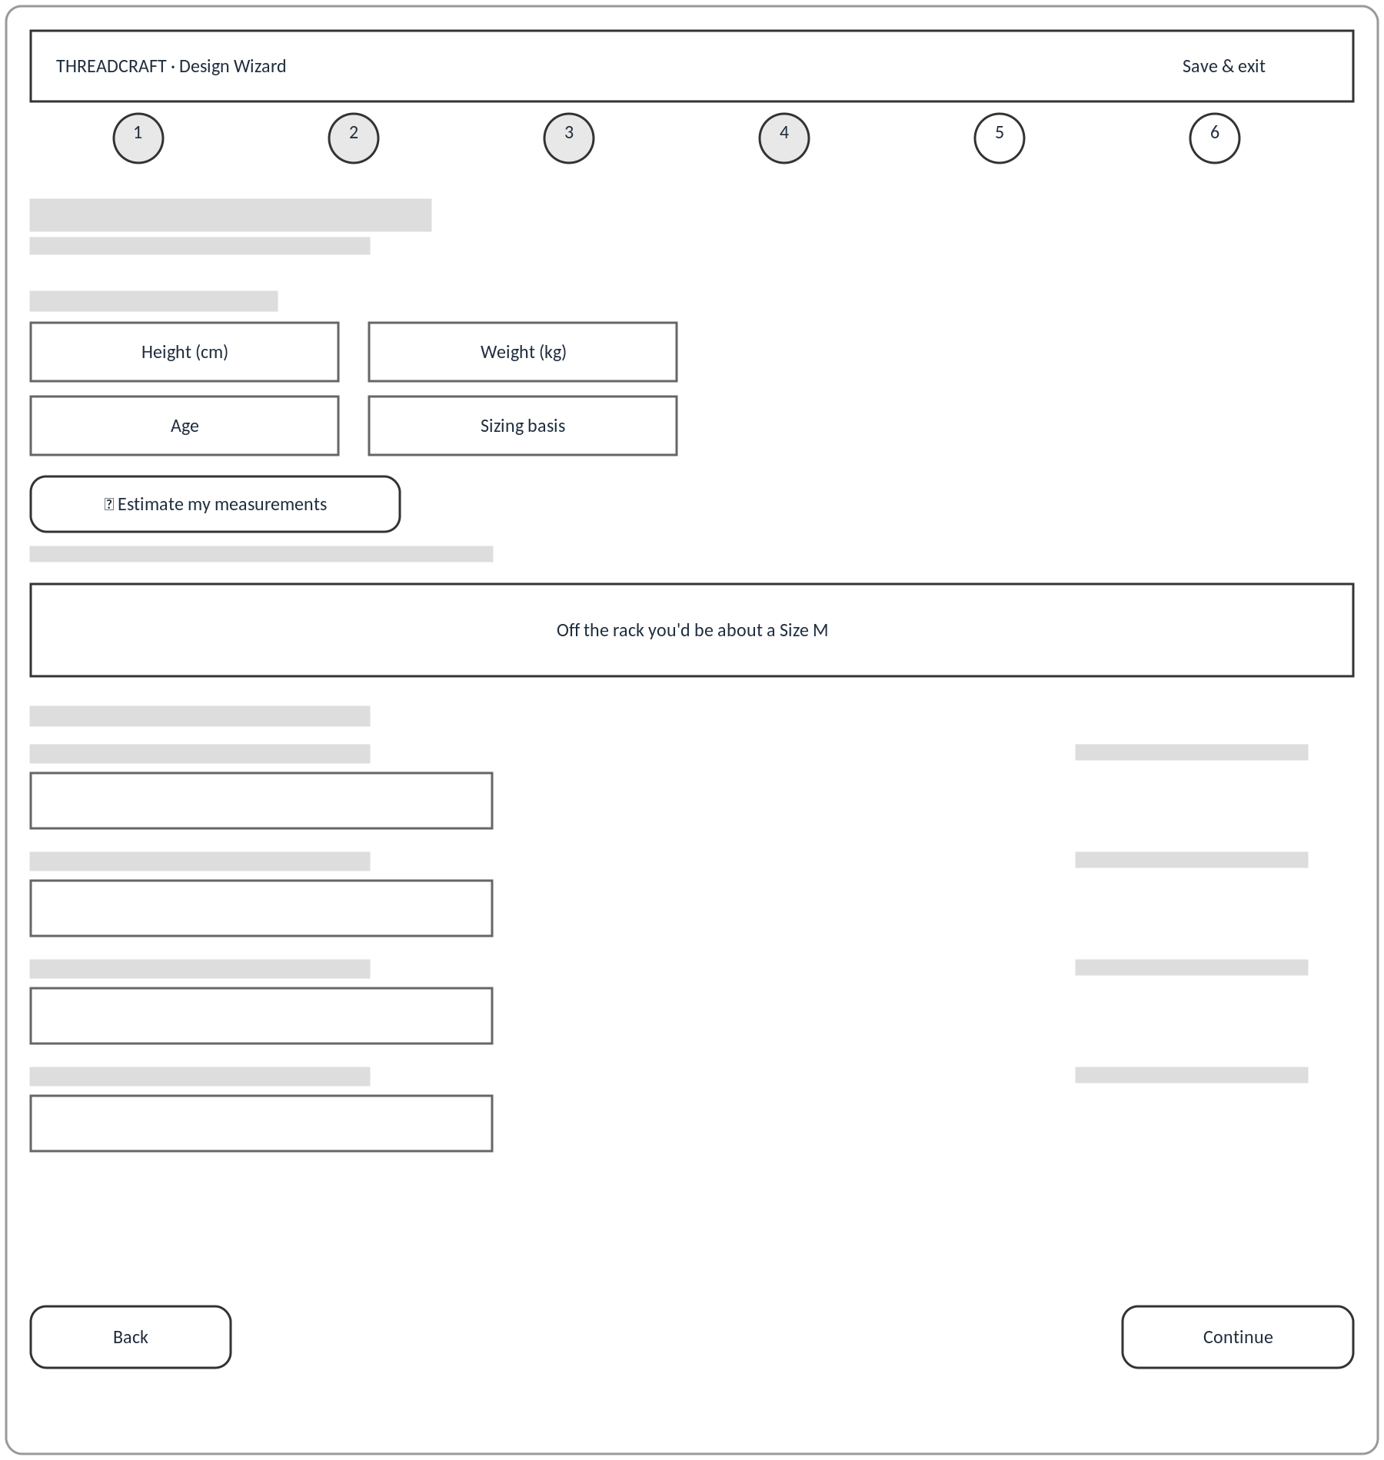
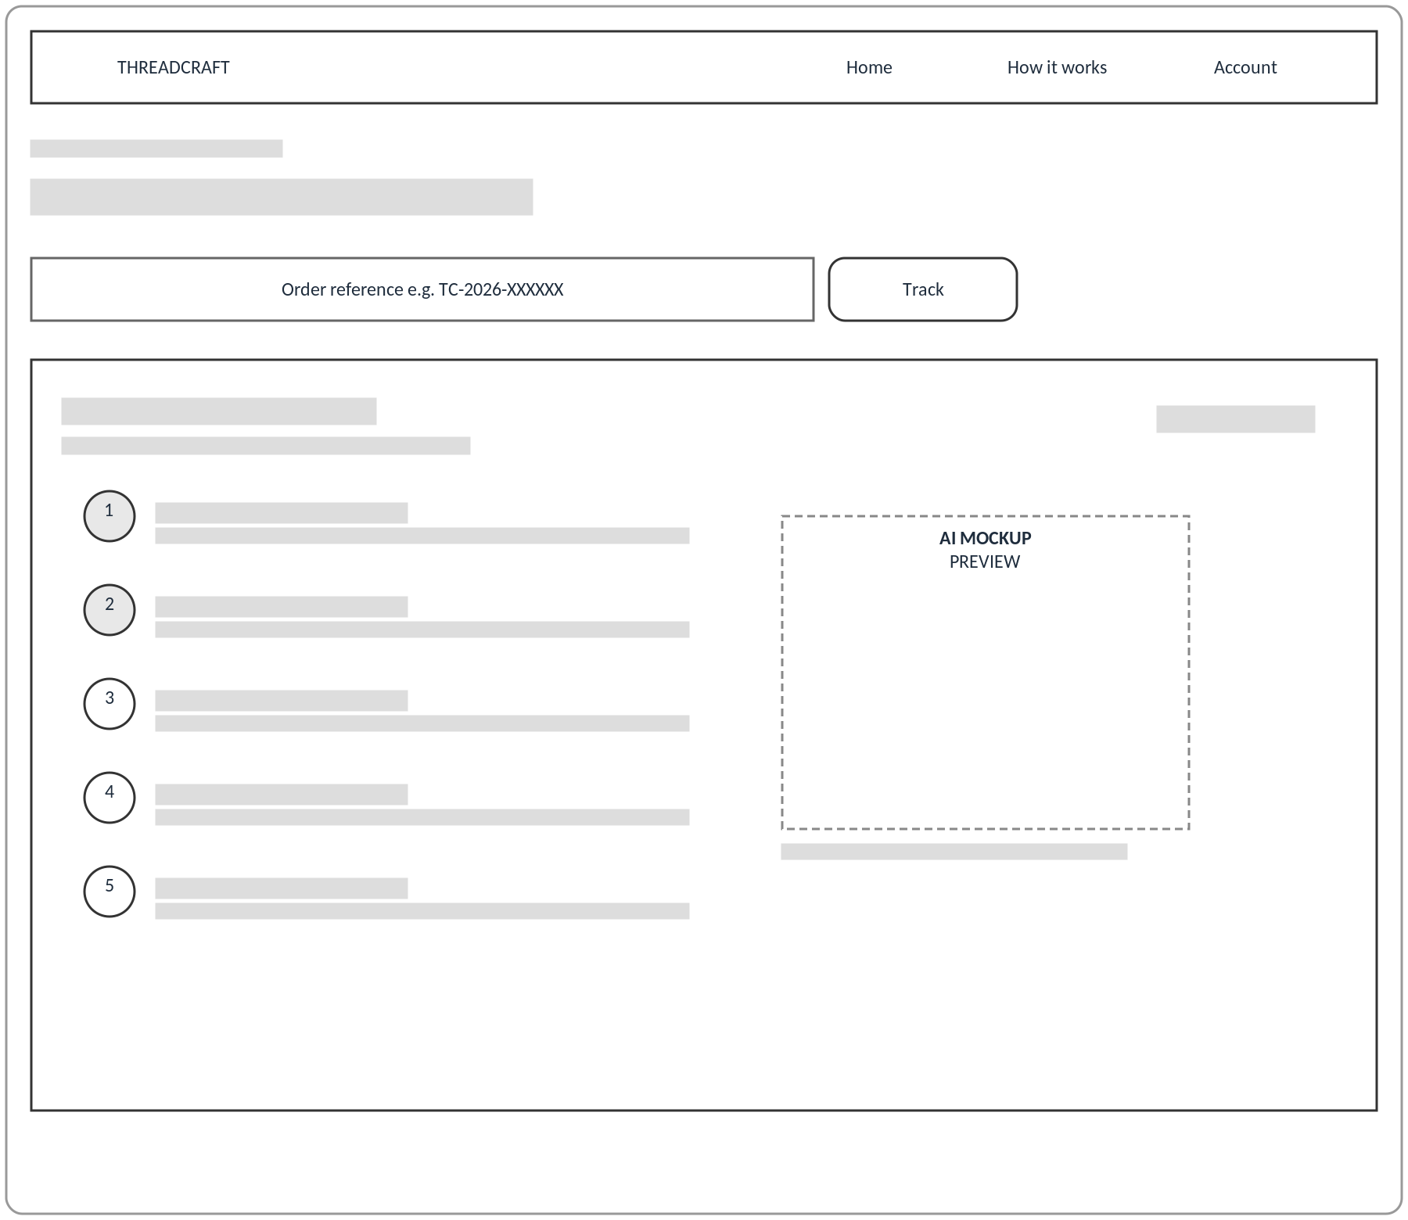
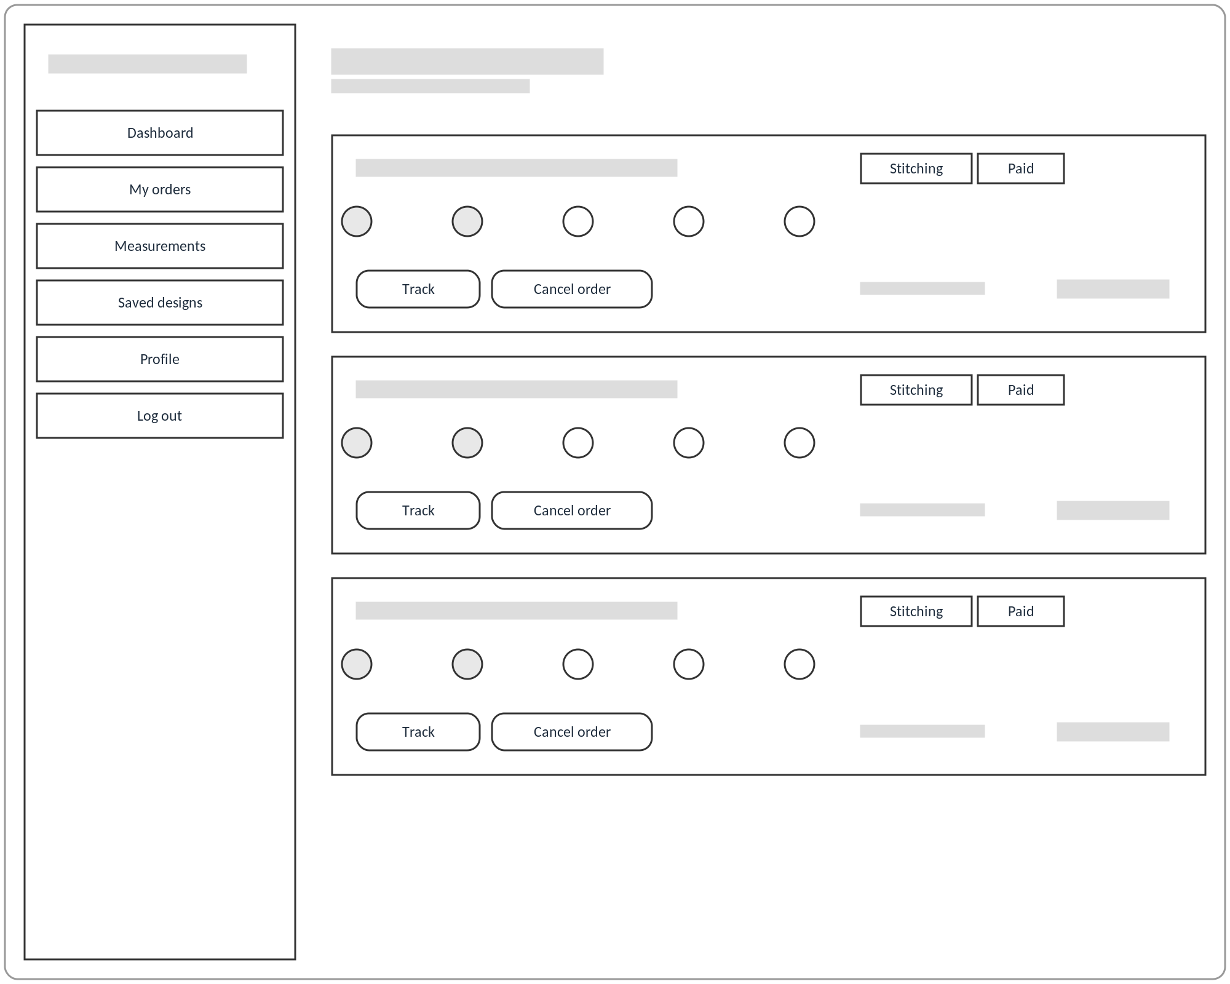
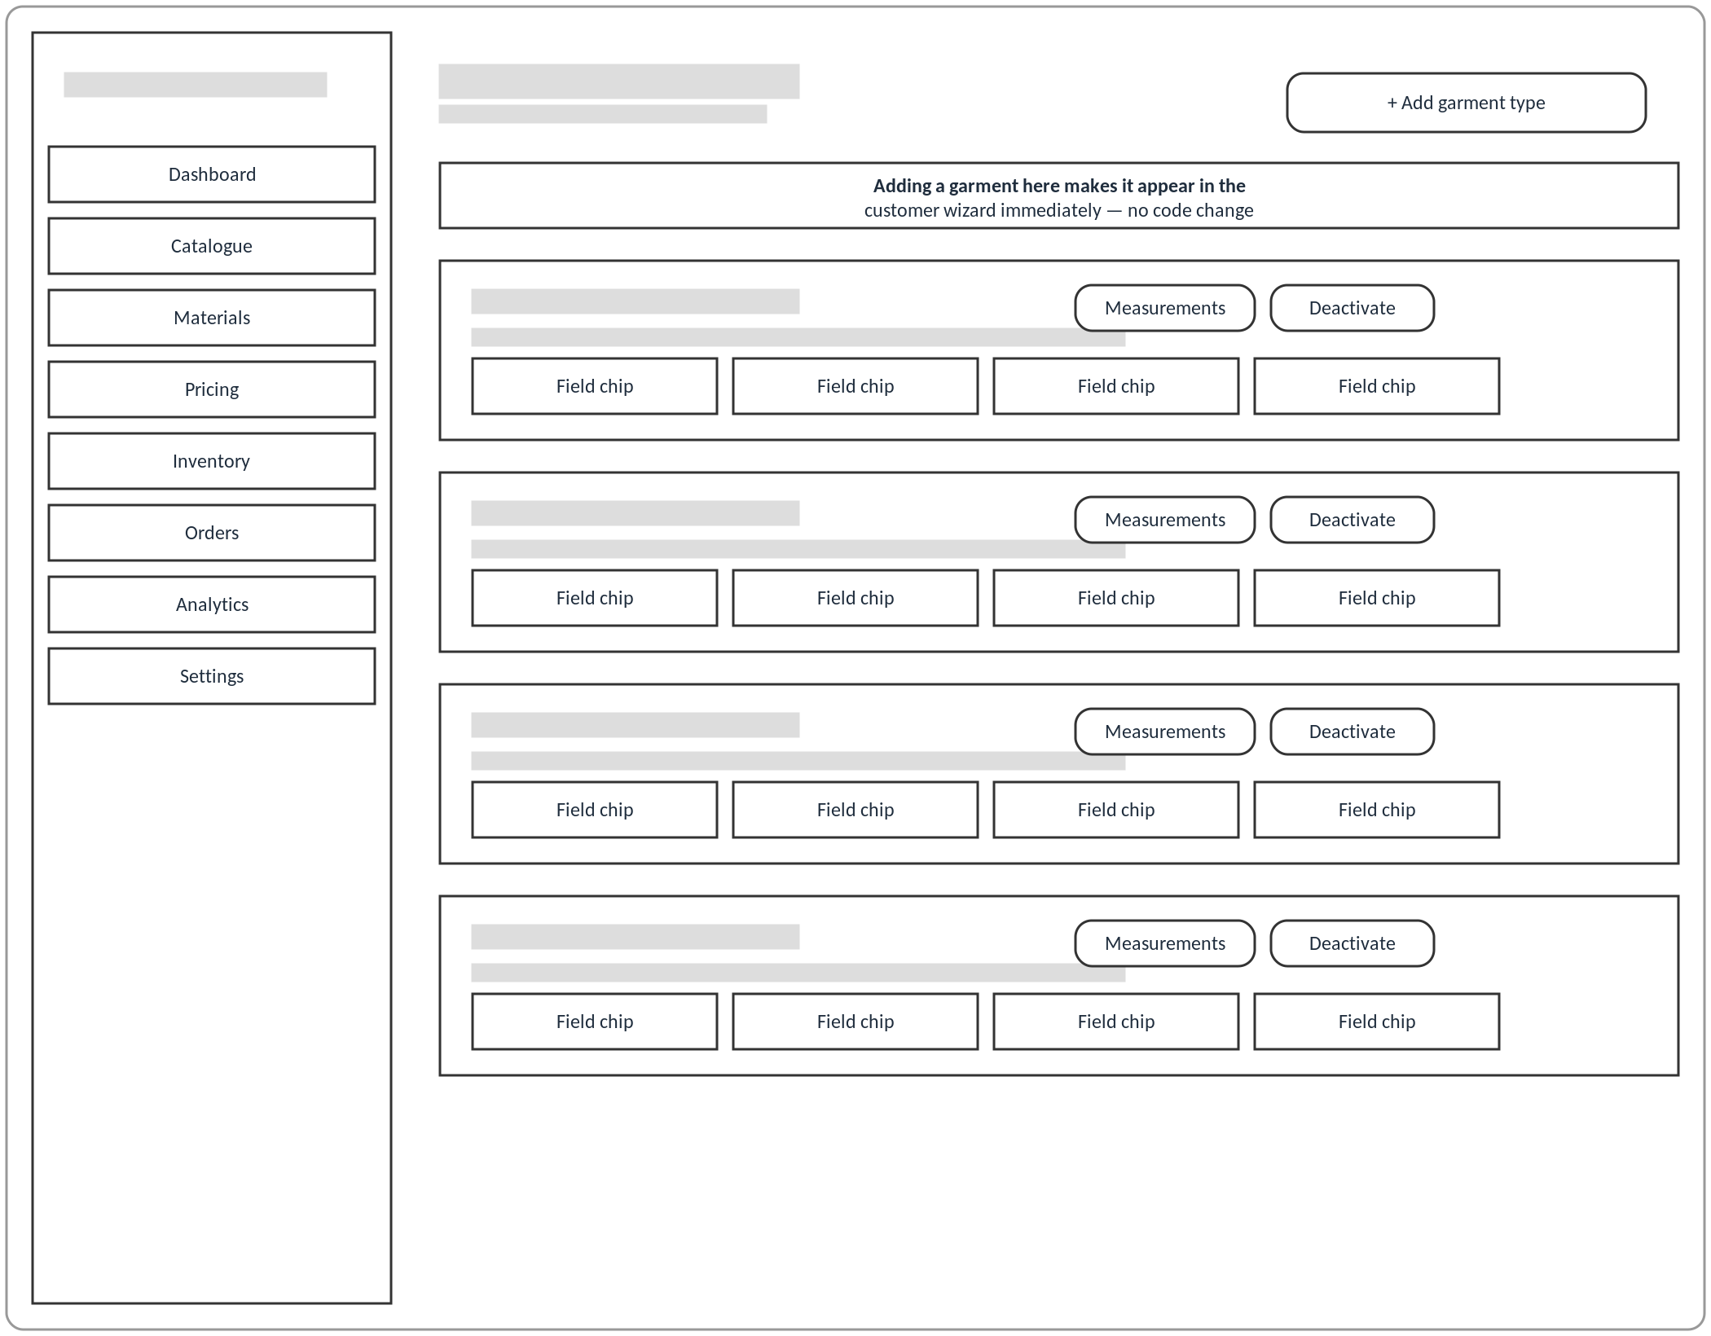

5.8 API Design
ThreadCraft exposes a conventional REST API rather than GraphQL or RPC, consistent with FastAPI's idiomatic style and with the project's preference for tooling a small operator can reason about without additional infrastructure. Authentication uses a bearer token issued at login, checked on every state-changing request; administrative routes additionally require the authenticated user's role field to equal admin, enforced as a dependency rather than repeated per-handler, so that every route under app/routers/admin/ inherits the same check by construction rather than by convention. Read-heavy, publicly accessible routes — browsing the catalogue, tracking an order by its order number — deliberately do not require authentication at all, reflecting the requirement that guest checkout and anonymous order tracking be first-class flows rather than degraded versions of an authenticated one (section 4.2). Every route's request and response bodies are declared as Pydantic v2 schemas (app/schemas/), giving the API automatic OpenAPI documentation and request validation without hand-written boilerplate, and giving the frontend's typed api/ wrapper layer a single, generated source of truth for the shape of every request it makes.

5.9 Design Rationale Summary
The design decisions traced through this chapter — a configuration-driven catalogue instead of hardcoded garment logic, immutable order snapshots instead of live foreign keys, a multi-provider fallback chain instead of a single point of generation failure, and a thin-router/pure-service layering instead of business logic embedded in route handlers — all trace back to specific functional or non-functional requirements established in Chapter 4 rather than to generic good-practice advice followed for its own sake. This traceability is deliberate: Chapter 6 now turns from what the system is structured to do to how each of these pieces is actually implemented, including the one component — the fit/size-recommendation model — whose implementation was evaluated against this same design discipline and, as a result, withheld from the design described above.

Chapter 6: Implementation

6.1 Implementation Overview
This chapter turns from what Chapter 5 established the system should do to how each part is actually built, and — in the case of one component — how rigorous evaluation of what was built led to a deliberate decision not to ship it. The implementation follows the same thin-router/pure-service layering introduced in section 5.1 throughout: every route handler under app/routers/ is limited to request validation against a Pydantic v2 schema, a call into a corresponding function in app/services/, and response serialisation, with no pricing arithmetic, prompt construction, or model-inference logic living inside a handler itself. This separation was not a stylistic preference but a direct consequence of the non-functional requirement in section 4.3 that pricing, prompt construction, and measurement prediction be unit-testable without an HTTP request-response cycle; every service function discussed in this chapter is, in fact, covered by tests that import and call it directly, with no test client or running server involved. The remainder of this chapter works through five services in the order a customer's order actually passes through them — pricing.py, prompt.py, mockup.py, the measurement-prediction half of ml.py together with sizing.py — before turning to the evaluation methodology that governed which of ThreadCraft's four machine-learning artefacts were judged fit to reach a customer at all.

6.2 The Dynamic Pricing Engine (`pricing.py`)
Pricing is implemented as a single pure function, calculate_price, that accepts a PricingInput dataclass — the chosen cloth type's base figures, the customer's measurements, the selected material and colour, and a list of OptionInput records for each chosen design option — and returns a PriceBreakdown dataclass of itemised LineItems plus a total. No database session, HTTP request, or global state is touched inside the function; every value it needs is passed in as a plain argument, which is what makes it possible to unit-test the pricing algorithm exhaustively against hand-computed expected totals without a database fixture.
The algorithm proceeds in six steps, each contributing one or more line items to the breakdown. First, a size_factor is derived from the customer's measurements relative to the cloth type's reference_body_cm figure, clamped to a sensible range so that an outlying measurement cannot produce a runaway price; this factor scales the base price rather than replacing it, so a made-to-measure order for a larger frame costs proportionally more fabric and labour rather than a flat surcharge. Second, the number of fabric metres required is computed from the cloth type's base_fabric_metres figure, adjusted by the size factor and by any fabric_multiplier attached to the selected design options — a design option such as a lining or an extra panel is represented in the catalogue as a multiplier on fabric consumption rather than as a hard-coded exception in the pricing code, consistent with ADR 0003's requirement that no design option carry per-garment logic outside the database. Third, material cost is the product of the computed fabric metres and the selected MaterialColor's combined cost_per_metre and surcharge. Fourth, stitching cost starts from the cloth type's base_stitching_cost and adds each selected design option's stitching_premium as its own labelled line item, so a customer's price breakdown shows exactly which choices — puff sleeves, an extra pocket, a particular collar style — added to the base price, rather than presenting only an opaque total. Fifth, these components are summed to a subtotal. Sixth, a delivery charge is applied according to a configured free-delivery threshold, and the final total is produced.
Every monetary step uses Python's Decimal type rather than float, and every intermediate result is rounded with ROUND_HALF_UP at the point it is computed rather than only at the point it is displayed — a deliberate choice to avoid the classic floating-point accumulation error in which summing many already-rounded figures produces a total that does not match the sum of the individually displayed line items. Because calculate_price takes the entire catalogue (cloth type figures, option premiums and multipliers, material cost) as plain input values rather than looking them up itself, the same function prices a garment whether those figures come from a live PostgreSQL row or a row seeded directly in a unit test, which is what allows the pricing algorithm to be tested independently of the API layer as section 4.3 required.

6.3 The AI Prompt-Engineering Pipeline (`prompt.py`)
The second pure service in the order-placement path, build_prompt, is responsible for translating a customer's structured design choices into the text prompt that FLUX.1-schnell (or its Hugging Face fallback) is asked to render. Its input is a PromptSpec dataclass carrying the cloth type's ai_prompt_noun, the material and colour's ai_prompt_term values, the ai_prompt_term of every selected design option, and an optional free-text description the customer may have typed; its output is a BuiltPrompt dataclass containing the assembled positive prompt and a fixed negative prompt.
The positive prompt is built from a template (DEFAULT_POSITIVE_TEMPLATE) that interpolates these ai_prompt_term values in a fixed order — garment noun, material and colour, then each design option's term — rather than concatenating the customer-facing option labels directly. This is the same decoupling recorded in the domain model (section 5.3): a design option's UI label ("Puff sleeve") and its ai_prompt_term (which might be phrased differently for the diffusion model's benefit) are independent fields, so a copywriting change to the wizard's UI never silently changes what gets sent to the image model, and a prompt-engineering change never requires touching the customer-facing catalogue text. A fixed DEFAULT_NEGATIVE_PROMPT is attached to every request to suppress the failure modes most commonly seen during development — malformed hands, text artefacts, and warped seams — rather than being left to the model's defaults.
The one piece of free-text input in this pipeline — the customer's optional design description — is passed through a _sanitize_description step before being interpolated into the template: control characters are stripped and the string is truncated to MAX_DESCRIPTION_CHARS (200) before it ever reaches the template or the outbound HTTP request to an image-generation provider. This is a narrow, deliberately defensive measure — it is not a general-purpose input-sanitisation framework, but it is enough to prevent a customer's free-text field from injecting unbounded or non-printable content into a third-party API call, and it is exercised directly by unit tests on build_prompt rather than only indirectly through the mockup-generation flow.

6.4 AI Mockup Generation and the Three-Tier Provider Fallback (`mockup.py`)
mockup.py implements the reliability requirement traced through section 5.1 and modelled as the alt fragment in the sequence diagram (Figure 5.3, section 5.4): a customer-facing mockup image must be produced even if every external AI provider is unavailable. The public entry point, generate_mockup, first computes a content hash of the built prompt (together with the relevant cloth type, material, and colour identifiers) and checks R2 object storage for an image already stored under that key; because the diffusion prompt is fully determined by the customer's structured choices via build_prompt, two customers who configure an identical garment are served the same cached image rather than paying to regenerate it, and the cache lookup itself is the first line of defence against unnecessary provider calls.
On a cache miss, _generate_cloudflare is attempted first. Its implementation encodes a constraint that is easy to get wrong from documentation alone: the Cloudflare Workers AI endpoint for FLUX.1-schnell accepts only the keys listed in CLOUDFLARE_ALLOWED_KEYS — prompt, steps, and seed — and does not accept a negative_prompt field or a num_steps key (the parameter is named steps), so the negative prompt assembled in section 6.3 is deliberately dropped for this provider rather than sent and silently ignored or rejected. The call is bounded by mockup_timeout_seconds; if it does not return within that window, or raises, control passes to _generate_huggingface, a Hugging Face Inference call to a fallback model that does accept a negative prompt. Because Hugging Face Inference endpoints can be cold and return an HTTP 503 while a model loads, _generate_huggingface includes bounded retry logic specifically for that status code rather than treating a 503 as a hard failure equivalent to a network error. If this second provider also fails or times out, _placeholder_svg deterministically renders a locally generated SVG labelled "PREVIEW UNAVAILABLE — PLACEHOLDER", built from the same prompt text so that it still reflects the customer's configured garment (cloth type and colour) rather than being a generic error graphic; this is the second else branch shown in Figure 5.3 and guarantees that generate_mockup always returns an image, never an exception, to its caller.
Whichever branch produces an image, the result is stored in R2 keyed by the content hash described above, and a MockupGeneration row is written recording which provider actually served the request, its latency, and whether it succeeded outright or fell back — the same log referenced in section 5.3's domain model as giving auditability to the mockup pipeline. A separate provider_status() function exposes the current reachability of each provider without generating an image, intended to be checked before a live demonstration so that a provider outage is visible in advance rather than discovered mid-demonstration.

6.5 Measurement Prediction and Deterministic Sizing (`ml.py`, `sizing.py`)
ml.py integrates the three models ThreadCraft trains and publishes to the Hugging Face Hub (a fourth, FLUX.1-schnell, is a pretrained third-party model consumed as-is and was already introduced in section 6.4). Three design points recur across every model it loads, stated directly in the module's own documentation and worth restating here because they follow from the same reliability requirement as the mockup fallback chain: nothing is downloaded at import time, so the application boots even on a host with no Hugging Face access at all; a failed model load is never allowed to become a 500 error, only a reported "unavailable" state, because every model integrated here is assistive rather than load-bearing for checkout; and a failure is remembered only for a bounded MODEL_RETRY_AFTER_SECONDS window (300 seconds) rather than for the lifetime of the process, because on a long-lived free-tier host a single transient Hub error or DNS blip must not silently disable a feature until the next redeploy.
The measurement predictor — threadcraft-measurement-predictor, an ensemble of HistGradientBoostingRegressor models trained on the ANSUR II anthropometric dataset referenced in the requirement-gathering discussion of section 4.1.3 — is exposed through two functions. suggest_measurements predicts whichever body measurements a customer has not supplied, deriving a BMI feature from height and weight where both are available and reindexing the input frame to whatever feature set each target measurement's underlying model was trained on, so a missing input feature becomes an explicit NaN rather than a silent zero. validate_measurements runs the same models in the opposite direction: for each measurement the customer did supply, it predicts an expected value from the customer's other supplied measurements and flags the entered figure if it deviates from the expected value by more than that field's stored threshold, surfacing a message such as a chest measurement that "looks inconsistent" with the rest of the customer's profile. Together these two functions realise the <<include>> relationship shown from "Enter Measurements" to both "Predict Measurements" and "Validate Measurements" in the use-case diagram (Figure 5.1, section 5.2).
Deliberately, no model in ml.py predicts a garment size directly. That step is handled by sizing.py, a small deterministic module with no learned parameters at all: WOMENS_BANDS and MENS_BANDS are tuples of UK size bands with inclusive-lower, exclusive-upper centimetre ranges for chest, waist, and hip, and estimate_size looks up which band each of a customer's three measurements falls into and returns the largest of the three resulting sizes — a direct encoding of standard tailoring practice that a garment can be taken in at a seam but not let out, so sizing conservatively toward the larger indicated size avoids producing a garment that cannot be altered to fit. This composition — a genuinely learned model (the measurement predictor) feeding a hand-authored, monotonic lookup table (the size bands) — is the answer to a question the next section addresses in full: what a size-recommendation feature looks like once a different, and more ambitious, approach to the same problem had been evaluated and rejected.

6.6 Machine-Learning Evaluation Methodology
Every claim made about a ThreadCraft model in this chapter and the last was measured against the exact artefact downloaded from its Hugging Face Hub repository at inference time, not against a copy of a metric printed once in a training notebook. This distinction mattered in practice: the training notebook for the fit-recommendation model included a two-point sanity check that could not, by construction, have revealed the non-monotonic behaviour described in section 6.6.2 below, because two points cannot detect non-monotonicity in a function of one variable. The evaluation approach adopted instead was a parameter sweep — holding every input but one fixed and varying that one input across its plausible range, then inspecting whether the model's output moved in the direction a domain expert would expect. This is a substantially more demanding test than a held-out accuracy figure, because a model can score well on aggregate metrics while still producing behaviour that is unusable, or actively misleading, for any single customer who queries it — which is exactly what the sweep in the next section found.
Four models were built over the course of the project, and the table below records the status each reached after this evaluation process.
Model | Type | Status
FLUX.1-schnell | Pretrained (Apache-2.0), not trained by the project | Surfaced — mockup generation (section 6.4)
threadcraft-measurement-predictor | HistGradientBoostingRegressor ensemble, trained on ANSUR II | Surfaced — measurement prediction and validation (section 6.5)
threadcraft-garment-classifier | Fine-tuned ViT, trained on a fashion product-image dataset | Trained; not deployed to production (section 6.7)
threadcraft-fit-recommender | HistGradientBoostingClassifier, trained on RentTheRunway fit data | Trained; withdrawn from every customer-facing framing (section 6.6.2–6.6.4)

6.6.1 Baseline evaluation of the fit recommender
Evaluated the conventional way — a held-out test split, scored against its own labels — the fit recommender's model card reported an exact size-match rate of 0.036, a within-one-size rate of 0.186, and a within-two-sizes rate of 0.434, alongside a macro F1 of 0.4051 against a 0.2830 majority-class baseline and a balanced accuracy of 0.3960 against a 0.3333 chance level for a three-class problem. Taken alone, these figures describe a model that modestly beats chance and a naive baseline — unremarkable, but not obviously disqualifying. The two framings evaluated next are what changed that conclusion.

6.6.2 Framing A — direct size recommendation — rejected as non-monotonic
The first framing tested the model as it would actually be used: given a customer's height, weight, and (optionally) bust band and cup, recommend a size. Sweeping weight at a fixed height of 170 cm produced the following recommended sizes, reproduced here exactly as recorded in the project's evaluation record:
Height | Weight | Recommended size
170 cm | 45 kg | 27
170 cm | 55 kg | 0
170 cm | 65 kg | 15

A monotonic model would recommend a strictly increasing (or at worst non-decreasing) size as weight rises at a fixed height; instead the recommended size fell from 27 to 0 and then rose again to 15 — reversed at both tested extremes, with no consistent direction at all. Two causes were identified. First, the training data's size field is RentTheRunway's own raw numeric size scale, used by the model with no rescaling to a standard UK/US size progression, so the model's internal notion of "size order" does not correspond to a real, ordered garment-size axis in the first place. Second, two features the model was trained on — bust_band and bust_cup — are not obtainable from ThreadCraft's own API at inference time, forcing those inputs to NaN and pushing every real request down whatever split path the underlying trees use for missing values, regardless of the customer's actual measurements. The endpoint was withdrawn and pinned at HTTP 404 by an automated test, test_the_size_sweep_is_no_longer_reachable, so this specific failure mode cannot silently reappear if the route is ever re-added by mistake.

6.6.3 Framing B — fit-risk advisory — also rejected, inverted direction
Because a size recommendation is a strong claim, a softer framing was tried before abandoning the model altogether: rather than recommending a size, report the probability that a customer's selected size would run small, leaving the sizing decision with the customer. This framing failed for a different reason. Sweeping body size upward at a fixed selected size, the predicted probability of "runs small" fell as body size increased — the opposite of the expected direction — and this inversion held both when bust_band/bust_cup were left absent and when they were explicitly supplied, ruling out the missing-feature explanation that accounted for Framing A's failure.

6.6.4 Root cause and decision
The root cause identified for both framings is the same: the RentTheRunway fit label records a customer's satisfaction with the size they themselves chose to order, not an objective measurement of size-to-body fit. A customer who orders a size they already suspect runs small and compensates by sizing up will report "fit" even though the raw body-to-garment relationship was mismatched, and this selection bias is baked into the label itself — it cannot be corrected by engineering better input features at inference time, because the problem is in what the target variable measures, not in what predicts it. Given this, the project's decision was that threadcraft-fit-recommender would not be surfaced to customers in any framing. The trained model, its model card, the dataset, and its evaluation metrics remain published as artefacts — the finding itself has value, and hiding it would misrepresent what was actually learned during the project — but the product-facing claim is withdrawn, and /api/ml/fit-risk is retained solely as a reproducible evaluation surface for exactly this kind of audit, not as a route called anywhere in the customer-facing wizard. Section 6.5 above described what replaced it in the shipped product: the composition of the genuinely predictive measurement model with a hand-authored, monotonic size-band lookup, whose monotonicity is itself asserted directly by an automated test, test_the_chart_is_monotonic_in_every_measurement, rather than left as an informal claim.

6.7 The Garment Classifier: A Hosting Constraint, Not a Modelling Failure
The third trained model, threadcraft-garment-classifier, is a Vision Transformer fine-tuned across 25 garment classes, reaching 0.6875 accuracy and a macro F1 of 0.3482 on its own held-out evaluation split — a materially different situation from the fit recommender, because nothing about the sweep-based evaluation methodology applied here revealed a directional or logical failure in the model's predictions. Its exclusion from the deployed product was instead a consequence of the same free-tier hosting constraint discussed as a portability requirement in section 4.3 and again in ADR 0001: the fine-tuned ViT is roughly 350 MB, which a 512 MB free-tier instance cannot comfortably hold alongside the rest of the running application, and every hosting alternative evaluated was rejected for a specific, recorded reason — a Render free-tier instance's RAM ceiling, a Hugging Face Inference Providers endpoint that returned an empty model mapping for this repository, a Hugging Face Space on CPU hardware that now requires a paid PRO subscription, and a Hugging Face Space on ZeroGPU hardware that requires an account older than thirty days. ml.py reflects this directly: ML_ENABLE_CLASSIFIER gates the classifier separately from every other model specifically because of its memory footprint, and the deployed site reports the feature as unavailable explicitly rather than hiding the gap.
A second, independent finding emerged once the classifier was evaluated against ThreadCraft's own photographs rather than the catalogue-style training images it had originally been evaluated on: accuracy fell from 0.67 on training-distribution images to 0.125 on ThreadCraft's own lifestyle photography, and the model was not merely less accurate but confidently wrong — a photograph of a dress, for instance, was classified as "Bra" with 0.55 confidence. Part of this is structural rather than fixable by better inference-time handling: several underwear-adjacent classes present in the original label set describe garments ThreadCraft does not tailor at all, so any prediction landing on one of those classes is wrong by construction regardless of the model's confidence. Two guards were added in response, both implemented as simple, auditable post-processing rather than as retraining: predictions are only ever surfaced to a customer if their label maps to a garment category ThreadCraft actually offers, and a confidence floor of 0.35 is applied below which no suggestion is shown at all. The measured effect of both guards together was a rise in the precision of suggestions actually shown to a customer from the raw 0.67 figure to 0.86, at the cost of the feature staying silent more often than it would unguarded — a deliberate precision-over-recall trade for a feature that is assistive rather than load-bearing. A smaller, unrelated bug was also found and fixed during this evaluation: a substring label-matching routine was conflating "Tshirts" and "T-shirt" as different categories due to inconsistent normalisation, corrected once identified.

6.8 What This Cost, and What It Bought
Two features that were built, trained, and evaluated in full did not reach ThreadCraft's customers in the form originally intended: the fit recommender was withdrawn entirely rather than shipped in either framing tested, and the garment classifier runs only locally rather than in the deployed application. Neither exclusion is an admission that the corresponding piece of engineering work failed — the classifier performs as its architecture and training data would predict, and the fit recommender's underlying gradient-boosted classifier is not itself broken, only asked a question its training label cannot honestly answer. What the evaluation methodology in section 6.6 bought instead is the ability to state, with sweep-based evidence rather than by assertion, exactly which of ThreadCraft's machine-learning features can be trusted in production and which cannot, and to make that distinction visible in the codebase itself — through withdrawn routes pinned at 404 by name-specific tests, through a classifier gated behind its own feature flag, and through a deterministic sizing chart whose correctness is asserted by a test rather than left as an unverified claim — rather than only in this dissertation's prose.

Chapter 7: Testing and Validation

7.1 Testing Strategy and Scope
Consistent with the evaluation approach scoped in section 1.8.1, ThreadCraft was verified primarily through its own automated backend test suite rather than through a moderated external user study, on the basis that a systems-integration project whose central claims are about correctness, reliability, and graceful degradation is better served by tests that can be re-run deterministically on every change than by a one-off usability session. The suite lives under backend/tests/ and, at the time of writing, comprises 19 test modules containing 208 individual test functions (a figure obtained by counting def test_ declarations directly in the source, not estimated), organised around the same service/router boundary described in Chapter 5 rather than around arbitrary feature groupings. Two distinct levels of testing are deliberately combined in the same suite rather than split into a separate unit-test project and integration-test project: pure-function unit tests that exercise a single service module (pricing.py, prompt.py, sizing.py) with no HTTP request or database involved at all, and integration tests that exercise a full request through FastAPI's TestClient, the real routing and dependency-injection layer, and a real (in-memory) database. This combination exists because several of the project's most safety-relevant requirements — a price that can never be manipulated by a client, a fabric requirement that can never go negative, a status machine that can never skip a step — are properties of the pure functions themselves, while others — an unauthenticated user being refused access to admin routes, a cancelled order actually returning fabric to stock — can only be verified by exercising the full stack.
The scope of this chapter is the automated backend test suite and the continuous-integration configuration that runs it; the frontend's own lint and build checks (also part of the same CI pipeline, described in section 7.7) are noted but not treated in the same depth, since the dissertation's research question in section 1.6 is concerned with where machine-learning and backend-architecture decisions earn their place, not with frontend testing practice. The ML evaluation methodology that produced the decision to withdraw the fit-recommendation model is treated separately in Chapter 6 and is referenced rather than repeated here.

7.2 Test Environment and Tooling
Table 7.1 lists the concrete tools and configuration the test suite runs under, all drawn directly from backend/requirements-dev.txt, backend/pyproject.toml, and backend/tests/conftest.py rather than from a generic testing-stack description.
Table 7.1 — Test environment and tooling
Component | Tool / configuration | Purpose
Test runner | pytest 8.3.4 (pytest-cov 6.0.0 for coverage) | Discovers and executes all 208 test functions; --cov=app --cov-report=term-missing reports line coverage per module
HTTP client | FastAPI TestClient (built on httpx 0.28.1) | Drives real requests through the actual ASGI app and dependency-injection graph, rather than calling route functions directly
Test database | SQLite, in-memory, single shared connection via SQLAlchemy's StaticPool | Gives each test function a fresh schema (Base.metadata.create_all/drop_all per test) while remaining fast enough to run the whole suite in seconds; the same constraint (SQLite-compatible column types only) is why every JSON-ish column in app/models uses plain sqlalchemy.JSON rather than a Postgres-only type, as noted in section 5.1
External-service isolation | Session-scoped, autouse isolate_from_developer_env fixture in conftest.py | Forces ml_enabled, Hugging Face, and Cloudflare settings off for the entire test session regardless of the developer's local .env, so the suite always exercises the graceful-degradation path described in section 5.1/5.6 rather than making real network calls or behaving differently machine-to-machine
Shared fixtures | client, db_session, seeded_catalog, registered_user, admin_user (conftest.py) | Provide, respectively, an authenticated-or-not HTTP client wired to the test database, a raw database session for direct assertions, a minimal but realistic catalogue (one cloth type, one material with a stocked colourway, one design option), and one customer and one admin account with real hashed passwords
Static analysis / style gate | ruff 0.14.4 (ruff check ., ruff format --check .) | Enforces lint rules (E, F, I, UP, B rule sets) and formatting as a precondition to the test job in CI, catching a class of defects before the test suite itself runs
Continuous integration | GitHub Actions (.github/workflows/ci.yml) | Runs the full backend job (ruff check, ruff format --check, pytest -q --cov=app --cov-report=term-missing) and a separate frontend job (npm run lint, npm run build) on every pull request and on every push to main

7.3 Test Plan
Table 7.2 sets out the test plan followed for the backend: the levels of testing applied, what each level targets, and which modules in the real suite realise it. This plan was arrived at by first identifying, from Chapter 4's functional and non-functional requirements, the properties that most needed a repeatable, automatable check (server-side price recomputation, stock integrity, status-transition legality, role-based access, resilience to a missing AI provider) and then writing or organising tests against those properties rather than writing tests opportunistically after the fact.
Table 7.2 — Test plan
Level | Target | Objective | Representative modules | Tooling
Unit (pure function) | pricing.py, prompt.py, sizing.py | Verify deterministic business logic — pricing arithmetic, prompt construction, size-band lookup — in isolation from any HTTP request or database, so a failure here can never be masked or caused by an unrelated layer | test_pricing.py, test_prompt.py, test_sizing.py | pytest, @pytest.mark.parametrize
Integration (API + database) | FastAPI routers, Pydantic schemas, SQLAlchemy models | Verify request validation, persistence, and role-based authorisation end-to-end through the real ASGI application | test_api_auth.py, test_api_orders.py, test_api_quote.py, test_admin_catalogue_crud.py, test_api_admin.py, test_customer_account.py | pytest, FastAPI TestClient, in-memory SQLite
Workflow / state-machine | Order production status | Verify that only the legal received → fabric_cut → stitching → qc → dispatched/cancelled transitions are accepted and that every non-terminal state can still reach cancelled | test_status_workflow.py, test_order_cancellation.py | pytest, parametrize over transition pairs
External-service resilience | AI mockup chain, ML measurement/classifier endpoints, Stripe integration | Verify the system degrades gracefully — reporting unavailability rather than raising an unhandled error — when a provider is unconfigured, and verify the fallback and caching logic in mockup.py/ml.py behave as designed | test_api_ml.py, test_api_mockup.py, test_ml_cache.py, test_mockup_payload.py, test_payments.py | pytest, monkeypatch
Notification | Transactional email content and delivery fallback | Verify email content is complete and correctly formatted, and that a failure to send never propagates back to the customer-facing request | test_email.py | pytest, capsys
Cross-cutting / configuration | Environment/config parsing, CORS | Verify malformed or missing configuration produces a clear, named error rather than a silent misconfiguration | test_config.py | pytest, parametrize
Regression gate | Entire backend | Prevent a change from silently breaking any of the above on every pull request and every push to main | Full suite (208 tests) | GitHub Actions ci.yml

7.4 Unit-Level Testing: Pure Service Functions
test_pricing.py verifies the pricing engine referenced throughout Chapter 5 against a table of twenty hand-computed cases (test_exactly_20_cases_present guards against the table itself silently shrinking), and separately asserts two properties that matter more than any individual case: that the reported total always equals the reported subtotal plus delivery (test_total_always_equals_subtotal_plus_delivery) and that the individual line items always sum to the reported totals (test_line_items_sum_to_reported_totals), so that a future change which alters one figure without correspondingly updating the other cannot pass unnoticed. test_negative_measurement_deviation_never_produces_negative_fabric targets a specific edge case directly relevant to the fabric-requirement calculation described in section 5.1: a customer's measurement deviating below the reference body must never drive the computed fabric requirement below zero.
test_prompt.py verifies the diffusion-model prompt builder in isolation from any actual call to Cloudflare or Hugging Face, checking that prompt construction is deterministic for identical inputs (test_prompt_is_deterministic, a property the mockup-caching behaviour in section 5.6 and Chapter 6 depends on), that a garment with no selected design options still falls back to a sensible default description (test_empty_option_terms_falls_back_to_classic_silhouette), and that a customer's free-text description is safely bounded — truncated to 200 characters and stripped of newlines and control characters — before being included in a prompt sent to an external API (test_custom_description_is_truncated_to_200_chars, test_custom_description_strips_newlines_and_control_chars).
test_sizing.py verifies the deterministic UK size-band lookup that was shipped in place of the withdrawn fit-recommendation model (Chapter 6), checking that the band boundaries are monotonic and gap-free across the whole measurement range (test_the_chart_is_monotonic_in_every_measurement, test_the_chart_has_no_gaps_or_overlaps), that a body outside the smallest or largest defined band is clamped to the nearest band rather than silently dropped (test_a_body_below_the_smallest_band_is_clamped_not_dropped, test_a_body_above_the_largest_band_is_clamped), and that when a customer's individual measurements disagree about which band they belong to, the larger band wins and the disagreement is surfaced to the customer rather than hidden (test_the_largest_band_wins_when_measurements_disagree, test_a_disagreement_is_explained_rather_than_hidden) — a direct, tested consequence of the evaluation judgement discussed in Chapter 6 that a wrong undersized recommendation is a worse outcome than an explained, conservative one.

7.5 Integration Testing: API and Database Layer
The integration layer of the suite exercises the same properties end-to-end through a real HTTP request. Authentication and account management (test_api_auth.py, test_customer_account.py) verify both the presence and the correctness of access control: registration and login succeed only with correct credentials (test_register_creates_user_and_returns_token, test_login_with_wrong_password_rejected), a duplicate email is rejected (test_duplicate_email_rejected), and — reflecting a security requirement rather than a convenience one — changing an account's email or password always requires re-supplying the current password (test_changing_the_email_requires_the_current_password, test_a_wrong_current_password_is_rejected). Order placement (test_api_orders.py, test_api_quote.py) verifies the single most safety-relevant property in the whole checkout flow: that the price charged is always recomputed server-side from the submitted cloth type, material, colour, and options, and any client-supplied price hint is ignored (test_price_is_recomputed_server_side_and_ignores_client_hints, test_quote_total_equals_the_price_charged), alongside stock-integrity checks that a fabric-short order is rejected before it can decrement stock below zero (test_insufficient_stock_rejected).
Role-based access is verified as a first-class concern rather than assumed: test_api_admin.py and test_admin_catalogue_crud.py check that every admin-only write is rejected for a signed-in but non-admin customer (test_admin_catalogue_writes_require_admin, test_non_admin_gets_403_on_admin_orders), while the same modules verify ADR 0003's configuration-driven catalogue concretely — that a newly added cloth type, material, colourway, or design option reaches the public customer-facing catalogue and correctly affects the computed price without any code change (test_admin_can_add_cloth_type_without_code_changes, test_a_new_fabric_reaches_the_customer_catalogue_and_prices_correctly, test_a_new_design_option_reaches_the_wizard_and_moves_the_price), and that deactivating a material, colour, or option removes it from the customer-facing wizard while leaving it visible to an administrator (test_deactivated_fabric_disappears_for_customers_but_not_for_admin, test_withdrawn_colour_leaves_the_wizard).
Order cancellation (test_order_cancellation.py) is tested as a small state machine in its own right, verifying that fabric is correctly returned to stock on cancellation but only while production has not yet started (test_cancelling_returns_the_fabric_to_stock, test_cannot_cancel_once_production_has_started), that ownership is enforced correctly for both guest orders (which require the order's email to be confirmed) and account orders (test_a_signed_in_customer_cannot_cancel_someone_elses_order, test_a_guest_email_cannot_cancel_an_account_order), and that every cancellation is recorded in the order's status history (test_cancellation_is_recorded_in_the_status_history), consistent with the auditability requirement discussed in section 5.4. The AI mockup chain and ML endpoints (test_api_mockup.py, test_api_ml.py, test_ml_cache.py, test_mockup_payload.py) verify the three-tier fallback behaviour from Figure 5.5 directly: that mockup generation still succeeds via the deterministic SVG fallback when no remote provider is configured (test_mockup_generates_via_fallback_when_no_provider), that a repeat request for an identical prompt is served from cache rather than regenerated (test_mockup_is_cached_on_repeat_request), and that every ML endpoint reports itself as unavailable rather than raising an unhandled error when its underlying model cannot be loaded (test_suggest_reports_unavailable_rather_than_failing, test_classify_reports_unavailable_rather_than_failing) — including an explicit regression test that the withdrawn fit-recommender's endpoints have in fact been removed rather than merely disabled (test_the_fit_recommender_endpoints_are_gone, test_the_size_sweep_is_no_longer_reachable).
Payment integration (test_payments.py) verifies that the amount charged through Stripe always matches the server-computed order total (test_charged_amount_matches_the_order_total), that a Stripe checkout session is accepted as proof of payment only when it genuinely belongs to the order in question (test_a_session_belonging_to_another_order_is_rejected), that verification is idempotent (test_verify_marks_the_order_paid_and_is_idempotent), and — a test that spans the whole flow rather than a single unit — that exactly one confirmation email is sent across an entire successful order-to-payment sequence, no more and no fewer (test_exactly_one_confirmation_email_across_the_whole_flow). Analytics (test_api_analytics.py) verifies that revenue and average-order-value figures count only paid orders (test_revenue_counts_only_paid_orders, test_average_order_value_uses_paid_orders_only), that time-series data is zero-filled for periods with no orders rather than simply omitted (test_revenue_trend_is_zero_filled), and that fulfilment-time measurement correctly ignores orders still in progress (test_fulfilment_time_ignores_orders_still_in_progress).

7.6 Representative Test Cases
Table 7.3 presents a representative sample of individual test cases drawn directly from the suite described above, spanning positive, negative, and boundary conditions across the modules most central to the system's functional and non-functional requirements. Every row names a real test function that exists in the codebase and can be re-run with pytest tests/<file> -k <name>.
Table 7.3 — Representative test cases
ID | Module | Test case | Type | Expected result
TC-01 | test_pricing.py | test_total_always_equals_subtotal_plus_delivery | Positive / invariant | Computed total is exactly subtotal + delivery for every one of the 20 pricing cases
TC-02 | test_pricing.py | test_negative_measurement_deviation_never_produces_negative_fabric | Boundary | Fabric requirement is clamped at zero rather than going negative for an extreme measurement deviation
TC-03 | test_prompt.py | test_custom_description_is_truncated_to_200_chars | Boundary | A free-text description longer than 200 characters is truncated before being sent to the diffusion model
TC-04 | test_sizing.py | test_a_body_above_the_largest_band_is_clamped | Boundary | A body exceeding the largest defined size band is clamped to that band rather than left unclassified
TC-05 | test_api_auth.py | test_duplicate_email_rejected | Negative | Registration with an email already in use returns a validation error, no duplicate account is created
TC-06 | test_api_auth.py | test_changing_the_email_requires_the_current_password | Negative / security | An email change without the correct current password is rejected
TC-07 | test_api_orders.py | test_price_is_recomputed_server_side_and_ignores_client_hints | Positive / security | The order is priced from server-side catalogue data; any client-supplied price is discarded
TC-08 | test_api_orders.py | test_insufficient_stock_rejected | Negative | An order that would require more fabric than is in stock is rejected and stock is left unchanged
TC-09 | test_admin_catalogue_crud.py | test_admin_can_add_cloth_type_without_code_changes | Positive | A cloth type added via the admin API immediately appears in and can be ordered through the public wizard
TC-10 | test_admin_catalogue_crud.py | test_admin_catalogue_writes_require_admin | Negative / security | A signed-in non-admin customer receives 403 on every admin catalogue write route
TC-11 | test_order_cancellation.py | test_cannot_cancel_once_production_has_started | Negative / workflow | An order whose fabric has already been cut cannot be cancelled through the customer-facing endpoint
TC-12 | test_order_cancellation.py | test_cancelling_returns_the_fabric_to_stock | Positive / workflow | Cancelling a pre-production order restores the reserved fabric quantity to stock
TC-13 | test_status_workflow.py | test_invalid_transitions_raise | Negative / workflow | An out-of-sequence status transition (e.g. received → dispatched) is rejected
TC-14 | test_api_mockup.py | test_mockup_generates_via_fallback_when_no_provider | Positive / resilience | With no AI provider configured, the request still completes and returns a locally rendered placeholder image
TC-15 | test_api_ml.py | test_the_fit_recommender_endpoints_are_gone | Negative / regression | The withdrawn fit-recommendation endpoints return 404, confirming removal rather than silent disablement
TC-16 | test_payments.py | test_a_session_belonging_to_another_order_is_rejected | Negative / security | A Stripe session ID belonging to a different order is rejected as proof of payment for the order in question
TC-17 | test_payments.py | test_exactly_one_confirmation_email_across_the_whole_flow | Positive / end-to-end | Exactly one confirmation email is dispatched across the full order-to-payment sequence
TC-18 | test_api_analytics.py | test_revenue_counts_only_paid_orders | Positive / correctness | Unpaid or cancelled orders are excluded from the reported revenue figure
TC-19 | test_email.py | test_send_order_confirmation_never_raises_on_a_bad_order | Negative / resilience | A malformed or incomplete order object never causes the email-sending path to raise
TC-20 | test_config.py | test_malformed_json_names_the_variable_and_the_expected_shape | Negative / configuration | A malformed environment variable produces an error that names the offending variable and the shape expected, rather than a generic parse failure

7.7 Continuous Integration and Regression Testing
The suite is not only run manually during development but is enforced automatically on every pull request and every push to main through the GitHub Actions workflow defined in .github/workflows/ci.yml. The workflow runs two independent jobs in parallel. The backend job installs the pinned dependency set from requirements-dev.txt, runs ruff check . and ruff format --check . as a style and static-analysis gate, and then runs pytest -q --cov=app --cov-report=term-missing against an ephemeral SQLite database (DATABASE_URL=sqlite:///./test.db), so that a change cannot be merged into main while any of the 208 tests fail or while lint/formatting rules are violated. The frontend job separately runs npm run lint and npm run build against the React/Vite codebase. Configuring pull_request without a branches filter (a deliberate choice recorded as a comment in the workflow file) ensures that a stacked pull request — one feature branch based on another, not yet merged, branch — is still checked, rather than silently skipping checks for exactly the branches most likely to contain an unreviewed defect. This CI configuration is the mechanism by which the test suite in sections 7.1–7.6 functions as an actual regression gate rather than a body of tests that is only ever run by a developer's own choice.

7.8 Relationship to ML Model Evaluation
The three machine-learning models described in section 1.8.1 — the measurement predictor, the garment-image classifier, and the fit/size recommender — were evaluated by a distinct methodology from the pytest suite described in this chapter, because their correctness properties (predictive accuracy against held-out anthropometric data, calibration, and the fitness-for-production judgement that led to one of the three being withdrawn) are not properties a request/response-level integration test can meaningfully assert. That evaluation methodology, and the evidence that led to the fit recommender being withdrawn in favour of the deterministic size-band lookup validated in section 7.4, is documented in full in Chapter 6 and is not repeated here; the two chapters are complementary rather than overlapping, with this chapter's test_sizing.py and test_api_ml.py cases verifying that the replacement behaviour and the withdrawal itself are correctly implemented, and Chapter 6 documenting why that replacement was the right call.

7.9 Summary
Testing and validation for ThreadCraft were treated as a first-class engineering activity rather than a final checklist item, structured around the same layered architecture the system is built with: pure business-logic functions are verified in isolation, the full request/response/database path is verified through integration tests, safety- and security-relevant properties (server-side price recomputation, role-based access, stock integrity, status-transition legality) are verified explicitly rather than incidentally, and the entire suite is re-run automatically on every proposed change through continuous integration rather than left to manual discipline. The 208 tests across 19 modules described in this chapter, together with the separate ML evaluation methodology documented in Chapter 6, together constitute the evidence base against which Chapter 8 now assesses the project against its original aims and objectives.

Chapter 8: Conclusion

8.1 Overview
This chapter closes the dissertation by returning to the aim, objectives, and research question set out in Chapter 1 and assessing, with the evidence assembled across Chapters 5 to 7, how far ThreadCraft actually met them. It then states the project's contributions, its limitations, the future work those limitations point to, and a short reflection on the engineering and research process the project followed. Consistent with the discipline established in Chapter 6 and tested in Chapter 7, this chapter tries to state what was and was not achieved as precisely as the evidence allows, rather than rounding an partially-met objective up to a fully-met one.

8.2 Evaluation Against Aims and Objectives
Section 1.7 set the project's aim as designing, building, and evaluating a system that demonstrates where generative AI and applied machine learning genuinely improve a self-service ordering experience, and where they do not, and broke this down into seven specific objectives. Table 8.1 revisits each objective in turn against the evidence produced in the chapters that followed it, rather than restating the aim only in the abstract.
Table 8.1 — Objectives from section 1.7 evaluated against project evidence
Objective (section 1.7) | Status | Evidence
Admin-configurable garment catalogue (cloth types, measurement fields, design-option groups, materials) addable without a code change | Met | ADR 0003 (section 5.1); domain model (section 5.4, Figure 5.3) and ER diagram/normalisation (section 5.5, Figure 5.4); directly asserted by test_admin_can_add_cloth_type_without_code_changes (Chapter 7, TC-09)
Deterministic, transparent pricing engine producing an itemised breakdown | Met | pricing.py (section 6.2); server-side recomputation verified by test_price_is_recomputed_server_side_and_ignores_client_hints (Chapter 7, TC-07); arithmetic invariants verified by TC-01/TC-02
Measurement-prediction model trained on anthropometric data, used for prediction and validation | Met | ANSUR II analysis and accuracy figures (section 4.1.3); suggest_measurements/validate_measurements (section 6.5); monotonicity and boundary behaviour verified in Chapter 7, section 7.4
Fit/size-recommendation model trained, evaluated, and an explicit evidence-based decision made about production fitness | Met, with the decision being withdrawal | Full sweep-based evaluation methodology, both rejected framings, and root-cause analysis (section 6.6); withdrawal enforced by a named regression test, test_the_fit_recommender_endpoints_are_gone (Chapter 7, TC-15)
AI mockup-generation pipeline with a resilient multi-provider fallback | Met | Three-tier Cloudflare → Hugging Face → local-SVG chain (section 6.4, Figure 5.1 architecture view, Figure 5.5 sequence view); fallback behaviour and caching verified by TC-14 and the mockup test modules (Chapter 7, section 7.5)
Administrator dashboard covering catalogue, pricing, inventory, order-status, and analytics | Met | Catalogue/pricing/inventory CRUD and order-status workflow (sections 4.2, 5.4–5.5); analytics correctness (revenue-counts-only-paid-orders, zero-filled trends) verified in Chapter 7, section 7.5 and TC-18; representative wireframes in section 5.7, Figures 5.6g–5.6h
Evaluate the system against the research question, documenting which ML components were retained and which withdrawn | Met | Section 8.3 below; the retained/withdrawn distinction is documented with evaluation evidence in Chapter 6 and enforced as a regression property (not just a documentation claim) by the tests catalogued in Chapter 7

Every objective set in section 1.7 was therefore met, though the fourth objective in particular was met by demonstrating that a trained model should not ship rather than by producing a shippable fit-recommendation feature — an outcome the objective was explicitly written to permit, and the one the project's evaluation methodology (section 6.6) actually pointed to once the parameter-sweep evidence was examined.

8.3 Answering the Research Question
Section 1.6 asked whether a web-based ordering platform combining an admin-configurable catalogue, a deterministic pricing engine, an ML-assisted measurement pipeline, and a generative-AI mockup pipeline can deliver a coherent, trustworthy self-service custom-apparel ordering experience, and — specifically — where machine-learning components earn their place in production versus where a simpler, non-ML approach performs better. The first half of this question is answered affirmatively by the system itself: the six-step ordering wizard, its server-side pricing and validation, its resilient mockup pipeline, and its configuration-driven catalogue together let a customer specify, price, preview, and pay for a bespoke garment without a human intermediary, and the administrator side lets a small business operator configure and run that catalogue without engineering support — the specific gap identified in sections 1.3 and 1.4.
The second half of the question is where this project's most substantive finding sits, and it is a finding about production judgement rather than about model architecture. Of the three models ThreadCraft trained, one — the measurement predictor — earned its place in production on the strength of genuinely useful accuracy (R² of 0.818–0.826 across configurations, MAE of 1.21–1.62 cm, section 4.1.3) applied to a task machine learning is well suited to: interpolating a person's likely measurements from a few known ones. A second — the garment classifier — was technically sound (0.6875 held-out accuracy) but did not earn a place in the deployed product for an entirely different reason: a free-tier hosting constraint, not a modelling failure, kept it local-only, and even where it could run, two simple guards (a catalogue-membership filter and a 0.35 confidence floor) were needed to turn a confidently-wrong prediction into a safely-silent one. The third — the fit recommender — did not earn its place at all, in either framing tested, because the label it was trained to predict measures a customer's satisfaction with a size they themselves already chose and compensated for, not an objective body-to-garment fit; no amount of feature engineering at inference time can correct a target variable that measures the wrong thing. In its place, a hand-authored, monotonic UK size-band lookup — verifiably correct by construction and by test — does the job a customer actually needs done. The research question's implicit premise, that some ML components will earn their place and others will not, is therefore not just conceded but demonstrated with sweep-based evidence rather than asserted, which is precisely the gap section 1.4 identified as under-documented in the existing literature.

8.4 Contributions
This project's principal contribution is the demonstration, backed by reproducible evaluation evidence rather than by assertion, that a machine-learning feature should be judged fit for production against the specific way it will actually be queried — a full parameter sweep across a model's input space — rather than against an aggregate held-out metric alone, and that a model scoring modestly above chance on the latter can still fail the former outright. A second contribution is the systems-integration artefact itself: a working demonstration that an admin-configurable catalogue, a deterministic pricing engine, an ML-assisted measurement pipeline, and a generative-AI mockup pipeline can be combined into one coherent, testable, free-tier-deployable application, addressing the integration gap identified in section 1.4 rather than treating catalogue configuration and generative AI as separate research concerns. A third, smaller contribution is the specific finding that the RentTheRunway fit-satisfaction label is unsuitable as a training target for an objective size-recommendation feature on a made-to-order platform with no purchase history to key on — a finding published alongside the withdrawn model's artefacts (section 6.6.4) rather than left unrecorded, so that a future project working from the same or a similar dataset does not have to rediscover it from scratch.

8.5 Limitations
Several limitations follow directly from the scope boundary set in section 1.8.2 and should be read alongside the achievements claimed above rather than as an afterthought. The system was evaluated in Stripe's test mode throughout, so no claim is made about behaviour under real payment volume, real fraud patterns, or real customer support load. The evaluation methodology in Chapter 7 is an automated backend test suite rather than a moderated study with real users, so while the suite gives strong evidence that the system behaves correctly against its own specification, it cannot speak to usability questions a human-participant study would surface — whether, for instance, a first-time customer actually understands the wizard's measurement-prediction step without guidance. The measurement-prediction model is trained on ANSUR II, a U.S. Army population, and section 4.1.3 already flagged that Sri Lankan body proportions are not guaranteed to match this distribution; the UI's framing of a prediction as an editable starting point rather than an authoritative value is a mitigation, not a resolution, of this limitation. The garment classifier's exclusion from the deployed product is a hosting-cost limitation specific to the free-tier budget this project operated under (section 6.7) rather than an inherent property of the model, and would not necessarily recur on a paid hosting tier. Finally, the fit-recommender finding in section 6.6 is itself a limitation of the specific public dataset used, not a general claim that no fit-recommendation feature could ever work for a made-to-order platform — a differently sourced dataset, in particular one collecting actual body-to-garment fit outcomes independent of the customer's own sizing choice, could plausibly succeed where this one did not.

8.6 Future Work
The most direct piece of future work is a formal, moderated usability study — explicitly out of scope per section 1.8.2 — to test whether real customers understand and trust the measurement-prediction and AI-mockup features as designed, complementing the automated correctness evidence in Chapter 7 with evidence about comprehension and trust that only human participants can provide. A second, concrete piece of future work is collecting or sourcing a body-measurement dataset more representative of ThreadCraft's actual target market than ANSUR II, to test whether the measurement predictor's accuracy figures (section 4.1.3) hold on a Sri Lankan population or need recalibration. A third is revisiting the fit/size-recommendation problem with a differently structured dataset — ideally one recording an outcome closer to objective fit than to purchase-time satisfaction — to test whether the negative result in section 6.6 is a property of the RentTheRunway data specifically or of the underlying problem more broadly. A fourth, more operational piece of future work is deploying the garment classifier on infrastructure that can hold its ~350 MB footprint, whether through a modest paid hosting tier or through model compression (quantisation or distillation) that might bring it within the current free-tier constraint, to test whether the classifier's accuracy on ThreadCraft's own photography (section 6.7) can be materially improved through targeted fine-tuning rather than only through the confidence-floor and catalogue-filter guards currently in place. Finally, moving beyond Stripe test mode to a live payment integration, and validating the system against a real, operating made-to-order tailoring business rather than seeded illustrative catalogue data, would test the project's central claims under the conditions the system was ultimately designed for.

8.7 Reflection
The most significant methodological lesson from this project was the value of treating a machine-learning feature's evaluation as adversarial to the feature itself, rather than as a confirming step performed once training finished. The fit recommender's baseline held-out metrics (section 6.6.1) gave no indication of the non-monotonic and, in a second framing, inverted behaviour that a parameter sweep subsequently exposed; had the evaluation stopped at the held-out metric, a demonstrably broken feature would very plausibly have been shipped to real customers on the strength of a macro F1 that beat a majority-class baseline. Deciding to withdraw a model that had already been trained, evaluated once, and provisionally accepted required treating that withdrawal as a legitimate engineering outcome in its own right rather than as a failure to be hidden or worked around, and Chapter 6 and Chapter 7 were both written, and tested, on that basis — the withdrawal is enforced by a named regression test precisely so that the decision, once made, cannot silently be undone by a future change. The second reflection is more general: building the pricing engine, prompt builder, and mockup fallback chain as pure, independently testable functions rather than as logic embedded in route handlers (section 5.1) made it possible to write the kind of exhaustive, invariant-checking unit tests described in Chapter 7 (all twenty pricing cases, every size-band boundary, prompt determinism) with a confidence that would have been much harder to achieve had that logic been entangled with the HTTP and database layers from the outset — a structural decision made early, for testability reasons stated in section 4.3, that continued to pay off through to the very last chapter of this dissertation.

8.8 Concluding Remarks
ThreadCraft set out to answer a question with two parts — can a self-service, AI-assisted custom-apparel ordering platform be built, and where specifically does its machine learning earn its place — and this dissertation has answered both with a working system and with evaluation evidence rather than with assertion alone. The catalogue, pricing, ordering, and administrative machinery described in Chapters 4 and 5 and implemented in Chapter 6 demonstrate that the first part of the question can be answered yes for a small, made-to-order apparel business operating on a free-tier budget. The measurement predictor, the garment classifier, and above all the withdrawn fit recommender demonstrate that the second part of the question has no single answer that holds across every model — it depends, concretely and differently in each of the three cases examined, on what the model is asked to do, what its training label actually measures, and what it costs to run — and that the only way to find out is to build the model, evaluate it as rigorously as the sweep-based methodology in Chapter 6 and the regression suite in Chapter 7 allow, and be willing to withhold it if the evidence says so.

References
Black Forest Labs (2024) FLUX.1-schnell [Model card]. Available at: https://huggingface.co/black-forest-labs/FLUX.1-schnell (Accessed: 18 August 2026).
Choi, Y., Kwak, S., Lee, K., Choi, H. and Shin, J. (2024) 'Improving diffusion models for authentic virtual try-on in the wild', in Proceedings of the European Conference on Computer Vision (ECCV 2024).
Davis, F.D. (1989) 'Perceived usefulness, perceived ease of use, and user acceptance of information technology', MIS Quarterly, 13(3), pp. 319–340.
Davis, R.L., Wambsganss, T., Jiang, W., Kim, K.G., Käser, T. and Dillenbourg, P. (2024) 'Fashioning creative expertise with generative AI: graphical interfaces for design space exploration better support ideation than text prompts', in Proceedings of the 2024 CHI Conference on Human Factors in Computing Systems. New York: ACM. doi:10.1145/3613904.3642908.
Deldjoo, Y., Nazary, F., Ramisa, A., McAuley, J., Bellogín, A. and Di Noia, T. (2023) 'A review of modern fashion recommender systems', ACM Computing Surveys, 56(4), pp. 1–37. doi:10.1145/3624733.
Ding, Y., Lai, Z., Mok, P.Y. and Chua, T.-S. (2023) 'Computational technologies for fashion recommendation: a survey', ACM Computing Surveys. doi:10.1145/3627100.
Dosovitskiy, A., Beyer, L., Kolesnikov, A., Weissenborn, D., Zhai, X., Unterthiner, T., Dehghani, M., Minderer, M., Heigold, G., Gelly, S., Uszkoreit, J. and Houlsby, N. (2020) 'An image is worth 16x16 words: transformers for image recognition at scale', arXiv preprint, arXiv:2010.11929.
ECDB (2024) Worldwide Apparel E-Commerce Market. Hamburg: ECDB.com. Available at: https://ecdb.com/resources/sample-data/market/ww/apparel (Accessed: 18 August 2026).
Friedman, J.H. (2001) 'Greedy function approximation: a gradient boosting machine', Annals of Statistics, 29(5), pp. 1189–1232.
Gordon, C.C., Blackwell, C.L., Bradtmiller, B., Parham, J.L., Barrientos, P., Paquette, S.P., Corner, B.D., Carson, J.M., Venezia, J.C., Rockwell, B.M., Mucher, M. and Kristensen, S. (2014) 2012 Anthropometric Survey of U.S. Army Personnel: Methods and Summary Statistics (ANSUR II), Technical Report NATICK/TR-15/007. Natick, MA: U.S. Army Natick Soldier Research, Development and Engineering Center.
Ke, G., Meng, Q., Finley, T., Wang, T., Chen, W., Ma, W., Ye, Q. and Liu, T.-Y. (2017) 'LightGBM: a highly efficient gradient boosting decision tree', Advances in Neural Information Processing Systems, 30, pp. 3146–3154.
Khleborodova, A. and Kim, S. (2026) 'From prompting to attribute-based interaction: a taxonomy-driven framework for fashion image generation', Fashion and Textiles, 13, article 27. doi:10.1186/s40691-026-00477-8.
Lee, H.-H. and Chang, E. (2011) 'Consumer attitudes toward online mass customization: an application of extended technology acceptance model', Journal of Computer-Mediated Communication, 16(2), pp. 171–200. doi:10.1111/j.1083-6101.2010.01530.x.
Liu, Y. and Wang, L. (2024) 'MYCloth: towards intelligent and interactive online T-shirt customization based on user's preference', arXiv preprint, arXiv:2404.15801.
Liu, Z., Luo, P., Qiu, S., Wang, X. and Tang, X. (2016) 'DeepFashion: powering robust clothes recognition and retrieval with rich annotations', in Proceedings of the IEEE Conference on Computer Vision and Pattern Recognition (CVPR), pp. 1096–1104. doi:10.1109/CVPR.2016.124.
Majumdar, P. (2025) 'Architecting an integrated AI platform for the apparel industry', American Journal of Information Science and Technology, 9(3), pp. 194–210.
Misra, R., Wan, M. and McAuley, J. (2018) 'Decomposing fit semantics for product size recommendation in metric spaces', in Proceedings of the 12th ACM Conference on Recommender Systems (RecSys '18). New York: ACM, pp. 422–426.
Rombach, R., Blattmann, A., Lorenz, D., Esser, P. and Ommer, B. (2022) 'High-resolution image synthesis with latent diffusion models', in Proceedings of the IEEE/CVF Conference on Computer Vision and Pattern Recognition (CVPR), pp. 10684–10695.
Sheikh, A.-S., Guigourès, R., Koriagin, E., Ho, Y.K., Shirvany, R., Vollgraf, R. and Bergmann, U. (2019) 'A deep learning system for predicting size and fit in fashion e-commerce', in Proceedings of the 13th ACM Conference on Recommender Systems (RecSys '19). New York: ACM. doi:10.1145/3298689.3347006.
Wan, S., Li, Y., Chen, J., Pan, Y., Yao, T., Cao, Y. and Mei, T. (2024) 'Improving virtual try-on with garment-focused diffusion models', in Proceedings of the European Conference on Computer Vision (ECCV 2024).
Zhang, Y. and Liu, C. (2024) 'Unlocking the potential of artificial intelligence in fashion design and e-commerce applications: the case of Midjourney', Journal of Theoretical and Applied Electronic Commerce Research, 19(1), pp. 654–670.

