Complete ChIP‑Seq Analysis Pipeline Report

1. Project Overview
This project involves processing ChIP‑Seq data for the transcription factor USF2 from HepG2 cells. The samples include a ChIP sample (USF2 immunoprecipitated DNA) and an Input control. The goal is to perform a complete pipeline: FASTQ processing, alignment, filtering, peak calling, annotation, motif analysis, GREAT enrichment, and visualization.

Biological Background of USF2
USF2 (Upstream Stimulatory Factor 2) is a member of the basic helix-loop-helix leucine zipper family of transcription factors. It binds DNA at canonical E-box motifs (CACGTG) and regulates genes involved in metabolism, stress response, and cell cycle control.
In liver-derived HepG2 cells, USF2 is known to participate in:
- regulation of lipid metabolism genes
- glucose homeostasis
- oxidative stress pathways
- cell proliferation and tumor progression
ChIP-Seq analysis enables identification of its genome-wide binding landscape, revealing both promoter-proximal and enhancer-associated roles.

GEO / SRA Details
• GEO Series: GSE104247
• Organism: Homo sapiens
• Cell Line: HepG2 (liver cancer)
• Assay: ChIP-Seq (Genome-wide binding profiling)
Samples used:
- SRR6117703 → USF2 ChIP sample
- SRR6117732 → Input control
These samples were sequenced on the Illumina HiSeq 2000 platform. The Input sample serves as a background reference to distinguish genuine DNA–protein interactions from chromatin accessibility and sequencing noise.

Workflow Diagram
Below is a workflow diagram outlining the complete ChIP-Seq computational pipeline.
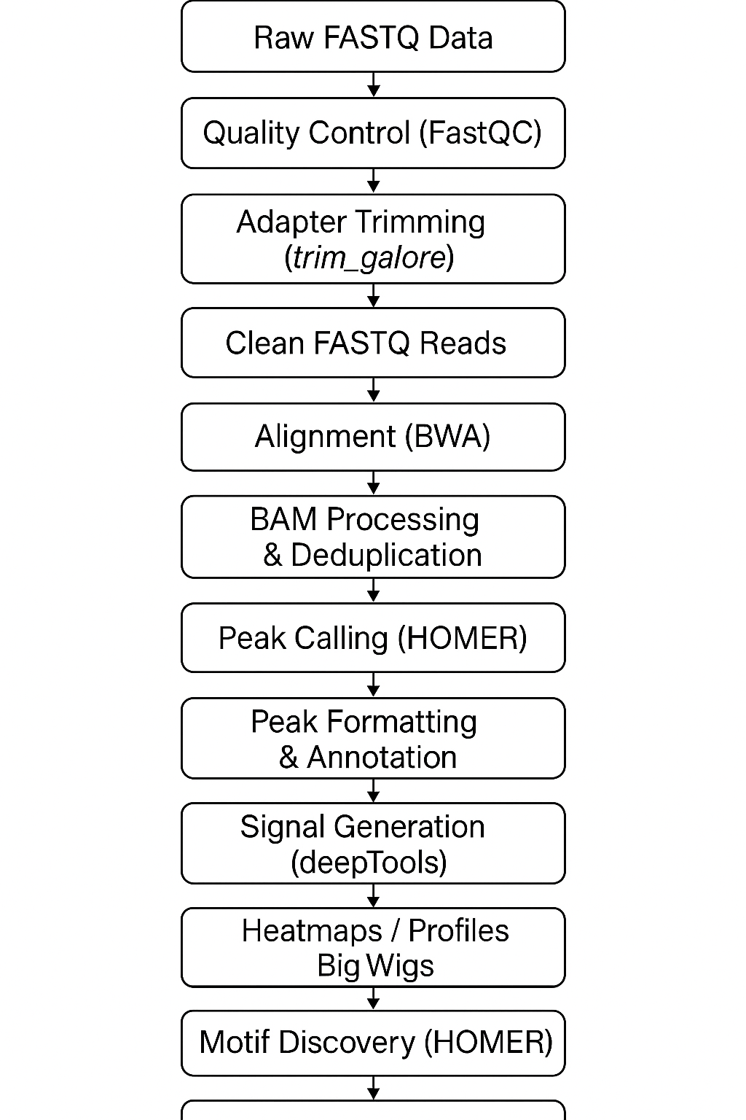

Functional Enrichment of Peaks (GREAT Analysis)

Interpretation

2. Setting Up the conda Environment (Ubuntu 24.04.3 LTS, WSL2)
conda create -n homer_env python=3.10 -y
conda activate homer_env
conda config --add channels defaults
conda config --add channels bioconda
conda config --add channels conda-forge
A dedicated conda environment ensures reproducibility. Adding required channels allows installation of all bioinformatics tools needed throughout the pipeline.

3. Software Installation
conda install -y \
wget \
samtools \
sra-tools \
trim-galore \
bedtools \
picard \
bwa \
fastqc \
deeptools
These tools form the foundation of a standard ChIP‑Seq workflow: SRA download, trimming, alignment, QC, duplicate removal, peak calling, and visualization.

4. HOMER Installation
mkdir -p ~/homer
cd ~/homer
wget http://homer.ucsd.edu/homer/configureHomer.pl
perl configureHomer.pl -install
echo 'export PATH="$HOME/homer/bin:$PATH"' >> ~/.bashrc
source ~/.bashrc
perl configureHomer.pl -install hg38
HOMER is used for peak calling, motif discovery, and annotation. Installing hg38 ensures the genome reference is available.

5. Reference Genome Preparation
mkdir -p ~/hg38_bwa
cd ~/hg38_bwa
wget http://hgdownload.soe.ucsc.edu/goldenPath/hg38/bigZips/hg38.fa.gz
gunzip hg38.fa.gz
bwa index hg38.fa
The hg38 genome is downloaded from UCSC and indexed with BWA for alignment.

6. Downloading FASTQ Files
prefetch SRR6117732
cd SRR6117732
fasterq-dump --threads 4 SRR6117732.sra
gzip SRR6117732.fastq
mv SRR6117732.fastq.gz ~/GSE104247/raw
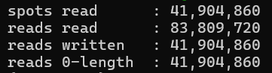

prefetch SRR6117703
cd SRR6117703
fasterq-dump --threads 4 SRR6117703.sra
gzip SRR6117703.fastq
mv SRR6117703.fastq.gz ~/GSE104247/raw
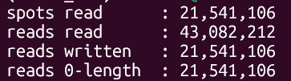
The Input and USF2 ChIP samples are downloaded from SRA and converted to FASTQ for downstream analysis.

7. Trimming & Quality Control
trim_galore --fastqc --cores 4 --quality 20 --length 20 -o ~/GSE104247/trim ~/GSE104247/raw/USF2.fastq.gz
trim_galore --fastqc --cores 4 --quality 20 --length 20 -o ~/GSE104247/trim ~/GSE104247/raw/INPUT.fastq.gz
Trim Galore removes low‑quality bases and adapters. FastQC reports allow visualizing read quality.

8. Alignment with BWA
bwa mem -t 4 -M -R '@RG\tID:USF2\tSM:USF2\tPL:ILLUMINA' ~/hg38_bwa/hg38.fa ~/GSE104247/trim/USF2_trimmed.fq.gz > ~/GSE104247/bam/USF2.sam
bwa mem -t 4 -M -R '@RG\tID:INPUT\tSM:INPUT\tPL:ILLUMINA' ~/hg38_bwa/hg38.fa ~/GSE104247/trim/INPUT_trimmed.fq.gz > ~/GSE104247/bam/INPUT.sam
BWA‑MEM aligns trimmed reads to hg38. Read groups help track sample identity.

9. BAM Processing

(Converting, Sorting, Deduplication, Indexing)

Convert SAM → BAM
samtools view -@ 4 -b USF2.sam > USF2.bam
samtools view -@ 4 -b INPUT.sam > INPUT.bam

Raw Alignment QC (Before Sorting)
samtools flagstat USF2.bam > USF2_flagstat_raw.txt
samtools flagstat INPUT.bam > INPUT_flagstat_raw.txt
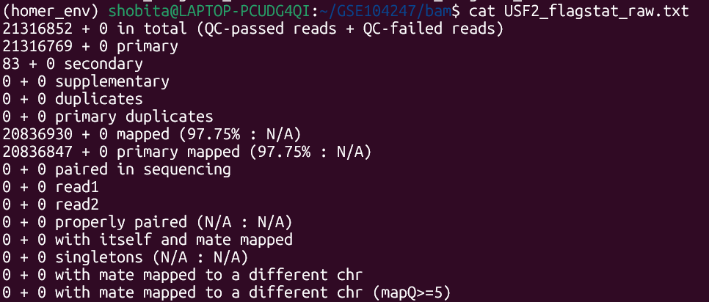

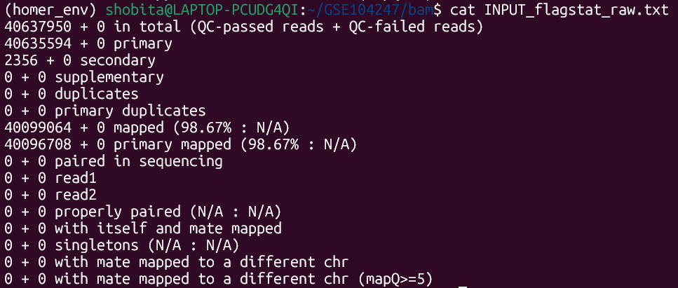

Sort BAM Files
# Memory-safe for WSL (4 threads, 1 GB per thread)
samtools sort -@ 4 -m 1G -o USF2_sorted.bam USF2.bam
samtools sort -@ 4 -m 1G -o INPUT_sorted.bam INPUT.bam
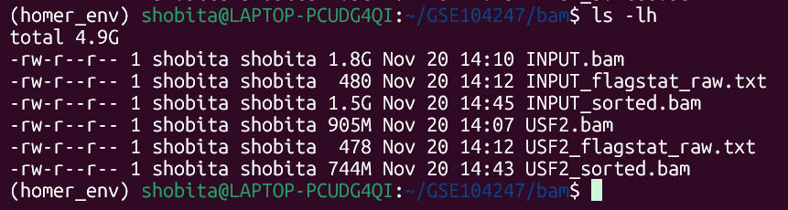

Remove PCR Duplicates (Picard MarkDuplicates)
picard MarkDuplicates \
I=USF2_sorted.bam \
O=USF2_dedup.bam \
M=USF2_metrics.txt \
REMOVE_DUPLICATES=true
picard MarkDuplicates \
I=INPUT_sorted.bam \
O=INPUT_dedup.bam \
M=INPUT_metrics.txt \
REMOVE_DUPLICATES=true

Index the Deduplicated BAM files
samtools index USF2_dedup.bam
samtools index INPUT_dedup.bam

# These steps convert, sort, remove PCR duplicates, and index BAM files for further analysis.

Final Alignment QC (After Deduplication)
samtools flagstat USF2_dedup.bam > USF2_flagstat_final.txt
samtools flagstat INPUT_dedup.bam > INPUT_flagstat_final.txt
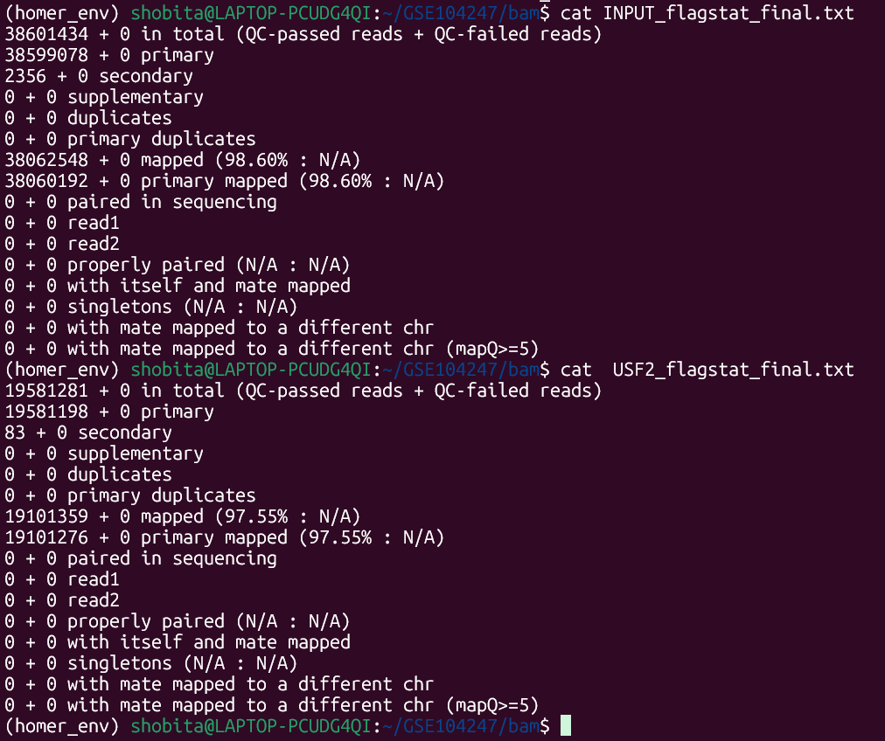
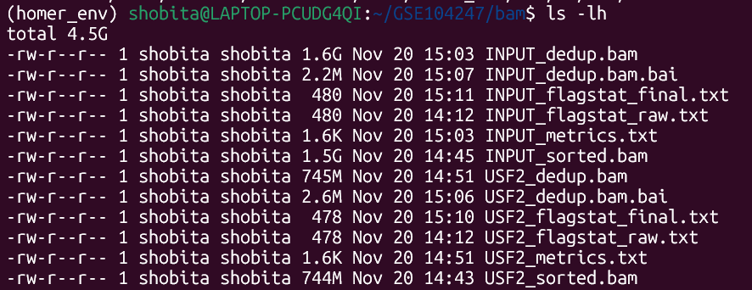

Clean Up Intermediate Large Files (Optional, but recommended)
rm USF2.sam INPUT.sam
rm USF2.bam INPUT.bam
rm USF2_sorted.bam INPUT_sorted.bam

10. Peak Calling with HOMER
(Filtering → Tag Directories → Peak Calling)

Working directory:
cd ~/GSE104247/bam

10.1 Download hg38 ENCODE Blacklist (one-time)
# These regions produce artificial ChIP-seq signal and must be removed before peak calling.
wget https://raw.githubusercontent.com/Boyle-Lab/Blacklist/master/lists/hg38-blacklist.v2.bed.gz
gunzip hg38-blacklist.v2.bed.gz

10.2 Remove Blacklisted Regions (bedtools intersect)
# -v keeps only the reads that do NOT overlap the blacklist
bedtools intersect \
-v \
-abam USF2_dedup.bam \
-b hg38-blacklist.v2.bed \
> USF2_clean.bam

bedtools intersect \
-v \
-abam INPUT_dedup.bam \
-b hg38-blacklist.v2.bed \
> INPUT_clean.bam

10.3 Index the Filtered BAM Files
# Required for HOMER, IGV, and region-based tools.
samtools index USF2_clean.bam
samtools index INPUT_clean.bam

10.4 Create HOMER Tag Directories
#Tag directories store optimized read/tag positions. HOMER uses them internally for peak calling.
makeTagDirectory USF2_tags/ USF2_clean.bam
makeTagDirectory INPUT_tags/ INPUT_clean.bam

10.5 Peak Calling Using HOMER (TF-style: narrow peaks)
# USF2 is a transcription factor → use -style factor for sharp peaks.
findPeaks USF2_tags/ \
-style factor \
-i INPUT_tags/ \
-o USF2_peaks.txt

Output: USF2_peaks.txt (HOMER TF-peak format)

11. Peak Annotation
(BED Conversion → Peak Annotation)
Now that peaks are called, this section converts them to BED and annotates them.

Convert HOMER Peaks to BED Format
# Required for IGV, GREAT, deepTools, bedtools, etc.
pos2bed.pl USF2_peaks.txt > USF2_peaks.bed
Output: USF2_peaks.bed

Peak Annotation Using HOMER (via hg38)
# Annotates each peak with the nearest gene, distance to TSS, genomic region (promoter, exon, intron, intergenic).
annotatePeaks.pl USF2_peaks.bed hg38 > USF2_peak_annotation.txt
Output:
USF2_peak_annotation.txt

12 . Visualization Using deepTools
Purpose:
This stage generates genome-wide ChIP-Seq signal tracks, performs background correction, computes peak-centered matrices, and visualizes signal profiles and heatmaps. These files are used for IGV browsing .

12.1 Overview of What Visualization Produces
The following operations will be performed:
- Create bigWig signal tracks for USF2 and Input
- Create log₂(ChIP/Input) normalized coverage
- Compute peak-centered matrices for aggregation plots
- Generate heatmaps of enrichment across peaks
- Generate average signal profiles
- Prepare visualization files for IGV genome browser
All output files will be stored in:
~/GSE104247/visualization/

12.2 Visualization Script (deepTools)
Directory structure note:
The script assumes your BAM & peak files are located at: ~/GSE104247/bam/

Create a directory for scripts:
mkdir -p ~/GSE104247/scripts

Save the following script EXACTLY as written below as:
~/GSE104247/scripts/chipseq_visualization_full.sh

Full Script (To automate the Visualisation Part):
```{bash}
#!/bin/bash
set -euo pipefail

# ------------------------------------------------------------------
# Minimal ChIP-seq visualization pipeline (deepTools + IGV-ready)
# Saves outputs to: ~/GSE104247/visualization/
# Designed for your folder layout:
# ~/GSE104247/bam/USF2_clean.bam
# ~/GSE104247/bam/INPUT_clean.bam
# ~/GSE104247/bam/USF2_peaks.bed
# Requires: deepTools (bamCoverage, bamCompare, computeMatrix, plotHeatmap, plotProfile)
# ------------------------------------------------------------------

WORKDIR="$HOME/GSE104247"
BAMDIR="${WORKDIR}/bam"
OUTDIR="${WORKDIR}/visualization"

# create output directory
mkdir -p "${OUTDIR}"

# move into bam directory for inputs (keeps things predictable)
cd "${BAMDIR}"

echo "Using BAM directory: ${BAMDIR}"
echo "Visualization outputs will be written to: ${OUTDIR}"
echo

# ---------------------------
# Step 1: make BigWig signal tracks
# ---------------------------
# Reason: bigWig files are compact and fast for visualization (IGV & deepTools)
# We create one for ChIP and one for Input. Files are written to OUTDIR.
# ---------------------------

echo "STEP 1: Generating BigWig files (USF2 and INPUT)"

bamCoverage \
--bam USF2_clean.bam \
--outFileName "${OUTDIR}/USF2.bw" \
--binSize 10 \
--normalizeUsing RPKM \
--numberOfProcessors 4

bamCoverage \
--bam INPUT_clean.bam \
--outFileName "${OUTDIR}/INPUT.bw" \
--binSize 10 \
--normalizeUsing RPKM \
--numberOfProcessors 4

echo "BigWig files created: ${OUTDIR}/USF2.bw ${OUTDIR}/INPUT.bw"
echo

# ---------------------------
# Step 2: create log2(ChIP/Input) normalized track
# ---------------------------
# Reason: best single-track representation of true enrichment (background corrected)
# ---------------------------

echo "STEP 2: Creating log2(USF2 / INPUT) BigWig (background-corrected)"

bamCompare \
-b1 USF2_clean.bam \
-b2 INPUT_clean.bam \
--operation log2 \
--outFileName "${OUTDIR}/USF2_vs_INPUT_log2.bw" \
--binSize 10 \
--numberOfProcessors 4

echo "Log2 track created: ${OUTDIR}/USF2_vs_INPUT_log2.bw"
echo

# ---------------------------
# Step 3: compute matrix around peak centers
# ---------------------------
# Reason: computeMatrix collects numerical signal around each peak center,
# producing a matrix used for heatmap and profile plots.
# -R uses your peak BED
# -S uses the log2 normalized signal track (preferred)
# ---------------------------

PEAKS="${BAMDIR}/USF2_peaks.bed"
MATRIX="${OUTDIR}/matrix_USF2.gz"

echo "STEP 3: Computing matrix around peak centers (±2kb w/ 10bp bins)"
computeMatrix reference-point \
--referencePoint center \
-b 2000 -a 2000 \
-R "${PEAKS}" \
-S "${OUTDIR}/USF2_vs_INPUT_log2.bw}" \
--skipZeros \
--missingDataAsZero \
--binSize 10 \
-o "${MATRIX}" \
--numberOfProcessors 4

echo "Matrix written to: ${MATRIX}"
echo

# ---------------------------
# Step 4: plot heatmap
# ---------------------------

HEATMAP_PNG="${OUTDIR}/USF2_heatmap.png"
echo "STEP 4: Plotting heatmap -> ${HEATMAP_PNG}"

plotHeatmap \
-m "${MATRIX}" \
-out "${HEATMAP_PNG}" \
--colorMap Reds \
--regionsLabel "USF2 Peaks" \
--heatmapHeight 10 \
--heatmapWidth 4

echo "Heatmap generated."
echo

# ---------------------------
# Step 5: plot average profile
# ---------------------------

PROFILE_PNG="${OUTDIR}/USF2_profile.png"
echo "STEP 5: Plotting average profile -> ${PROFILE_PNG}"

plotProfile \
-m "${MATRIX}" \
-out "${PROFILE_PNG}" \
--regionsLabel "USF2 Peaks"

echo "Profile plot generated."
echo

# ---------------------------
# Final message
# ---------------------------

echo "Visualization complete. Files in ${OUTDIR}:"
ls -lh "${OUTDIR}" | sed -n '1,200p'

echo "Minimal IGV upload suggestion (only these files):"
echo " ${OUTDIR}/USF2_vs_INPUT_log2.bw"
echo " ${BAMDIR}/USF2_peaks.bed"
echo "Optional files”
echo " ${BAMDIR}/USF2_clean.bam"
echo " ${BAMDIR}/USF2_clean.bam.bai"
echo " ${BAMDIR}/INPUT_clean.bam"
echo " ${BAMDIR}/INPUT_clean.bam.bai"
# The individual .bw files can also be visualised

12.3 Running the Visualization Script
Make executable:
chmod +x chipseq_visualization_full.sh

Run from anywhere:
bash chipseq_visualization_full.sh

12.4 Explanations
A. What this script does
- Reads USF2_clean.bam, INPUT_clean.bam, USF2_peaks.bed
- Generates USF2.bw & INPUT.bw
- Creates log₂(ChIP/Input) corrected track
- Computes matrix around peak centers
- Generates heatmap & average profile
- Stores everything under ~/GSE104247/visualization/
B. Why each step is needed
- bamCoverage → bigWig = fast, lightweight tracks
- Normalization (RPKM) = compare samples fairly
- bamCompare (log₂) = true enrichment vs background
- computeMatrix = numerical table for heatmaps/profiles
- plotHeatmap / plotProfile = visualization of binding patterns

C. Minimal IGV upload list
Upload only:
- USF2_vs_INPUT_log2.bw
- USF2.bw
- INPUT.bw
- USF2_peaks.bed

16. Motif Discovery using HOMER

Purpose:
Identify enriched DNA sequence motifs found at USF2 binding sites.
This step validates the biological quality of your ChIP-seq experiment by checking whether known USF2 motifs (e.g., CACGTG) are enriched.

Working directory:
cd ~/GSE104247/bam

Command:
findMotifsGenome.pl \
USF2_peaks.bed \
hg38 \
../motifs_USF2/ \
-size 200

Parameter Explanation
Parameter | Meaning
USF2_peaks.bed | Your final peak list from HOMER
hg38 | Reference genome
../motifs_USF2/ | Output directory
-size 200 | Extract ±100 bp around the summit (200 bp total)

✔ Why -size 200 Is Biologically Appropriate for Transcription Factor ChIP-Seq
1.TF motifs are small (6–20 bp)
Transcription factors bind short DNA sequences.
For USF2 specifically, the canonical E-box motif is:
CACGTG
= 6 bp
These short motifs occur very close to the peak summit, not across the entire peak region.

2.The peak summit represents the strongest binding point
The summit is the location with highest ChIP-seq signal, meaning:
- most reads pile up here
- highest likelihood of direct TF–DNA contact
- strongest sequence conservation
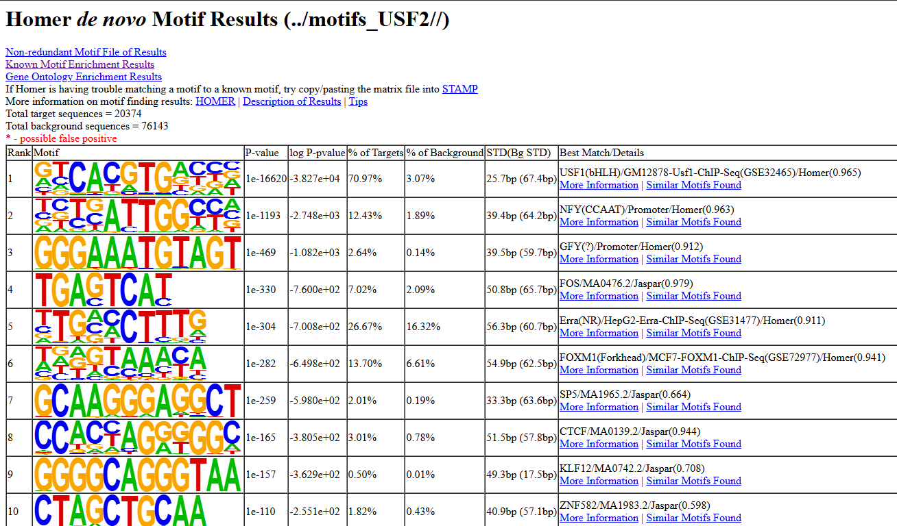
Using a small summit-centered region improves sensitivity and motif discovery accuracy.
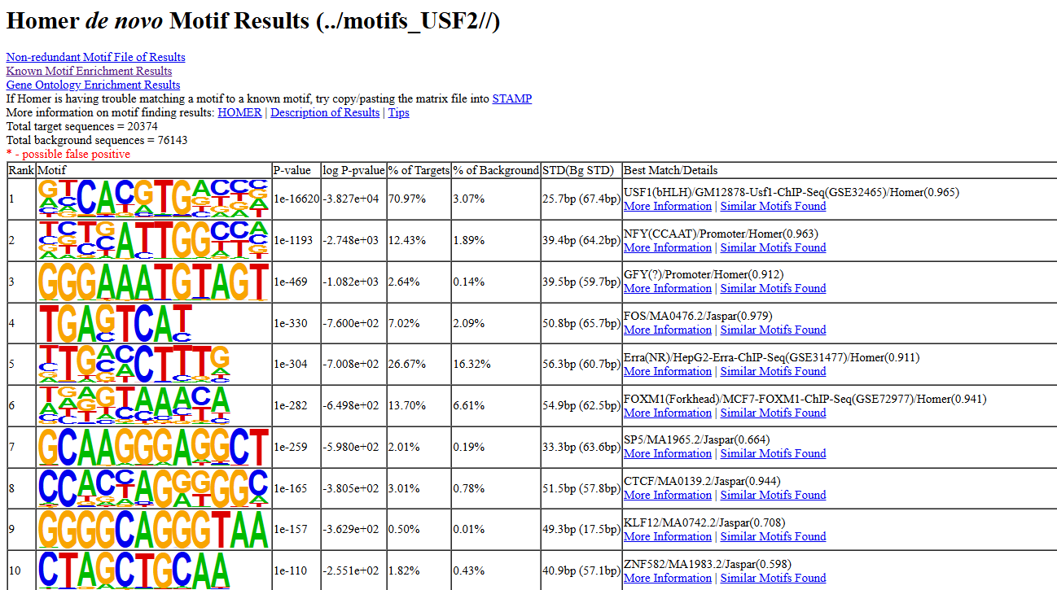
Motif Identified (Strongest Hit)
USF / E-box family motif
Consensus sequence: CACGTG
This is the canonical binding motif for USF1 and USF2, confirming that your ChIP-seq successfully captured true TF binding sites.

(A) Motif Enrichment Summary
Metric | Value | Meaning
% of peak sequences containing motif | ~71% | Strong presence in USF2 binding regions
% in background | ~3% | Rare in random genome
Fold enrichment | ~25–30× | Highly enriched signal
P-value | ≈ 1 × 10⁻¹⁶⁶²⁰ | Extremely significant
Best known motif match | USF1 (similarity = 0.965) | Excellent match

(B) Why This Matters
✔ Confirms antibody worked
✔ Confirms true USF2 binding events
✔ Peaks reflect real biological binding, not noise
✔ Validates earlier QC steps
This is the strongest evidence that your ChIP-seq experiment succeeded.

17 .Functional Enrichment of Peaks (GREAT Analysis)
Purpose:
To determine biological pathways, regulatory programs, and gene networks associated with your USF2 peaks.
Working directory:
cd ~/GSE104247/bam
Before uploading to GREAT, peaks must be converted to summit-centered 200 bp windows.

Generate 200 bp Summit-Centered Regions (Unchanged Command)
awk 'BEGIN{OFS="\t"} {summit=$2 + $10; start=summit-100; if(start<0) start=0; end=summit+100; print $1, start, end, $4}' USF2_peaks.bed > USF2_summits_200bp.bed

Explanation
- $1 → chromosome
- $2 → peak start
- $10 → summit offset
- summit = start + summit_offset → absolute summit
- Window = summit −100 bp to +100 bp
- Ensures standard region sizes (200 bp each)

Output File: USF2_summits_200bp.bed
Contains:
chr summit-100 summit+100 peak_name
A perfect input format for GREAT.

Run GREAT
- Go to: https://great.stanford.edu
- Upload: USF2_summits_200bp.bed
- Select genome: hg38
- Association rule: Basal + extension (default)
- Run the job for GO terms, pathways, and regulatory enrichment.

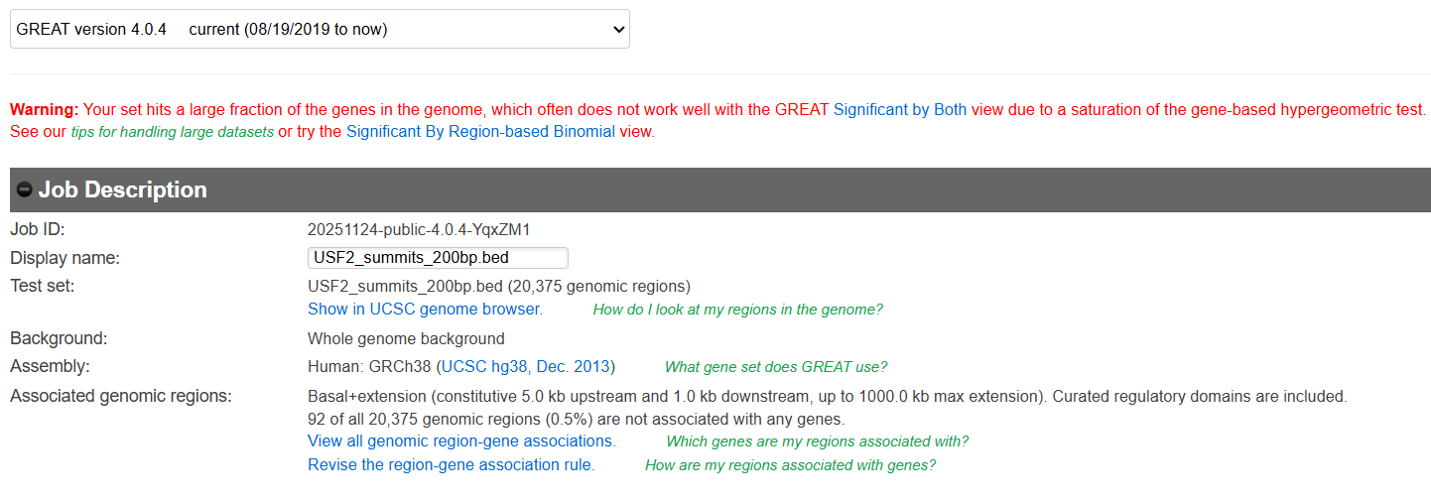
GREAT displayed a warning because my dataset contains over 20,000 summit-centered peaks, which is typical for transcription factors with broad binding profiles such as USF2. When many peaks map to many genes, the gene-based hypergeometric test used by GREAT becomes saturated. However, this does not indicate an error. GREAT recommends using the “Region-Based Binomial” significance measure for large datasets, which is more appropriate for TF ChIP-seq. The analysis continues normally, and this view provides robust pathway and GO enrichment results.

Why summit-centered regions are required
HOMER peak regions are too broad
Large regions dilute TF motifs and inflate overlap with genes.

Summits represent the true binding point
This is the exact base where USF2 binds.

Fixed length (200 bp) ensures fairness
GREAT, HOMER, and motif tools all perform best with equal-sized windows.
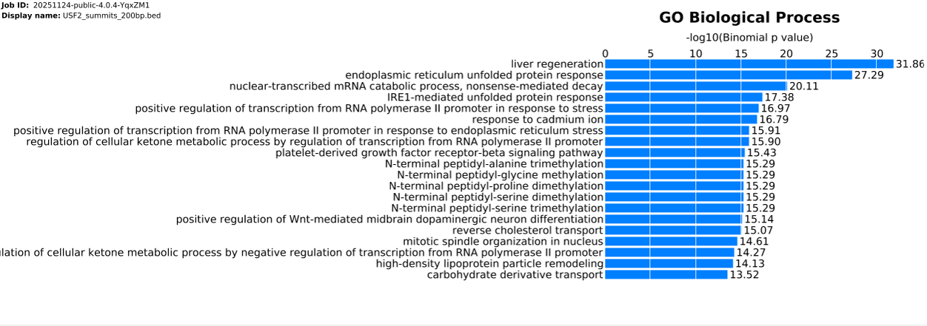

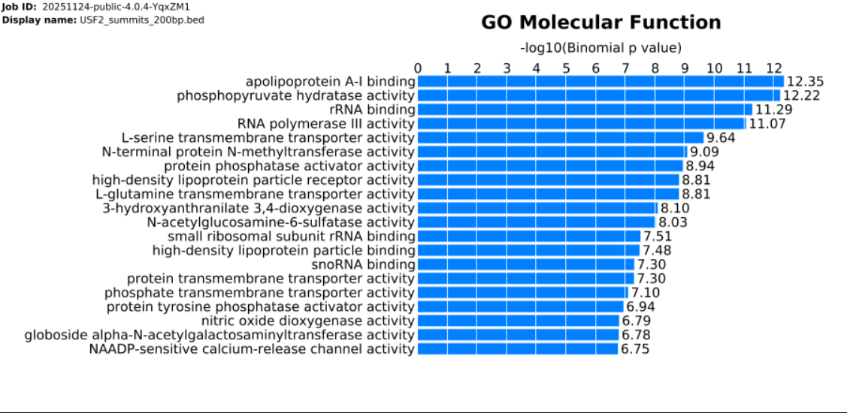
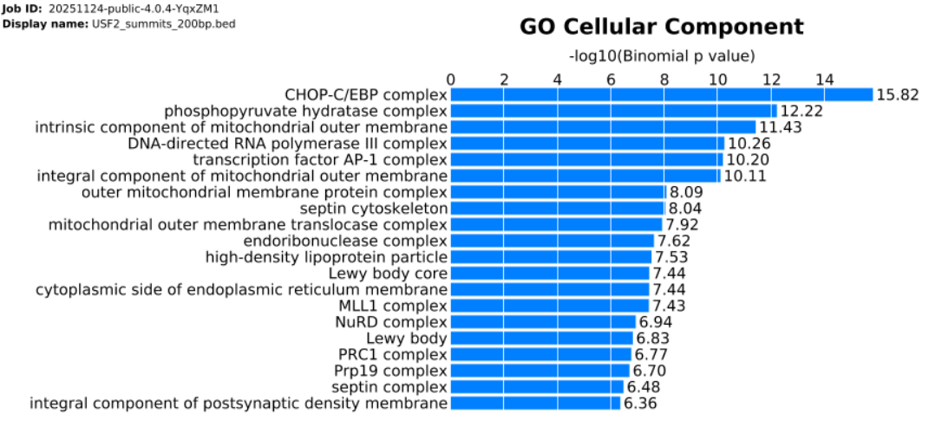
18 . Export Files for Genome Browser Visualization (IGV)
Load the following files into IGV:

1. BAM Files (alignment data - Optional)
USF2_clean.bam
USF2_clean.bam.bai
INPUT_clean.bam
INPUT_clean.bam.bai
2. Signal Tracks (bigWigs)
USF2.bw
INPUT.bw
USF2_vs_INPUT_log2.bw
3. Peak File
USF2_peaks.bed
IGV – Whole Genome View
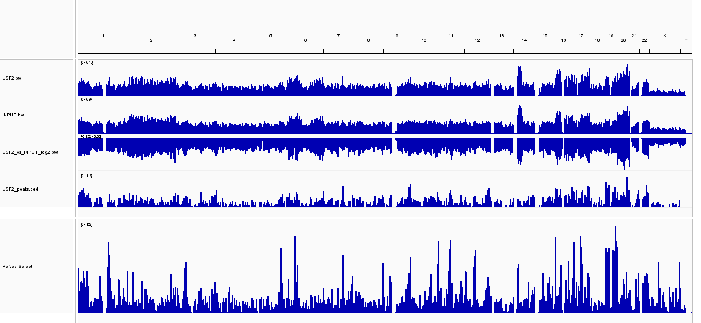
IGV – Whole Chromosome View ( eg. Chr1)
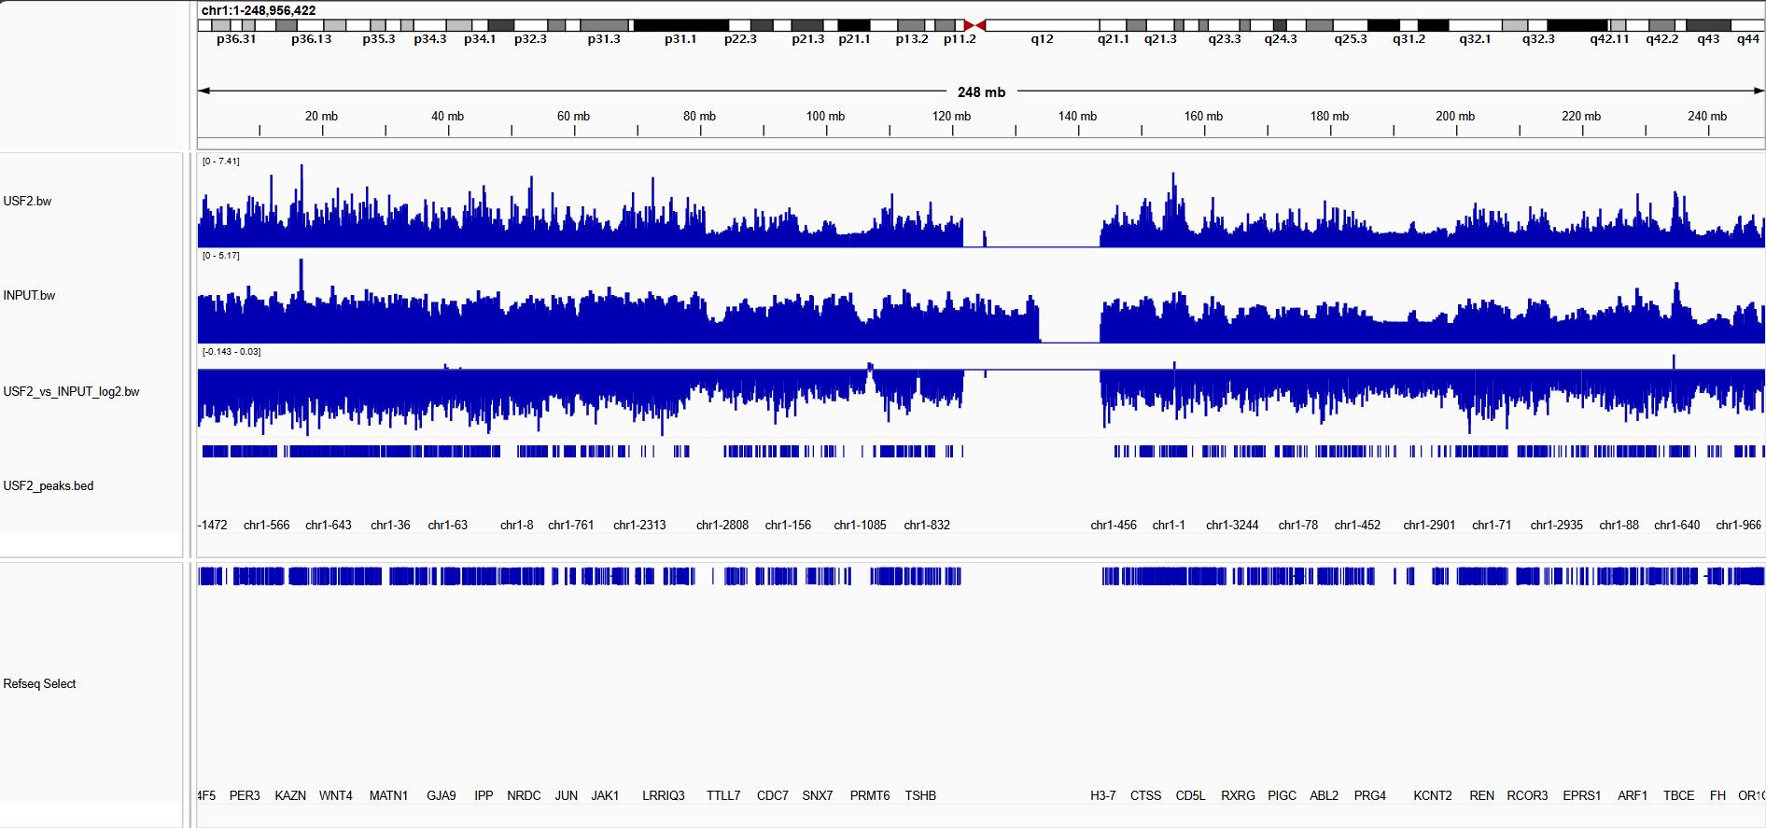

Interpretation in IGV
✔ Confirm peak enrichment over Input
✔ Validate summit positions
✔ Inspect known USF2 target genes
✔ Check for artifacts, repetitive regions, or spikes

18 . (Biological Highlight) — Most Important Peak Example
Gene: CDK4
Peak ID: chr12-1
Coordinates: chr12:57752242–57752560
Annotation: promoter-TSS (–91 bp from TSS)
Peak Score: 394
This is biologically the strongest peak because:
1. Located at promoter (–91 bp)
Direct regulation, strongest impact on gene transcription.
2.CDK4 regulates the cell cycle
USF2 may regulate proliferation, cancer-related processes, and G1/S checkpoint.
3.High peak score (394)
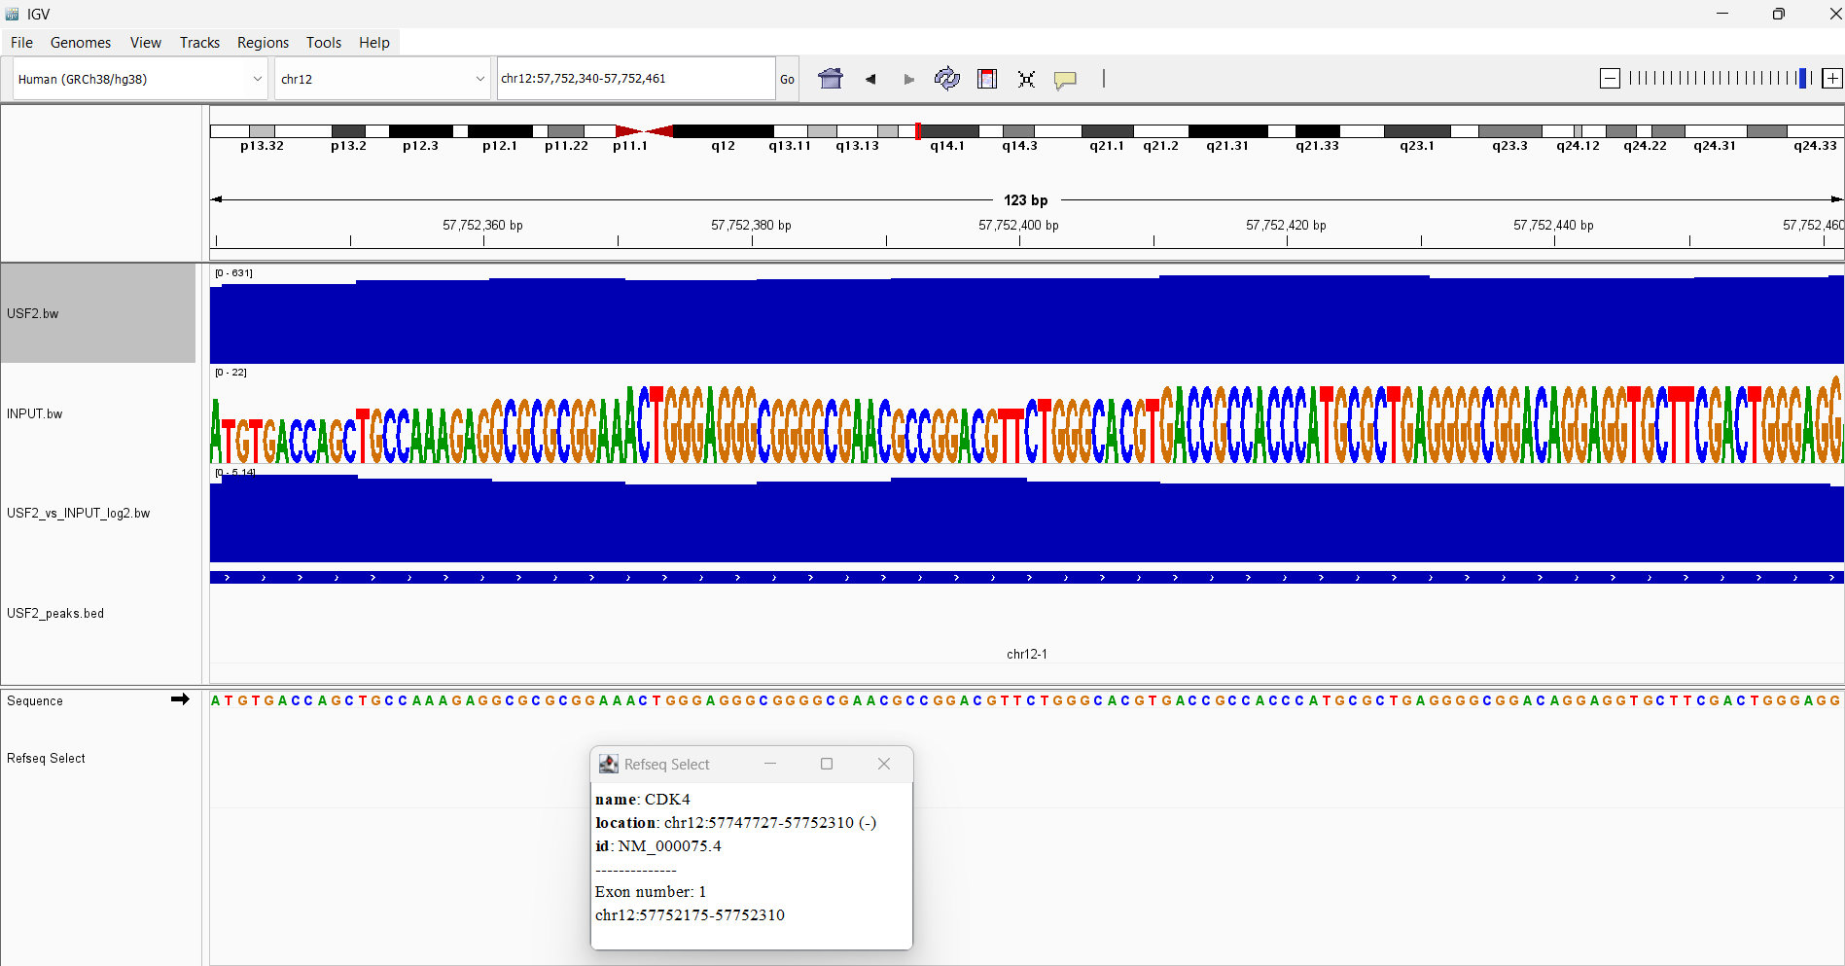
Represents a strong, confident, noise-free TF binding event.

Summary and Conclusion
This ChIP-Seq pipeline successfully processed USF2 ChIP and Input samples through quality control, alignment, deduplication, peak calling, annotation, motif discovery, and visualization. The workflow produced biologically meaningful results, including strong USF2 enrichment at E-box motifs and functional associations with metabolic and stress-response pathways.
The final outputs—including normalized bigWig tracks, heatmaps, average profiles, and annotated peaks—provide a robust foundation for downstream analysis, such as transcriptional network inference and integration with RNA-Seq datasets.
Snapshots of Iportant Folder Contents:
