ChIP_Data_Analysis
By: Gayatri Sunil Samant

1. Overview
This project involves processing ChIP‑Seq data for USF2 from HepG2 cells, covering QC, trimming, alignment, peak calling, annotation, visualization, motif discovery, and GREAT enrichment.

GEO metadata and experimental context
GEO Series: GSE104247
Organism: Homo sapiens (human)
Cell line: HepG2 (liver cancer cell line)
Assay: ChIP-seq — genome binding/occupancy profiling by high-throughput sequencing
Platform: Illumina HiSeq 2000
Study design (summary): - Profiles of many transcription factors/CAPs across replicates. - Two biological replicates + input controls per factor in the full series.
Specific runs used in this analysis: - SRR6117703 — ChIP (USF2 IP) - SRR6117732 — Input (control)
Both runs are single-end and come from the same GEO Series (GSE104247). SRR6117703 is the ChIP sample used to call USF2 binding sites and SRR6117732 is the input (background) used for control and normalization.

2. Environment Setup (Ubuntu 24.04.3 LTS, WSL2)
All commands were executed under a conda environment named homer_env (Python 3.10).

conda create -n homer_env python=3.10 -y
conda activate homer_env
conda config --add channels defaults
conda config --add channels bioconda
conda config --add channels conda-forge

3. Software Installation
conda install -y \
wget \
samtools \
sra-tools \
trim-galore \
bedtools \
picard \
bwa \
fastqc \
deeptools

4. HOMER Installation
mkdir -p ~/homer
cd ~/homer
wget http://homer.ucsd.edu/homer/configureHomer.pl
perl configureHomer.pl -install
echo 'export PATH="$HOME/homer/bin:$PATH"' >> ~/.bashrc
source ~/.bashrc
perl configureHomer.pl -install hg38

5. Reference Genome Preparation
mkdir -p ~/hg38_bwa
cd ~/hg38_bwa
wget http://hgdownload.soe.ucsc.edu/goldenPath/hg38/bigZips/hg38.fa.gz
gunzip hg38.fa.gz
bwa index hg38.fa

6. Downloading FASTQ Files

prefetch SRR6117732
cd SRR6117732
fasterq-dump --threads 4 SRR6117732.sra
gzip SRR6117732.fastq
mv SRR6117732.fastq.gz ~/GSE104247/raw
prefetch SRR6117703
cd SRR6117703
fasterq-dump --threads 4 SRR6117703.sra
gzip SRR6117703.fastq
mv SRR6117703.fastq.gz ~/GSE104247/raw

7. Trimming & Quality Control
trim_galore --fastqc --cores 4 --quality 20 --length 20 -o ~/GSE104247/trim ~/GSE104247/raw/USF2.fastq.gz
trim_galore --fastqc --cores 4 --quality 20 --length 20 -o ~/GSE104247/trim ~/GSE104247/raw/INPUT.fastq.gz

8. Alignment with BWA
bwa mem -t 4 -M -R '@RG\tID:USF2\tSM:USF2\tPL:ILLUMINA' ~/hg38_bwa/hg38.fa ~/GSE104247/trim/USF2_trimmed.fq.gz > ~/GSE104247/bam/USF2.sam
bwa mem -t 4 -M -R '@RG\tID:INPUT\tSM:INPUT\tPL:ILLUMINA' ~/hg38_bwa/hg38.fa ~/GSE104247/trim/INPUT_trimmed.fq.gz > ~/GSE104247/bam/INPUT.sam

9. BAM Processing
samtools view -@ 4 -b USF2.sam > USF2.bam
samtools view -@ 4 -b INPUT.sam > INPUT.bam
samtools flagstat USF2.bam > USF2_flagstat_raw.txt
samtools flagstat INPUT.bam > INPUT_flagstat_raw.txt
samtools sort -@ 4 -m 1G -o USF2_sorted.bam USF2.bam
samtools sort -@ 4 -m 1G -o INPUT_sorted.bam INPUT.bam
picard MarkDuplicates \
I=USF2_sorted.bam \
O=USF2_dedup.bam \
M=USF2_metrics.txt \
REMOVE_DUPLICATES=true
picard MarkDuplicates \
I=INPUT_sorted.bam \
O=INPUT_dedup.bam \
M=INPUT_metrics.txt \
REMOVE_DUPLICATES=true
samtools index USF2_dedup.bam
samtools index INPUT_dedup.bam

10. Peak Calling with HOMER
wget https://raw.githubusercontent.com/Boyle-Lab/Blacklist/master/lists/hg38-blacklist.v2.bed.gz
gunzip hg38-blacklist.v2.bed.gz
bedtools intersect -v -abam USF2_dedup.bam -b hg38-blacklist.v2.bed > USF2_clean.bam
bedtools intersect -v -abam INPUT_dedup.bam -b hg38-blacklist.v2.bed > INPUT_clean.bam
samtools index USF2_clean.bam
samtools index INPUT_clean.bam
makeTagDirectory USF2_tags/ USF2_clean.bam
makeTagDirectory INPUT_tags/ INPUT_clean.bam
findPeaks USF2_tags/ -style factor -i INPUT_tags/ -o USF2_peaks.txt

11. Peak Annotation
pos2bed.pl USF2_peaks.txt > USF2_peaks.bed
annotatePeaks.pl USF2_peaks.bed hg38 > USF2_peak_annotation.txt

12. Visualization Script (deepTools)

Visualization includes:
- making bigWig signal tracks and preparing files for IGV genome browser
- generating normalized ChIP–Input log2 signal
- plotting heatmaps and signal profiles
mkdir -p ~/GSE104247/scripts
Saving this script as chipseq_visualization_full.sh in ~/GSE104247/scripts

```{bash}
#!/bin/bash
set -euo pipefail
WORKDIR="$HOME/GSE104247"
BAMDIR="${WORKDIR}/bam"
OUTDIR="${WORKDIR}/visualization"
mkdir -p "${OUTDIR}"
cd "${BAMDIR}"
bamCoverage --bam USF2_clean.bam --outFileName "${OUTDIR}/USF2.bw" --binSize 10 --normalizeUsing RPKM --numberOfProcessors 4
bamCoverage --bam INPUT_clean.bam --outFileName "${OUTDIR}/INPUT.bw" --binSize 10 --normalizeUsing RPKM --numberOfProcessors 4
bamCompare -b1 USF2_clean.bam -b2 INPUT_clean.bam --operation log2 --outFileName "${OUTDIR}/USF2_vs_INPUT_log2.bw" --binSize 10 --numberOfProcessors 4
computeMatrix reference-point --referencePoint center -b 2000 -a 2000 -R "${BAMDIR}/USF2_peaks.bed" -S "${OUTDIR}/USF2_vs_INPUT_log2.bw" --skipZeros --missingDataAsZero --binSize 10 -o "${OUTDIR}/matrix_USF2.gz" --numberOfProcessors 4
plotHeatmap -m "${OUTDIR}/matrix_USF2.gz" -out "${OUTDIR}/USF2_heatmap.png" --colorMap Reds --regionsLabel "USF2 Peaks" --heatmapHeight 10 --heatmapWidth 4
plotProfile -m "${OUTDIR}/matrix_USF2.gz" -out "${OUTDIR}/USF2_profile.png" --regionsLabel "USF2 Peaks"
```

Make the script executable and run it:
chmod +x chipseq_visualization_full.sh

# run it from anywhere; it changes to the BAM directory automatically
bash chipseq_visualization_full.sh

16. Motif Discovery
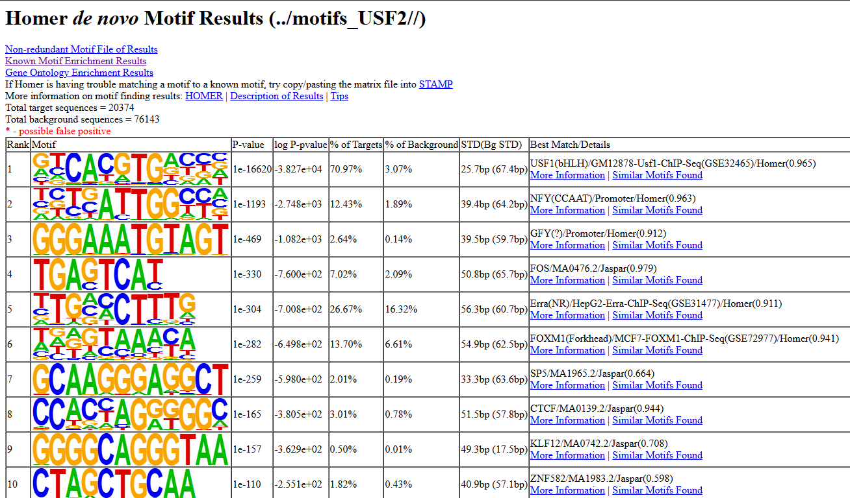
findMotifsGenome.pl \
USF2_peaks.bed \
hg38 \
../motifs_USF2/ \
-size 200
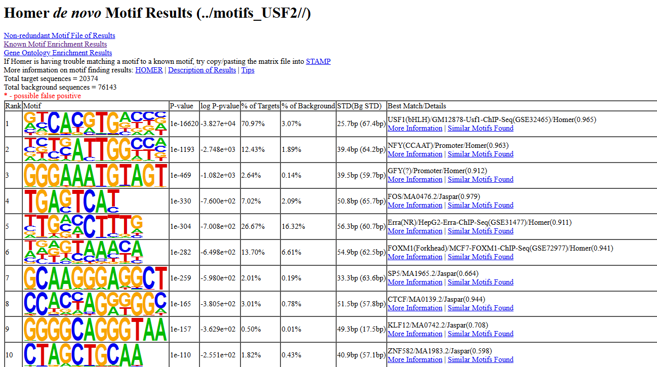
Motif Identified: (Strongest Enrichment)
USF family E-box motif
Consensus sequence: CACGTG
This is the exact DNA motif recognized by both USF1 and USF2 (basic helix–loop–helix transcription factors).

17. GREAT Functional Enrichment of peaks

cd ~/GSE104247/bam
We will extract it and create a 200 bp (±100 bp) window around the summit.
awk 'BEGIN{OFS="\t"} {summit=$2 + $10; start=summit-100; if(start<0) start=0; end=summit+100; print $1, start, end, $4}' USF2_peaks.bed > USF2_summits_200bp.bed
Then:
- Go to GREAT: https://great.stanford.edu
- Upload USF2_summits_200bp.bed as the input regions
- Select genome assembly hg38
- Keep the default association rule: Basal + extension
- Run the job to obtain pathway enrichment, GO terms, and regulatory annotations

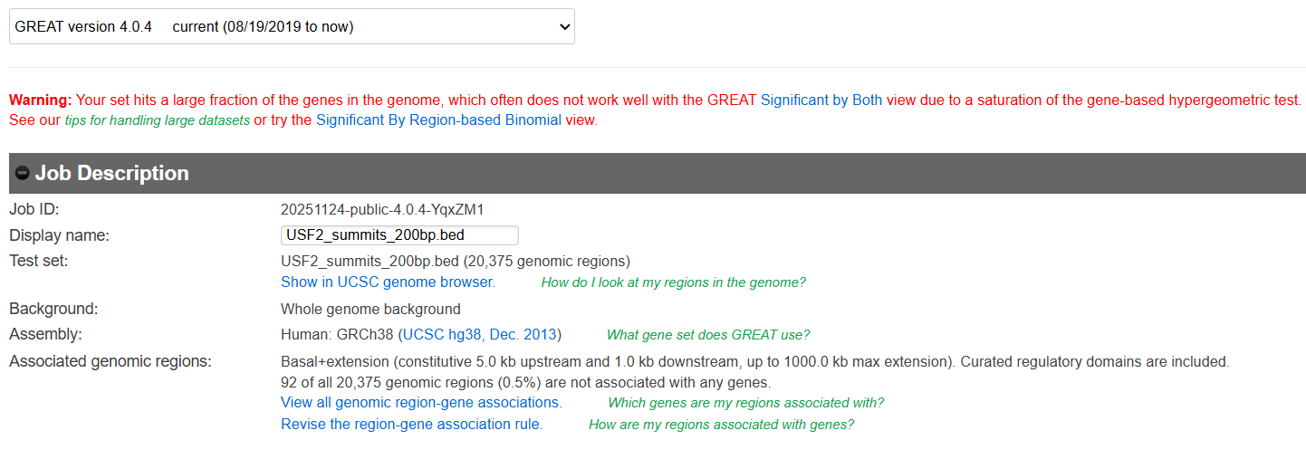
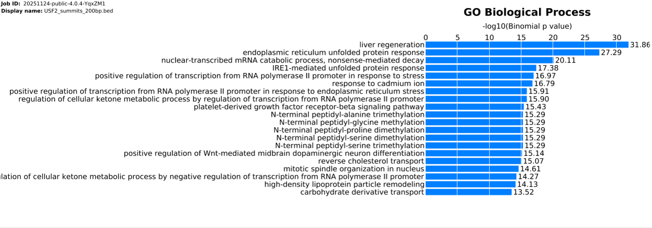
GREAT displayed a warning because my dataset contains over 20,000 summit-centered peaks, which is typical for transcription factors with broad binding profiles such as USF2. When many peaks map to many genes, the gene-based hypergeometric test used by GREAT becomes saturated. However, this does not indicate an error. GREAT recommends using the “Region-Based Binomial” significance measure for large datasets, which is more appropriate for TF ChIP-seq. The analysis continues normally, and this view provides robust pathway and GO enrichment results.
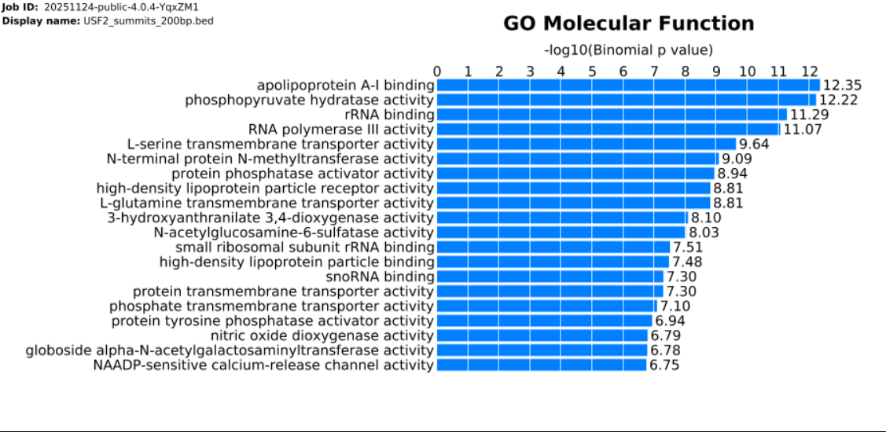

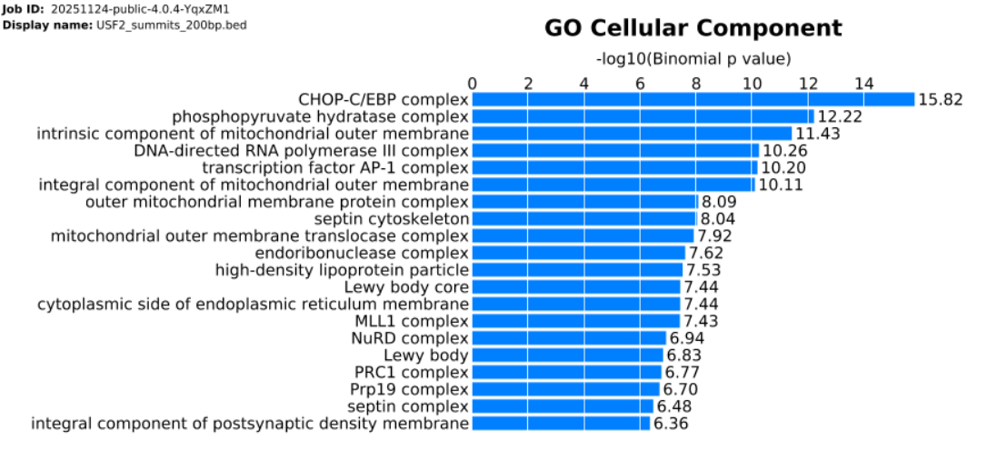

18. Export Files to IGV

Optional files:
USF2_clean.bam, USF2_clean.bam.bai , INPUT_clean.bam , INPUT_clean.bam.bai
Important files:
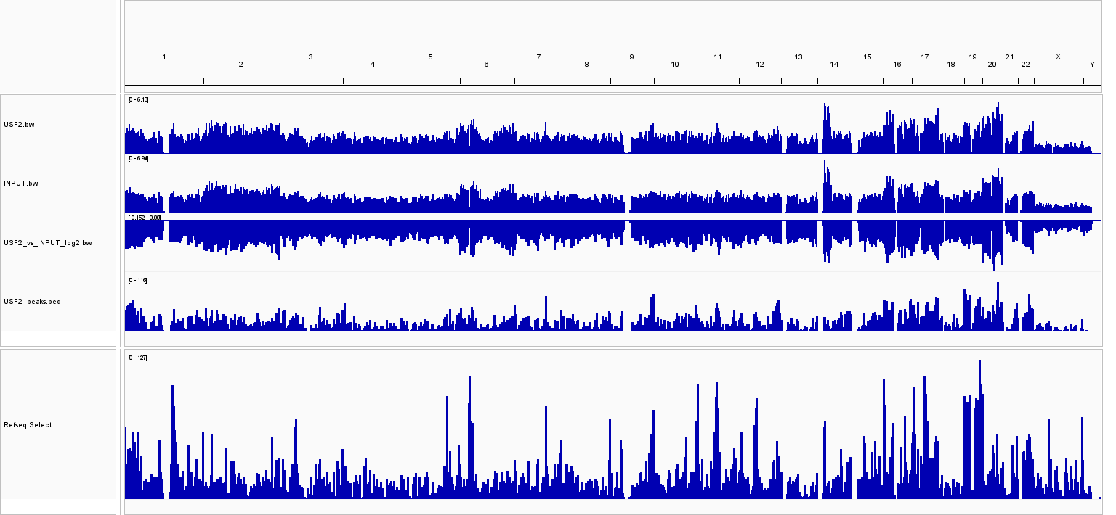
USF2.bw , INPUT.bw , USF2_vs_INPUT_log2.bw , USF2_peaks.bed
Key Example: Identifying the Most Biologically Important Peak from Annotation
Among all peaks in your annotation file, the CDK4 promoter peak stands out as the most important based on biological relevance, regulatory potential, and signal strength.
This peak corresponds to:
Peak ID: chr12-1
Coordinates: chr12:57752242–57752560
Nearest Gene: CDK4
Annotation: promoter-TSS (−91 bp from TSS)
Distance to TSS: -91
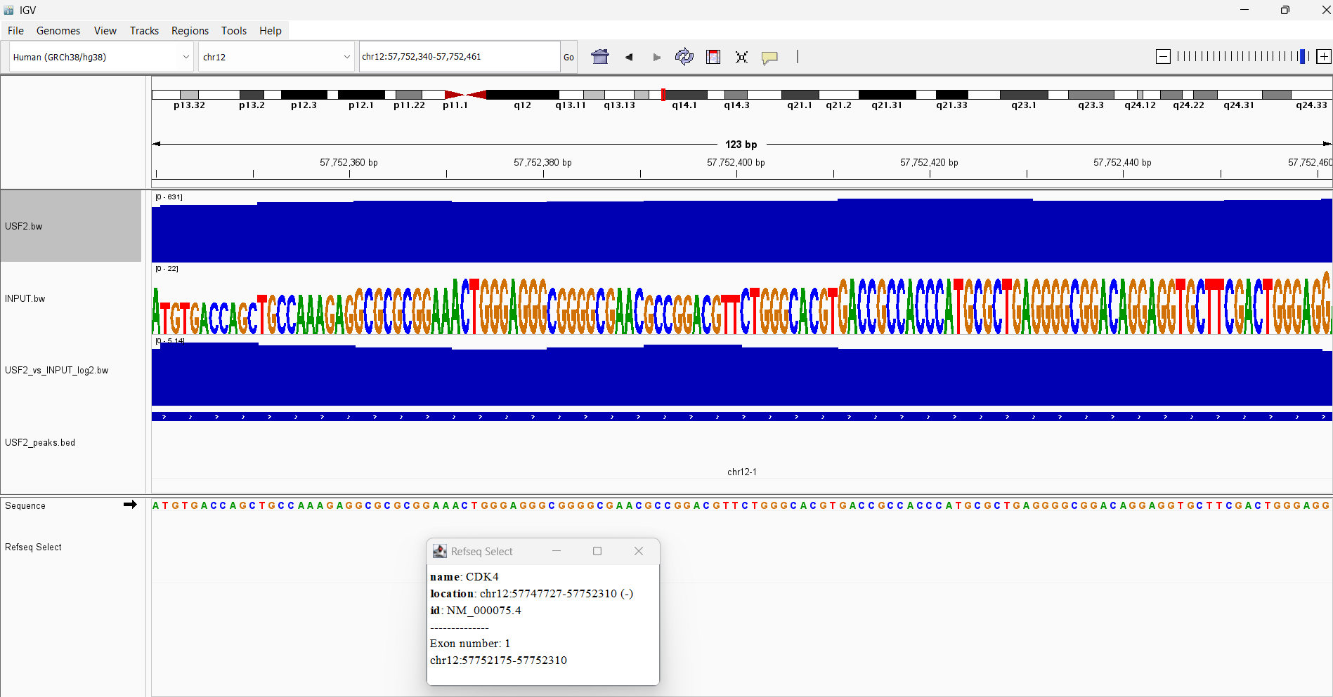
Peak Score: 394

Summary
This pipeline successfully processed raw data through alignment, filtering, peak calling, motif analysis, visualization, and functional enrichment.

