**Part 01: Introduction to HTML**

 Bookmark this page

**Scenario/Use Case**

Imagine you are a budding web developer seeking to establish an online presence. Your goal is to create a personal portfolio that includes sections for your bio, skills, projects, and contact information. Through the HTML portion of the project, you will structure the content of your portfolio, incorporate images of your work, establish clickable links to your projects, and create interactive forms for visitor feedback.

**Objective Design**

1.  Understanding HTML Syntax:

a. Create a basic HTML document with necessary structure.

b. Use various HTML elements to structure content effectively.

2. Formatting and Styling in HTML:

a. Apply formatting options to text content.

b. Implement inline and block-level elements for proper styling.

3. Incorporating Images and Hyperlinks:

a. Embed images and provide alternative text.

b. Create hyperlinks to external projects and resources.

4. Utilizing Global HTML Attributes:

a. Apply global attributes such as 'class' and 'id' for styling and identification.

5. Developing Navigation Menus and Forms:

a. Create a navigation menu using lists.

b. Construct interactive forms for user engagement.

6. Organizing and Structuring Content:

a. Understand and implement semantic HTML elements.

b. Organize content with proper document structure.

7. Constructing Tables:

a. Build tables to display project or skill-related data.

**Conclusion**

By completing this project, learners will have developed a fully functional personal portfolio website that reflects their skills and showcases their work in an aesthetically pleasing manner. The portfolio will include a professional bio, a display of acquired skills, a showcase of completed projects, and a means for visitors to get in touch. This project provides a comprehensive understanding of HTML and CSS, allowing learners to create a tangible output that can be used in their professional journey as web developers.

Congratulations on building your personal portfolio and taking a significant step towards establishing your online presence!

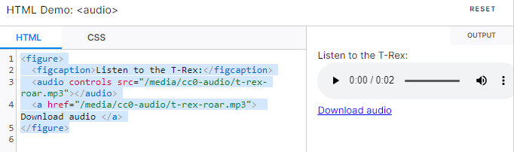

* back to top links