Abacavirinol

Samantha Lee

Fall 2018

LBGTguys <- filter(abac, LBGT=="yes")

males <- filter(abac, sex=="M")  
females <- filter(abac, sex=="F")

IVuser <- filter(abac, Ivdrug=="user")

# Introduction

A new preventative aides (abacavirinol) is under test in clinical trials. Analyze the effectiveness of this drug across the board. Consider population subgroups by gender, drug use, and sexual orientation. Finish this!

# Methods

To decide the effectiveness of the drug, we will determine whether there is a difference among the amount of people who were infected that received the drug and that recieved the placebo, between the males and females, drug users and non-drug users, and LBGT and non-LBGT people.

#### Chapter 1 Effectiveness of drug

# Results

## Descriptive Results

### Graphical Descriptive Results

barchartGC(~infected + treatment, data=abac, type = "percent")

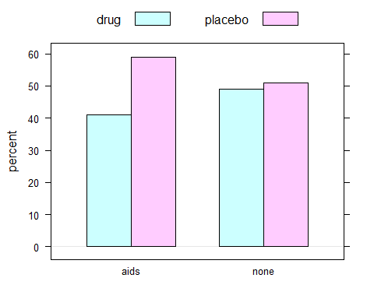

### Numerical Descriptive Results

tab1 =xtabs(~treatment+infected, data=abac)  
rowPerc(tab1)

## infected  
## treatment aids none Total  
## drug 4.04 95.96 100.00  
## placebo 5.54 94.46 100.00

colPerc(tab1)

## infected  
## treatment aids none  
## drug 40.93 49.1  
## placebo 59.07 50.9  
## Total 100.00 100.0

## Inferential Results

chisq.test(tab1)

##   
## Pearson's Chi-squared test with Yates' continuity correction  
##   
## data: tab1  
## X-squared = 5.7138, df = 1, p-value = 0.01683

chisqtestGC(tab1)

## Pearson's Chi-squared test with Yates' continuity correction   
##   
## Observed Counts:  
## infected  
## treatment aids none  
## drug 97 2303  
## placebo 140 2387  
##   
## Counts Expected by Null:  
## infected  
## treatment aids none  
## drug 115.45 2284.55  
## placebo 121.55 2405.45  
##   
## Contributions to the chi-square statistic:  
## infected  
## treatment aids none  
## drug 2.95 0.15  
## placebo 2.80 0.14  
##   
##   
## Chi-Square Statistic = 5.7138   
## Degrees of Freedom of the table = 1   
## P-Value = 0.0168

fisher.test(tab1)

##   
## Fisher's Exact Test for Count Data  
##   
## data: tab1  
## p-value = 0.01634  
## alternative hypothesis: true odds ratio is not equal to 1  
## 95 percent confidence interval:  
## 0.5449798 0.9433871  
## sample estimates:  
## odds ratio   
## 0.7181794

# Discussion and Conclusion

#### Chapter 2 Effectiveness with LBGT individuals

# Methods

# Results

## Descriptive Results

### Graphical Descriptive Results

barchartGC(~infected + treatment, data=LBGTguys, type = "percent")

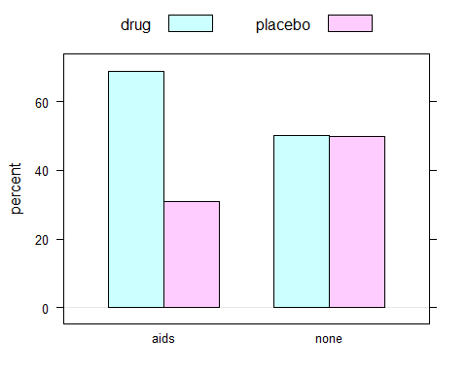

### Numerical Descriptive Results

tab2 =xtabs(~treatment+infected, data=LBGTguys)  
rowPerc(tab2)

## infected  
## treatment aids none Total  
## drug 6.51 93.49 100.00  
## placebo 3.06 96.94 100.00

colPerc(tab2)

## infected  
## treatment aids none  
## drug 68.97 50.17  
## placebo 31.03 49.83  
## Total 100.00 100.00

## Inferential Results

chisq.test(tab2)

##   
## Pearson's Chi-squared test with Yates' continuity correction  
##   
## data: tab2  
## X-squared = 3.1843, df = 1, p-value = 0.07435

chisqtestGC(tab2)

## Pearson's Chi-squared test with Yates' continuity correction   
##   
## Observed Counts:  
## infected  
## treatment aids none  
## drug 20 287  
## placebo 9 285  
##   
## Counts Expected by Null:  
## infected  
## treatment aids none  
## drug 14.81 292.19  
## placebo 14.19 279.81  
##   
## Contributions to the chi-square statistic:  
## infected  
## treatment aids none  
## drug 1.82 0.09  
## placebo 1.90 0.10  
##   
##   
## Chi-Square Statistic = 3.1843   
## Degrees of Freedom of the table = 1   
## P-Value = 0.0743

fisher.test(tab2)

##   
## Fisher's Exact Test for Count Data  
##   
## data: tab2  
## p-value = 0.05698  
## alternative hypothesis: true odds ratio is not equal to 1  
## 95 percent confidence interval:  
## 0.9400645 5.5951059  
## sample estimates:  
## odds ratio   
## 2.203969

# Discussion and Conclusion

#### Chapter 3 drug effectiveness with men

# Methods

# Results

## Descriptive Results

### Graphical Descriptive Results

barchartGC(~infected + treatment, data=males, type = "percent")

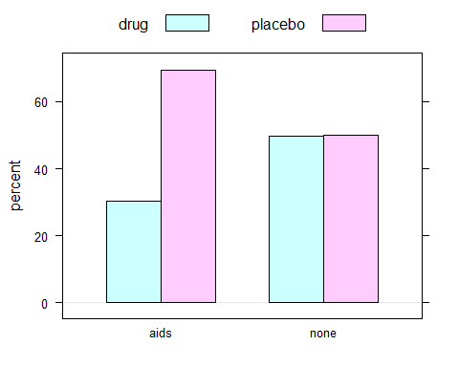

### Numerical Descriptive Results

tab3 =xtabs(~treatment+infected, data=males)  
rowPerc(tab3)

## infected  
## treatment aids none Total  
## drug 4.14 95.86 100.00  
## placebo 8.92 91.08 100.00

colPerc(tab3)

## infected  
## treatment aids none  
## drug 30.46 49.86  
## placebo 69.54 50.14  
## Total 100.00 100.00

## Inferential Results

chisq.test(tab3)

##   
## Pearson's Chi-squared test with Yates' continuity correction  
##   
## data: tab3  
## X-squared = 20.472, df = 1, p-value = 6.052e-06

chisqtestGC(tab3)

## Pearson's Chi-squared test with Yates' continuity correction   
##   
## Observed Counts:  
## infected  
## treatment aids none  
## drug 46 1066  
## placebo 105 1072  
##   
## Counts Expected by Null:  
## infected  
## treatment aids none  
## drug 73.36 1038.64  
## placebo 77.64 1099.36  
##   
## Contributions to the chi-square statistic:  
## infected  
## treatment aids none  
## drug 10.20 0.72  
## placebo 9.64 0.68  
##   
##   
## Chi-Square Statistic = 20.4718   
## Degrees of Freedom of the table = 1   
## P-Value = 0

fisher.test(tab3)

##   
## Fisher's Exact Test for Count Data  
##   
## data: tab3  
## p-value = 4.352e-06  
## alternative hypothesis: true odds ratio is not equal to 1  
## 95 percent confidence interval:  
## 0.3013934 0.6360948  
## sample estimates:  
## odds ratio   
## 0.4407101

# Discussion and Conclusion

#### Chapter 4 Effectiveness with women

# Methods

# Results

## Descriptive Results

### Graphical Descriptive Results

barchartGC(~infected + treatment, data=females, type = "percent")

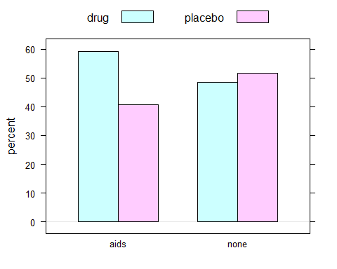

### Numerical Descriptive Results

tab4 =xtabs(~treatment+infected, data=females)  
rowPerc(tab4)

## infected  
## treatment aids none Total  
## drug 3.96 96.04 100.00  
## placebo 2.59 97.41 100.00

colPerc(tab4)

## infected  
## treatment aids none  
## drug 59.3 48.47  
## placebo 40.7 51.53  
## Total 100.0 100.00

## Inferential Results

chisq.test(tab4)

##   
## Pearson's Chi-squared test with Yates' continuity correction  
##   
## data: tab4  
## X-squared = 3.4843, df = 1, p-value = 0.06195

chisqtestGC(tab4)

## Pearson's Chi-squared test with Yates' continuity correction   
##   
## Observed Counts:  
## infected  
## treatment aids none  
## drug 51 1237  
## placebo 35 1315  
##   
## Counts Expected by Null:  
## infected  
## treatment aids none  
## drug 41.99 1246.01  
## placebo 44.01 1305.99  
##   
## Contributions to the chi-square statistic:  
## infected  
## treatment aids none  
## drug 1.93 0.07  
## placebo 1.84 0.06  
##   
##   
## Chi-Square Statistic = 3.4843   
## Degrees of Freedom of the table = 1   
## P-Value = 0.062

fisher.test(tab4)

##   
## Fisher's Exact Test for Count Data  
##   
## data: tab4  
## p-value = 0.04911  
## alternative hypothesis: true odds ratio is not equal to 1  
## 95 percent confidence interval:  
## 0.980258 2.472003  
## sample estimates:  
## odds ratio   
## 1.548757

# Discussion and Conclusion

#### Chapter 5 Effectiveness with drug users

# Methods

# Results

## Descriptive Results

### Graphical Descriptive Results

barchartGC(~infected + treatment, data=IVuser, type = "percent")

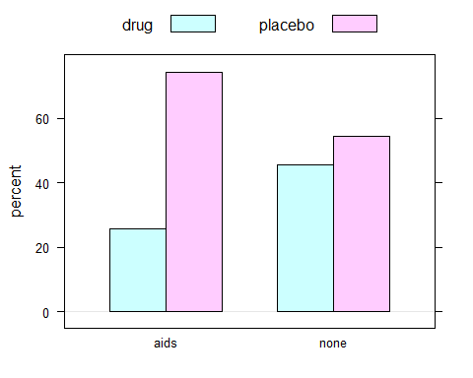

### Numerical Descriptive Results

tab5 =xtabs(~treatment+infected, data=IVuser)  
rowPerc(tab5)

## infected  
## treatment aids none Total  
## drug 3.17 96.83 100.00  
## placebo 7.40 92.60 100.00

colPerc(tab5)

## infected  
## treatment aids none  
## drug 25.64 45.66  
## placebo 74.36 54.34  
## Total 100.00 100.00

## Inferential Results

chisq.test(tab5)

##   
## Pearson's Chi-squared test with Yates' continuity correction  
##   
## data: tab5  
## X-squared = 5.1942, df = 1, p-value = 0.02266

chisqtestGC(tab5)

## Pearson's Chi-squared test with Yates' continuity correction   
##   
## Observed Counts:  
## infected  
## treatment aids none  
## drug 10 305  
## placebo 29 363  
##   
## Counts Expected by Null:  
## infected  
## treatment aids none  
## drug 17.38 297.62  
## placebo 21.62 370.38  
##   
## Contributions to the chi-square statistic:  
## infected  
## treatment aids none  
## drug 3.13 0.18  
## placebo 2.52 0.15  
##   
##   
## Chi-Square Statistic = 5.1942   
## Degrees of Freedom of the table = 1   
## P-Value = 0.0227

fisher.test(tab5)

##   
## Fisher's Exact Test for Count Data  
##   
## data: tab5  
## p-value = 0.01929  
## alternative hypothesis: true odds ratio is not equal to 1  
## 95 percent confidence interval:  
## 0.1757111 0.8844152  
## sample estimates:  
## odds ratio   
## 0.4108953

# Discussion and Conclusion