Objective
This project allows a user to plan a 2-5 day long vacation in a European city. It includes tag selection so the user only gets suggestions for activities that interest them. The user can select a starting time and duration. They can decide how many activities they want in a day, which ranges from 1 to 3. Google Gemini uses the country, city, date, tags, duration, and starting time to generate a numbered list of 5 activities that fit that criteria. The user can select one to add to their schedule. The final output is a schedule for each day that includes the activity’s name, start time, and end time.
Methodology
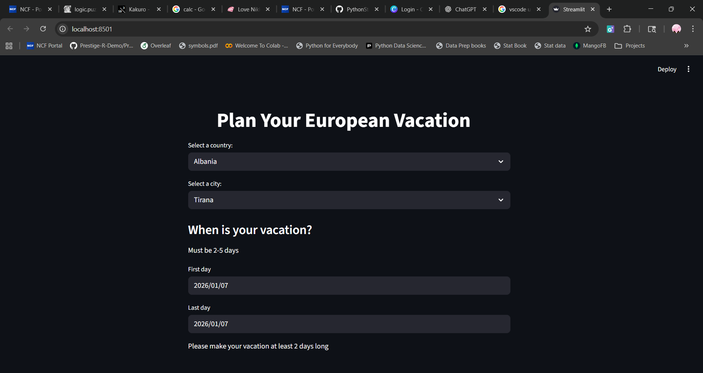
The user can select a country and city using st.selectbox. Depending on the country, the cities available will change.
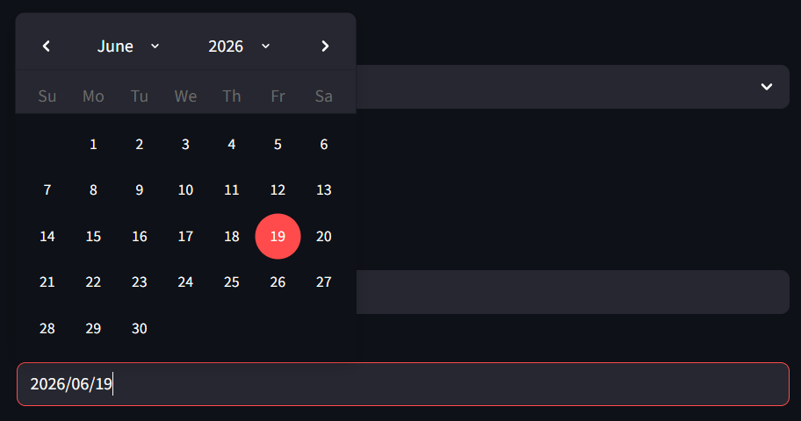
They can choose what date the vacation starts and ends with st.date_input. Its duration is calculated by using .days to get the day value from start date and end date, then subtracting.
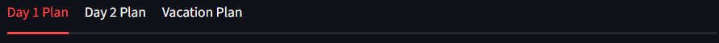
If the duration is longer, more tabs, made with st.tabs, appear. For instance, if it’s 2 days, there’s a “Day 1 Plan”, “Day 2 Plan”, and “Vacation Plan” tab. If it’s 5 days, there’s also a “Day 3 Plan”, “Day 4 Plan”, and “Day 5 Plan” tab.
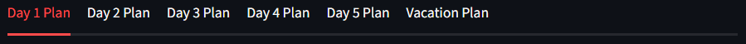
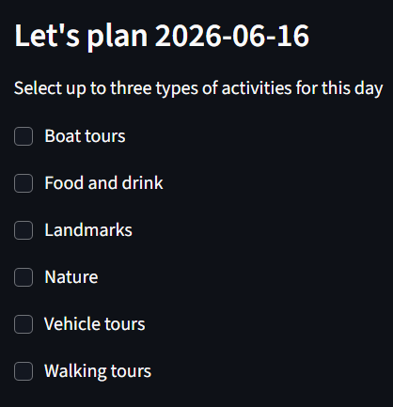
Three empty lists are created, repeatlist, actlist, and times. Repeatlist will store activity names across all days, actlist will store activity names for only one day, and times stores the start and end times of s day’s activity. The user can select up to three tags to describe a day’s activity with st.checkbox. They can choose different tags for different days.
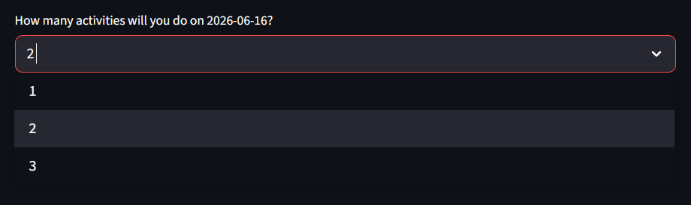
They can choose how many activities they want to do on that day.
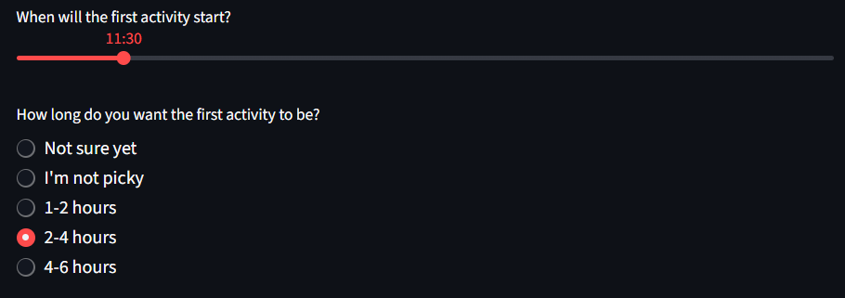
Using a st.slider slider, each activity can be given a starting time. With st.radio, they can choose a duration between one and six hours. The start and end times of each activity are added to the times list with .append.
The prompt for gemini 2.5 flash is as folows: f"Make a numbered list of the 5 most popular tourist attractions/destinations in {citty}, {ctry} that will definitely be available on {fdaygpt} involving {tags[0]}. Do not include {repeatlist}. Make sure they are between {longchoice} and start at {timey}. Don't include the start time in the list. Include a one sentence description and its duration in hours. If the duration is a range, put the duration as the higher estimate. Put a colon after the attraction's name." It takes the city, country, date, tags, previous activities, duration, and starting time into account. It can include up to three tags. There is another version of this prompt that doesn’t take previous activities into account that’s used for the first activity on the first day.
After the numbered list is generated, the user can select an activity by selecting the number on the st.radio panel that matches the one on the numbered list. Once one is chosen, the user can move on to the next one if they chose to have more than one that day.
The name and duration is extracted with .find, .replace, and .strip. The end time of each activity is the duration plus the starting time. The starting time of the next activity is the end time of the previous activity plus an hour to account for transport, a lunch break, or a rest.
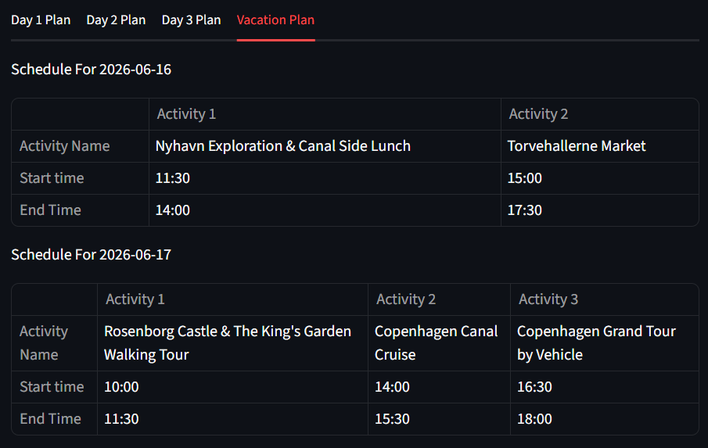
Each day’s schedule starts as an empty dataframe. The name, start time, and end time of each activity is filled in by actlist, and times. The “Vacation Plan” tab contains the schedules for all days.

