**Super Mics Documentation**

**Topology Diagram:**

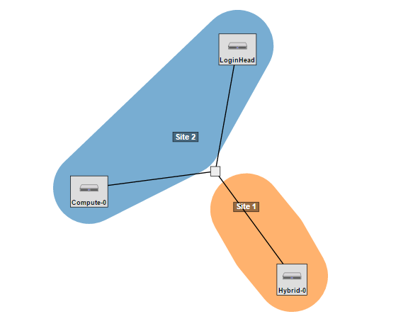

**Architecture-** SuperMic has two defining features to its architecture. Firstly is the two login Nodes that are the entryway into the computing nodes. Both login nodes are slightly different, with one running an NVIDIA GPU and the other using Intel coprocessors. We will simplify this and only include one login node in our topology. This will will also represent the home node that will contain the file sharing, and be represented by Wisconsin's C220G2. Next is the two types of computing nodes, simple nodes and hybrid nodes. There are have the Intel coprocessors, and the Hybrid Nodes contain both the Intel and NVIDIA, giving it quite the boost in power. We have another Wisconsin based C220G2to represent the simple nodes, and the C4130 from Clemsonto properly represent the hybrid nodes. We will have one of each node, since these are both fairly powerful nodes, and getting more of each will be difficult. The most difficult portion of creating this topology is the fact that the C4130 closely represents the E5-2680 processors that SuperMIC uses, but there are only 2 of these hosted on cloudlab. The other nodes chosen (C220G2) were the ones that closest resembled the nodes after the C4130.

**Source:** <https://portal.xsede.org/lsu-supermic>

**Scripts:** We have two sets of setup scripts, one set for Ubuntu and one set for Centos. The Ubuntu scripts are able to fully install Torque as either the head or a compute node. For the compute node, this is just setting up and installing the Torque client. For the head node, this involves setting up the server and scheduler as well. The head node script also sets up PBS and the ability to use it. The Ubuntu scripts do not include Lustre. We have code that is not functional for this in each script commented out, as we ran into difficulty with Ubuntu. Lustre’s requirements for kernels that are older than what Ubuntu offers was the major roadblock.

For the Centos scripts, there are 9 scripts. These scripts handle installing, setting up, and configuring Lustre and Torque. There are 3 install scripts, one for Torque and two for Lustre (client and server), and 6 configuration scripts that will handle Torque clients and servers and Lustre clients and servers. These configuration scripts include everything that is needed to make sure the clients and servers are running the way we need them.

Our github repository also includes two readme files, one for Ubuntu and one for Centos. These provide the exact details on running the scripts to install and configure Torque and Lustre for head nodes or compute nodes.

**Validation:** Validation was something that we never were fully able to achieve. We could test the installation of Torque no problem, however with the issues we encountered installing Lustre we were never able to fully validate the system.