Initial model:
Item | Type | Description
Vanilla | Int | Icecream flavor
Chocolate | Int | Icecream flavor
Cherry | Int | Icecream flavor
Coffee | Int | Icecream flavor
Caramel | Int | Icecream flavor
Peanut butter | int | Icecream flavor

Low Fidelity:
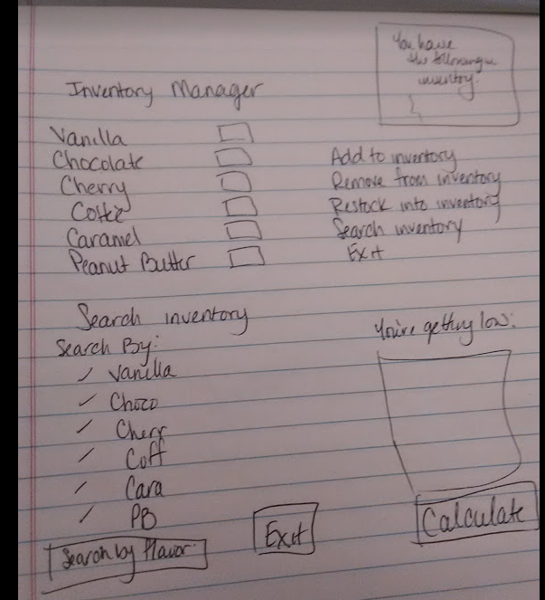

High Fidelity:
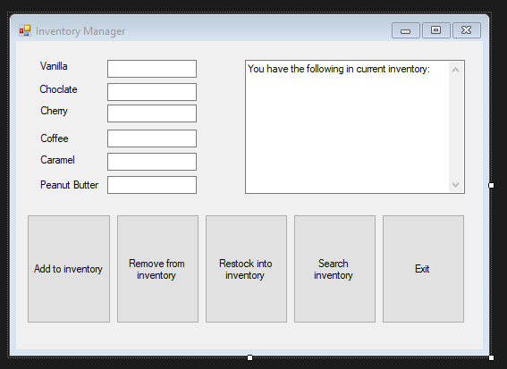
You can enter any amount into the textbox and choose what to do with the amount: Add, remove, or restock. The large textbox will adjust to show the current inventory after each change. The search inventory will pop up with a second form where you are able to search the inventory from there.
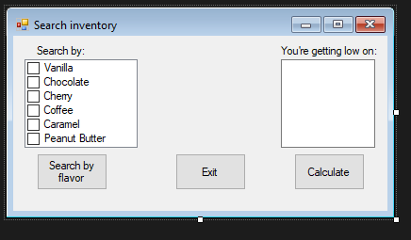
In the search inventory: You can search either by flavor, which will pop up a window to tell you what inventory you have for the selected flavor, or by low inventory which will list the flavors that have less than x amount in inventory.

