**Database Application Programming**

**Project Status and Design Report**

|  |  |
| --- | --- |
| **Topic:** | *Final Blog Application* |
| **Date:** | *April 2019* |
| **Revision:** | *9.0* |
| **Team:** | *Samantha Krall* |
| **Team Status:** | |  | | --- | | **Task** | | *All necessary SQL tables, PHP code, HTML, JavaScript* | | *List of known bugs* | | *Suggested implementations for next version* | |  | |
| **GIT URL:** | *https://github.com/SamanthaKrall/CST-126* |
| **Hosting URL:** | *https://portal.azure.com/#@mygcuedu6961.onmicrosoft.com/resource/subscriptions/74ab4d5e-49e5-4cd3-884b-12c354d4cd07/resourcegroups/CST-126/providers/Microsoft.Web/sites/CST-126/appServices* |

**Supporting Design Documentation**

**Install Instructions:**

*localhost:3306/milestone*

**General Technical Approach:**

*Constrain column width (80 characters or less, including spaces), Use headers and sub headers, Use font without squiggles, Large font size, Use a pleasant contrast between background color and text color so you can read the text easily*

*I wanted to create a web application that was appealing, clean, and easy to navigate.*

**Key Technical Design Decisions:**

*Constrain column width (80 characters or less, including spaces), Use headers and sub headers, Use font without squiggles, Large font size, Use a pleasant contrast between background color and text color so you can read the text easily*

**ER Diagram:**

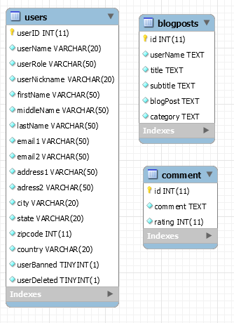

**DDL Scripts:**

[*https://github.com/SamanthaKrall/CST-126*](https://github.com/SamanthaKrall/CST-126)

**Sitemap Diagram:**

Index

Login

Register

Add a new blog post

Add/ Read comments

Main

Read limited Blog info

Login

Register

Delete post

Update post

Read full blog post

**User Interface Diagrams:**

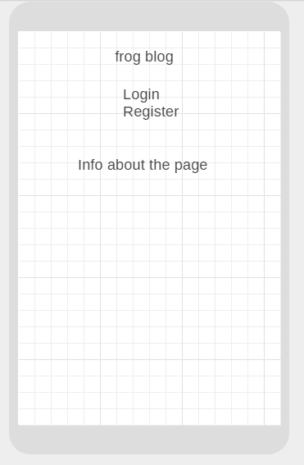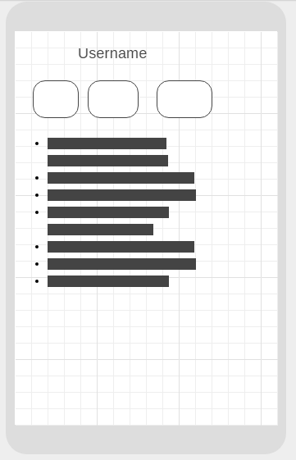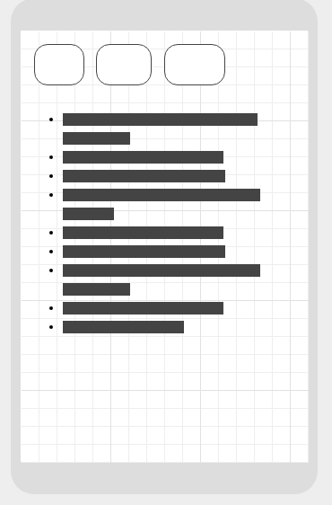

**Other Documentation:**

**Presentation Link:** [**https://www.loom.com/share/af527b3e57d5469a97a70c98c525f6e7**](https://www.loom.com/share/af527b3e57d5469a97a70c98c525f6e7)

|  |
| --- |
| **Known Bugs:** |
| **When you click the “Home” button on pages within the application, it takes you to the loginHandler but does not load properly.** |
|  |

|  |
| --- |
| **Suggested Future Implementation:** |
| **I would have liked to have had less page hopping and more of the information on the same page. This would be something I would strive to do in future implementations.** |
|  |

|  |  |
| --- | --- |
| **Module** |  |
| **Milestone 1** | **User Registration Module** |
| **Milestone 2** | **Login Module** |
| **Milestone 3** | **Blog Post** |
| **Milestone 4** | **Deploying and Hosting Your Website** |
| **Milestone 5** | **User Administration** |
| **Milestone 6** | **List of Blog Posts With Update and Delete Blog Module** |
| **Milestone 7** | **Search Blog Module** |
| **Milestone 8** | **Comment On and Rate a Blog Post** |