**Database Application Programming**

**Project Status and Design Report**

|  |  |  |
| --- | --- | --- |
| **Topic:** | *Milestone 3: Blog Post* | |
| **Date:** | *March 2019* | |
| **Revision:** | *3.0* | |
| **Team:** | 1. *Samantha Krall* | |
| **Team Status:** | |  |  |  |  | | --- | --- | --- | --- | | **Task** | **Team**  **Member** | **Hours**  **Worked** | **Hours Remaining** | | *MySQL- build necessary tables to store the information required during the blog posting process* |  |  |  | | *PHP- write functions that will enable capturing of new post and store in the database* |  |  |  | | *HTML- build minimally functional form to capture the new post* |  |  |  | | *PHP- perform the necessary verification of compliance with constraints decided upon.* |  |  |  | | *Diagram details of user experience* |  |  |  | | *MySQL- build tables to store information and enable desired functionality* |  |  |  | |  |  |  |  | |  |  |  |  | |  |  |  |  | |  |  |  |  | | |
| **GIT URL:** | *https://github.com/SamanthaKrall/CST-126* | |
| **Hosting URL:** | *https://portal.azure.com/#@mygcuedu6961.onmicrosoft.com/resource/subscriptions/74ab4d5e-49e5-4cd3-884b-12c354d4cd07/resourcegroups/CST-126/providers/Microsoft.Web/sites/CST-126/appServices* | |
| **Peer Review:** | *Y* | We acknowledge that our team has reviewed this Report and we agree to the approach we are all taking. |

**Supporting Design Documentation**

**Install Instructions:**

*localhost:3306/milestone*

**General Technical Approach:**

*Constrain column width (80 characters or less, including spaces), Use headers and sub headers, Use font without squiggles, Large font size, Use a pleasant contrast between background color and text color so you can read the text easily*

**Key Technical Design Decisions:**

*Any final technical design decisions, such as framework decisions etc., should be documented here. This should list the technology/framework, its purpose in the design, and why it was chosen.*

**ER Diagram:**

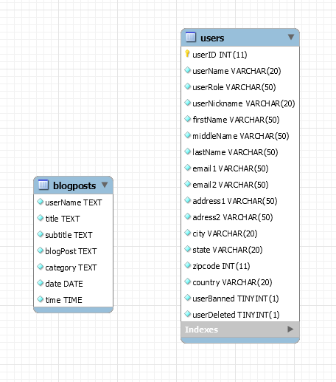

**DDL Scripts:**

[*https://github.com/SamanthaKrall/CST-126*](https://github.com/SamanthaKrall/CST-126)

**Sitemap Diagram:**

*Image file of your Sitemap diagram.*

**User Interface Diagrams:**

*You should insert any wireframe drawings or white board concepts that were developed to support your application. If you have no supporting documentation please explain the rational why you are able to leave this section as N/A.*

**Other Documentation:**