**Database Application Programming**

**Project Status and Design Report**

|  |  |
| --- | --- |
| **Topic:** | *Milestone 6: List of Blog Posts with Update and Delete blog Module* |
| **Date:** | *April 2019* |
| **Revision:** | *6.0* |
| **Team:** | *Samantha Krall* |
| **Team Status:** | |  | | --- | | **Task** | | *MySQL- build necessary tables to store the information required during the blog listing and individual post display process, to reflect new information required by the list of blog and content display* | | *PHP- write the functions that will enable the extraction of data from content tables and their display* | | *Implement several filters to display only sorted posts that meet certain criteria such as data, time, content, authors, etc* | | *HTML- build the minimally functional form to display lists of posts, the associated content, relevant information about the author, and GUI elements connected with the PHP backend functionality* | | *PHP- perform verification of compliance with constraints you decided upon* |   PHP- implement a statistics tool to inform blog managers metrics such as number of users, number of posts, size of data, dates, etc |
| **GIT URL:** | *https://github.com/SamanthaKrall/CST-126* |
| **Hosting URL:** | *https://portal.azure.com/#@mygcuedu6961.onmicrosoft.com/resource/subscriptions/74ab4d5e-49e5-4cd3-884b-12c354d4cd07/resourcegroups/CST-126/providers/Microsoft.Web/sites/CST-126/appServices* |

**Supporting Design Documentation**

**Install Instructions:**

*localhost:3306/milestone*

**General Technical Approach:**

*Constrain column width (80 characters or less, including spaces), Use headers and sub headers, Use font without squiggles, Large font size, Use a pleasant contrast between background color and text color so you can read the text easily*

**Key Technical Design Decisions:**

*Constrain column width (80 characters or less, including spaces), Use headers and sub headers, Use font without squiggles, Large font size, Use a pleasant contrast between background color and text color so you can read the text easily*

**ER Diagram:**

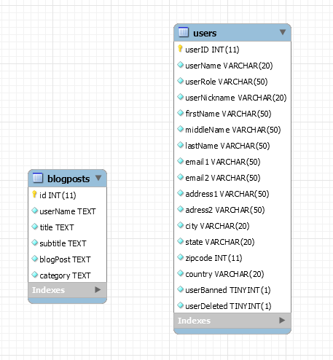

**DDL Scripts:**

[*https://github.com/SamanthaKrall/CST-126*](https://github.com/SamanthaKrall/CST-126)

**Sitemap Diagram:**

Admin Page

**User Interface Diagrams:**

*Future implementation*

**Other Documentation:**