**Database Application Programming**

**Project Status and Design Report**

|  |  |
| --- | --- |
| **Topic:** | *Milestone 8: Comment on and Rate a Blog Post* |
| **Date:** | *April 2019* |
| **Revision:** | *8.0* |
| **Team:** | *Samantha Krall* |
| **Team Status:** | |  | | --- | | **Task** | | *MySQL build necessary tables to store the information required during the blog commenting and rating process* | | *PHP write the functions that will enable the capturing of the new comment post and store in the database* | | *HTML build the minimally functional form to capture the new comment and rating* | | *PHP perform the necessary verification of compliance with constraints you decided upon* | |  | |
| **GIT URL:** | *https://github.com/SamanthaKrall/CST-126* |
| **Hosting URL:** | *https://portal.azure.com/#@mygcuedu6961.onmicrosoft.com/resource/subscriptions/74ab4d5e-49e5-4cd3-884b-12c354d4cd07/resourcegroups/CST-126/providers/Microsoft.Web/sites/CST-126/appServices* |

**Supporting Design Documentation**

**Install Instructions:**

*localhost:3306/milestone*

**General Technical Approach:**

*Constrain column width (80 characters or less, including spaces), Use headers and sub headers, Use font without squiggles, Large font size, Use a pleasant contrast between background color and text color so you can read the text easily*

**Key Technical Design Decisions:**

*Constrain column width (80 characters or less, including spaces), Use headers and sub headers, Use font without squiggles, Large font size, Use a pleasant contrast between background color and text color so you can read the text easily*

**ER Diagram:**

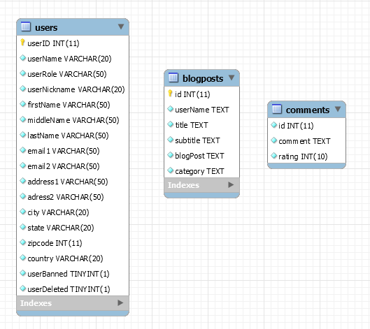

**DDL Scripts:**

[*https://github.com/SamanthaKrall/CST-126*](https://github.com/SamanthaKrall/CST-126)

**Sitemap Diagram:**

Admin Page

**User Interface Diagrams:**

*Future implementation*

**Other Documentation:**