Samantha Krall
CST-221
Producer and Consumer
April 2018

The first step that I took was to attempt to understand what the question was and research what I needed with C. The book had already gone over the problem of the producer and the consumer, and different situations that could allow for it. We are asked to not use semaphores or other synchronization methods but can use pthreads, sleep and wakeup commands.

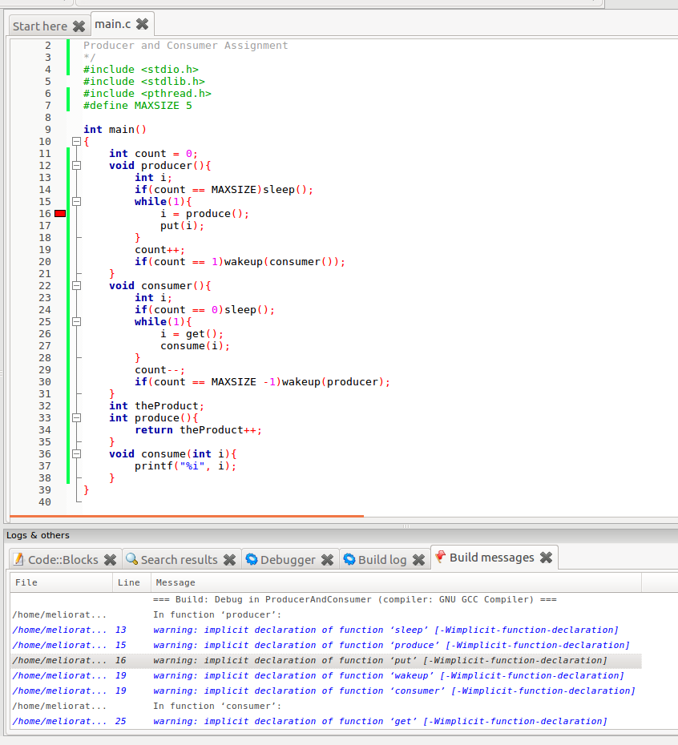
https://github.com/SamanthaKrall/CST-221

Resources:
https://viewer.gcu.edu/c8Hqea

