Samantha Krall
CST-235
Assignment 3
https://github.com/SamanthaKrall/CST-235
3A:
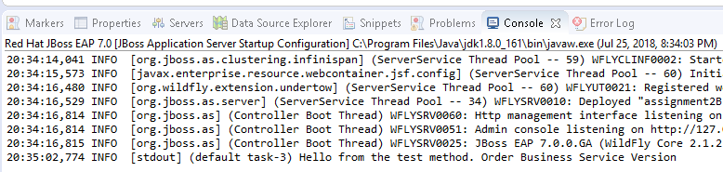
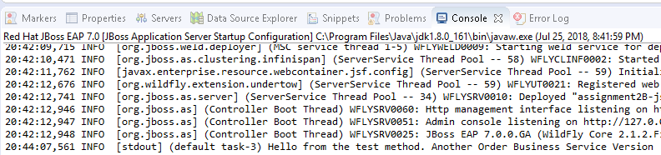
3B:
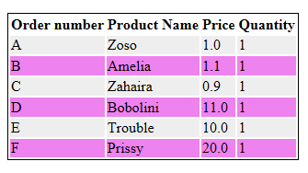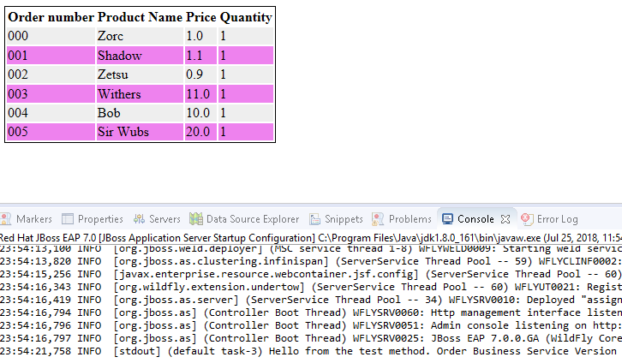
3C:
