My project proposal is for an animal shelter. The properties of the product would be what type of animal (cat, dog, or pocket pet), breed, name, color, age, known health issues, known behavioral issues (only pet, food aggression, no kids, etc), vet treatment history, intake date, available for adoption date, and adoption date.

Java III Application Programming
Project Status and Design Report
Topic: | CLC Project Milestone 1
Date: | July 2018
Revision: | 1.0
Team: | - Samantha Krall
GIT URL: | https://github.com/SamanthaKrall/CST-235

Design Documentation
General Technical Approach:
The first thing that I needed to do was decide what domain and products I would like to make the application manage. I decided to do one for an animal shelter where the products are the animals currently in possession of the shelter. From there, I needed to decide what all aspects would be needed to know for each animal and then approach the rest of the project requirements.
Key Technical Design Decisions:
The page would load to the login or register page, after which you could go into the animals. From there you could choose either cats, dogs, pocket pets or list all. Once on a page with animals, you can edit an existing animal record, add a new animal record or search.
Using:
RedHat JBoss
Eclipse

Known Issues:
Risks:

Risk | Details | Strategy for Risk  Avoidance | Strategy for Mitigation
Internet service failure | I will not be able to submit work on time due to an interruption in internet service | Work ahead on class assignments instead of wait until the last minute. Ensure that I have reliable internet service | Go someplace that has internet available to finish class work.
Unsure how to accomplish a specific coding task | Questions will not get answered immediately. Unsure how to go about task given | Work ahead on class assignments so that I am not struggling or if I am, I have the time available to get the help I need. | Submit questions with all the information, including source code and errors

ER Diagram:
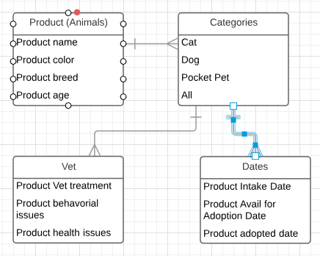
DDL Scripts:
https://github.com/SamanthaKrall/CST-235
Sitemap Diagram:

Login / Register
Animals
Edit
Create New
Cat / Dog / Pocket Pet/ List All

User Interface Diagrams:
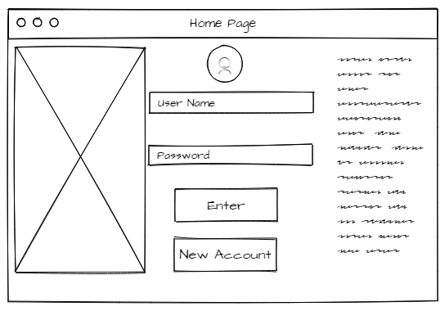
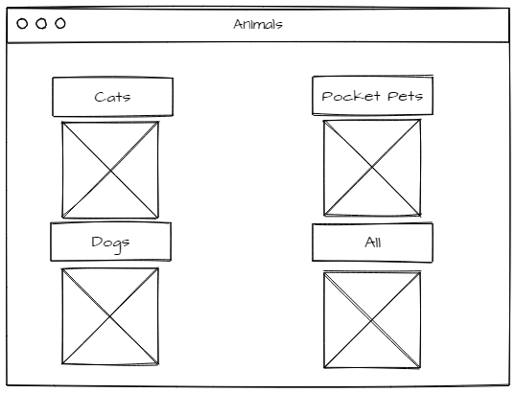
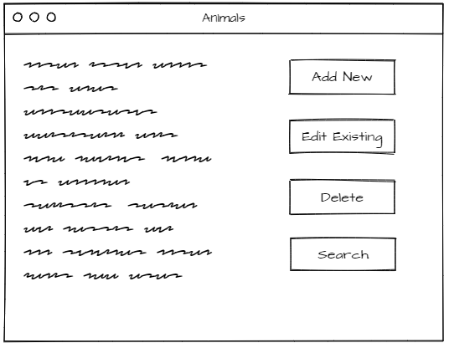
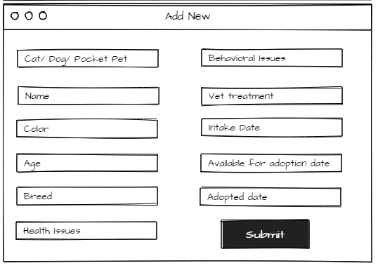
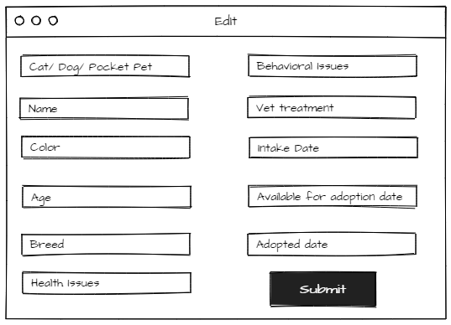
Class Diagrams:
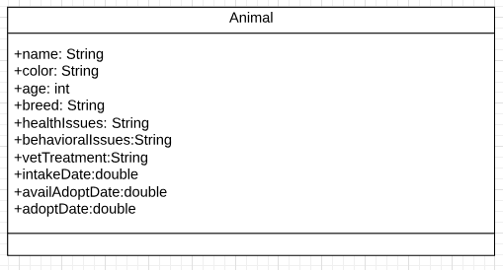
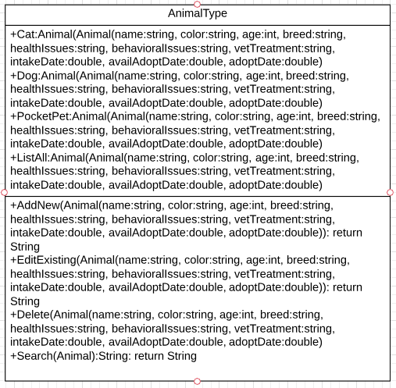
Service API Design:
Security Design:
Other Documentation:
