CST-361 Design Patterns in Java
Samantha Krall
Activity 8: Research Anti-Patterns and Best Practices
February 2019

Write Up:
Anti patterns are patterns that are similar to design patterns in the aspect that they document best solutions to common issues in specific context, but they differ in the aspect that their use or misuse produces negative consequences to the application. An anti pattern is a literary form that describes a commonly occurring solution to a problem that generates decidedly negative consequences. The anti pattern may be the result of a manager or developer not knowing any better, not having sufficient knowledge or experience in solving a particular type of problem, or having applied a perfectly good pattern in the wrong context.
Reinventing the wheel:
An anti pattern of frequent occurrence is the lack of knowing the existence of some useful frameworks/ libraries. A general rule is not trying to reinvent the wheel. Some people like to write their own code to do what a library has a way of doing already.
Cargo cult programming:
Cargo cult programming is a style of programming in which patterns and methods are used without understanding why. The term cargo cult originally referred to aboriginal religions which grew up in the South Pacific after World War II. The practices of these groups centered on building elaborate mock ups of airplanes and military landing strips in the hope of summoning the god like airplanes that had brought marvelous cargo during the war. Most of the time this way of programming is used by unskilled or inexperienced programmers that copy and paste code from somewhere else. Some examples include adding unnecessary comments to self explanatory code, adding deletion code for objects that garbage would have collected automatically with no problem or creating factories to build simple objects.
Inheritance hell:
Inheritance should be handled with care. It is very useful but you should only use it for what it is intended for. If the inheritance tree becomes too bloated, something is wrong. Do not write abstract classes for one specific case, use composition instead. For example, if your JSF managed bean “EditUserManagedBean” extends AbstractEditingManagedBean which extends AbstractSelectionManagedBean which extends AbstractParentDetailManagedBean which extends AbstractManagedBean you should know that something is wrong and there should be other ways to implement this behavior.
There are dozens of books and hundreds (perhaps more) of articles that provide insight into how Java EE applications should be written. There are so many resources, often with contradictory recommendations, that merely navigating this maze has itself become an obstacle to adopting Java EE.
Always use MVC:
Cleanly separate business logic (Java beans and EJB components) from controller logic (servlets/ Struts actions) from presentation (JSP, XML/ XSLT). Good layering can cover a multitude of sins. This practice is so central to the successful adoption of Java EE. MVC is fundamental to the design of good Java EE applications. There are a number of problems that can emerge from not following basic MVC architecture. The most problems occur from putting too much into the View portion of the architecture. Practices like using JSP tag libraries to perform database access, or performing application flow control within a JSP are relatively common small scale applications, but these can cause issues in later development as JSP’s become progressively more difficult to maintain and debug. It would be a shame to have to redevelop an applications core business logic every time the preferred user interface technology changes.
Don’t reinvent the wheel
I talked about this previously, as an anti pattern. It is a best practice to heed the advice of not reinventing the wheel as well. You should use common, proven frameworks and patterns.
Apply automated unit tests and test harnesses at every layer
You should not test your GUI only, layered testing makes debugging and maintenance vastly simpler. One of the advantages of the MVC architecture is that the componentization of the elements make it possible, and relatively easy, to test your application in pieces. Therefore, you can easily write tests to separately test persistence, session beans and portions of the user interface outside of the rest of the code base. Despite all of the great information about deeply testing your application, there are many projects out there where it is believed that if the GUI is tested, then the entire application has been comprehensively tested. With GUI testing, it is difficult to test every path through the system. There may be background jobs, scripts, and various other access points that also need to be tested that do not have GUI’s associated with them. Testing at the GUI level is very coarse grained. A GUI tests how the system behaves at the macro level of the system, meaning that if problems are found, entire subsystems must be considered, making finding any bugs identified extremely difficult. GUI testing can not be done well until late in the development cycle when the GUI is fully defined. This means that latent bugs will not be found systematically until very late.
Deliverables:
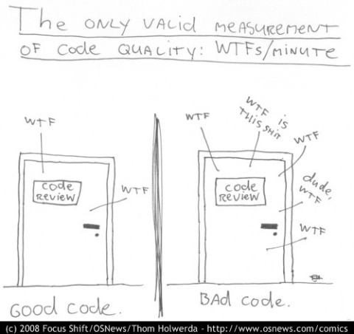
Sorry for the language in the comic, but I found it to pertain to the current topic.
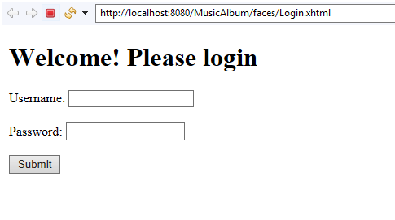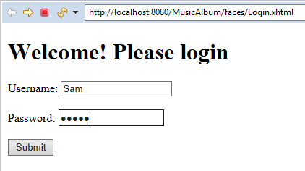


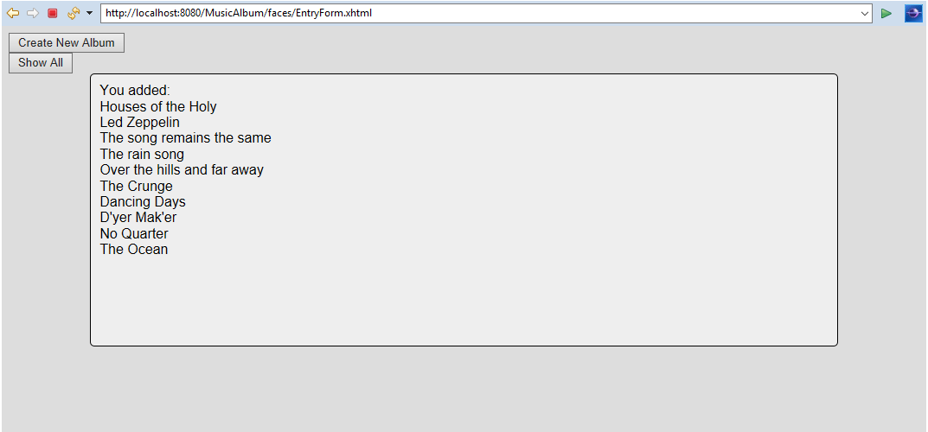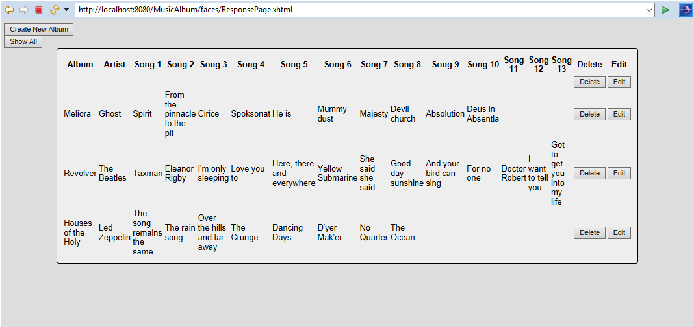
After hitting delete:
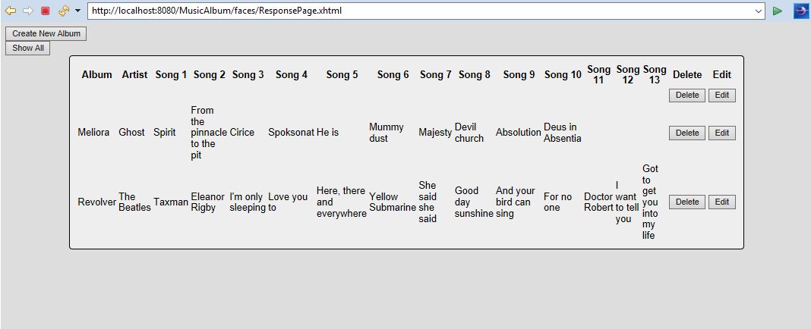

References:
https://www.oreilly.com/library/view/java-ee-7/9781782176428/ch10s02.html
https://www.javacodegeeks.com/2011/10/programming-antipatterns.html
https://www.ibm.com/developerworks/websphere/techjournal/0701_botzum/0701_botzum.html

