CST-361 Design Patterns in Java
Samantha Krall
Activity 9: Research Enterprise Roles
February 2019

Write up:
MVC divides an application into three distinct but collaborating components: the model manages the data of the application by applying business rules, the view is responsible for displaying the application data and presenting the control that allows the users to further interact with the system and the controller takes care of the mediation between the model and the view. MVC was first described in 1979 in a paper called “Applications Programming in Smalltalk-80: How to use Model-View-Controller. “ It was primarily devised as a strategy for separating user interface logic from business logic. It also suggests adding a layer of indirection to join and mediate between the presentation and business layer logic, known as the controller layer. Thus, MVC divides an application into three distinct but collaborating components. MVC provides guidelines for a clean separation of responsibilities in an application allowing for multiple views and controller to have the ability to work with the same model. Layered architecture is an extension of the MVC architecture. In the traditional MVC architecture, the data access or integration layer was assumed to be part of the business layer. However, in Java EE, it has been reclaimed as a separate layer since enterprise Java applications integrate and communicate with a variety of external information system for business data. Therefore, positioning integration services as a separate layer helps the business layer concentrate on its core function of executing business rules. The benefits of the loosely coupled layered Java EE architecture is since the implementation details are encapsulated within individual layers, they can be easily modified without deep impact on neighboring layers allowing for flexibility and ease of maintenance. Since each layer has its own defined roles and responsibilities, it is simpler to manage while still providing important services.
The Decorator pattern allows a user to add new functionality to an existing object without altering its structure. The decorator pattern is well known and frequently used. It is a structural pattern since the pattern acts as a wrapper to existing class, allowing modification of functionality of an object at runtime. It creates a decorator class which wraps the original class and provides dynamic additional functionality keeping class methods signature intact. The decorator design pattern is structurally similar to the chain of responsibility pattern, though in the chain of responsibility, exactly one of the classes handles the request while the decorator pattern has all the classes’ handles the request. It is often useful for adhering to the Single Responsibility Principle as it allows functionality to be divided between classes with unique areas of concern.
Application design can be immensely simplified by applying Java EE design patterns. Java EE design patterns have been documented in the famous book, “Design Patterns: Elements of Reusable Object-Oriented Software” also known as the Gang of Four (GOF) patterns. Design patterns describe reusable solutions to commonly occurring design problems. They are tested guidelines and best practices accumulated and documented by experienced developers and designers. A pattern has three main characteristics: the context is the surrounding condition under which the problem exists, the problem is the difficult and uncertain subject area in the domain and is limited by the context in which it is being considered, and the solution is the remedy for the problem under consideration. Every solution to a problem does not qualify as a pattern, the problem must be occurring frequently in order to have a reusable solution and to be considered as a pattern. Patterns must also establish a common vocabulary to communicate design solutions to developers and designers.
Deliverables:
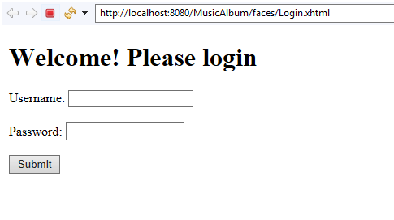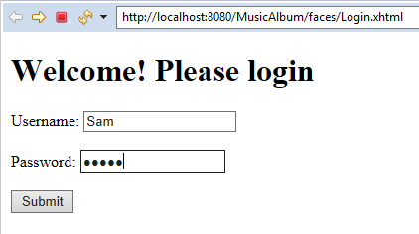

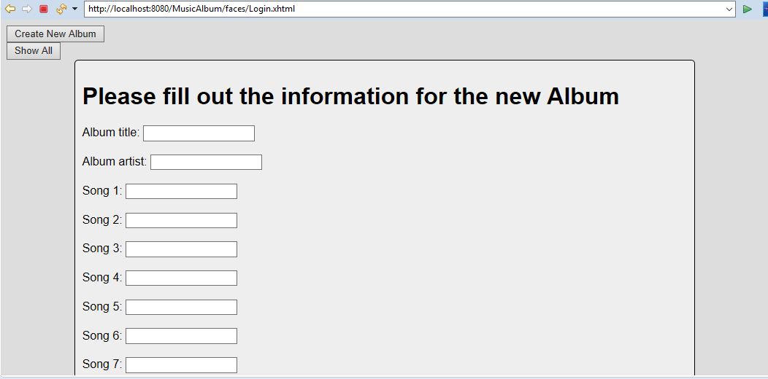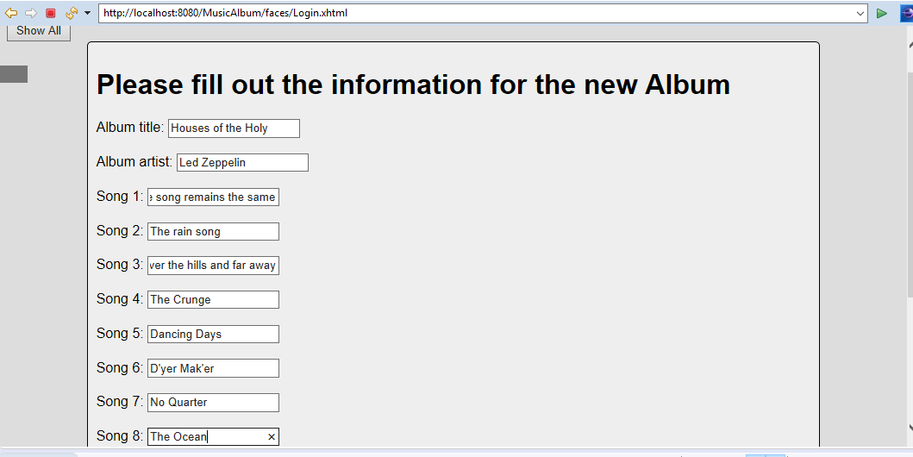
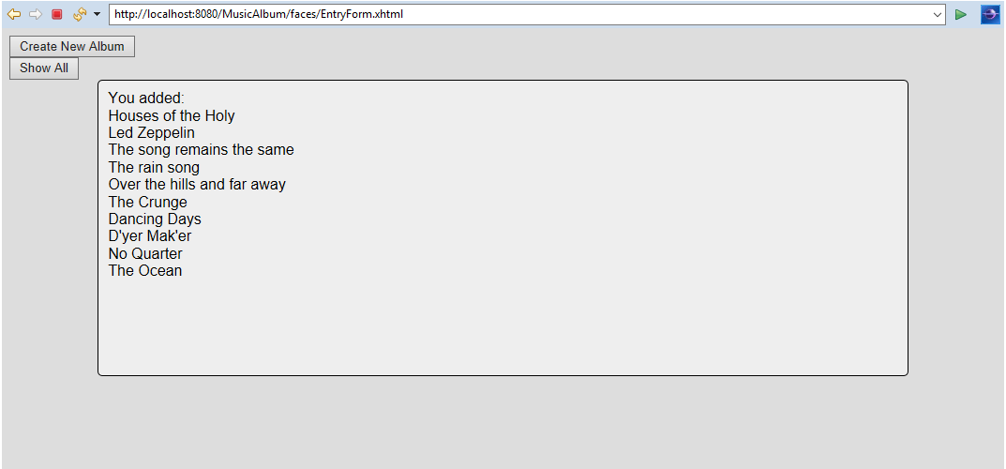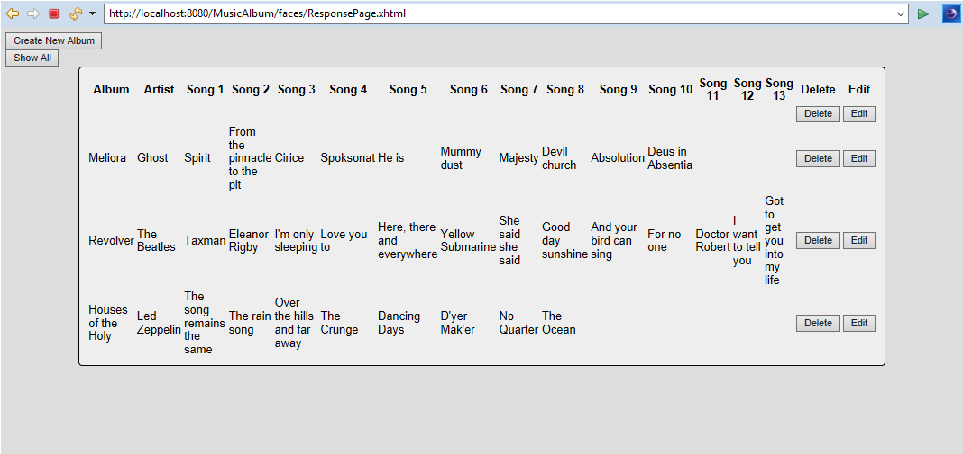
After hitting delete:
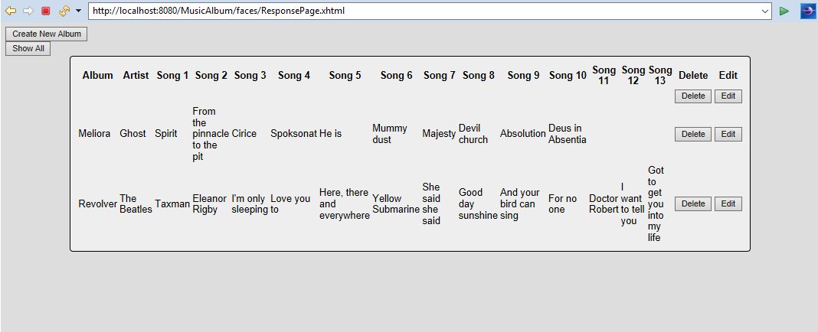
References:
https://www.developer.com/design/article.php/10925_3808106_3/Introducing-Enterprise-Java-Application-Architecture-and-Design.htm
https://www.tutorialspoint.com/design_pattern/decorator_pattern.htm

