CST-361 Design Patterns in Java
Samantha Krall
Activity 7A: Integration Layer Patterns
January 2019

Write up:
Context and Dependency Injection (CDI) for the Java EE platform is one of the features that help to knit together the web tier and the transactional tier of the Java EE platform. CDI is a set of services that make it easy for developers to use enterprise beans along with JavaServer Faces technology in a web application. Designed for use with stateful objects, CDI also has many broader uses, allowing developers a great deal of flexibility to integrate various kinds of components in a loosely coupled by typesafe way. Dependency Injection is a programming technique that makes a class independent of it’s dependencies by decoupling the usage of an object from its creation, ultimately improving the reusability of your code. Dependency Injection Design Pattern allows us to remove the hard coded dependencies and make our application loosely coupled, extendable and maintainable.

Deliverables:
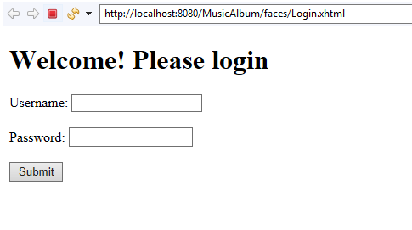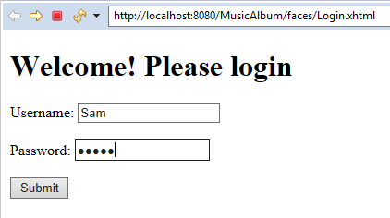

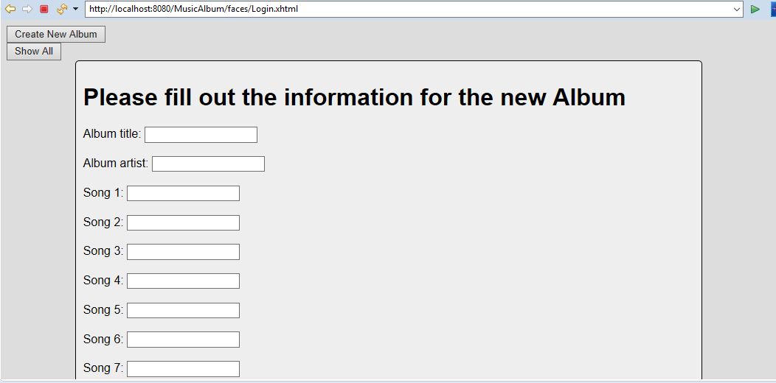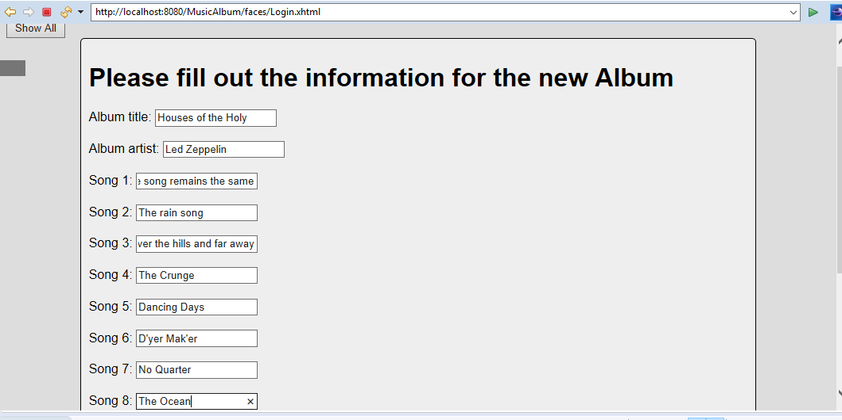
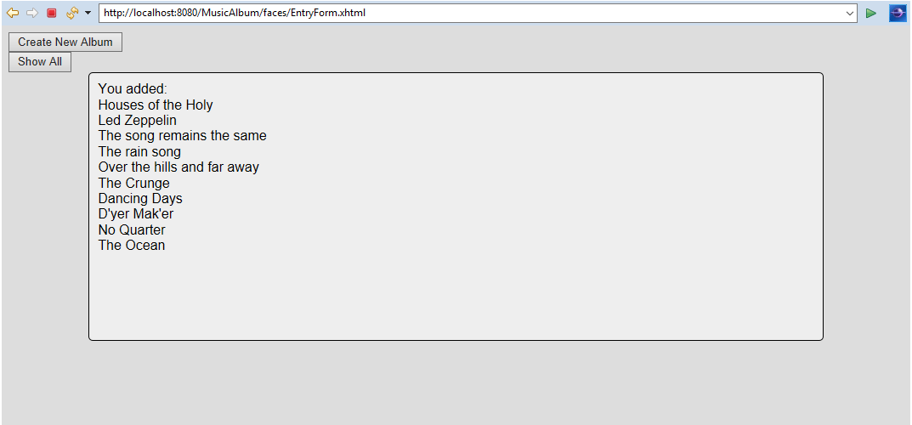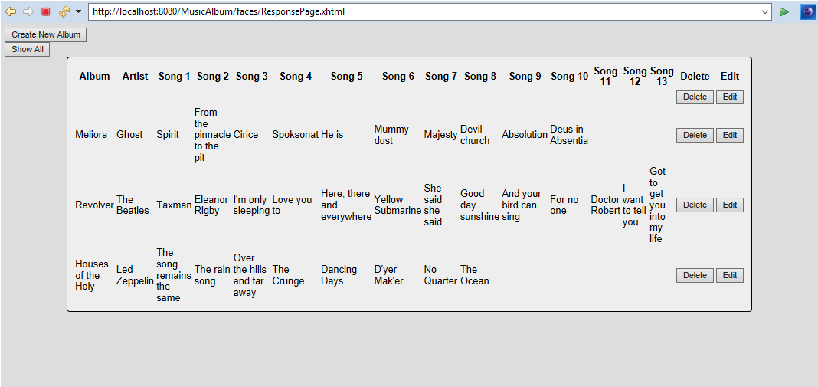
After hitting delete:
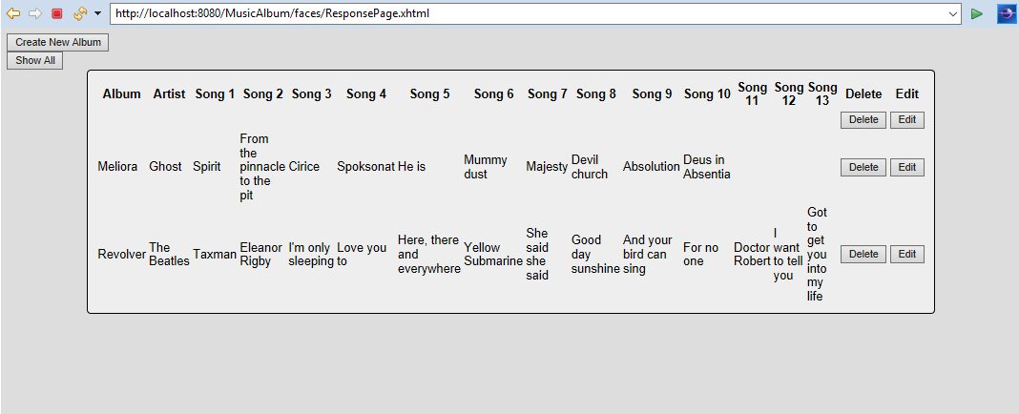

Resources:
https://docs.oracle.com/javaee/6/tutorial/doc/giwhb.html
https://www.journaldev.com/2394/java-dependency-injection-design-pattern-example-tutorial
https://stackify.com/dependency-injection/

