CST-361 Design Patterns in Java
Samantha Krall
Activity 7B: Integration Layer Patterns
February 2019

Write up:
The interceptor pattern is part of the Aspect orientated programming (AOP) paradigm which aims to add behavior to existing code to solve cross cutting concerns. Cross cutting concerns are non business related concerns, such as logging and security. They do not solve a business problem, but are nevertheless an important part of an applications makeup. The idea is that such concerns should not be addressed at the same time or in the same place as business concerns and should therefore be separate from the applications business logic. AOP relies on code injection to add the desired behavior or functionality to each point of an existing code base that is identified as a qualifying injection point. The interceptor pattern is one pattern that embraces AOP. It is also similar to the Decorator Pattern.
Deliverables:


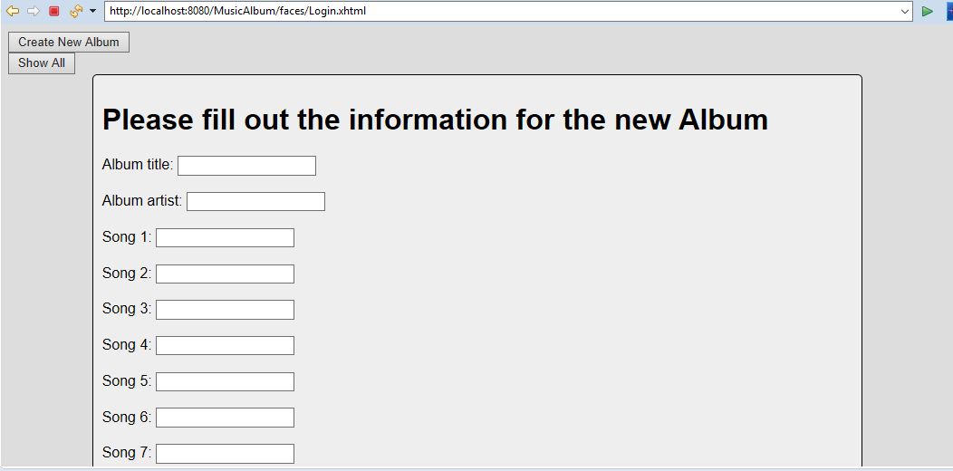
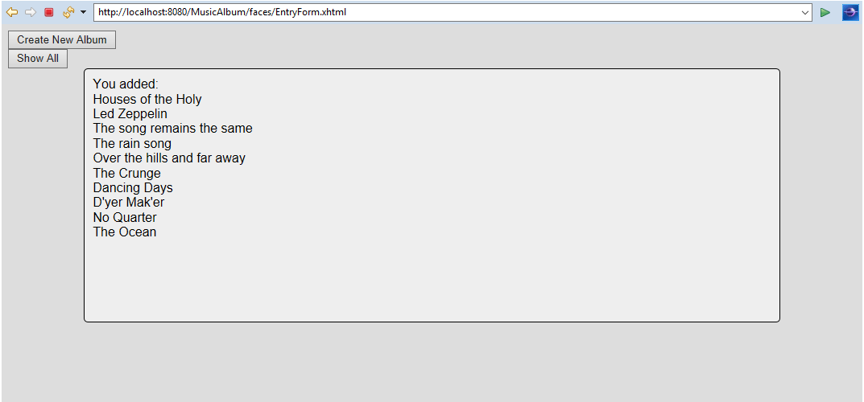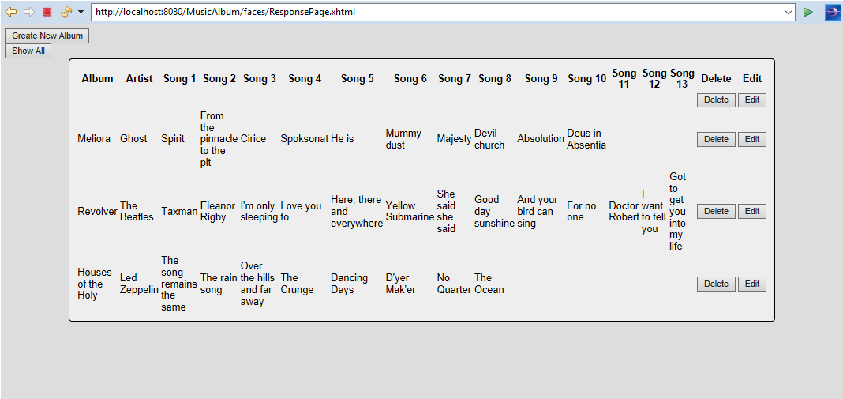
After hitting delete:
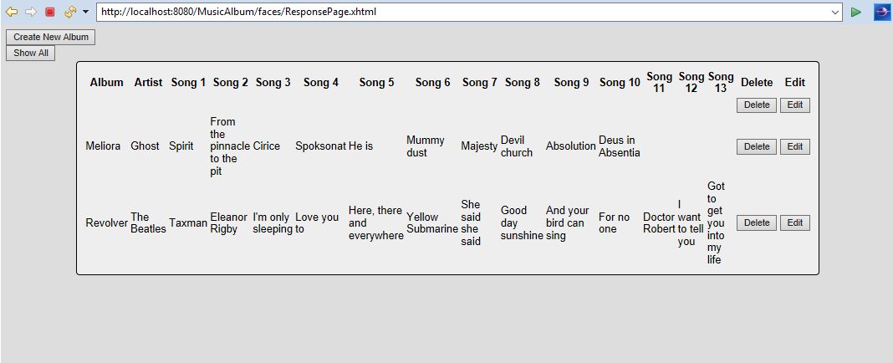

Resources:
https://www.lynda.com/Java-EE-tutorials/AOP-Interceptor-pattern/648935/732520-4.html

