CST-361 Design Patterns in Java
Samantha Krall
Activity 7C: Integration Layer Patterns
February 2019
☐ Research the Decorator Design Pattern. Describe, in 200-300 words and with UML diagrams, what this design pattern is used for, as well as how this design pattern could be implemented in a Java-based project. Include this write-up in your project report.

Write up:
The Singleton Pattern is a creational pattern as it provides one of the best ways to create an object. It involves a single class which is responsible to create an object while making sure that only single object gets created. This class provides a way to access its only object which can be accessed directly without need to instantiate the object of the class.
The Decorator pattern allows a user to add new functionality to an existing object without altering its structure. The decorator pattern is well known and frequently used. It is a structural pattern since the pattern acts as a wrapper to existing class, allowing modification of functionality of an object at runtime. It creates a decorator class which wraps the original class and provides dynamic additional functionality keeping class methods signature intact. The decorator design pattern is structurally similar to the chain of responsibility pattern, though in the chain of responsibility, exactly one of the classes handles the request while the decorator pattern has all the classes handles the request. It is often useful for adhering to the Single Responsibility Principle as it allows functionality to be divided between classes with unique areas of concern.
An example of implementation in Java would be to create a Shape interface and concrete classes implementing the Shape interface, and then create an abstract decorator class ShapeDecorator implementing the Shape interface and having Shape object as its instance variable. RedShapeDecorator is a concrete class that implements ShapeDecorator. DecoratorPatternDemo is the demo class that uses RedShapeDecorator to decorate Shape objects. The following UML diagram shows this example.
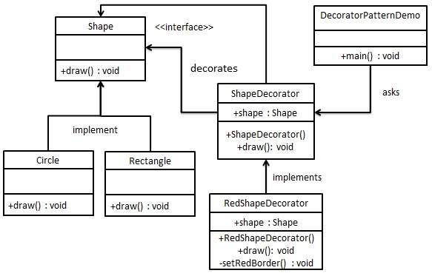

Deliverables:
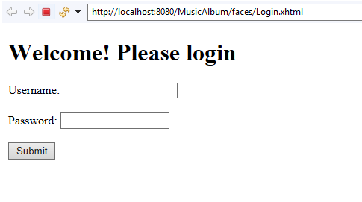

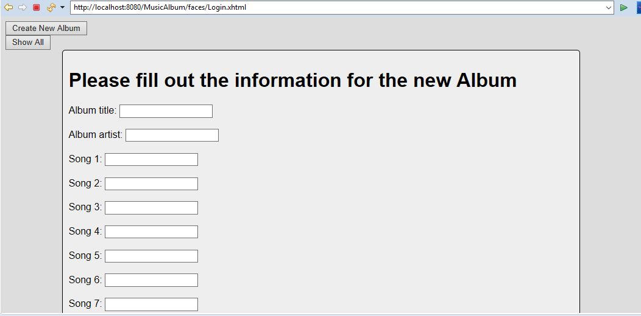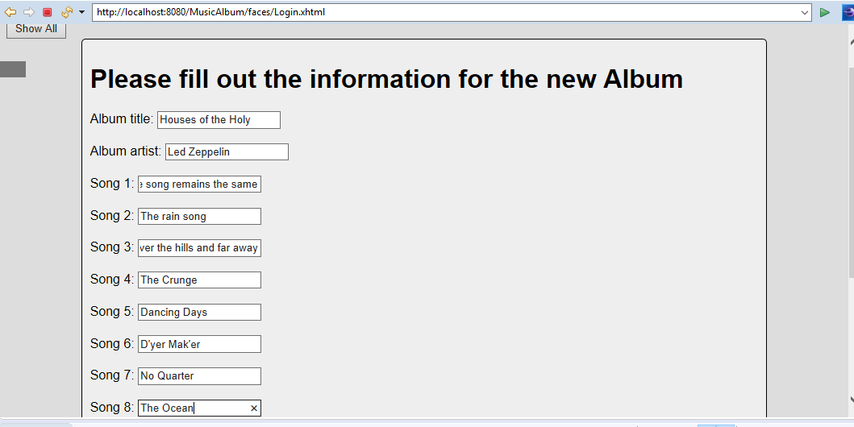
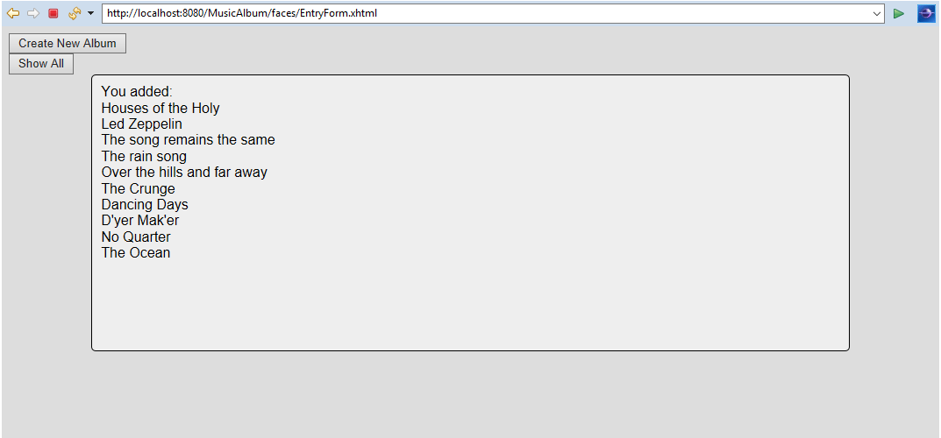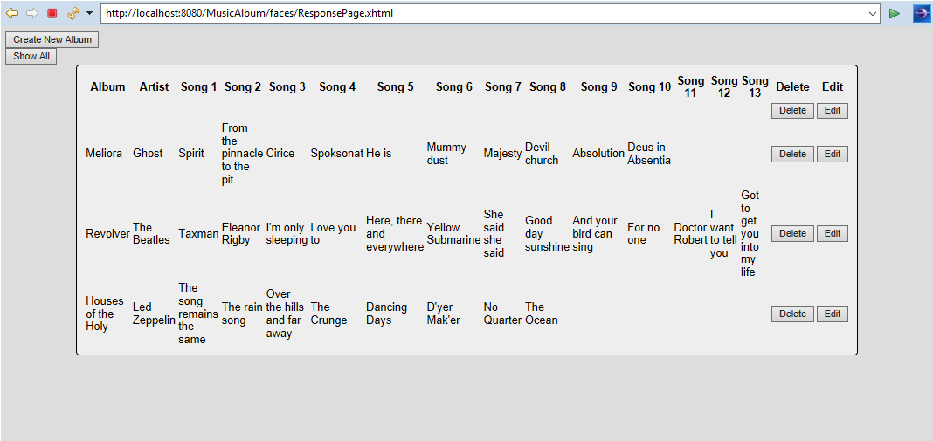
After hitting delete:
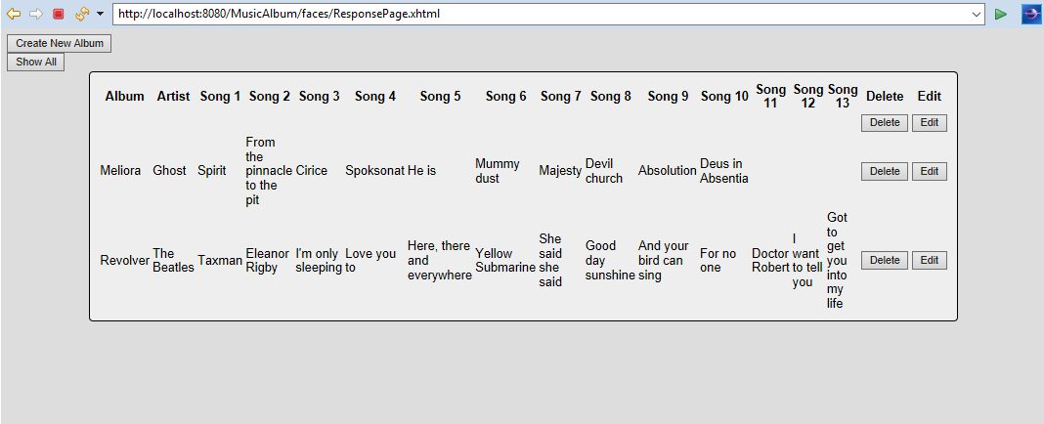

Resources:
https://www.tutorialspoint.com/design_pattern/singleton_pattern.htm
https://www.tutorialspoint.com/design_pattern/decorator_pattern.htm
https://dzone.com/articles/decorator-design-pattern-in-java
https://en.wikipedia.org/wiki/Decorator_pattern

