CST-361 Design Patterns in Java
Samantha Krall
Activity 6: REST API
January 2019
Write up:
The Transfer Object pattern is used when you want to pass data with multiple attributes in one shot from client to server. Transfer object is also known as Value Object. The Transfer Object is a simple POJO class having getter/ setter methods and is serializable so that it can be transferred over the network. It does not have any behavior. A server side business class normally fetches data from the database and fills the POJO and send it to the client or pass it by value. For client, transfer object is read only. The client can create its own transfer object and pass it to the server to update values in database in one shot. The entities of this design pattern are a business object (fills the transfer object with data), transfer object (simple POJO having getters and setters only), and the Client (either requests or sends the transfer object to the business object).
Deliverables:
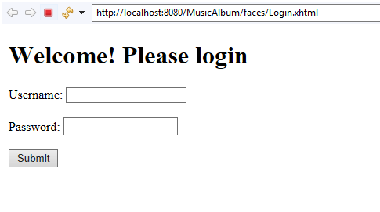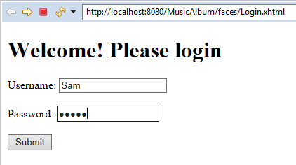
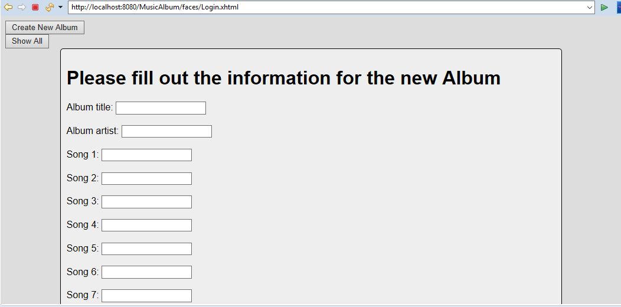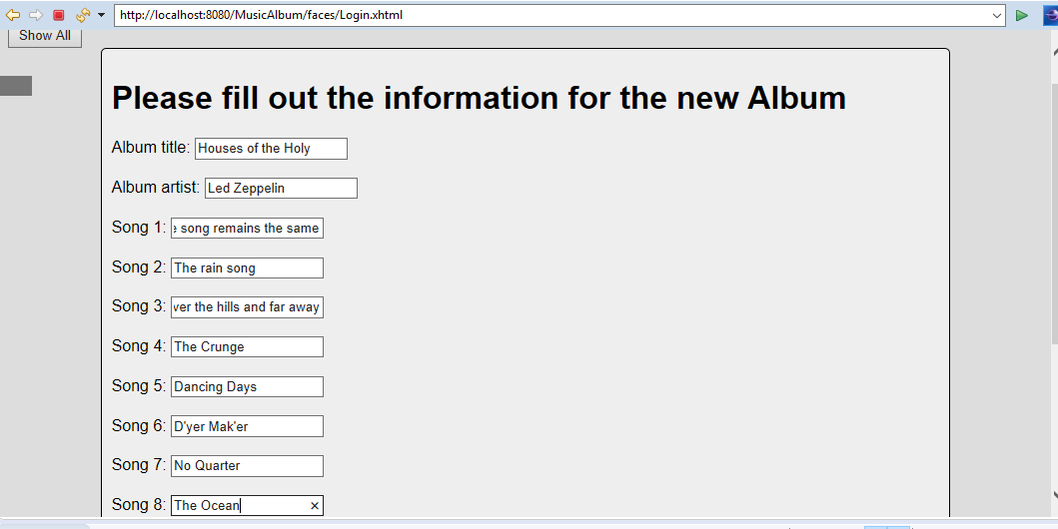
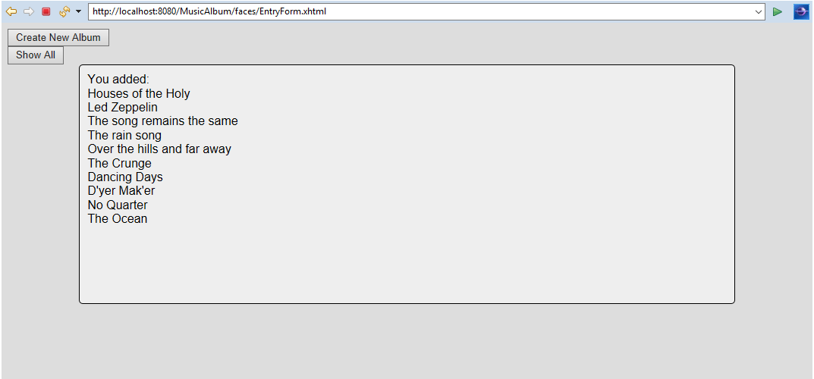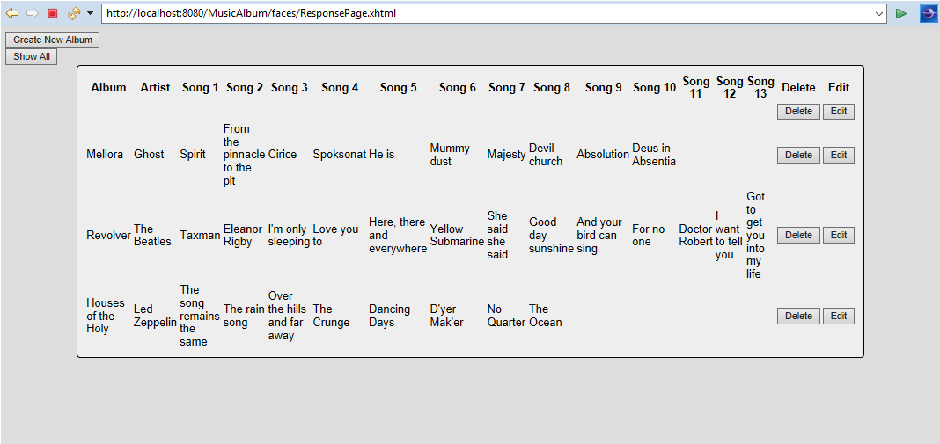
After hitting delete:
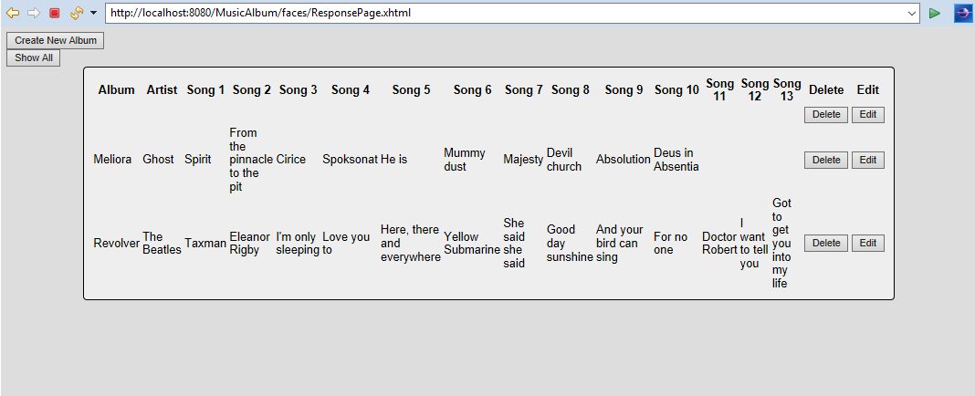
Album
+album:String
+artist:String
+song1:String
+song2:String
+song3:String
+song4:String
+song5:String
+song6:String
+song7:String
+song8:String
+song9:String
+song10:String
+song11:String
+song12:String
+song13:String
+Album()
+getters/setters for above variables
+Album(String, String, String, String, String, String, String, String, String, String, String, String, String, String, String)
Albums
+theList:ArrayList<Album>
+add(Album)
+printAll()
User
+name:String
+password:String
+getters/setters for name and password
+User()
+User(String, String)
AlbumRestService
+bs:BusinessServiceInterface
+getAllJson():List<Albums>
+getAllXml():Album[]

BusinessService
+db:DatabaseInterface
+deleteOne(String):int
+insertOne(Album):int
+readAll():ArrayList<Album>
+updateOne(String, Album):int
BusinessServiceInterface
+deleteOne(String):int
+insertOne(Album):int
+readAll():ArrayList<Album>
+updateOne(String, Album):int
FormController
+bs:BusinessServiceInterface
+onSubmit():String
+FormController()
+fetchAll():ArrayList<Albums>
+onDelete(Album):String
+onEdit(Album):String
+onSubmitEdit():String
+showEntryForm():String
+showIndex():String
+onLogin():String
DatabaseInterface
+deleteOne(String):int
+insertOne(Album):int
+readAll():ArrayList<Album>
+updateOne(String, Album):int

DatabaseService
+dbURL:String
+user:String
+password:String
+c:Connection
+pstmt:PreparedStatement
+stmt:Statement
+rs:ResultSet
+rowsAffected:int
+deleteOne(String):int
+insertOne(Album):int
+readAll():ArrayList<Album>
+updateOne(String, Album):int
UserDatabaseService
+dbURL:String
+user:String
+password:String
+c:Connection
+pstmt:PreparedStatement
+stmt:Statement
+rs:ResultSet
+rowsAffected:int
+numberOfRowsAffected:int
+deleteOne(String):int
+insertOne(User):int
+readAll():ArrayList<User>
+updateOne(String, User):int

Resources:
https://www.tutorialspoint.com/design_pattern/transfer_object_pattern.htm

