CST-361 Design Patterns in Java
Samantha Krall
Activity 4: Business Layers Patterns
January 2019

Write Up:
The façade pattern is used to shield/ abstract the client from the business process. It hides the complexities of the system and provides an interface to the client. This pattern is a structural pattern as it adds an interface to an existing system to hide its complexities. This pattern involves a single class which provides simplified methods required by client and delegates calls to methods of existing system classes. The Façade pattern is often used when a system is very complex or difficult to understand because the system has a large number of interdependent classes or its source code is unavailable. The pattern hides the complexities of the larger system and provides a simpler interface to the client. It typically involves a single wrapper class which contains a set of members required by client. These members access the system on behalf of the façade client and hide the implementation details.
Model View Controller (MVC) could have been used instead. The MVC pattern separates applications concerns into the model (which carries data), the view (which represents the visual aspects) and the controller (controls the data flow into model object and updates the view whenever data changes). MVC is an architectural pattern and mainly relates to the interaction layer of an application. The advantage of MVC is that multiple developers are able to simultaneously work on the model, view and controller.
Deliverables:
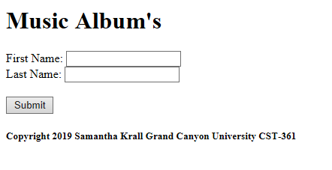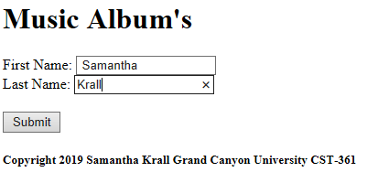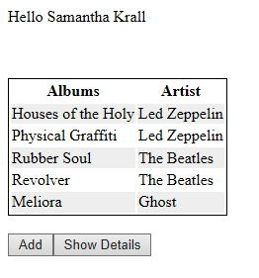
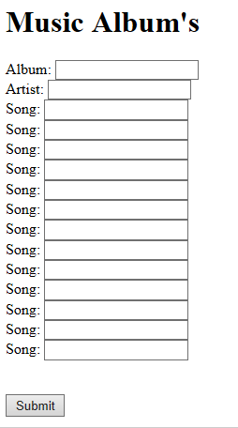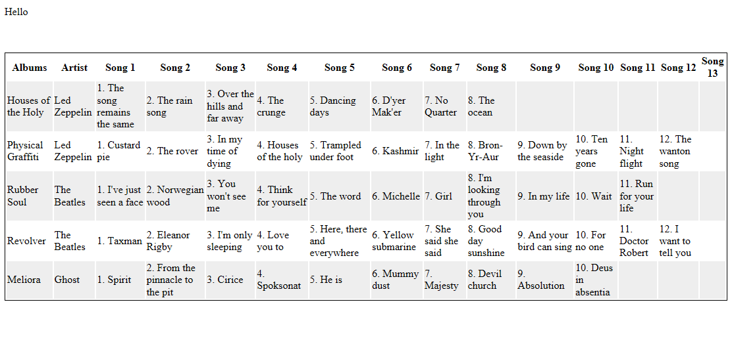
Retrieved from:
https://www.tutorialspoint.com/design_pattern/facade_pattern.htm
https://viewer.gcu.edu/f7fzvy
https://www.tutorialspoint.com/design_pattern/mvc_pattern.htm
http://jargon.js.org/_glossary/FACADE_PATTERN.md
https://www.geeksforgeeks.org/mvc-design-pattern/

