CST-361 Design Patterns in Java
Samantha Krall
Activity 5: Data Access Layer Patterns
January 2019

Write up:
The Data Access Object (DAO) pattern is a structural pattern that allows isolation of the application/ business layer from the persistence layer using an abstract API. The functionality of the API is to hide from the application all of the complexities involved in performing CRUD operations in the underlying storage mechanism. This permits both layers to evolve separately without knowing anything about one another. The DAO needs a data access object interface (defining the standard operations to be performed in a model object(s)), data access object concrete class (implementing the DAO interface and responsible to get data from a data source), and a model object or value object (simple POJO containing getters/ setters to store data retrieved using DAO class).
Deliverables:
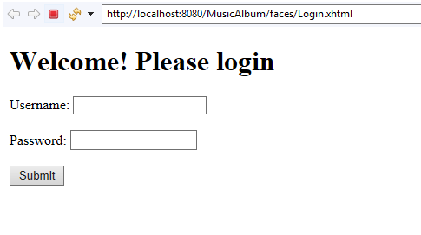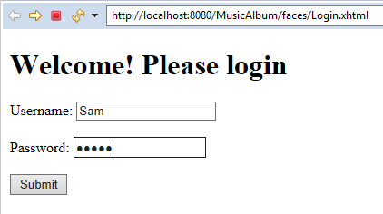
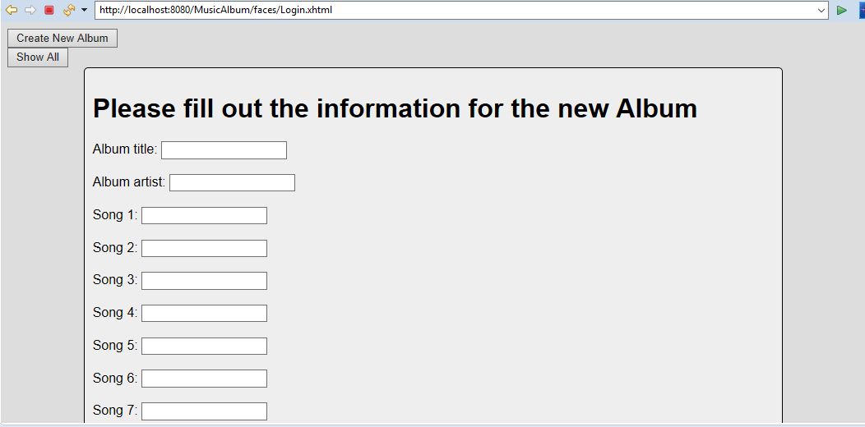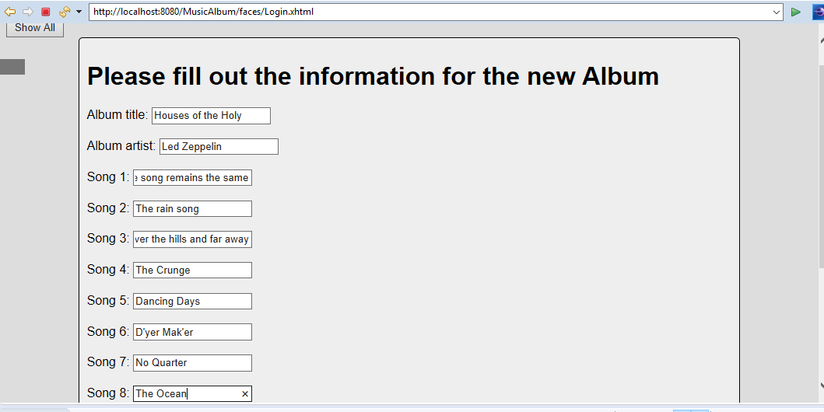
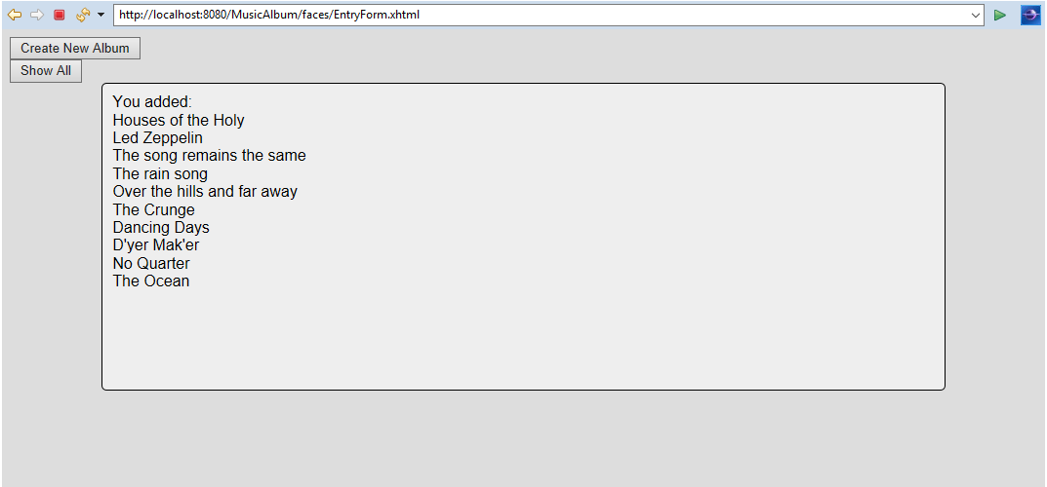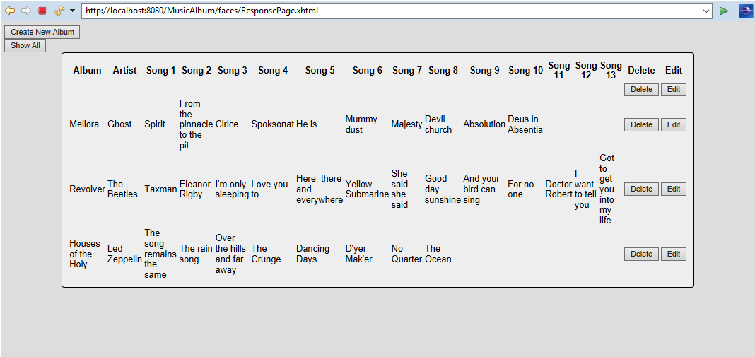
After hitting delete:
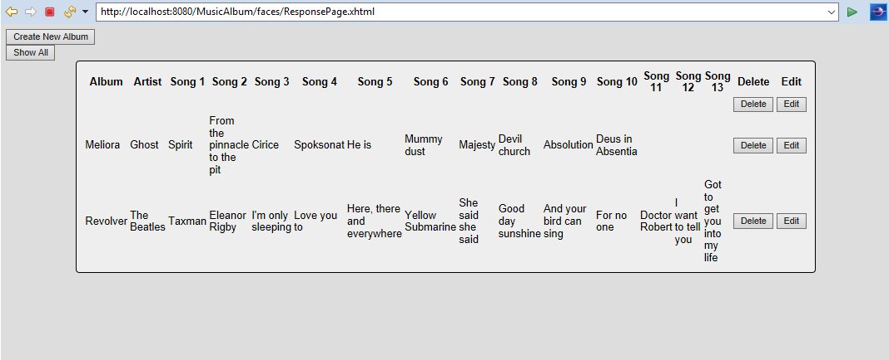
ER diagram:
Album
+album:String
+artist:String
+song1:String
+song2:String
+song3:String
+song4:String
+song5:String
+song6:String
+song7:String
+song8:String
+song9:String
+song10:String
+song11:String
+song12:String
+song13:String
+Album()
+getAlbum():String
+setAlbum(String)
+getArtist():String
+setArtist(String)
+getSong1():String
+setSong1(String)
+getSong2():String
+setSong2(String)
+getSong3():String
+setSong3(String)
+getSong4():String
+setSong4(String)
+getSong5():String
+setSong5(String)
+getSong6():String
+setSong6(String)
+getSong7():String
+setSong7(String)
+getSong8():String
+setSong8(String)
+getSong9():String
+setSong9(String)
+getSong10():String
+setSong10(String)
+getSong11():String
+setSong11(String)
+getSong12():String
+setSong12(String)
+getSong13():String
+setSong13(String)
+Album(String, String, String, String, String, String, String, String, String, String, String, String, String, String, String)

Resources:
https://www.baeldung.com/java-dao-pattern

