CST-361 Design Patterns in Java
Samantha Krall
Activity 3: Presentation Layer Patterns
December 2018

Write Up:
The model view controller (MVC) design pattern was used in this project. MVC is an architectural pattern that is commonly used for developing user interfaces that divides an application into three interconnected parts: model, view and controller. The idea is to separate the different concerns. Model View ViewModel (MVVM) or Model View Presenter (MVP) could have been used as well. The key differences between these design patterns is the derivatives on the dependency of each layer has on other layers as well as how tightly bound they are to one another. MVVM facilitates a separation of development of the graphical user interface (GUI) from development of the business logic. In MVP, the presenter assumes the functionality of the presentation logic.
Deliverables:
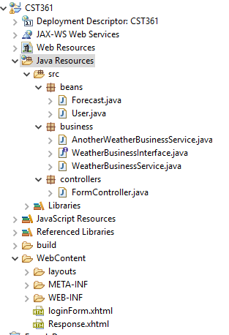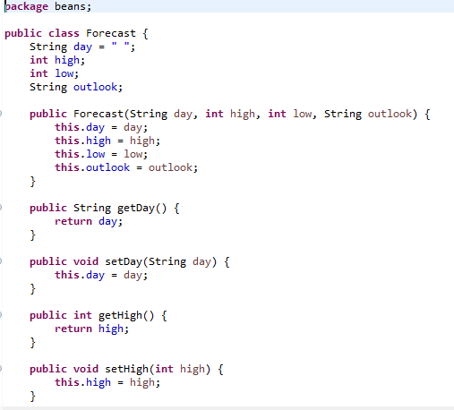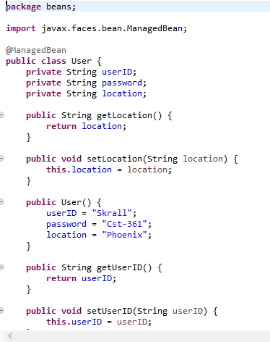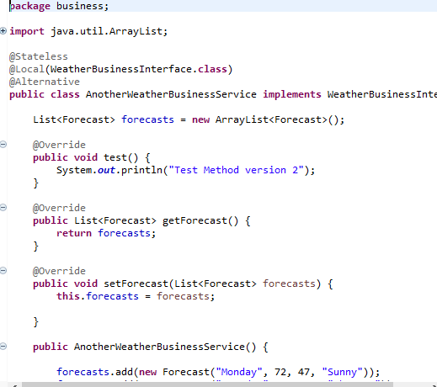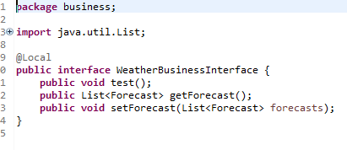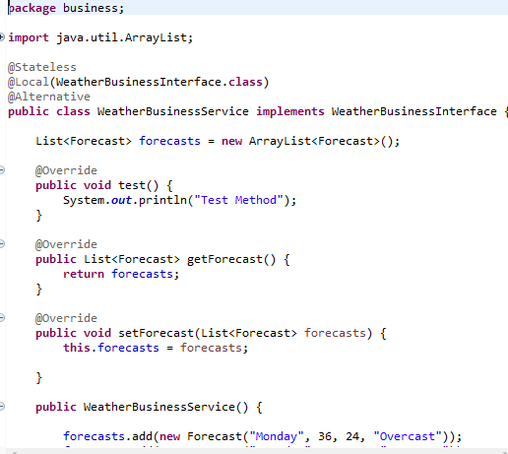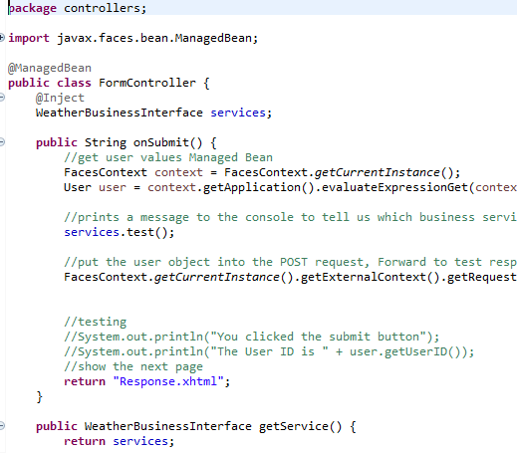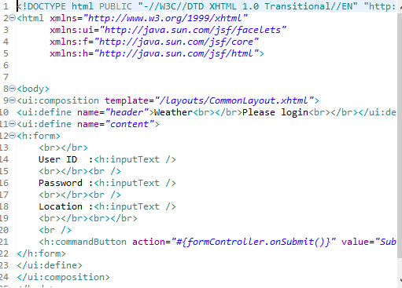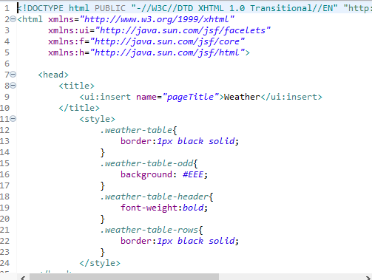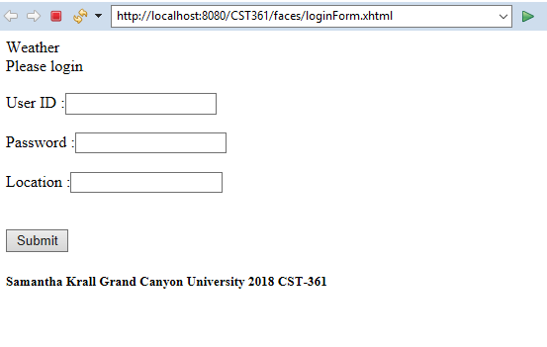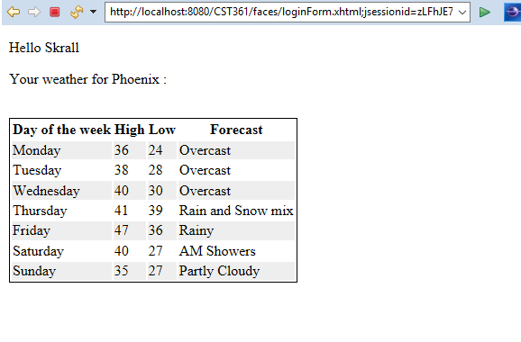

Resources:

https://en.wikipedia.org/wiki/Model%E2%80%93view%E2%80%93presenter
https://en.wikipedia.org/wiki/Model%E2%80%93view%E2%80%93viewmodel
https://en.wikipedia.org/wiki/Model%E2%80%93view%E2%80%93controller

