Deltek Maconomy Cloud 2.x

Update Sites

October 11, 2017

While Deltek has attempted to verify that the information in this document is accurate and complete, some typographical or technical errors may exist. The recipient of this document is solely responsible for all decisions relating to or use of the information provided herein.

The information contained in this publication is effective as of the publication date below and is subject to change without notice.

This publication contains proprietary information that is protected by copyright. All rights are reserved. No part of this document may be reproduced or transmitted in any form or by any means, electronic or mechanical, or translated into another language, without the prior written consent of Deltek, Inc.

This edition published October 2017.

© 2017 Deltek, Inc.

Deltek’s software is also protected by copyright law and constitutes valuable confidential and proprietary information of Deltek, Inc. and its licensors. The Deltek software, and all related documentation, is provided for use only in accordance with the terms of the license agreement. Unauthorized reproduction or distribution of the program or any portion thereof could result in severe civil or criminal penalties.

All trademarks are the property of their respective owners.

Contents

Update Sites 3

Update Sites Process 3

# Update Sites

Update Sites are used to automatically update the Maconomy Workspace Client when your Production environment is upgraded. An update is automatically applied the first time users open their Workspace Client following an upgrade.

The Workspace Client (WSC) is available for both Windows and for Macintosh users. The TPU package contains one WSC packaged into a Windows-installable package (.MSI), and one packaged into a Macintosh-installable package (.DMG). The WSC is also available in compressed packages (ZIP).

**Prerequisite:** It is recommended that installations of the Workspace Client on Windows platforms be performed using the ZIP packages and not the MSI installer. Please be aware that if the Workspace Client was installed using the MSI installer or Mac DMG installer, it will not update automatically for all upgrades. Workspace Client upgrades where the embedded Java is changed will only update automatically if installed using the zip packages.

Update Sites are going to be enabled in your Production environment and Preview environment, where one has been provided (Preview environments are provided for major upgrades). For users who need access to multiple environments (Non-Production, Preview and Production), it is recommended that one Workspace Client is installed for Production access only and one Workspace Client for Preview access only. These Workspace Clients will automatically update. A minimum of one other Workspace Client should be installed for the other Non-Production environments. When Non-Production environments are upgraded the new version of the Workspace Client should be downloaded from the link provided by Deltek and installed manually.

When the Update Sites are enabled it may update your users Workspace Clients when they go to login. This will only occur if users are not using the latest compatible version. An update package will average 60-70MB per download. There is no downtime associated with this process.

|  |  |
| --- | --- |
| note.jpg | Windows access rights management may prevent automatic updates from being successful if the Workspace Client was originally installed using the MSI installer or the Mac DMG installer. For this reason Deltek recommends that installations of the Workspace Client on Windows platforms be performed using the ZIP packages. ZIP packages need to install the Workspace Client to an unzipped read/write directory/folder. |

### Update Sites Process

When a Production upgrade has completed or a Preview environment provided, the Workspace Client automatically updates to the new version when a user opens the Workspace Client and connects.

1. Open the Workspace Client to start the update:

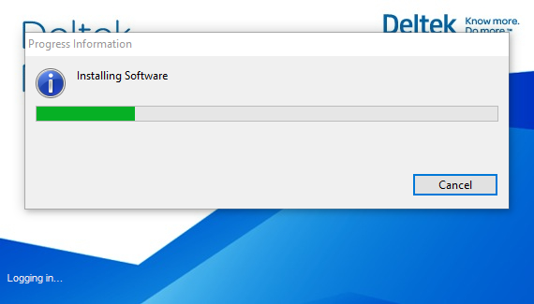

1. If you have a firewall in place, you may receive a warning message:

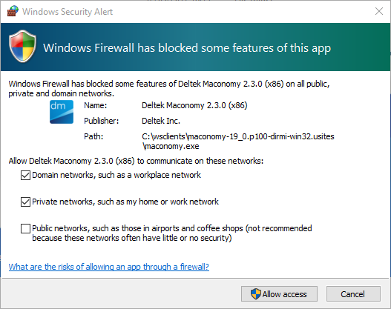

1. Select **Domain networks** and **Private networks**,and click **Allow Access**.

Once the Workspace Client is updated, you will receive the following message:

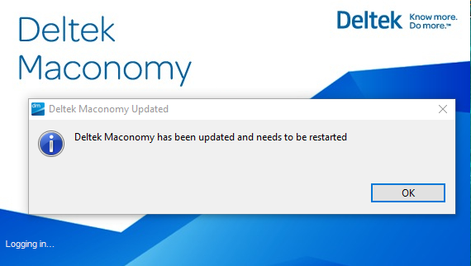

1. Restart the Workspace Client and continue to login.

|  |  |
| --- | --- |
| note.jpg | If network connection is lost during the Update process the Update Site will resume once connection is re-established. |