END SEMESTER PRACTICAL EXAMINATION
NAME: SAMANTHA NYATICHI MASAKI
ADM: 670455

Part A: Data Acquisition and Understanding (10 Marks)
1. Domain and Business Problem
- Domain: Hospitality and Restaurant Analytics.
- Business Problem: The restaurant lacks visibility into its transactional data, making it difficult to optimize menu offerings and track revenue. The objective is to analyze historical transactions to identify top-performing product categories, track revenue trends over time, and evaluate payment method preferences to improve operational efficiency.
2. Dataset Source The dataset is sourced from Kaggle and is titled "Restaurant Sales". Specifically, it is the "Restaurant Sales Dataset with Dirt", which introduces realistic inconsistencies to simulate real-world data environments.
3. Key Tables and Fields The raw dataset is initially a flat file that is logically split into two main tables for preparation:
- Order Table: Contains transaction-level summary data. Key fields include Order ID, Order Total, Order Date, and Payment Method.
- Customer Table: Contains line-item details for each order. Key fields include Customer ID, Category, Item, Price, Quantity, and Order ID.
4. Suitability for Advanced Power BI Analysis
This dataset meets all the requirements for an advanced analytical solution:
- Volume: It contains 17,534 transactional rows, easily exceeding the 9,000-row minimum requirement.
- Complexity: It includes a mix of categorical fields (Category, Payment Method) and numerical fields (Price, Quantity, Order Total) .
- Time Intelligence: It includes an 'Order Date' field, enabling calendar table creation and time-based DAX calculations .
- Transformation Needs: The "dirt" in the data (missing values, inconsistent text) requires substantial Power Query cleaning steps .
- Relational Modeling: The fields allow for normalization into a robust star schema consisting of a central Fact table and multiple dimension tables (Dim_Customer, Dim_Product, Dim_PaymentMethod, Dim_Date)
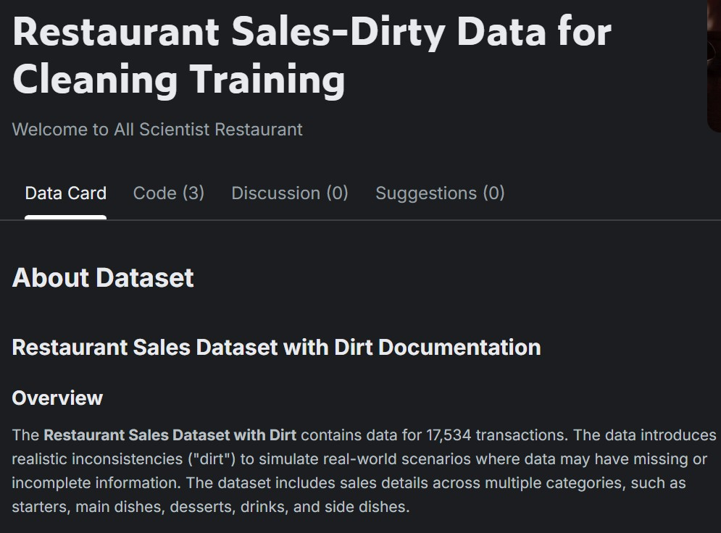
Details about the dataset can be found in the following image:

Columns Description

Column Name
Description Example Values

Order ID A unique identifier for each order. ORD_123456

Column Name

Description Example Values

Customer ID A unique identifier for each customer. CUST_001

Category The category of the purchased item. Main Dishes, Drinks

Item The name of the purchased item. May contain missing values due to data dirt.
Grilled Chicken, None

Price The static price of the item. May contain missing values. 15.0, None Quantity The quantity of the purchased item. May contain missing values. 1, None

Order Total The total price for the order (Price × Quantity). May contain missing values.
45.0, None

Order Date The date when the order was placed. Always present. 2022-01-15

Payment Method
The payment method used for the transaction. May contain missing values.
Cash, None

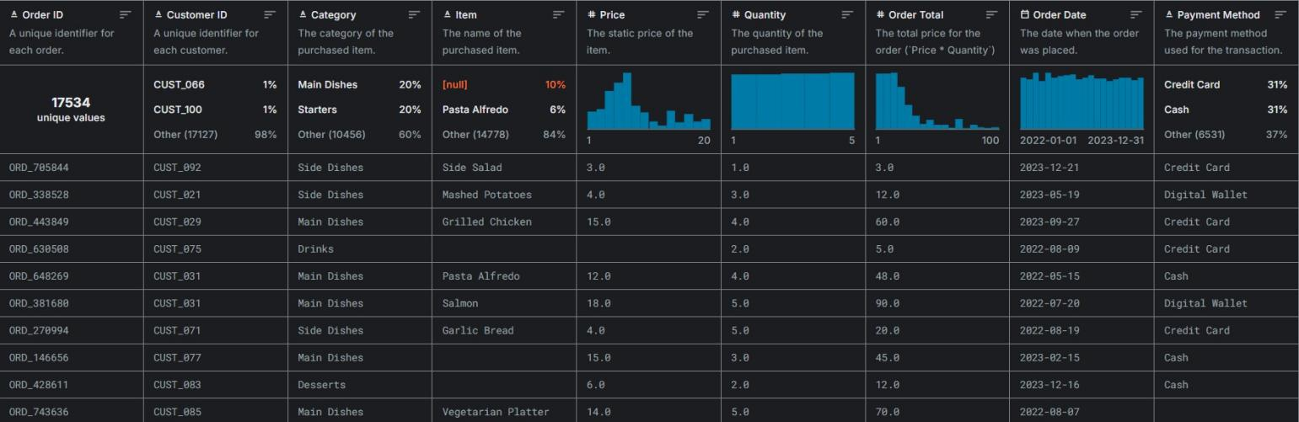
A sample of the dataset is shown below:

To obtain multiple tables, I split the dataset into two tables: Order Table and Customer Table.

import pandas as pd import numpy as np

# Load the dataset
data = pd.read_csv('restaurant_sales_data.csv')

# Splitting the data table1 = data[
['Order ID', 'Order Total', 'Order Date', 'Payment Method']
]

table2 = data[
['Customer ID', 'Category', 'Item', 'Price', 'Quantity', 'Order ID']
]

# Save the tables to new CSV files
table1.to_csv('Order Table.csv', index=False)
table2.to_csv('Customer Table.csv', index=False)
The Order Table contains the following columns: 'Order ID', 'Order Total', 'Order Date', 'Payment Method'
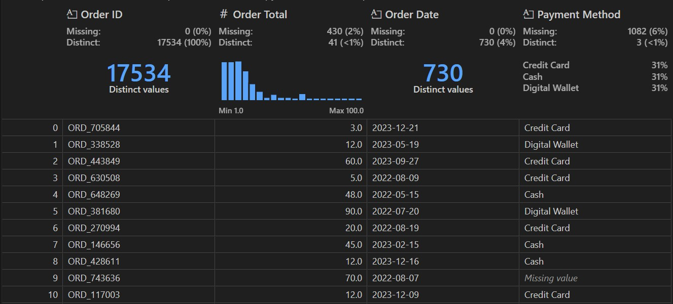

The Customer Table contains the following columns: 'Customer ID', 'Category', 'Item', 'Price', 'Quantity', 'Order ID'
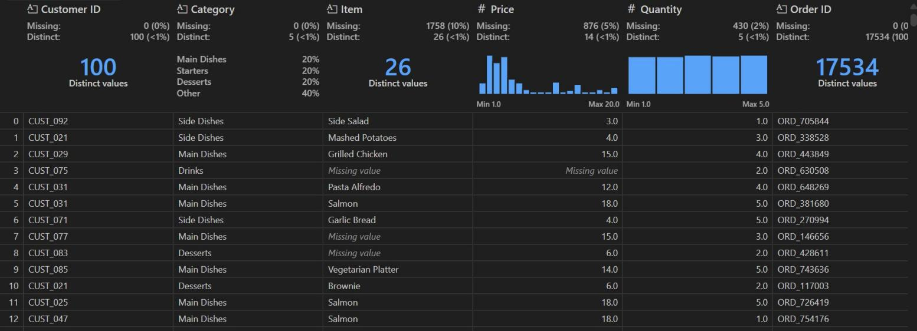

Part B: Data Cleaning and Transformation in Power Query (20 Marks)

Loading the data in Power BI
Loading process of the Customer Table
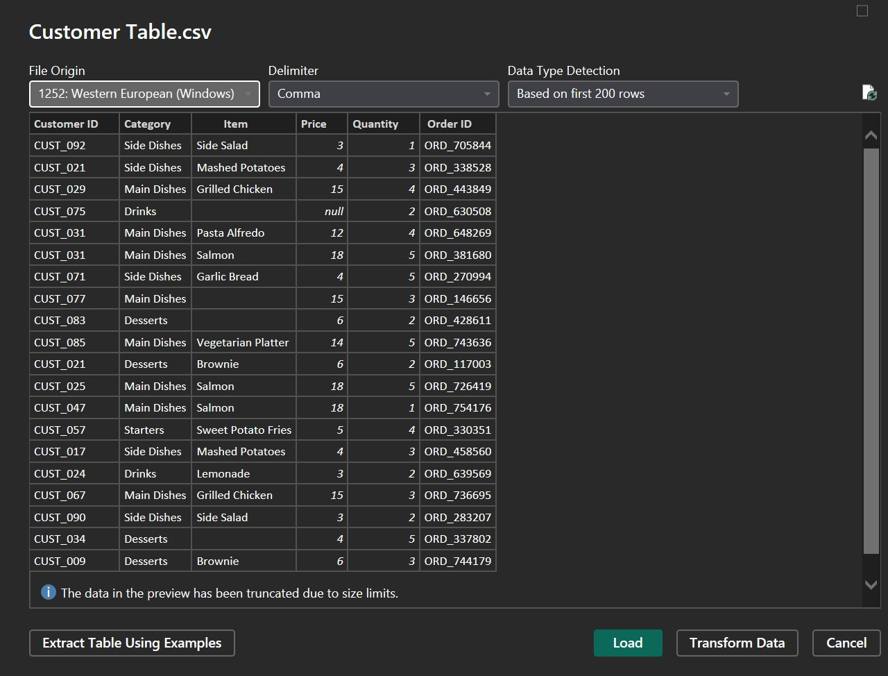
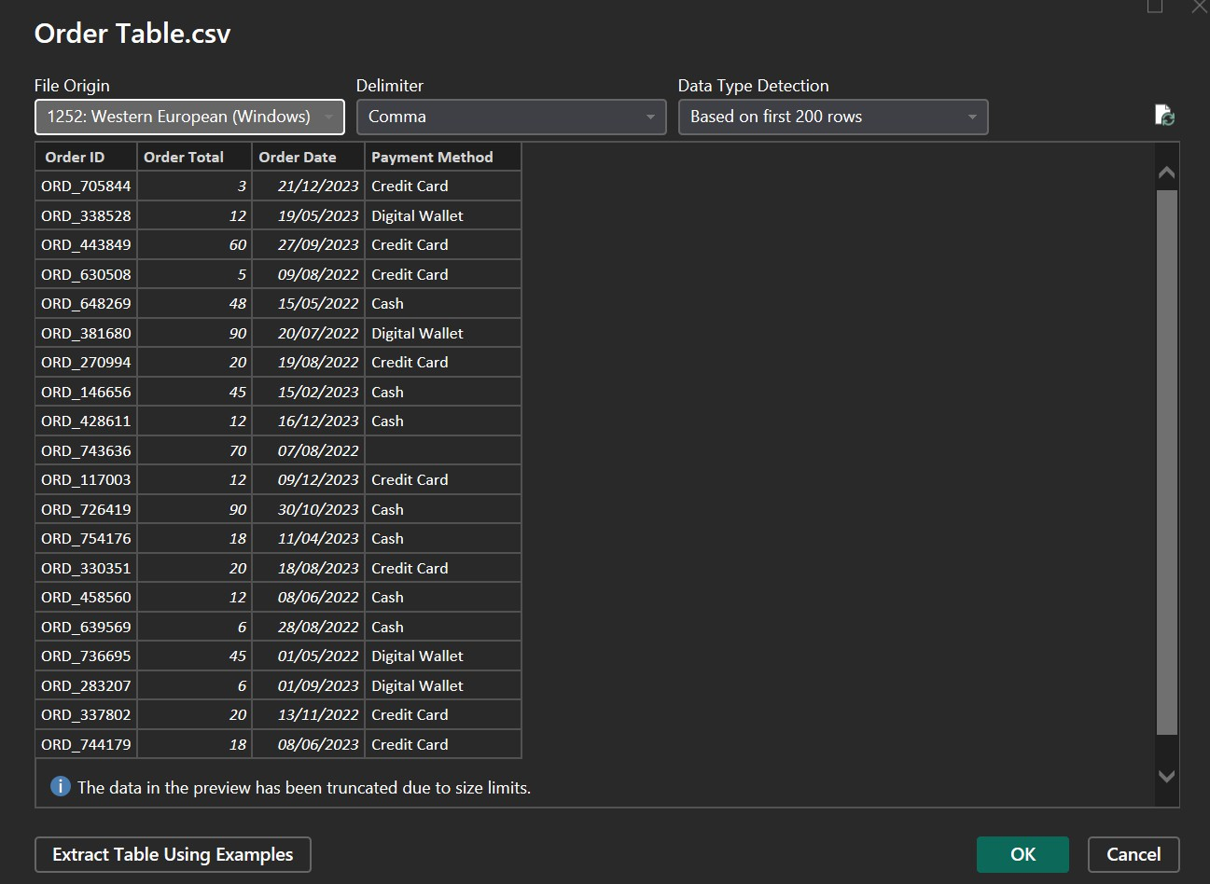
Loading process of the Order Table

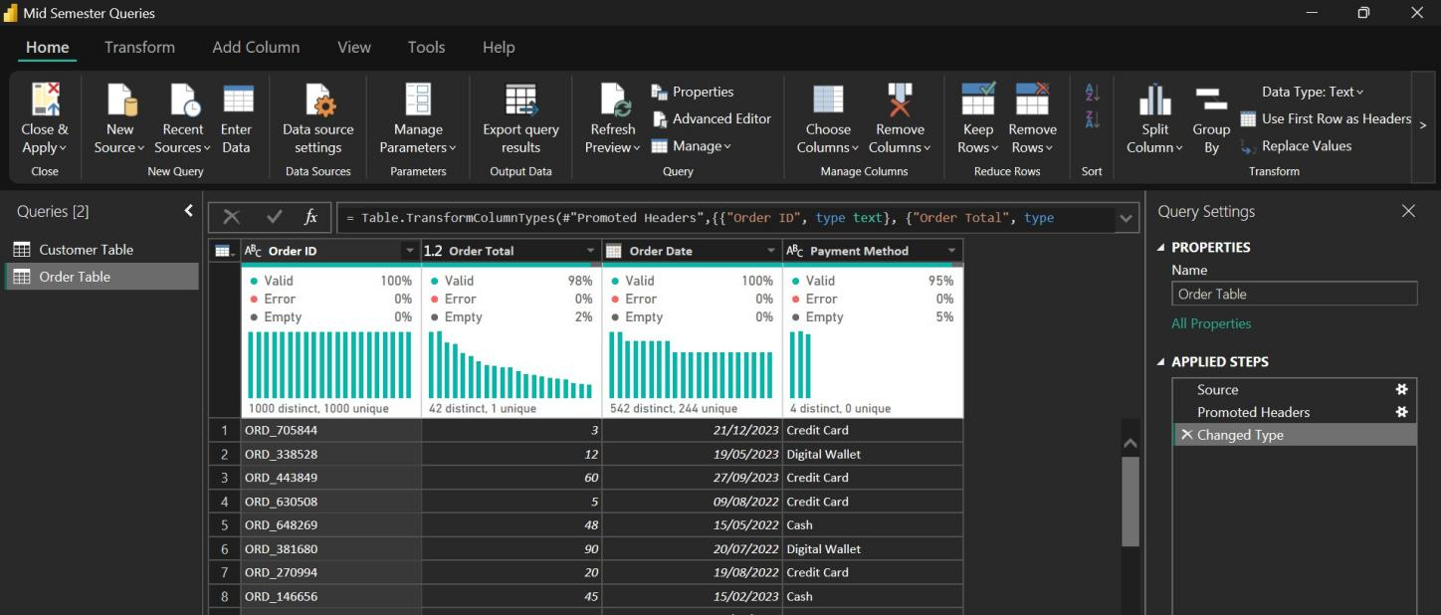
Power Query Editor after loading the tables

Data Cleaning and Transformation
Removing duplicates in the Customer Table
Handling missing or null values
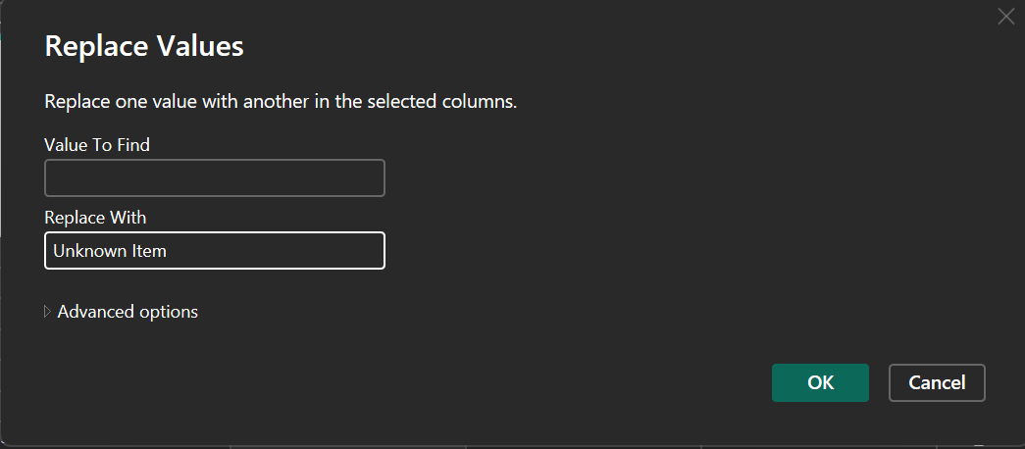
Filled missing Items and Payment Method with "Unknown Item"

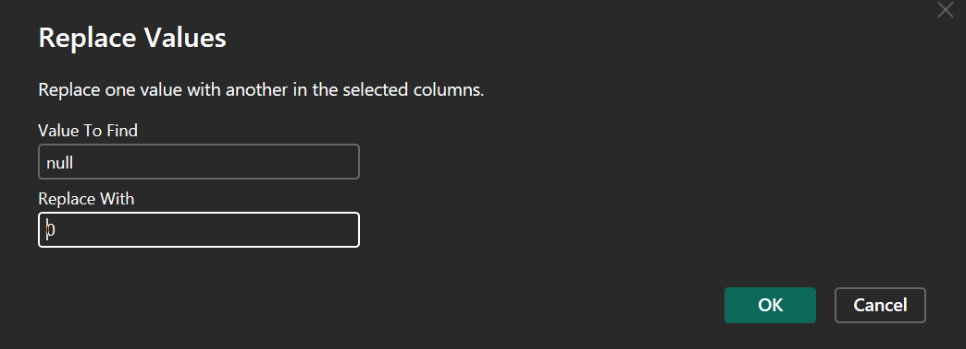
Filling the missing Price:

Filled missing Quantity with 1 because it is reasonable to assume that if an item was ordered, at least one unit was purchased.
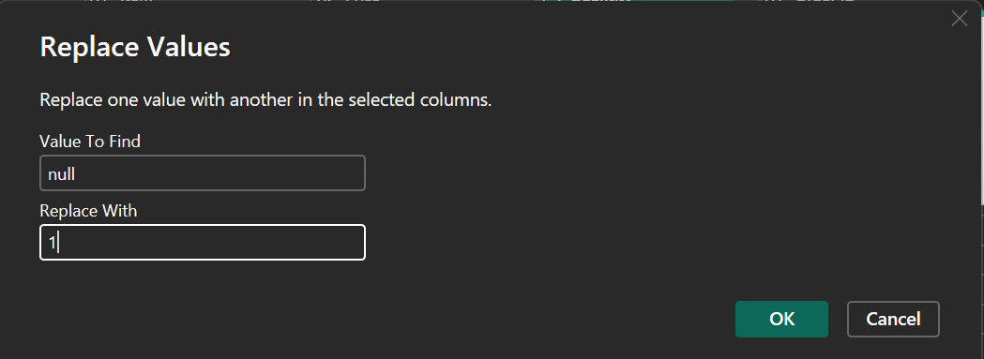

- Filling missing values
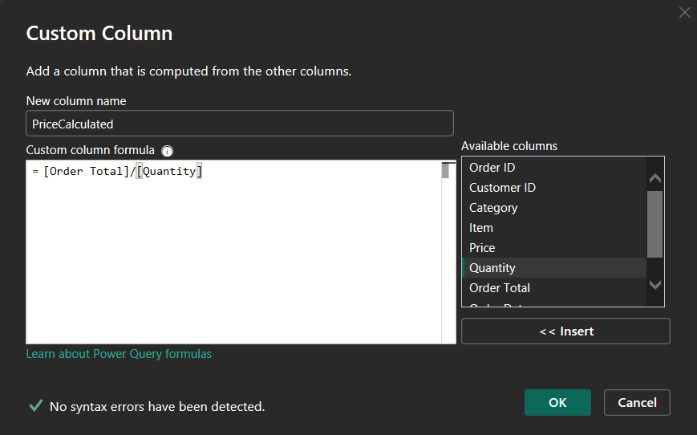
Standardizing inconsistent data entries
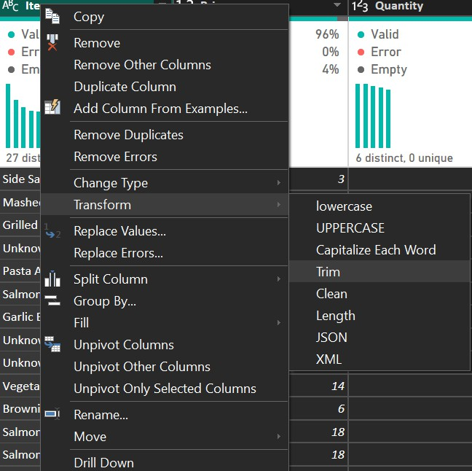
Removed leading and trailing spaces in the Item column
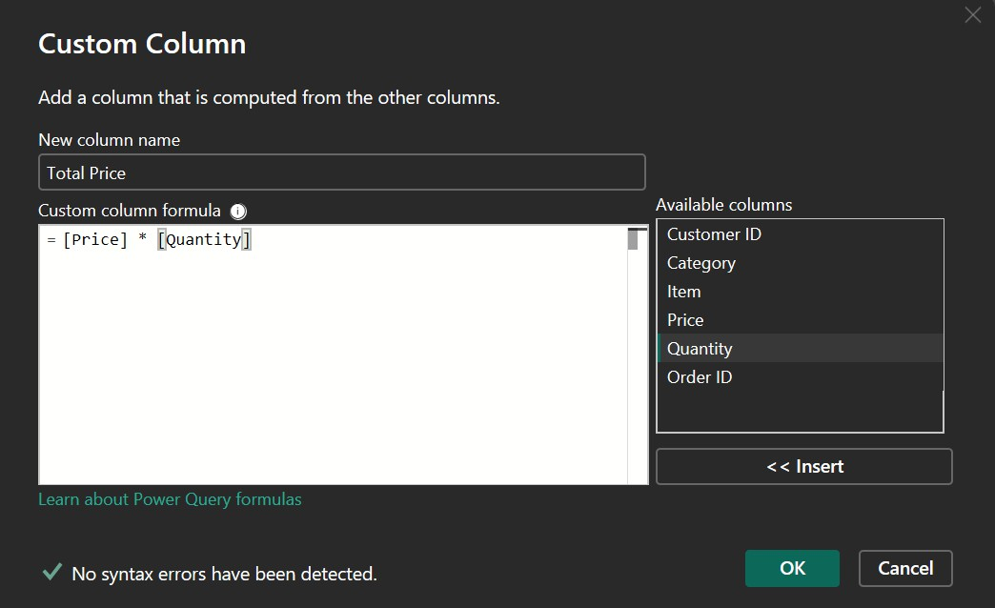
- Creating derived columns: Total Price = (Price × Quantity) in the Customer Table

- Extracting:
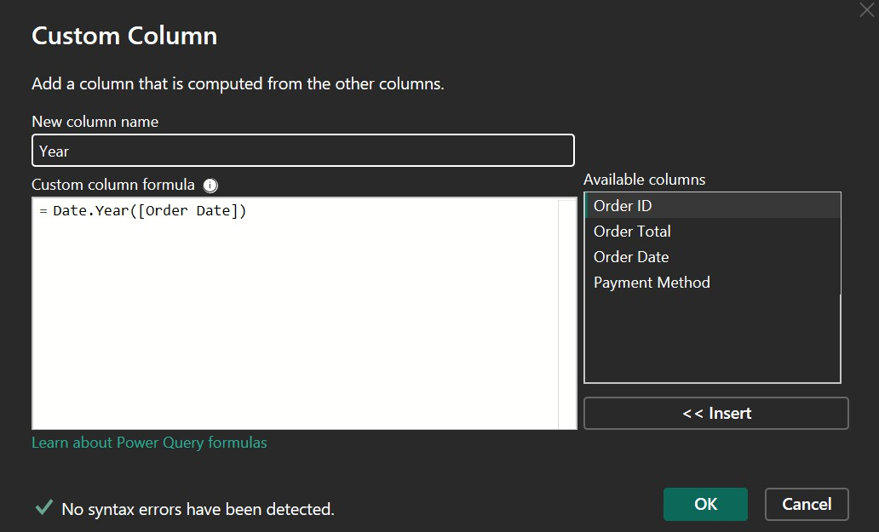
  - Year from the Order Date column to analyze sales trends over time
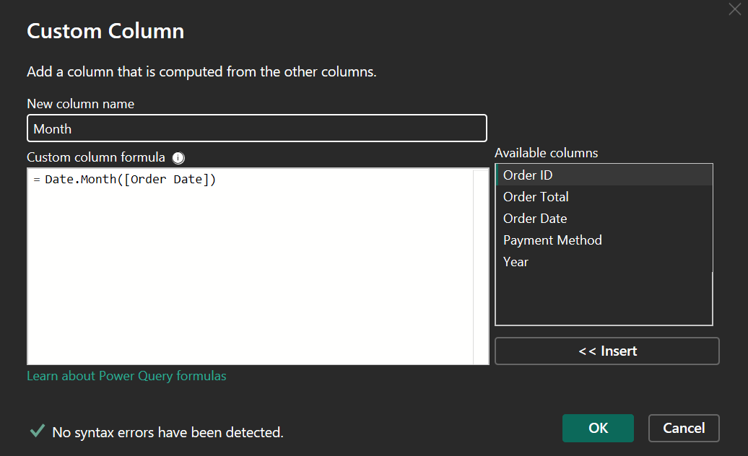
  - Month from the Order Date column to identify seasonal patterns in sales
  - Day of the week from the Order Date column to determine which days are busiest for the restaurant
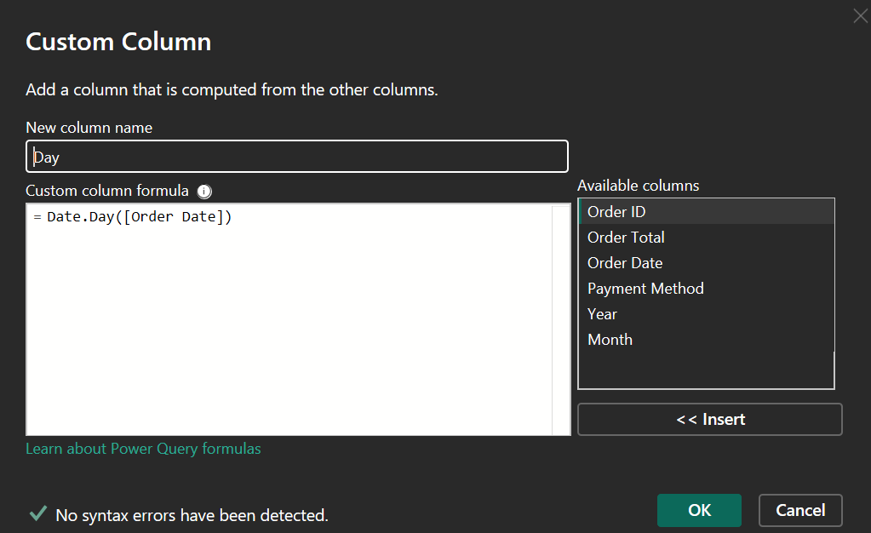
- Added price bins
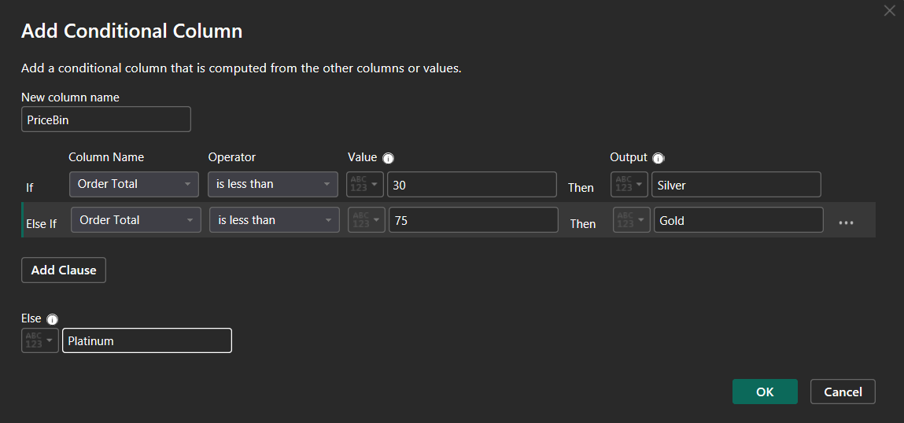
- Renaming queries professionally for better readability and organization
Before Renaming 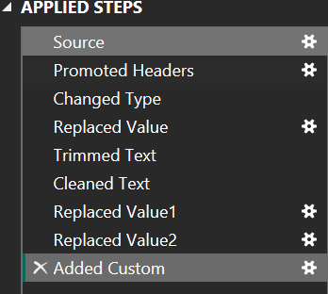
After Renaming 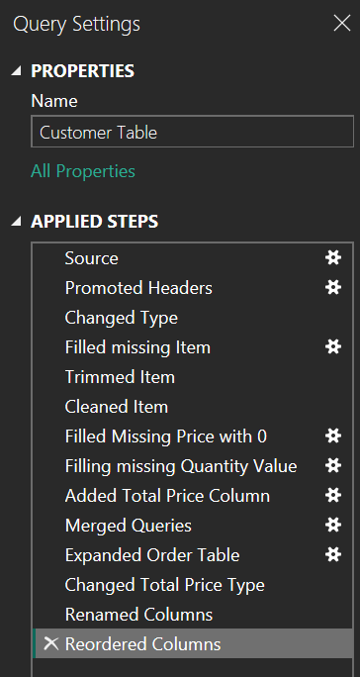
- Fixing data types:
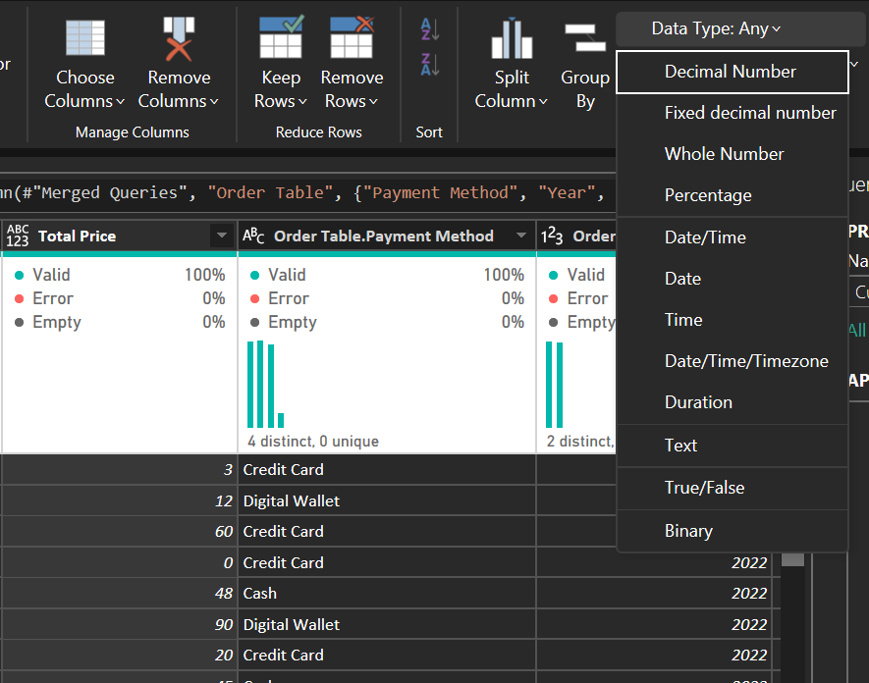
  - Changed Total Price to Decimal Number from Any
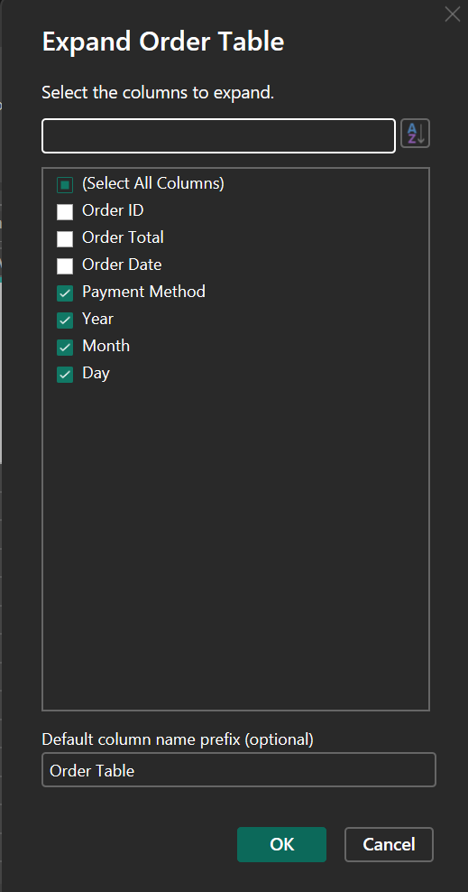
- Removing unnecessary columns that do not contribute to the analysis
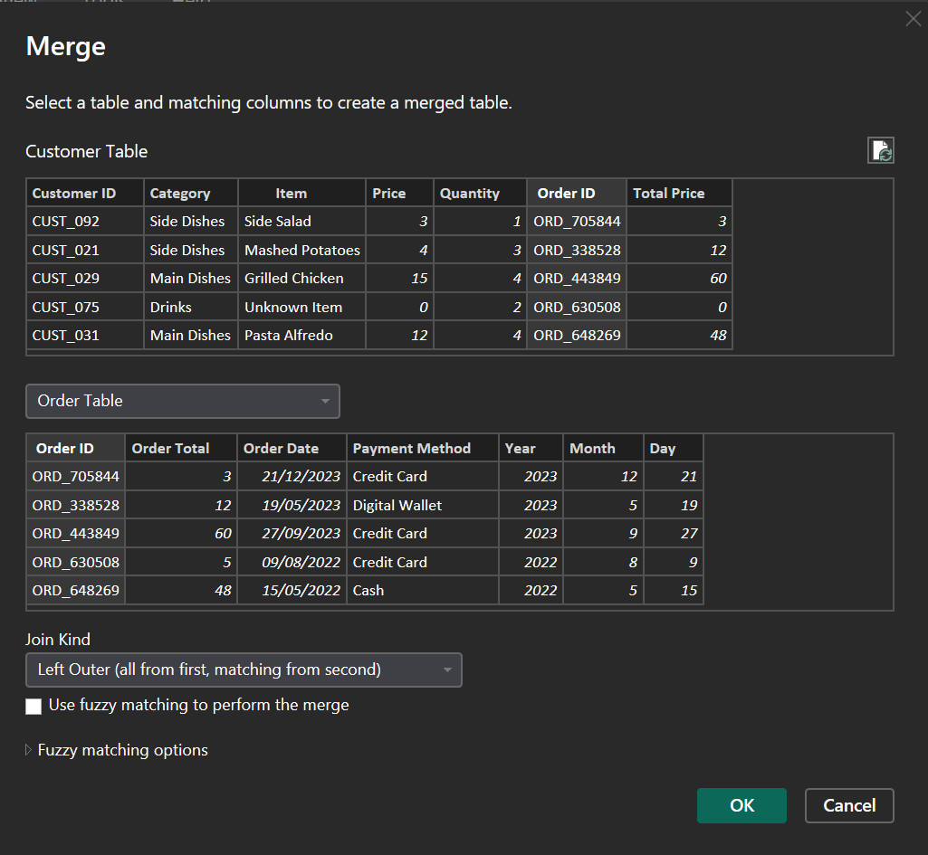
- Merging the two tables using the Order ID column to create a comprehensive dataset for analysis
- Extracted Month Name and Day Name - For time analysis.

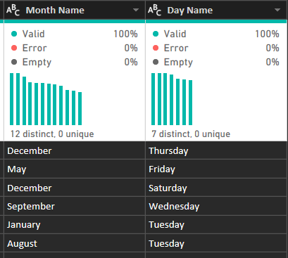

Part C: Data Modeling (15 Marks)

Relationship among tables

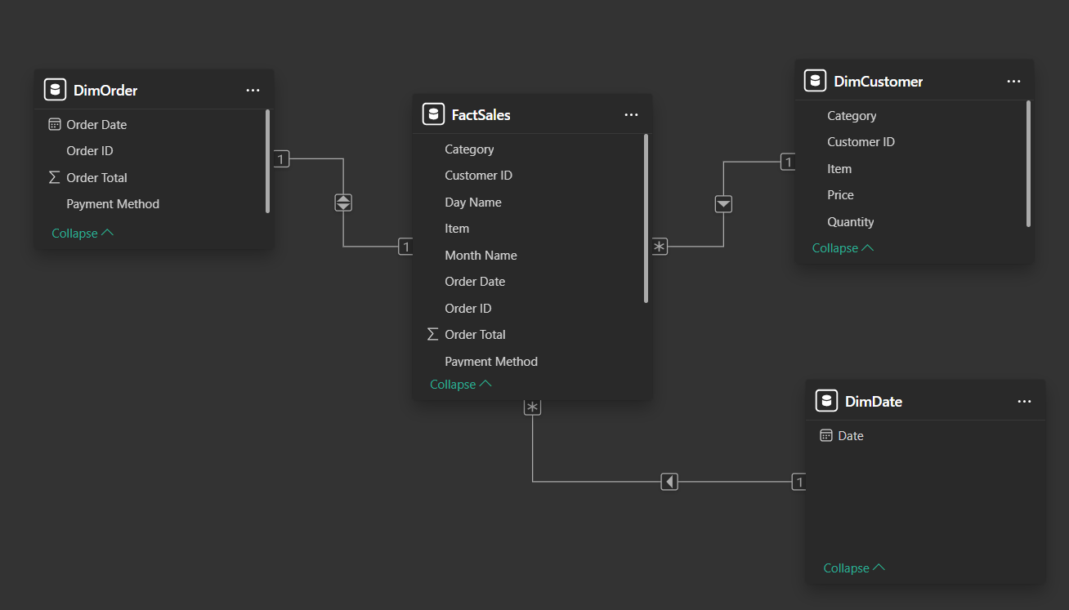

Creating a DateTable

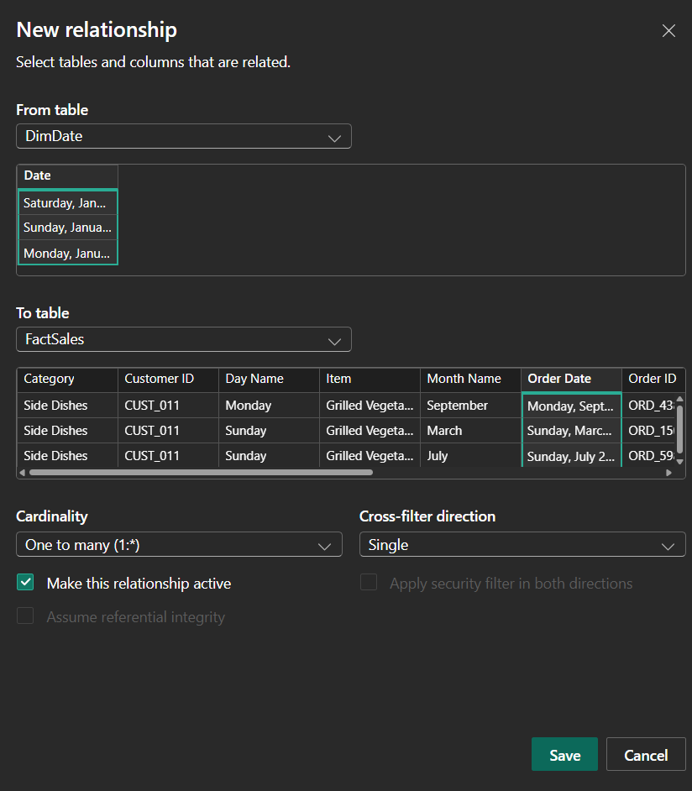

Identify and Justify Tables
- Fact Table: FactSales. Justification: It stores the measurable, quantitative transactional data (Quantity, Price, Order Total) and the foreign keys required to link to the descriptive tables.
- Dimension Tables: DimCustomer, DimProduct, DimDate. Justification: They contain the descriptive text attributes and time periods used to filter, slice, and group the metrics in the fact table.

Relationship Description
- DimCustomer [Customer ID] to FactSales [Customer ID]: 1-to-many (1:*), single cross-filter direction.
- DimProduct [Item] to FactSales [Item]: 1-to-many (1:*), single cross-filter direction.
- DimDate [Date] to FactSales [Order Date]: 1-to-many (1:*), single cross-filter direction.

Efficient Reporting Structure

This model utilizes a star schema optimized for the Power BI DAX engine. The single-directional 1-to-many relationships ensure filters flow downhill from dimensions to facts without creating circular dependencies. This structure minimizes data redundancy, compresses the file size, and significantly accelerates query performance for dashboard visuals.

Part D: DAX Measures and Calculated Columns (20 Marks)

Calculated columns

Transaction Size (Conditional Logic)
- DAX Formula: Transaction Size = SWITCH(TRUE(), FactSales[Order Total] < 20, "Small", FactSales[Order Total] <= 50, "Medium", "Large")
- What it calculates: Evaluates each transaction's total and categorizes it into "Small", "Medium", or "Large" buckets.
- Decision-making value: Allows management to analyze purchasing behaviors and see if the restaurant relies more on high-volume/low-ticket sales or low-volume/high-ticket sales, which informs promotional pricing strategies.

Is Weekend (Conditional Logic)
- DAX Formula: Is Weekend = IF(WEEKDAY(FactSales[Order Date], 2) >= 6, "Weekend", "Weekday")
- What it calculates: Looks at the order date and flags it as a "Weekend" (Saturday/Sunday) or "Weekday".
- Decision-making value: Helps staff scheduling and inventory planning by comparing weekend surge volume against baseline weekday traffic.

DAX Measures
1. Total Revenue (Total Amount)
- DAX Formula: Total Revenue = SUM(FactSales[Order Total])
- What it calculates: Sums up the total monetary value of all transactions in the current filter context.
- Decision-making value: This is the primary Key Performance Indicator (KPI) for the restaurant's financial health and serves as the foundational metric for most other calculations.
2. Total Orders (Distinct Count)
- DAX Formula: Total Orders = DISTINCTCOUNT(FactSales[Order ID])
- What it calculates: Counts the unique number of Order IDs, ensuring that an order with multiple items is only counted as a single customer transaction.
- Decision-making value: Tracks overall restaurant foot traffic and transaction volume independently of how much money was spent.
3. Average Order Value / AOV (Average Metric)
- DAX Formula: Average Order Value = DIVIDE([Total Revenue], [Total Orders], 0)
- What it calculates: Divides the total revenue by the distinct number of orders.
- Decision-making value: Crucial for measuring upselling success. If AOV increases, staff are successfully encouraging customers to add sides, drinks, or desserts to their main meals.
4. YTD Revenue (Time Intelligence)
- DAX Formula: YTD Revenue = TOTALYTD([Total Revenue], DimDate[Date])
- What it calculates: Calculates the cumulative total revenue from January 1st to the current date in the filter context.
- Decision-making value: Allows ownership to track performance against annual financial targets and compare cumulative growth against previous years.
5. Previous Month Revenue (Time Intelligence Helper)
- DAX Formula: Previous Month Revenue = CALCULATE([Total Revenue], DATEADD(DimDate[Date], -1, MONTH))
- What it calculates: Retrieves the Total Revenue for the exact same period one month prior.
- Decision-making value: Necessary for calculating month-over-month growth. It provides a baseline for short-term historical comparison.

6. MoM Revenue Growth % (Change Over Time)
- DAX Formula: MoM Revenue Growth % = DIVIDE([Total Revenue] - [Previous Month Revenue], [Previous Month Revenue], 0)
- What it calculates: The percentage increase or decrease in revenue compared to the previous month.
- Decision-making value: Acts as an early warning system. Negative growth alerts management to investigate recent menu changes, seasonal dips, or operational issues.
7. % of Total Revenue (Percentage Contribution)
- DAX Formula: % of Total Revenue = DIVIDE([Total Revenue], CALCULATE([Total Revenue], REMOVEFILTERS(DimProduct)))
- What it calculates: Calculates the revenue of a specific filter context (like a product category) and divides it by the grand total revenue across all products.
- Decision-making value: Highlights product dependency. It tells management exactly which menu categories (e.g., Main Dishes vs. Desserts) carry the business financially.
8. Product Category Rank (Ranking)
- DAX Formula: Category Rank = RANKX(ALL(DimProduct[Category]), [Total Revenue], , DESC, Dense)
- What it calculates: Assigns a numeric rank (1, 2, 3...) to product categories based on their total revenue generation.
- Decision-making value: Quickly identifies the "star" categories for marketing focus and the "dog" categories that might need menu redesign or removal.

Part E: Dashboard Design and Visualization

Page1: Executive Summary

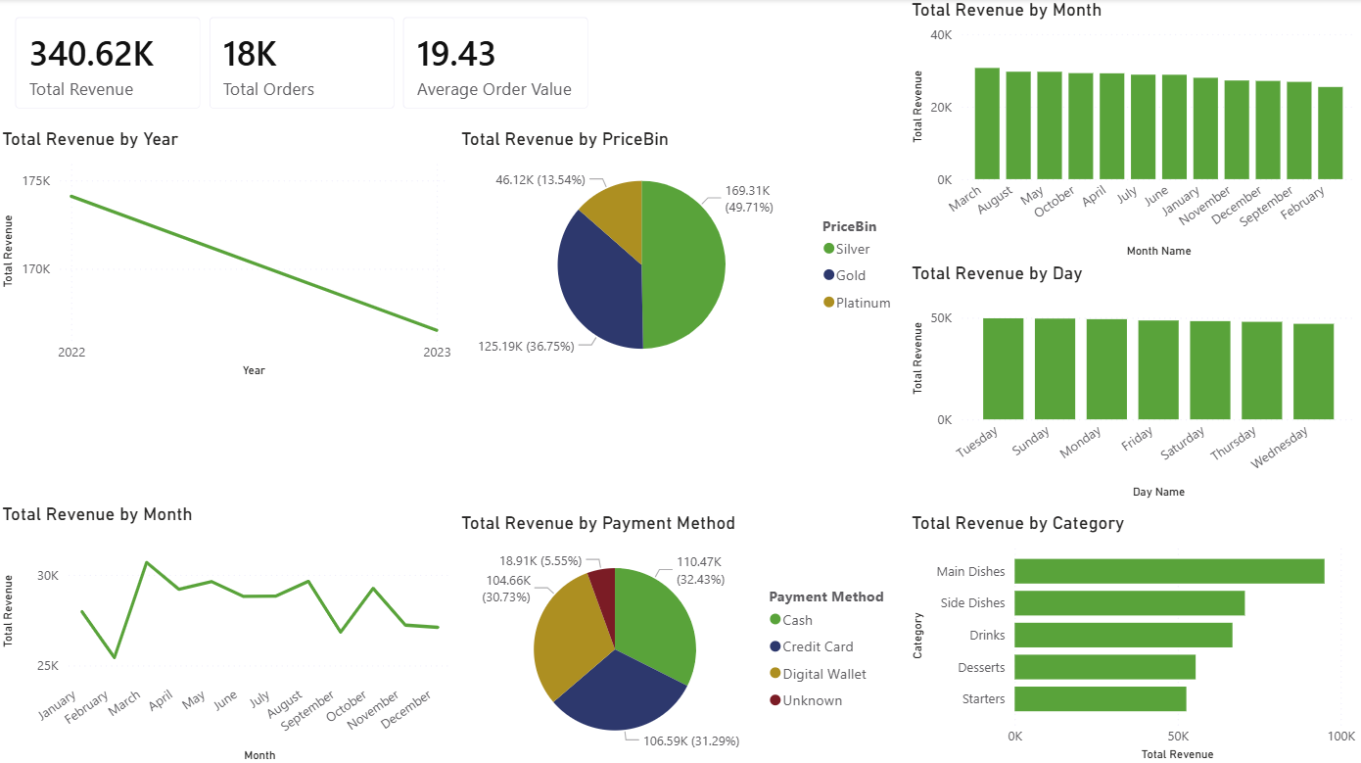

Page2: Detailed Analysis

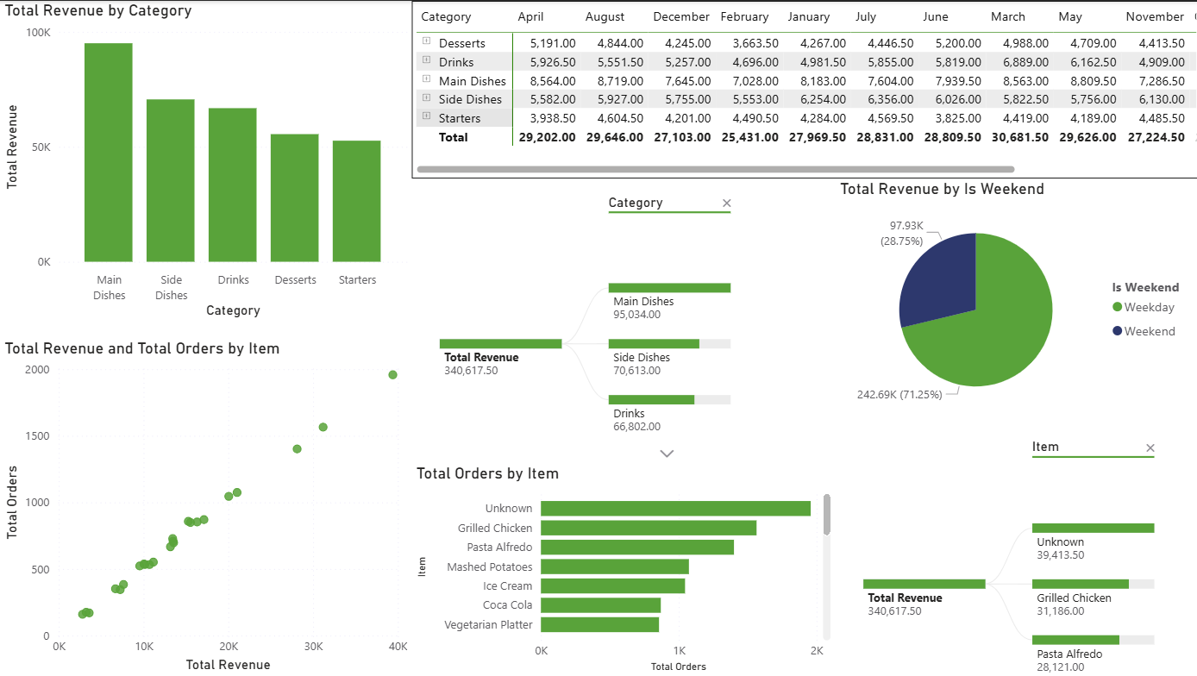

Page3: Insights and Perfomance Monitoring
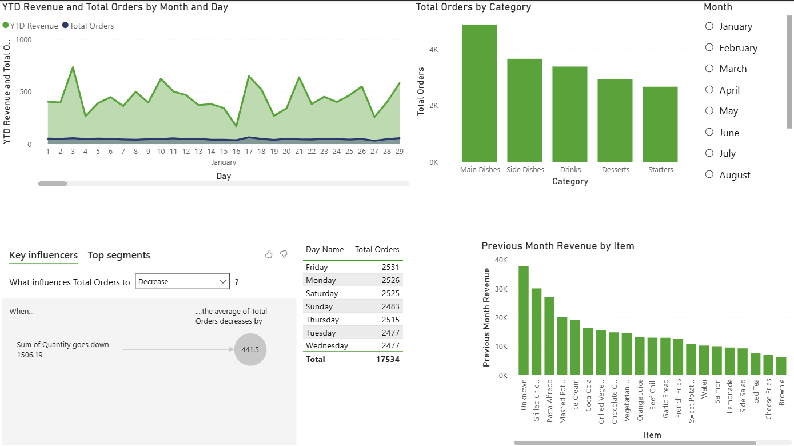
Explanation of Design Choices
The dashboard employs a top-down, left-to-right information architecture aligning with natural reading patterns. High-level KPI cards are anchored at the top for immediate visibility. A minimalist, high-contrast corporate color theme is applied consistently across all three pages to reduce cognitive load. Visual clutter is minimized by removing unnecessary gridlines and data labels, relying on tooltips for exact figures. Standard business visuals (bar, line, and matrix charts) were selected over complex or 3D visuals to ensure immediate interpretability by non-technical stakeholders.
Explanation of User Interactions
The dashboard supports multi-layered data exploration through synchronized cross-filtering. Selecting a specific category, such as 'Main Dishes', in a bar chart automatically filters all other visuals on the page to reflect only that category's metrics. Global slicers for Date and Payment Method are synced across all pages to maintain context during navigation. The Detailed Analysis page features hierarchical drill-down capabilities, allowing users to expand category-level data down to individual item performance. Users can hover over any visual element to trigger native tooltips displaying exact quantitative values and context.
Part F: Analytical Insights and Business Recommendations
Analytical Insights
Insight 1: Revenue Decline. Total Revenue dropped from approximately 175K in 2022 to roughly 166K in 2023.
Insight 2: Flat Daily Demand. Revenue is evenly distributed across all days of the week. Weekdays account for 71.25% of total revenue, and weekends account for exactly 28.75%.
Insight 3: Category Dominance. "Main Dishes" is the primary revenue driver, generating over 95K. This significantly outperforms "Starters", which generated approximately 50K.
Insight 4: Item-Level Concentration and Data Quality. Within Main Dishes, revenue is heavily concentrated in just two items: Grilled Chicken (31,186) and Pasta Alfredo (28,121). "Unknown" items account for an even larger share of overall revenue (39,413.50).
Insight 5: Payment Method Parity. Customers exhibit no strong preference for payment methods. Cash (32.43%), Credit Card (31.29%), and Digital Wallet (30.73%) are used almost equally.
Actionable Business Recommendations
Recommendation 1: Investigate Data Capture Issues. The high revenue attributed to "Unknown" items (39,413.50) indicates a critical failure in the data. Management must immediately audit the Point of Sale (POS) system and staff data entry protocols to accurately classify these sales and understand true product performance.
Recommendation 2: Implement Weekend Promotions. Daily revenue is entirely flat across the week. Weekends show no natural surge in customer spending compared to weekdays. The restaurant should introduce weekend-exclusive bundles, live entertainment, or events to drive higher foot traffic on Saturdays and Sundays.
Recommendation 3: Menu Diversification. "Main Dishes" relies heavily on just Grilled Chicken and Pasta Alfredo. This exposes the business to supply chain disruptions for these specific ingredients. Introduce new premium main dishes to spread revenue generation across a wider variety of menu items.

Conclusion

This project successfully delivered a comprehensive Business Intelligence solution to analyze and optimize restaurant sales performance. By ingesting and transforming over 17,000 raw transactional records into a structured star schema, we established a robust foundation for advanced analytics. The deployment of DAX-driven metrics and an interactive, three-page dashboard provided immediate visibility into critical operational areas. The analysis revealed significant revenue concentration in specific main dishes, flat daily demand, and critical data capture issues at the point of sale. By acting on the data-driven recommendations—specifically implementing strategic menu bundling, launching weekend promotions, and auditing POS data entry—the restaurant management can mitigate supply chain risks, increase average order value, and drive sustainable revenue growth.

Part G: GitHub Repository and Documentation (5 Marks)

1) GitHub Link: https://github.com/SamanthaMasaki/PowerBI_EndSemester_Project

2) Kaggle Link: https://www.kaggle.com/datasets/ahmedmohamed2003/restaurant-sales-dirty-data-for-cleaning-training

