PetPal Database Design

Project Overview
PetPal is a platform for pet selling, adoption, and fostering. Users can register pets, create listings, apply for adoption or fostering, chat with owners, and manage payments and notifications.

Core SQL Tables

users
- user_id (PK)
- name
- email
- phone
- password_hash
- role
- created_at

pets
- pet_id (PK)
- owner_id (FK)
- pet_name
- species
- breed
- age
- gender
- health_info

pet_images
- image_id (PK)
- pet_id (FK)
- image_url

pet_listings
- listing_id (PK)
- pet_id (FK)
- listing_type
- price
- status
- created_at

adoption_applications
- application_id (PK)
- listing_id (FK)
- applicant_id (FK)
- message
- status

foster_requests
- request_id (PK)
- listing_id (FK)
- foster_parent_id (FK)
- start_date
- end_date
- status

payments
- payment_id (PK)
- user_id (FK)
- amount
- payment_status

reviews
- review_id (PK)
- reviewer_id (FK)
- reviewed_user_id (FK)
- rating
- comment

messages
- message_id (PK)
- sender_id (FK)
- receiver_id (FK)
- message_text

notifications
- notification_id (PK)
- user_id (FK)
- title
- is_read

Entity Relationship Diagram
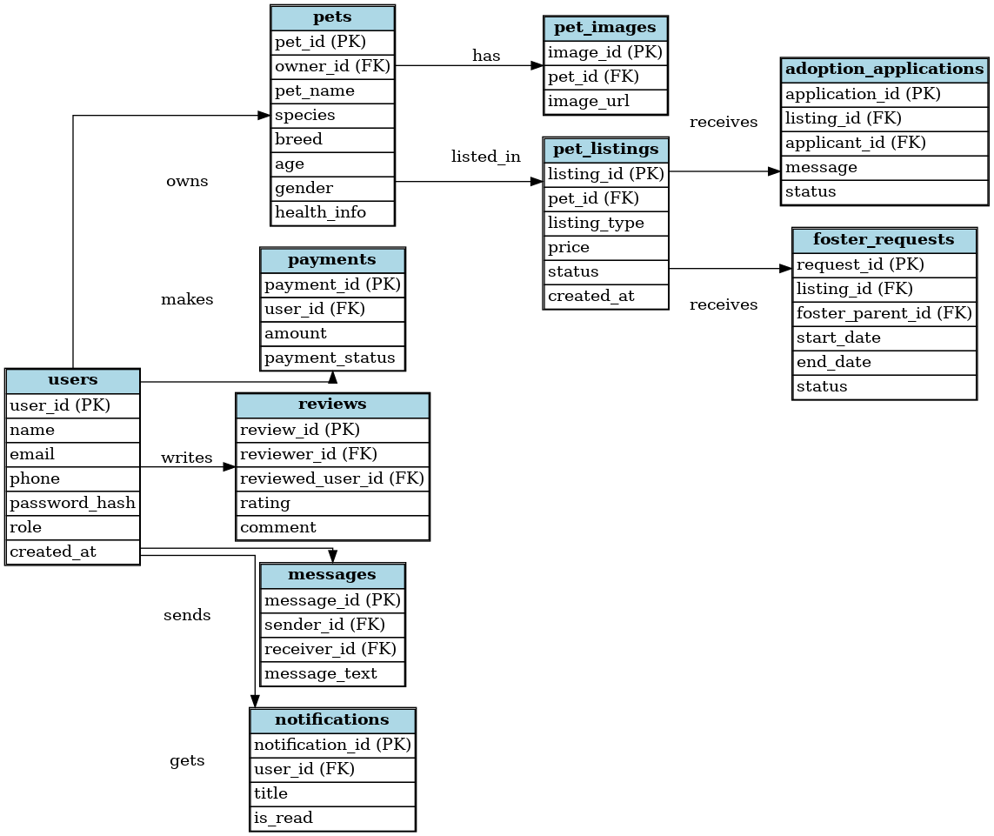

Key Relationships
- One user can own many pets.
- One pet can have many images.
- One pet can have one or more listings.
- One listing can receive multiple adoption applications.
- One listing can receive multiple foster requests.
- Users can send messages to each other.
- Users receive notifications from the system.

