Experiment – 2

Question:
Create a simple cloud software application for Flight Reservation System using any Cloud Service Provider to demonstrate SaaS.
Answer:

AIM: To create a simple cloud software application for flight reservation system using any cloud service provider to demonstrate saas.

PROCEDURE:
Step1: Go to zoho.com.
Step 2: Log into the zoho.com.
Step 3: Select one application step.
Step 4: Enter application name as flight reservation system.
Step 5: Created new application flight reservation system.
Step 6: Select one form
Step 7: The software has been created.

IMPLEMENTATION:

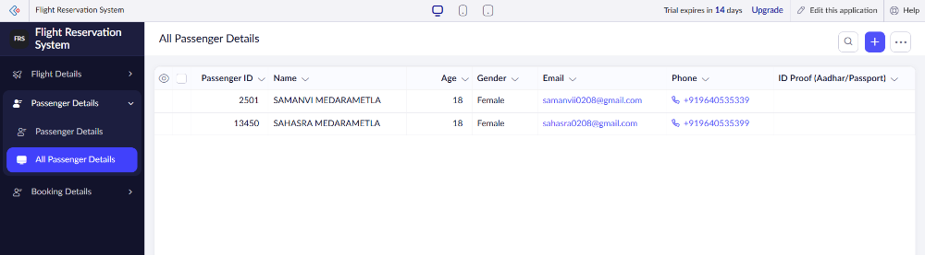
Flight Reservation System

