**Programming Contest Control System**

**Contestant’s Guide**

This guide is intended to explain the various components of the Programming Contest Control System (PC^2) interface. Once teams navigate to thePC^2 web interface through a supported browser (Firefox, Chrome, or Safari), the team will be presented with the login screen. Internet Explorer is not supported.

**Logging in**

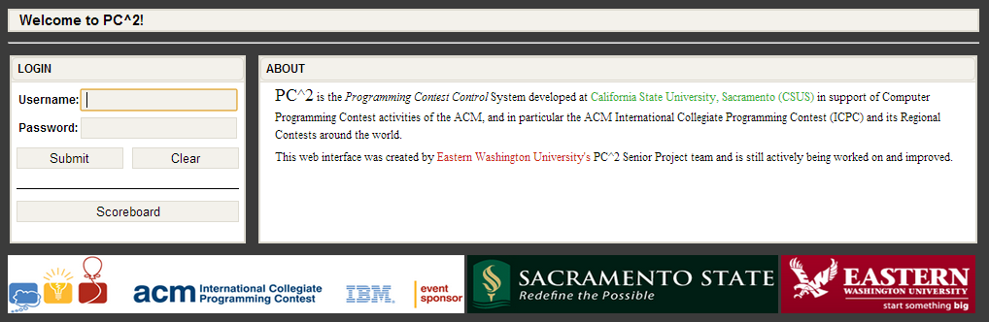

Login credentials will be provided by the contest administrator. To login to PC2, click once on the Username box on the login screen, enter your assigned team ID, press the TAB key or click on the Password box, then enter your assigned password. Your team ID will be of the form teamXX, where XX is your assigned team number (for example, “team3” or “team12”). After entering your team name and password, click on the Submit button to enter the team interface. Contest observers may view the scoreboard by clicking the Scoreboard button.

**Submitting Solutions**

Once logged in, users may begin interacting with the contest. To submit a solution, you will use the “SUBMIT RUN” panel. Select the problem that you are attempting to solve, the programming language that your solution is written in, and the source file of your solution. Finally, click the submit button to send your solution to the PC^2 judge.

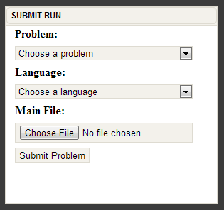

**Viewing Submissions**

To view previously submitted runs status’, navigate to the “VIEW RUNS” tab. Runs will be listed in order of submission time with the most recent being on top. If a submitted run is not listed, click the refresh button in the top right corner of the team interface. Once a submission is judged, the status will be updated.

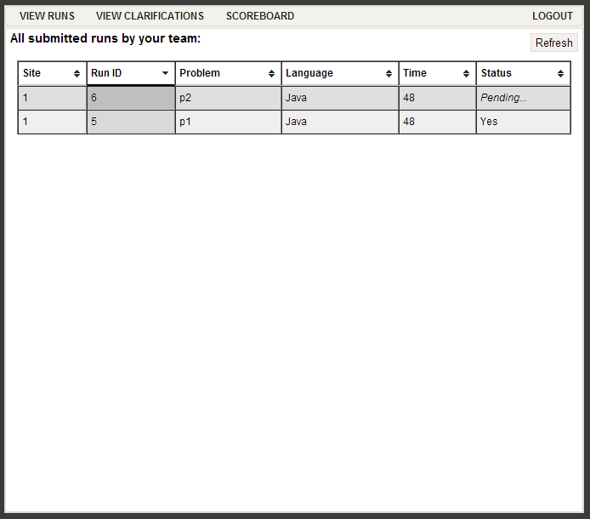

**Submitting a Clarification**

If a team has a question the team may send a clarification to the judges. To send a clarification, use the “SUBMIT CLARIFICATION” panel. Then select the problem and enter a question. Click submit clarification to send the message to the judges.

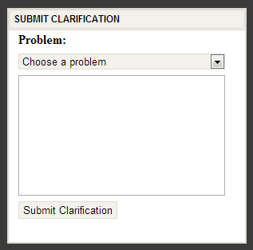

Similar to viewing runs, teams may view clarifications (and answers) using the “VIEW CLARIFICATIONS” tab. If a submitted clarification does not appear in the list, click the refresh button in the top right corner of the team interface. Judges’ responses will be listed in the Answer column once the clarification has been judged.

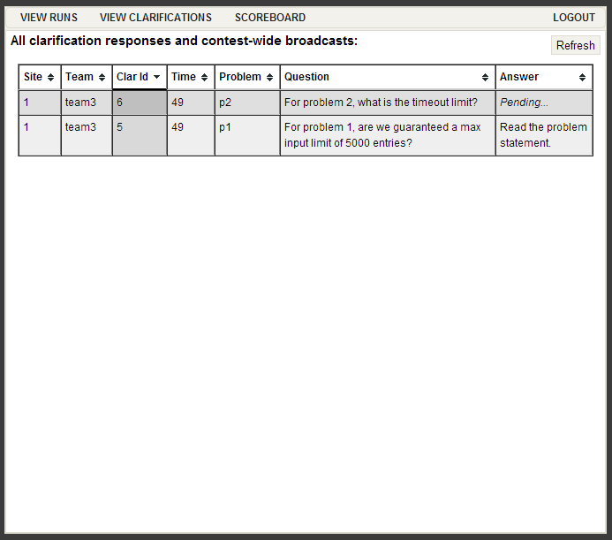

**Viewing the Scoreboard**

To view the current rank of each team in the contest, navigate to the “SCOREBOARD” tab. To get a live version of the scoreboard teams should click the refresh button. Green cells indicate a correct submission, while red indicates an unsolved problem. The numbers listed in the cells are number of attempts followed by the total penalty time for that submission.

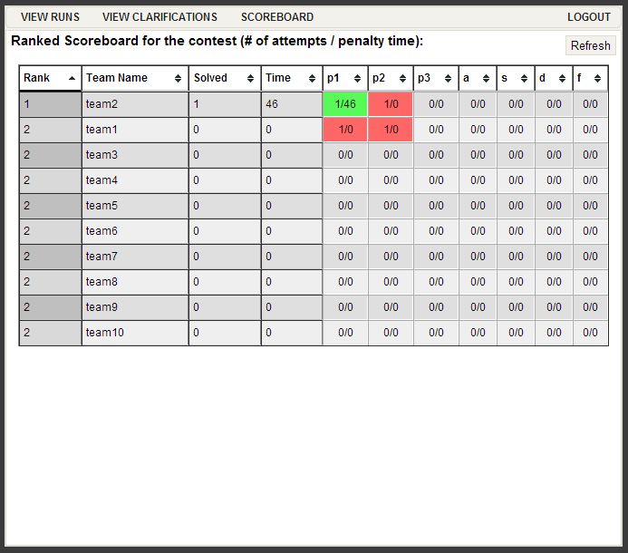

**Exiting PC^2**

The “LOGOUT” button logs your team out of PC2. This action does not affect the status of runs or clarification requests previously submitted, and any run or clarification responses. Note however that the dynamic “instant notification” messages which pop up on your screen to notify you of responses from the Judges will not appear unless you are logged in to PC2.