Accessibility conformance test report
Page evaluated:
Evaluator:

Summary of the conformance test
< include a brief (1 or 2 paragraphs) description of how the conformance test was conducted, the types of issues found and the overall state of the page in terms of accessibility. >

Results of the conformance test
Note that the information you will be reporting is in your own words, but is based on the ‘Details’ and ‘Reference’ sections in your WAVE conformance test results report.
Error type | Give one or two examples (images of the relevant part of the screen can be useful) | Why is this considered to be an issue? | What should be done? | What level of conformance does it break?
Language error | 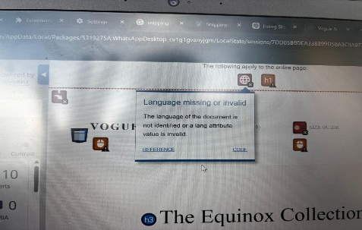 | It’s a standard for all crawlers | Add a lang attribute | WCG_A
Missing alternative text | 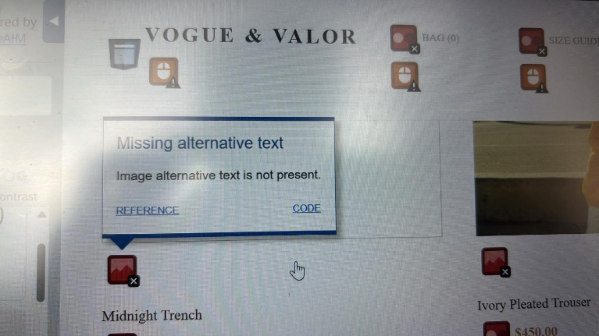 | Screen readers read out image or the file URL instead of describing the content, making the images meaningless to visually impaired people | Add a descriptive alt attribute to every <img> element, eg alt= “model wearing a dark belted trench coat” | A-WCAG 1.1.1 Non-context text
Empty Button | 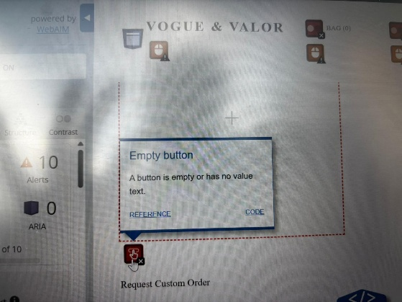 | Screen readers announce this as empty button with no name, users cannot determine the button purpose | Add aria label=”request a custom order” | A-WCAG 4.1.2 – Name, value
A

