State-of-Health Estimation

1. What the current approach does

The new algorithm estimates the State of Health based on the charge that was passed, relative to the State of Charge difference measured from the open circuit voltage using the OCV-SOC map.

The advantage of this solution is that it is straightforward to use and computationally inexpensive, yet reliable only if the pack had enough time to rest, if the OCV-SOC map was accurate, and if the SOC difference was wide enough to avoid noise influence.

2. Why move from the current method to a DEKF

Method | Strengths | Limitations | Best fit
Rest-based OCV + coulomb counting | Very simple; low CPU cost; easy to debug | Needs rest; only estimates capacity; sensitive to OCV table and small delta SOC | Prototype or periodic manual recalibration
DEKF | Good embedded tradeoff; widely used; supports online SOC and slower SOH tracking | Needs ECM identification and Jacobians; can diverge if badly tuned | Primary implementation path for this BMS
GRPF | Handles strong nonlinearity and non-Gaussian noise better | Higher memory, more tuning, and more compute | Future upgrade if DEKF accuracy is insufficient

3. SOH Estimator flow
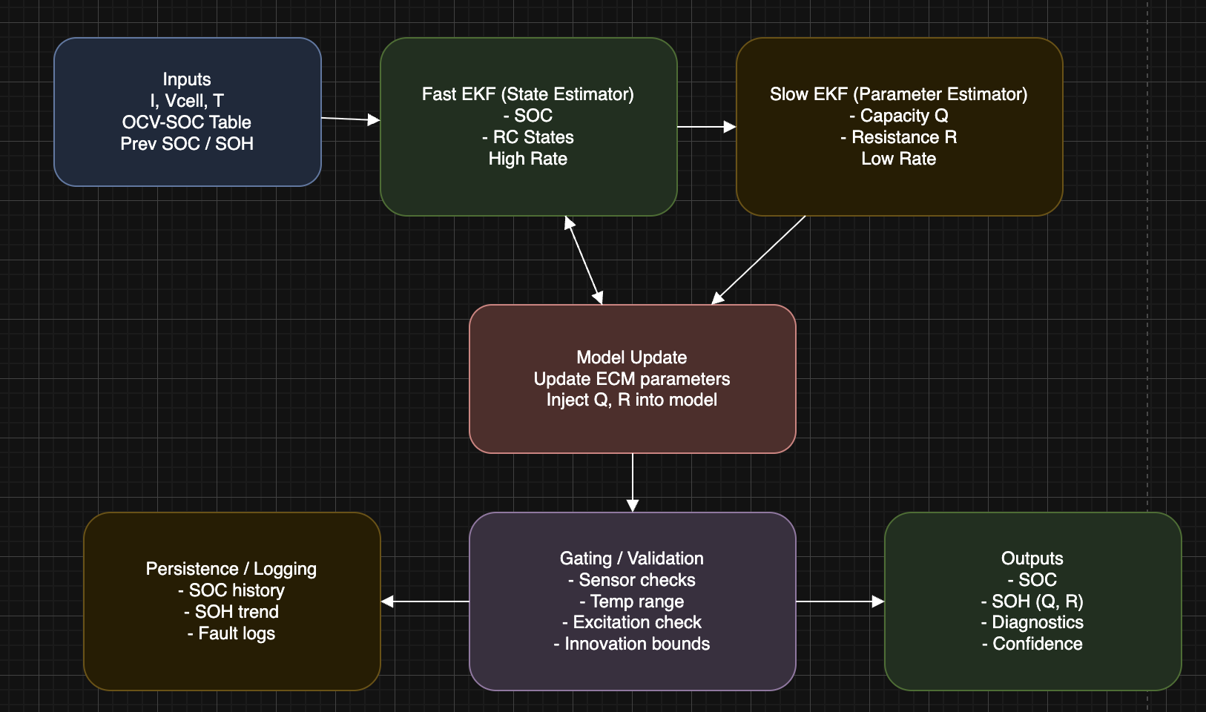
Figure 1. High-level DEKF-based SOH estimation flow for an embedded BMS.

4. Recommended software architecture
The fast estimation loop (EKF #1): It executes within the primary BMS loop, say every 50–100 ms. Its task is the estimation of SOC and RC polarization states based on the measured current and terminal voltage.
The slow estimation loop (EKF #2): It runs much slower, say every 10–60 seconds, to update aging parameters like available capacity Q and ohmic resistance R0. It shall run only if measurements are relevant and valid.
Gating conditions: The slow estimation loop needs to be gated under invalid sensors, current almost zero while the voltage is still relaxing, out-of-model temperatures, or estimator residuals indicating an unstable situation.
Persistence: Maintain persistence of the latest SOC and SOH of the pack, capacity estimation, resistance estimation, health of covariances, and time-stamped history.

5. Pseudocode
INITIALIZE ECM parameters, covariance matrices, and OCV-SOC lookup
LOAD previous SOC / SOH estimates from nonvolatile memory if available

LOOP every main-cycle dt_fast:
read current, cell voltages, pack voltage, temperatures
validate sensors

# Fast EKF: state = [SOC, V_rc1, V_rc2, ...]
predict SOC and RC voltages using current input
predict terminal voltage from ECM
compute voltage residual = V_measured - V_model
correct fast-state estimate with EKF update

if slow-timer expired AND gating conditions satisfied:
# Slow EKF: parameters = [Q_available, R0, optional R1/C1 terms]
form parameter-observer model using recent residual trends
predict SOH parameters
correct SOH parameters using informative voltage/current data
constrain parameters to physical limits

derive pack SOC from validated cell / pack state estimate
derive pack SOH from updated Q_available relative to Q_nominal
publish values over CAN / telemetry
periodically log estimates, residuals, and health flags to NVM

6. Embedded reference code (C implementation skeleton)
The code below is a reference skeleton meant to show structure and data flow. It is not a drop-in production implementation; the state-transition matrices, Jacobians, and tuning values must be derived from the identified ECM and validated on bench data.
typedef struct {
float soc; // 0.0 to 1.0
float v_rc1;
float v_rc2;
float P[3][3];
} FastState_t;

typedef struct {
float q_available_Ah;
float r0_ohm;
float P[2][2];
} SlowState_t;

typedef struct {
float current_A;
float voltage_V;
float temperature_C;
bool valid;
} Meas_t;

static void fast_ekf_predict(FastState_t *x, const SlowState_t *theta,
float current_A, float dt_s);
static void fast_ekf_update(FastState_t *x, const SlowState_t *theta,
float measured_voltage_V);
static void slow_ekf_predict(SlowState_t *theta, float dt_s);
static void slow_ekf_update(SlowState_t *theta, const FastState_t *x,
const Meas_t *m);
static bool slow_update_allowed(const Meas_t *m, float residual_V);
static float clampf(float x, float lo, float hi);

void soh_task_step(float dt_fast_s, bool slow_tick)
{
static FastState_t x = { .soc = 0.80f, .v_rc1 = 0.0f, .v_rc2 = 0.0f };
static SlowState_t theta = { .q_available_Ah = 13.0f, .r0_ohm = 0.003f };

Meas_t m = read_battery_measurements();
if (!m.valid) {
publish_estimator_fault();
return;
}

fast_ekf_predict(&x, &theta, m.current_A, dt_fast_s);
fast_ekf_update(&x, &theta, m.voltage_V);

float residual_V = m.voltage_V - ecm_terminal_voltage(&x, &theta, m.current_A);

if (slow_tick && slow_update_allowed(&m, residual_V)) {
slow_ekf_predict(&theta, dt_fast_s);
slow_ekf_update(&theta, &x, &m);

theta.q_available_Ah = clampf(theta.q_available_Ah, 0.5f * 13.0f, 1.05f * 13.0f);
theta.r0_ohm = clampf(theta.r0_ohm, 0.0005f, 0.0200f);
}

float pack_soc = clampf(x.soc, 0.0f, 1.0f);
float pack_soh = clampf(theta.q_available_Ah / 13.0f, 0.0f, 1.2f);

publish_soc_soh(pack_soc, pack_soh, theta.r0_ohm, residual_V);
estimator_log_if_due(pack_soc, pack_soh, theta.q_available_Ah,
theta.r0_ohm, residual_V, m.temperature_C);
}

7. Practical implementation plan
- The ECM is to be identified across temperature and SOC, with both the OCV-SOC look-up table and R-C parameters.
- Implement and test the fast SOC EKF using laboratory current and voltage information first.
- The slow SOH EKF is to be incorporated next to calculate changes to battery capacity and resistance within proper operating conditions.
- Record the estimator's residual errors, covariance increase, and parameter changes to calibrate the estimator with actual vehicle information.
- Cross check estimator calculations with capacity and resistance tests at regular intervals to determine errors.

8. References:
- Li et al., “State of Health Estimation and Battery Management Systems: A Review,” National Institutes of Health (PMC), Available: https://pmc.ncbi.nlm.nih.gov/articles/PMC12068027/
- ASME Journal of Electrochemical Energy Conversion, “State of Charge and State of Health Estimation of Lithium-Ion Batteries Using Equivalent Circuit Models and Kalman Filtering,” Available: https://asmedigitalcollection.asme.org/electrochemical/article/21/1/011004/1160621
- Wei et al., “Joint State of Charge and State of Health Estimation Using Equivalent Circuit Models,” MDPI Electronics, Available: https://www.mdpi.com/2079-9292/14/7/1290
- Zhang et al., “State of Health Estimation for Lithium-Ion Batteries Using Unscented Kalman Filter,” Journal of Power Sources, Available: https://www.sciencedirect.com/science/article/abs/pii/S0378775324014022
- PHM Society, “Battery State Estimation for Hybrid Electric Vehicles Using Dual Extended Kalman Filter,” Available: https://papers.phmsociety.org/index.php/phme/article/download/4032/2458
- Analog Devices, “A Closer Look at State of Charge (SOC) and State of Health (SOH) Estimation Techniques,” Available: https://www.analog.com/media/en/technical-documentation/tech-articles/a-closer-look-at-state-of-charge-and-state-health-estimation-tech.pdf
- Plett, G. L., “Extended Kalman Filtering for Battery Management Systems of LiPB-Based HEV Battery Packs,” Journal of Power Sources, 2004.

