Representative ADC Analysis for a BMS Project
Current-sense channel example using a 1 mOhm shunt, 50 V/V amplifier, and 12-bit MCU ADC
Range analyzed | ADC setup | Main conclusion
-30 A to +30 A | 3.3 V reference, mid-scale bias at 1.65 V | Resolution is adequate; component tolerance dominates absolute current accuracy.

Important note. The board is not back yet, so this is a representative pre-silicon style analysis rather than measured hardware data. It is still useful for showing expected ADC behavior, error sources, and what to verify once bring-up starts.
1. Assumptions and setup
- ADC resolution: 12 bits with a 3.3 V reference, so one LSB is 0.806 mV.
- Current measurement path: shunt = 1 mOhm, amplifier gain = 50 V/V, and output centered at 1.65 V for bidirectional current.
- Range chosen for the study: -30 A to +30 A. This is wide enough to represent charging, discharging, and transient operating points in a small-to-mid power BMS.
2. Key equations
- The analog transfer is Vout = Vcm + I x Rshunt x Gain.
- The ADC code is Code = round(Vout / Vref x (2^N - 1)).
- The reconstructed current is I_hat = ((Code / (2^N - 1)) x Vref - Vcm) / (Rshunt x Gain).
- Using the selected parameters, one ADC step corresponds to about 0.0161 A, or 16.1 mA per code.
3. Results and interpretation
- Figure 1 shows the full current-to-code transfer. The line is almost perfectly linear, which is what we want from the analog front end.
- Figure 2 shows the quantization staircase error. The error stays bounded to roughly half an LSB in current units, so quantization alone is not the limiting factor.
- Figure 3 shows a simple error budget. In this representative setup, shunt tolerance and amplifier gain error matter more than raw ADC resolution.
- Figure 4 shows why averaging is useful. Even simple 16-sample averaging noticeably tightens the distribution of reported current.
4. Design implications
- If the goal is better absolute current accuracy, improving shunt tolerance and amplifier gain accuracy will usually help more than moving from a 12-bit ADC to a slightly higher resolution converter.
- If the goal is better stability for SOC integration, digital filtering and averaging can reduce random measurement noise before coulomb counting.
- The first bring-up checks should compare zero-current offset, gain slope, and temperature drift. Offset is especially important because even a small offset can integrate into noticeable SOC drift over long durations.
5. Reflection
- This analysis is useful because it gives a baseline expectation before hardware bring-up. It shows what the ADC should do, which error terms matter most, and what should be measured first when the board arrives.
- Board will come next week, parts came, last week meeting was about removing errors for PCB design, and the PCB was sent for manufacturing.
- That means the next logical step is to convert this representative ADC study into a validation plan: check zero-current offset, verify gain using a known load, compare averaged versus unfiltered readings, and record temperature sensitivity.
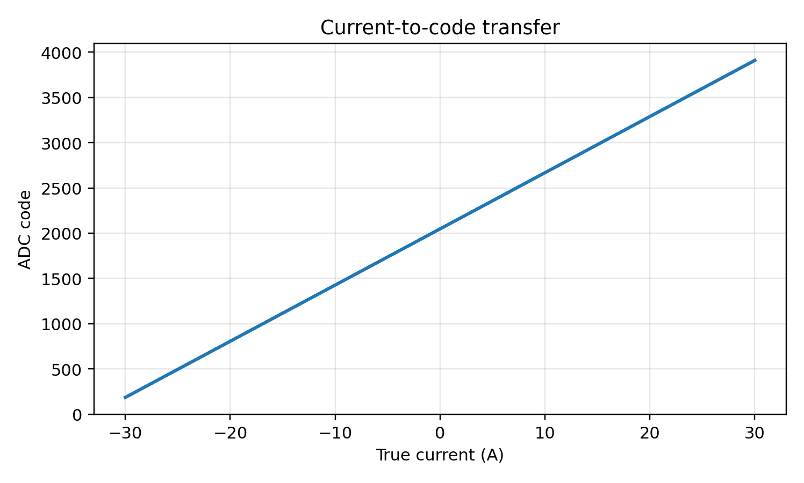
Figure 1. Transfer from true current to ADC code.
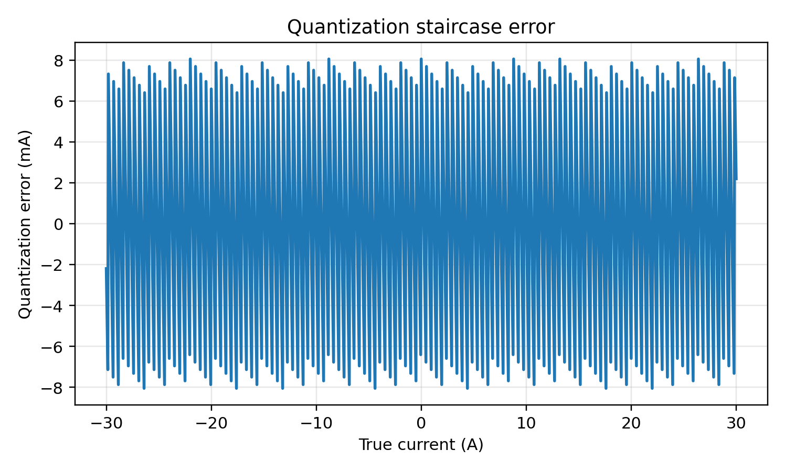
Figure 2. Quantization error expressed in mA across the operating range.
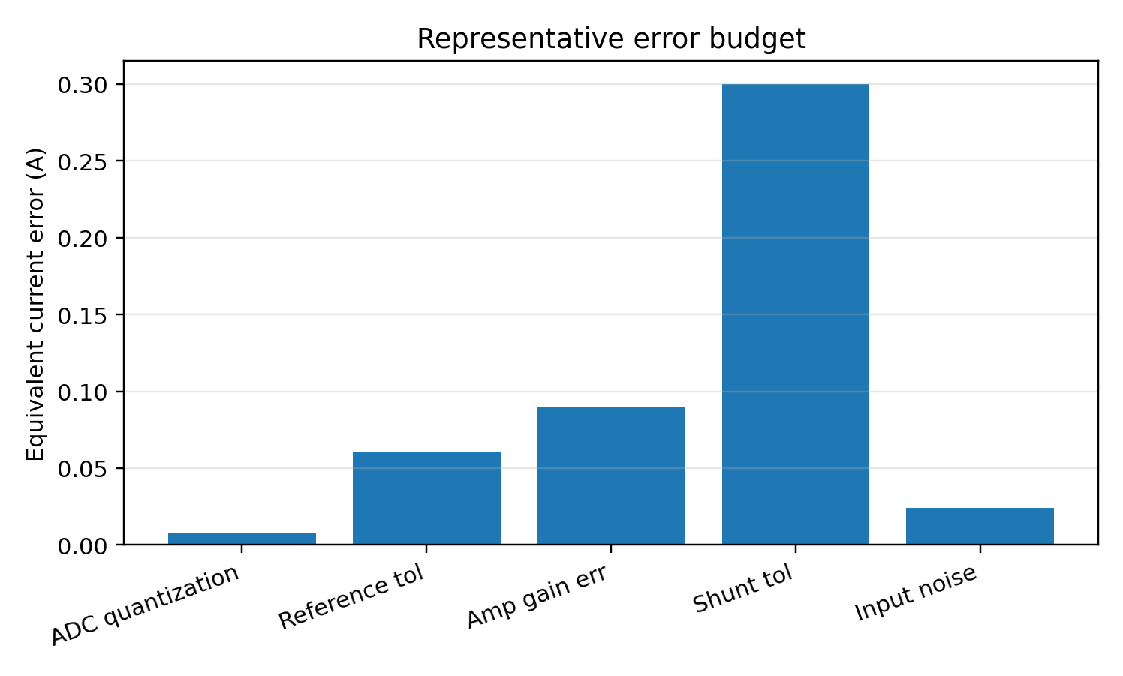
Figure 3. Representative error budget showing why passive and amplifier tolerance matter.
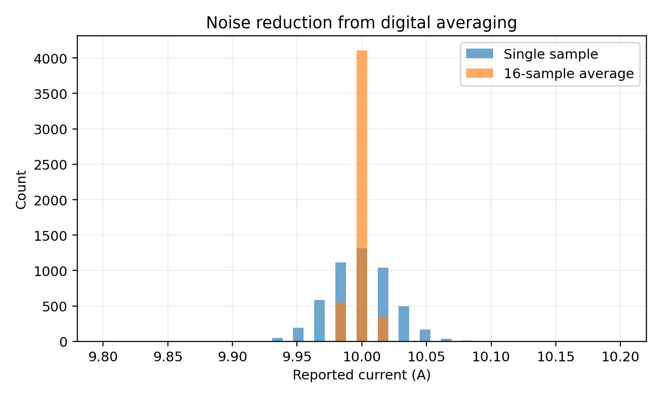
Figure 4. Simulated current histogram with and without 16-sample averaging.
Suggested bring-up checks
Check | Why it matters | Pass condition example
Zero-current offset | Prevents SOC drift and false current bias | Current near 0 A with load disconnected
Gain slope | Confirms shunt plus amplifier scaling | Measured slope matches applied current within tolerance
Noise with averaging | Shows whether firmware filtering helps | Averaged reading standard deviation drops as expected
Thermal drift | Checks stability over operating temperature | Offset and slope stay within calibration budget

