ASSIGNMENT – 1

PYTHON PROGRAMMING

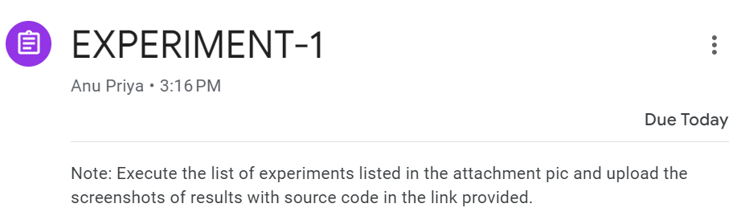

Prepared by:

Samar Mittal

Mis : 112315159

TASK 1:

import sys

print(sys.version)

OUTPUT:

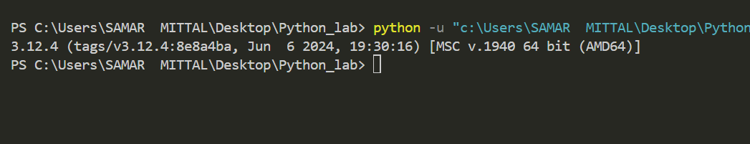

TASK 2:

import keyword

print(keyword.kwlist)

OUTPUT:

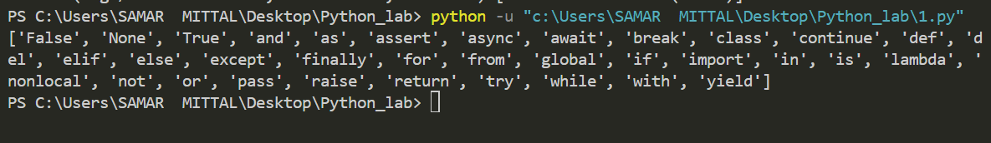

TASK 3:

name=input("Enter your Name : ")

age=int(input("Enter your age : "))

year=2024+(100-age)

print("-----------------")

print(name," your current age : ",age,"\nYou will turn 100 in  ",year)

OUTPUT:  
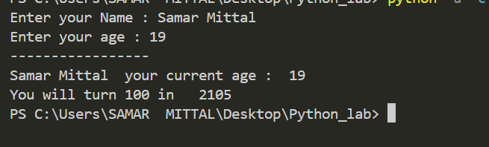

TASK 4:

from math import pi

r=float(input("Enter radius of circle : "))

print("Area of circle with radius r=",r," is ",pi\*r\*r)

OUTPUT:

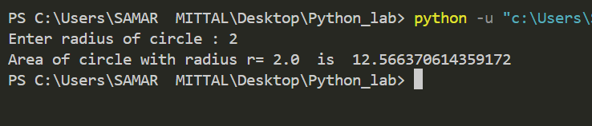

TASK 5:

n=int(input("Enter Any Number : "))

if (n%2==0):

    print("Entered Number is even ")

else:

    print("Entered number is odd")

OUTPUT:

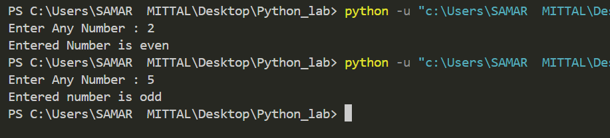

TASK 6:

from decimal import \*

print((0.1+0.2)==0.3)

print("--------------")

print("Ways to make it true")

print((Decimal('0.1')+Decimal('0.2'))==Decimal('0.3'))

OUTPUT:

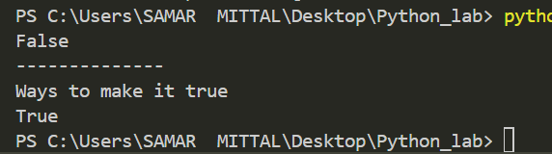

TASK 7:

a="Rajat"

b="Grover"

str1=b[:2:]+a[2::]

str2=a[:2:] + b[2::]

a=str1

b=str2

print(a," ",b)

OUTPUT:

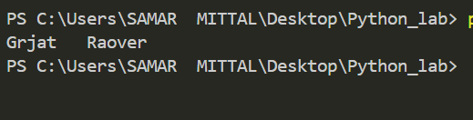

TASK 8:

s=input("enter identifier to check : ")

if (s.isidentifier()):

    print("VALID identifier")

else:

    print("Not a VALID identifier")

OUTPUT:

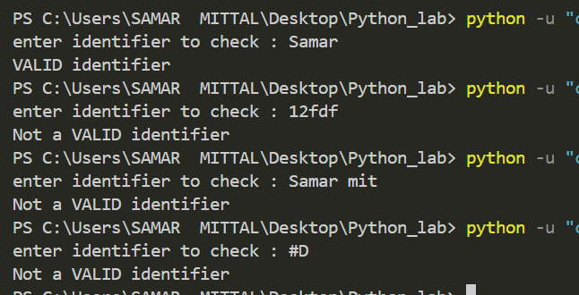

TASK 9:

a=input("Enter string : ")

str=a[-1]+a[1:-1:]+a[0]

print("Entered string : ",a)

print("After swapping : ",str)

OUTPUT:

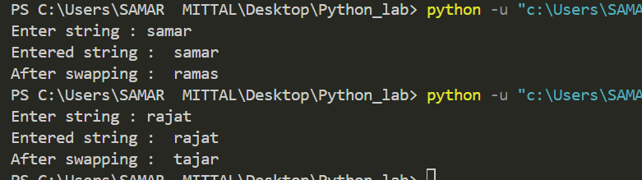

TASK 10:

str=input("Enter a string : ")

print("Uppercase string : ",str.upper())

print("Lowercase string : ",str.lower())

OUTPUT:

