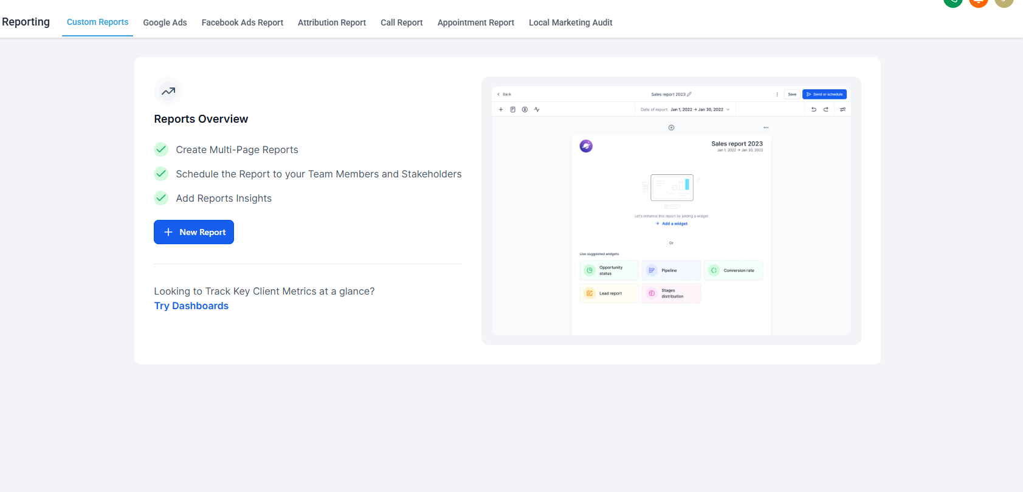

تمام. من الصورة واضح إن Levora فيها حاليًا Reporting Module وفيه:
Tabs موجودة: Custom Reports / Google Ads / Facebook Ads Report / Attribution Report / Call Report / Appointment Report / Local Marketing Audit
الحالة الحالية: صفحة Empty State للـ Custom Reports فيها New Report + فكرة Multi-page Reports وScheduling وInsights.
الفرصة: بدل ما النظام يبقى مجرد Reports، نضيف طبقة Growth Engine فوقه: Campaigns + Tracking + Attribution + Revenue + AI Insights.

الرؤية العامة
نبني داخل Levora نظام باسم مثل:
Growth Engine
أو
Campaign Intelligence
ويتكون من 6 Modules أساسية:
- Campaign Manager
- Tracking Links & Events
- Attribution Engine
- Funnel & Revenue Tracking
- Analytics Dashboard
- AI Growth Insights

Architecture المقترحة

1. Core Services
Campaign Service
مسؤول عن إنشاء الحملات وربطها بالبوستات، اللاندنج بيدجز، الفورمز، والمنصات.
Tracking Service
مسؤول عن توليد Tracking Links، Short Links، تسجيل Clicks وPage Views وEvents.
Attribution Service
مسؤول عن تحديد مصدر كل Lead: First Touch / Last Touch / Multi Touch لاحقًا.
Lead Sync Service
يربط البيانات مع CRM وConversations وFunnels.
Revenue Service
يربط Deals وPayments بالحملات.
Analytics Service
يجمع البيانات ويطلع Metrics وDashboards.
AI Insights Service
يحلل الأداء ويقترح تحسينات.

Tracking Flow
الرحلة تكون كالتالي:
Social Post
↓
Tracking Link
↓
Click Event
↓
Landing Page View
↓
Form Submit
↓
Lead Created in CRM
↓
Conversation Started
↓
Deal Created
↓
Payment Completed
↓
Revenue attributed to Campaign/Post/Platform
كل زائر يحصل على:
visitor_id
session_id
utm_source
utm_medium
utm_campaign
utm_content
campaign_id
post_id
platform
ويتم حفظ البيانات في Cookie أو Local Storage، ثم تنتقل مع أي Form Submit أو Checkout.

Database Schema الأساسي

campaigns
id
workspace_id
name
objective -- leads / sales / engagement
status -- draft / active / paused / completed
start_date
end_date
budget
created_by
created_at
updated_at

campaign_platforms
id
campaign_id
platform -- facebook / instagram / tiktok / linkedin / youtube / pinterest / threads / gbp / bluesky

campaign_posts
id
campaign_id
platform
post_id
post_url
caption
published_at
tracking_link_id

tracking_links
id
workspace_id
campaign_id
post_id
destination_url
short_url
utm_source
utm_medium
utm_campaign
utm_content
created_at

tracking_events
id
workspace_id
visitor_id
session_id
lead_id
campaign_id
post_id
tracking_link_id
event_type -- click / page_view / form_submit / purchase
platform
url
referrer
metadata_json
created_at

leads
id
workspace_id
name
email
phone
crm_contact_id
first_touch_event_id
last_touch_event_id
first_campaign_id
last_campaign_id
first_platform
last_platform
created_at

deals
id
workspace_id
lead_id
campaign_id
pipeline_id
stage_id
value
status -- open / won / lost
created_at
closed_at

payments
id
workspace_id
lead_id
deal_id
campaign_id
amount
currency
payment_status
payment_provider
paid_at

attribution_records
id
workspace_id
lead_id
campaign_id
post_id
platform
model -- first_touch / last_touch
event_id
attributed_at

API Endpoints

Campaigns
POST /api/campaigns
GET /api/campaigns
GET /api/campaigns/:id
PATCH /api/campaigns/:id
DELETE /api/campaigns/:id

Posts
POST /api/campaigns/:id/posts
GET /api/campaigns/:id/posts

Tracking Links
POST /api/tracking-links
GET /api/tracking-links
GET /t/:shortCode

Events
POST /api/events/click
POST /api/events/page-view
POST /api/events/form-submit
POST /api/events/purchase

Attribution
GET /api/leads/:id/attribution
GET /api/campaigns/:id/attribution

Analytics
GET /api/analytics/overview
GET /api/analytics/campaigns
GET /api/analytics/platforms
GET /api/analytics/posts
GET /api/analytics/funnel
GET /api/analytics/revenue

AI
POST /api/ai/campaign-analysis
GET /api/ai/insights
GET /api/ai/recommendations

Attribution Logic

First Touch
أول Event موثوق للزائر قبل ما يتحول إلى Lead.
مثال:
Instagram Post Click → Landing Page → Form Submit
إذًا:
first_platform = Instagram
first_campaign = Campaign A
first_post = Post 12

Last Touch
آخر Event قبل إنشاء الـ Lead أو قبل الشراء.
مثال:
TikTok Click → Instagram Retargeting Click → Form Submit
إذًا:
first_touch = TikTok
last_touch = Instagram

Revenue Attribution
في البداية:
Revenue ينسب إلى Last Touch Campaign
لاحقًا نضيف:
Linear Attribution
Time Decay Attribution
Position-Based Attribution

Dashboard UI/UX
بما إن الصورة الحالية فيها Reporting Tabs، الأفضل نضيف Tab جديد باسم:
Growth Engine
أو
Campaign Tracking
داخلها:

Overview
Cards:
Total Campaigns
Total Leads
Total Revenue
Conversion Rate
ROI
Top Platform

Campaign Performance Table
أعمدة:
Campaign
Objective
Platforms
Clicks
Leads
Deals
Revenue
Conversion Rate
ROI
Status

Platform Breakdown
Instagram: Clicks / Leads / Revenue
TikTok: Clicks / Leads / Revenue
LinkedIn: Clicks / Leads / Revenue
Facebook: Clicks / Leads / Revenue

Best Performing Posts
Post Preview
Platform
Clicks
Leads
Deals
Revenue
Lead Rate

Funnel Visualization
Clicks → Page Views → Form Submits → Leads → Deals → Payments
مع Conversion Rate بين كل خطوة.

Attribution View
لكل Lead:
First Touch
Last Touch
Campaign Journey
Revenue Source
Timeline

AI Layer
الـ AI يظهر كـ Insights Panel داخل Dashboard:
أمثلة:
Instagram Reels generated 42% more leads than image posts.
TikTok campaigns have high clicks but low form conversion.
Campaign A has the best revenue per lead.
LinkedIn leads convert slower but generate higher deal value.
اقتراحات:
Increase budget on Campaign A.
Create more short-form video posts.
Improve landing page for TikTok traffic.
Retarget users who clicked but did not submit forms.

MVP Roadmap

Phase 1 — Foundation
نبني:
Campaigns
Tracking Links
UTM Builder
Click Tracking
Lead Attribution
Basic Dashboard

Phase 2 — Funnel + CRM
نضيف:
Form Submit Tracking
CRM Contact Linking
Conversation Source Tracking
Deal Linking
Funnel Metrics

Phase 3 — Revenue
نضيف:
Payments Integration
Revenue per Campaign
ROI
Cost per Lead
Campaign Reports

Phase 4 — AI Growth Engine
نضيف:
AI Insights
Campaign Recommendations
Performance Predictions
Anomaly Detection

أهم نقطة ناقصة في الوصف
لازم نضيف مفهوم مهم جدًا:
Identity Resolution
لأن نفس الشخص ممكن يضغط من Instagram، ويرجع من TikTok، وبعدين يملأ Form من Google Chrome.
لازم النظام يربط:
anonymous visitor
session
cookie
email
phone
CRM contact
deal
payment
بدون ده الـ Attribution هيبقى ناقص.

نبدأ فعليًا بأول خطوة: تصميم الـ Architecture التفصيلي + Data Flow Diagram.

