Product Attribute Extraction - Project Explanation
Samar Markande
Objective
Develop an NLP-based system that converts unstructured fashion product descriptions into structured attributes such as Category, Silhouette, Fabric, Neckline, Sleeve, Length, Embellishment, and Color.
Dataset
The assignment required at least 50 labeled descriptions. A manually labeled dataset was prepared with additional samples to improve model learning. Each record contains a product description and labels for eight attributes.
Methodology
• Text preprocessing: lowercase conversion, punctuation and extra-space removal.
• Feature extraction using TF-IDF (unigrams and bigrams).
• One LinearSVC classifier trained for each attribute.
• Models, label encoders, and TF-IDF vectorizer saved using Joblib.
• FastAPI provides a POST /extract endpoint returning JSON attributes.
• A simple Streamlit interface allows users to test predictions.
Evaluation
Model performance is evaluated using Accuracy, Precision, Recall, and F1-score on a held-out test set.
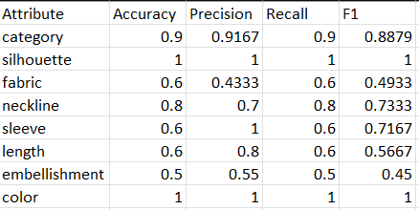

Common Failure Cases
• Small datasets reduce generalization.
• Unseen fashion terms may be misclassified.
• Missing attributes may still receive predictions because the classifier always predicts a known class.
• Descriptions containing multiple colors or fabrics are difficult for a single-label classifier.
• A production system would benefit from 1,000–2,000+ diverse labeled descriptions.
Conclusion
The project demonstrates a complete NLP workflow including data preparation, preprocessing, machine learning, evaluation, REST API development, and a simple user interface. It fulfills the assignment requirements while identifying practical limitations and future improvements.

