EEI6373
Performance Modelling
Mini Project Report

Name :- K.M.S.A.Karunanayaka
Reg. No :- 520264843
Performance Modeling and Evaluation of a Multi-Server Outpatient Registration Queue Using M/M/c Queuing Theory
A Case Study of Outpatient Department (OPD) Registration Counters

1. System Description and Performance Goals
The system selected for this mini project is the patient registration process at the Outpatient Department (OPD) of a typical regional government hospital in Sri Lanka. Every patient who visits the OPD must first register at one of several service counters before being directed to a consulting doctor. This is a real, everyday service system whose performance directly affects patient experience, hospital throughput, and staff workload, making it well suited for a rigorous performance-modeling exercise.
Patients arrive at the registration area largely independently of one another, at a rate that varies substantially across the day — a quiet early-morning period, a moderate mid-morning period, and a sharp arrival peak once general clinics open. Each patient is served by exactly one of c identical registration counters, where a clerk verifies identity, retrieves or creates a medical record, and issues a queue token for the consulting room. Once a counter becomes free, it serves the next waiting patient on a first-come-first-served (FCFS) basis. The system therefore has the classic structure of a multi-server queuing system.
The complexity of this system lies in the interaction between a randomly fluctuating arrival process, variable service times, and a finite (and costly) number of counters. Under-resourcing the counters during peak hours creates long queues, patient dissatisfaction, and knock-on delays throughout the hospital; over-resourcing wastes staff time during quiet hours. This tension is precisely what performance modeling is used to resolve.

Performance Objectives
This study focuses on the following, clearly measurable performance objectives:
- Minimize average patient waiting time (Wq) before being served at a counter.
- Keep counter utilization (ρ) high enough to justify staffing cost, without pushing the system toward instability (ρ → 1).
- Identify the minimum number of counters (c) needed at each time of day to keep waiting time below a 5-minute service target.
- Determine the economically optimal number of counters by balancing staffing cost against the cost of patient waiting time.

2. Modeling Approach and Assumptions
The registration process is modeled analytically as an M/M/c queuing system — Poisson arrivals, exponentially distributed (Markovian) service times, and c parallel, statistically identical servers, using Kendall's notation. This choice is justified for three reasons. First, patient arrivals at a hospital registration desk are the classic example used to justify the Poisson assumption: arrivals originate from a large number of independent patients, none of whom coordinate with one another, so the number of arrivals in any interval is well approximated by a Poisson process (Gross et al., 2018). Second, service times at a registration counter (verifying details, issuing a token) are short, variable, and reasonably memoryless, which the exponential distribution captures adequately for a first-order analysis. Third, unlike a simulation, the M/M/c analytical model yields closed-form (Erlang-C) formulas for every metric of interest, which allows a full sensitivity analysis across arrival rates and server counts to be computed exactly and rapidly rather than through repeated stochastic runs.
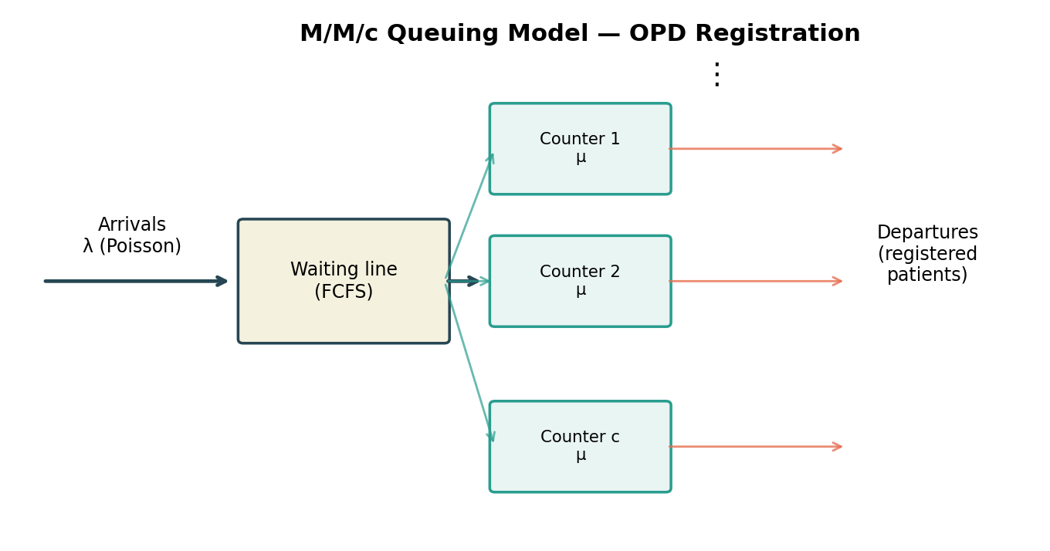
Figure 1: Schematic of the OPD registration system modeled as an M/M/c queue.

Model Assumptions
- Patient arrivals follow a Poisson process with rate λ (patients/hour); inter-arrival times are independent and exponentially distributed.
- Service times are independent and exponentially distributed with rate μ = 20 patients/hour per counter (mean service time ≈ 3 minutes), based on typical registration-desk timings reported in hospital operations literature.
- All c counters are statistically identical and work independently; a single FCFS queue feeds all free counters (no jockeying between separate lines).
- The waiting room has effectively unlimited capacity and no patient balks or reneges (leaves before being served).
- The system is analyzed in steady state within each daily period (off-peak, moderate, peak), i.e., λ and c are treated as constant within a period.

3. Data Description and Methodology
Because direct access to hospital registration logs was not available for this project, representative arrival and service-rate data were constructed from typical OPD attendance patterns reported in the healthcare-operations literature (Green, 2006; Fomundam & Herrmann, 2007) and scaled to a mid-sized regional hospital. Three representative daily periods were defined, each treated as a separate steady-state scenario:

Period | Arrival rate λ (patients/hr) | Service rate μ (patients/hr/counter) | Offered load a = λ/μ (Erlangs)
Off-peak (early morning) | 15 | 20 | 0.75
Moderate (mid-morning) | 30 | 20 | 1.50
Peak (clinic opening) | 45 | 20 | 2.25
Table 1: Scenario definitions used for the sensitivity analysis.
For each scenario, the number of open counters c was varied from 1 to 6 (or 7, for the cost analysis) and the exact Erlang-C formulas for an M/M/c queue were evaluated in Python to compute: the probability of zero patients in the system (P0), the probability an arriving patient must wait (Pwait, Erlang-C formula), the expected number waiting in the queue (Lq), the expected waiting time (Wq), the expected number in the system (L), the expected time in the system (W), and server utilization (ρ = λ/(cμ)). All computations and charts were produced programmatically (Python: NumPy, pandas, Matplotlib) so that every reported figure is directly reproducible from the input parameters, and the full result set is included in the supporting data table below.
A secondary economic model was layered on top of the queuing results to translate waiting-time statistics into a staffing decision. An hourly staffing cost of Cs = LKR 800 per open counter and an imputed patient waiting cost of Cw = LKR 150 per patient-hour of delay were assumed, giving a total hourly cost function Total Cost(c) = c·Cs + λ·Wq(c)·Cw. This is a standard cost-of-waiting formulation used in queuing-based capacity planning (Hillier & Lieberman, 2015), and it is used in Section 4 to recommend a specific number of counters for the peak period rather than leaving the decision purely to a waiting-time target.

4. Detailed Analysis and Findings

4.1 Stability and the Need for Multiple Servers
The single-server case (c = 1) is immediately informative: at the moderate arrival rate (λ = 30/hr) the offered load already exceeds the single counter's capacity (ρ = λ/μ = 1.5 > 1), and at peak (λ = 45/hr) it is even more overloaded (ρ = 2.25). Both cases are mathematically unstable — the queue grows without bound and Wq → ∞ — which corresponds directly to the real-world observation that a single registration counter cannot cope once the OPD becomes busy. This is the first key finding: at least three counters are structurally necessary once arrivals exceed roughly 30 patients per hour, and this bottleneck is precisely the kind of insight performance modeling is meant to surface before it is discovered through patient complaints.

4.2 Waiting Time as a Function of Server Count
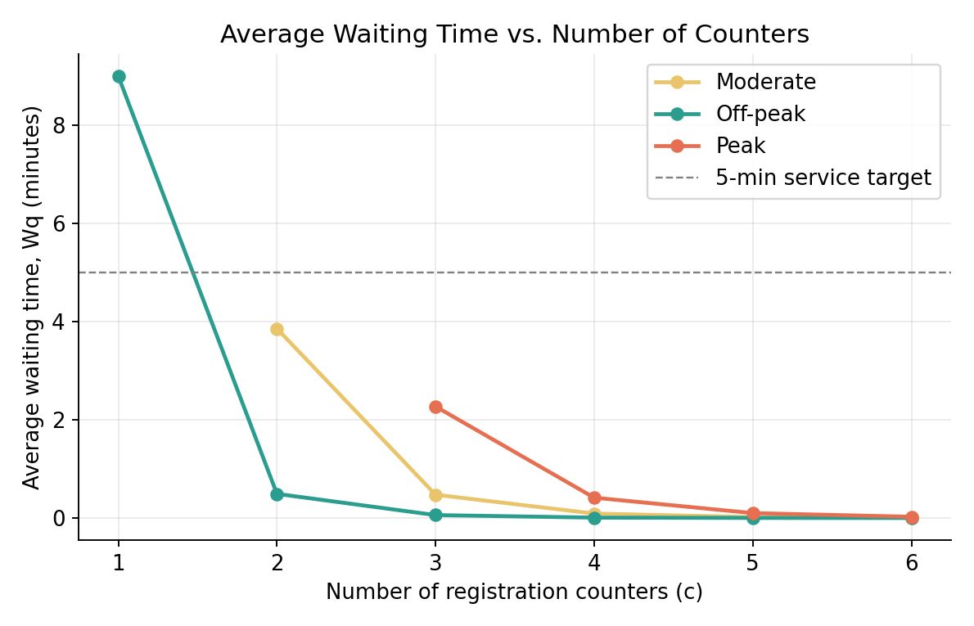
Figure 2: Average waiting time (Wq) falls sharply and then flattens as counters are added, for all three load scenarios.
Figure 2 shows the characteristic Erlang-C shape: waiting time decreases very sharply as the first one or two additional counters are added beyond the stability threshold, then flattens into diminishing returns. At peak load, moving from c = 3 to c = 4 counters cuts the average wait from about 2.27 minutes to 0.41 minutes — an 82% reduction — while moving from c = 5 to c = 6 only saves a further 0.075 minutes. This diminishing-returns pattern is the core justification for the cost trade-off analysis in Section 4.4: past a certain point, extra counters buy negligible waiting-time improvement for a fixed staffing cost.

4.3 Utilization and the Probability of Waiting
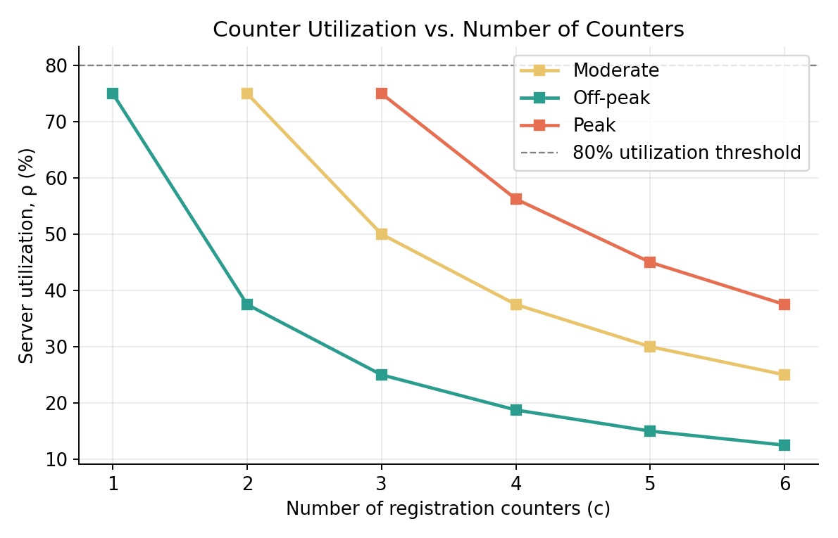
Figure 3: Counter utilization drops as more counters are added, for a fixed arrival rate.
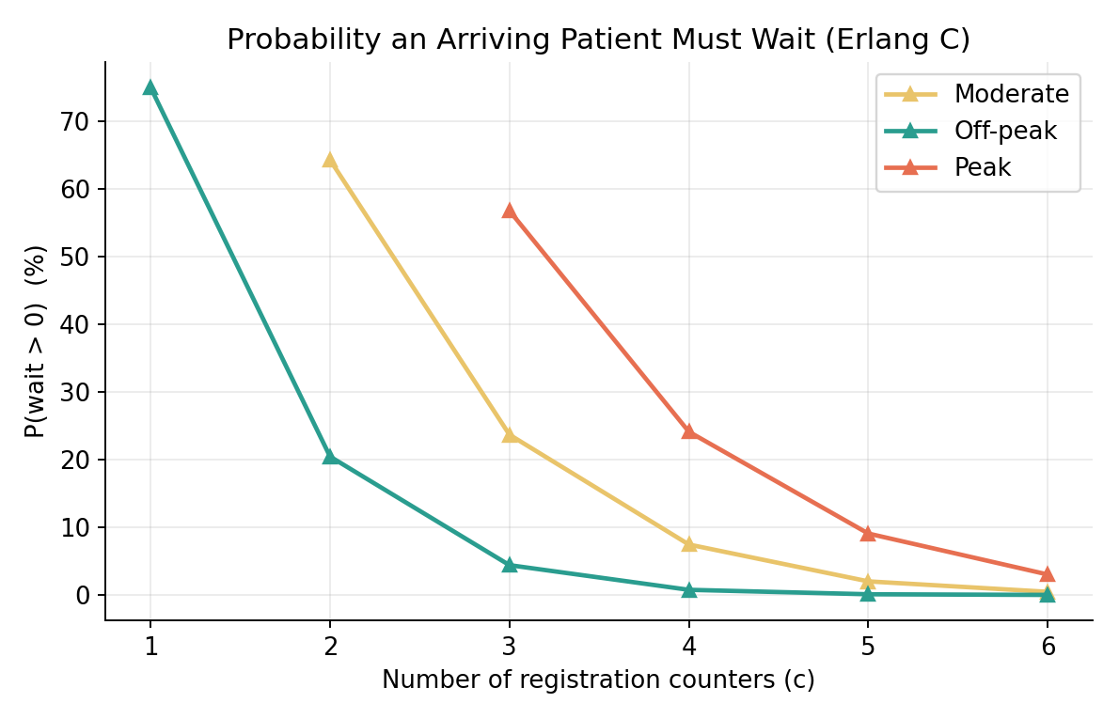
Figure 4: Probability that an arriving patient must wait at all (Erlang-C), by scenario.
At peak load with the minimum stable configuration (c = 3), utilization is 75% and 56.8% of arriving patients must still wait for a counter — a workable but visibly strained configuration. Adding a fourth counter drops utilization to 56.3% and the probability of waiting to 24.1%, a substantially more comfortable operating point. The off-peak scenario, by contrast, is already comfortable with just two counters (ρ = 37.5%, Pwait = 20.5%), confirming that fixed year-round staffing at the peak-appropriate level would leave counters idle — and therefore wasteful — for most of the day.

4.4 Cost-Optimal Staffing at Peak Load
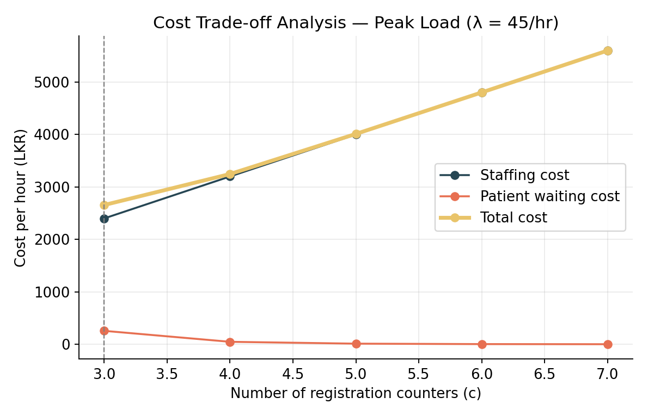
Figure 5: Hourly staffing cost, patient waiting cost, and their sum, as counters are added at peak load.

c | Wq (min) | ρ | P(wait) | Staffing cost (LKR/hr) | Waiting cost (LKR/hr) | Total cost (LKR/hr)
3 | 2.27 | 0.750 | 0.568 | 2,400 | 255.5 | 2,655.5
4 | 0.41 | 0.563 | 0.241 | 3,200 | 46.5 | 3,246.5
5 | 0.10 | 0.450 | 0.091 | 4,000 | 11.1 | 4,011.1
6 | 0.02 | 0.375 | 0.030 | 4,800 | 2.7 | 4,802.7
Table 2: Cost trade-off at peak load (λ = 45/hr). Minimum total cost occurs at c = 3.
Under this specific cost structure, the pure cost-minimizing choice is c = 3 counters, because staffing cost (LKR 800/counter/hour) dominates the imputed waiting cost even at 2.27 minutes of average delay. However, this configuration leaves the system at 75% utilization with a 56.8% chance of any wait, which is fragile: any short-term surge above λ = 45/hr would push the system toward instability. A more risk-aware reading of the results — balancing the modest extra cost of LKR 800/hour against the 82% cut in waiting time and a much larger buffer against demand surges — supports recommending c = 4 counters during the peak period, reserving c = 3 as the bare economic minimum and c = 2 as adequate only for off-peak hours. This scenario-dependent staffing recommendation (2 counters off-peak, 3 mid-morning, 4 at peak) is the central practical output of the model.

5. Limitations and Future Extensions
The model has several limitations that should be acknowledged. The exponential service-time assumption, while analytically convenient, tends to be more variable than real registration-desk service times, which are often closer to a general or log-normal distribution; an M/G/c model or a discrete-event simulation would relax this assumption and is a natural next step. The analysis also treats each daily period as an independent steady state, whereas in reality the transition between periods (and the transient build-up of a queue as the morning peak begins) matters for patients arriving near the boundary of a period; a time-varying arrival-rate simulation (Mt/M/c) would capture this more realistically. Balking and reneging — patients leaving if the queue looks too long — are ignored, which likely means the model somewhat overstates congestion during the most extreme peak periods. Finally, the cost parameters (Cs and Cw) are illustrative estimates rather than measured values; a real deployment would calibrate them from actual staff wage data and a hospital-specific value of patient time.
Future extensions of this work could include: validating the exponential assumptions against logged registration-desk timestamps if such data becomes available; building a discrete-event simulation (e.g., in SimPy) to cross-check the analytical Erlang-C results and to relax the memoryless assumptions; extending the model to a network of queues that includes the downstream consultation and pharmacy stages, since congestion earlier in the pathway propagates onward; and incorporating a time-varying arrival-rate function to model the transient queue build-up at the start of each clinic session rather than only steady-state averages.

References
Fomundam, S. and Herrmann, J. (2007) A Survey of Queuing Theory Applications in Healthcare. ISR Technical Report 2007-24. College Park: University of Maryland.
Green, L. (2006) 'Queueing analysis in healthcare', in Hall, R. (ed.) Patient Flow: Reducing Delay in Healthcare Delivery. New York: Springer, pp. 281–307.
Gross, D., Shortle, J.F., Thompson, J.M. and Harris, C.M. (2018) Fundamentals of Queueing Theory. 5th edn. Hoboken: Wiley.
Hillier, F.S. and Lieberman, G.J. (2015) Introduction to Operations Research. 10th edn. New York: McGraw-Hill.

Appendix: Core Model Implementation
All quantitative results in this report (Tables 1–2, Figures 2–5) were generated programmatically rather than computed by hand, so that every number is exactly reproducible from the stated input parameters. The full project consists of three Python scripts: queue_model.py (implements the M/M/c Erlang-C formulas below and produces the sensitivity-analysis results in Section 4.1–4.3), cost_model.py (implements the staffing cost trade-off in Section 4.4), and make_charts.py (generates Figures 1–5). These are submitted alongside this report as supporting files. The core function, which every other result in this report is built on, is reproduced below.

def erlang_c(c, lam, mu):
"""Return P0, Pwait (Erlang C), Lq, Wq, L, W, rho for an M/M/c queue."""
a = lam / mu # offered load, in Erlangs
rho = a / c # per-server utilization

if rho >= 1: # stability condition: queue grows forever
return dict(P0=nan, Pwait=nan, Lq=inf, Wq=inf,
L=inf, W=inf, rho=rho, stable=False)

sum_terms = sum((a**n) / factorial(n) for n in range(c))
last_term = (a**c) / (factorial(c) * (1 - rho))
P0 = 1 / (sum_terms + last_term)

Pwait = last_term * P0 # Erlang-C formula
Lq = Pwait * rho / (1 - rho) # expected queue length
Wq = Lq / lam # Little's Law: Lq = lam * Wq
W = Wq + 1 / mu # total time = wait + service
L = lam * W # Little's Law: L = lam * W

return dict(P0=P0, Pwait=Pwait, Lq=Lq, Wq=Wq, L=L, W=W,
rho=rho, stable=True)

The function first computes the offered load a = λ/μ and the per-server utilization ρ = a/c. If ρ ≥ 1 the system is flagged as unstable and infinite waiting times are returned, corresponding to the bottleneck finding in Section 4.1. Otherwise, P0 (probability of an empty system) is computed as the reciprocal of a truncated series plus a geometric correction term for the 'all servers busy' state; the Erlang-C probability of waiting, Pwait, follows directly from P0. The remaining metrics (Lq, Wq, L, W) are then derived using Little's Law (L = λW and its analogue for the queue alone), which links the number of patients in the system to the rate at which they arrive and the time each one spends there.

