**Task 7. Algorithms on graphs. Tools for network analysis**

**Samarin Anton, C4113**

**March 6, 2020**

Import data on GitHub. It is an unweighted undirected graph which represents relationships between developers and their followers.

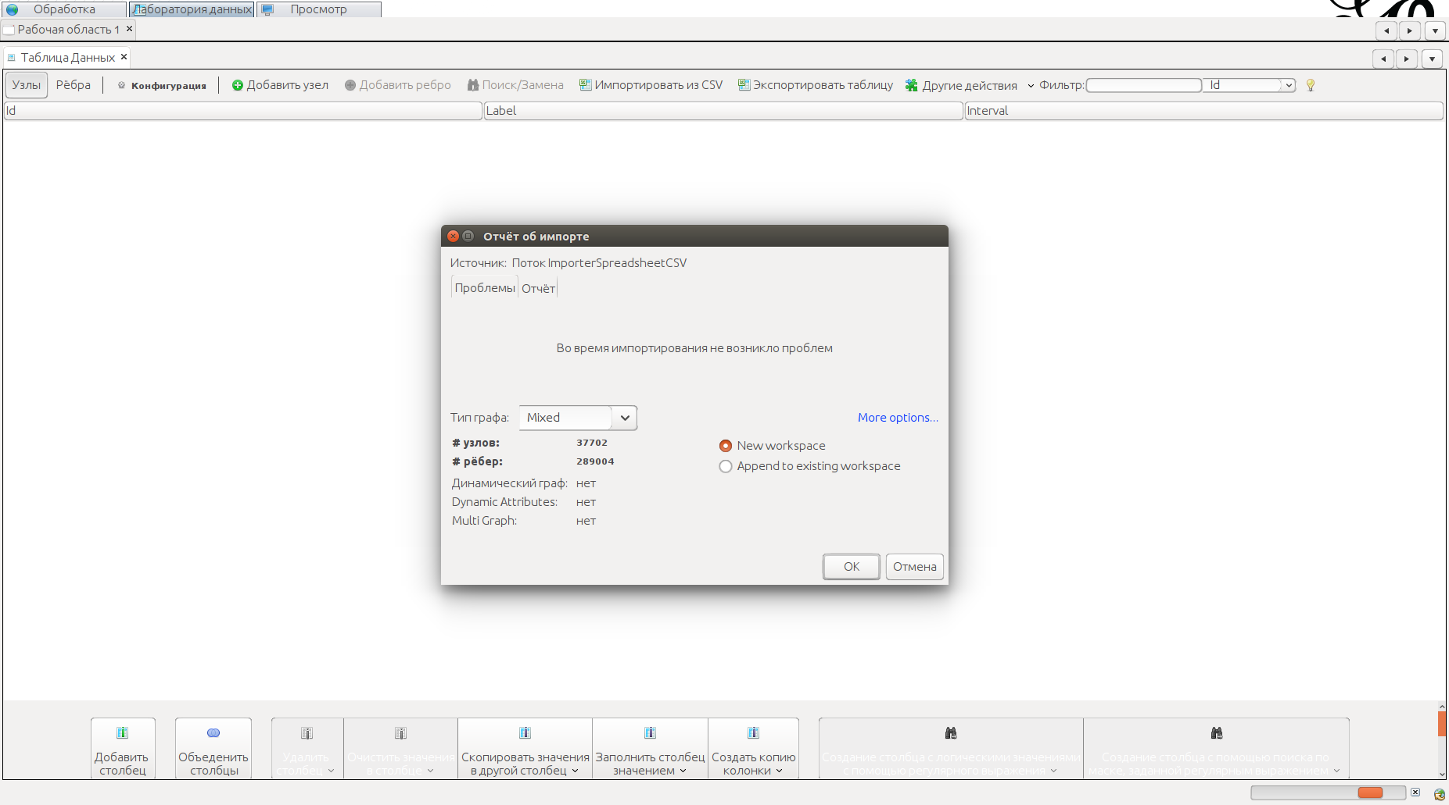

Import is successful. We can see data:

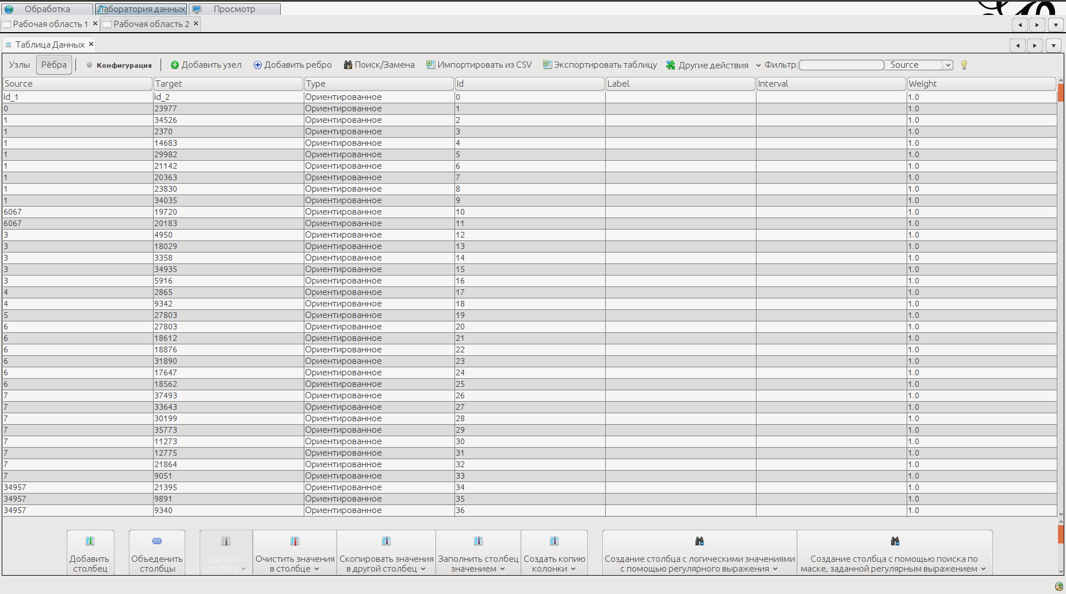

Also we can see structure our graph. But it is not informative.

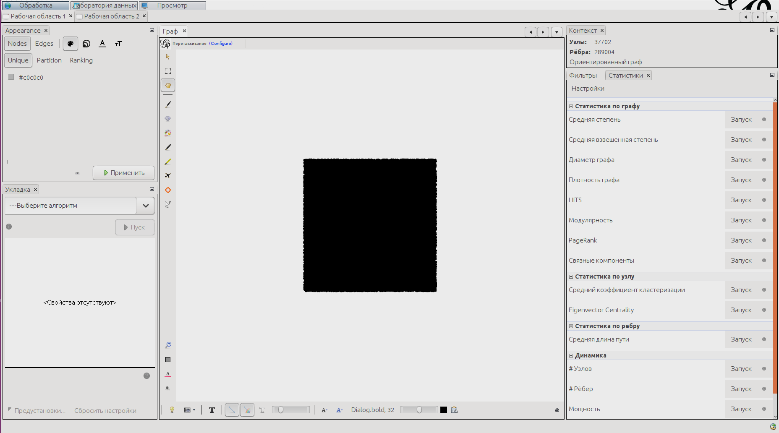

OpenOrd:

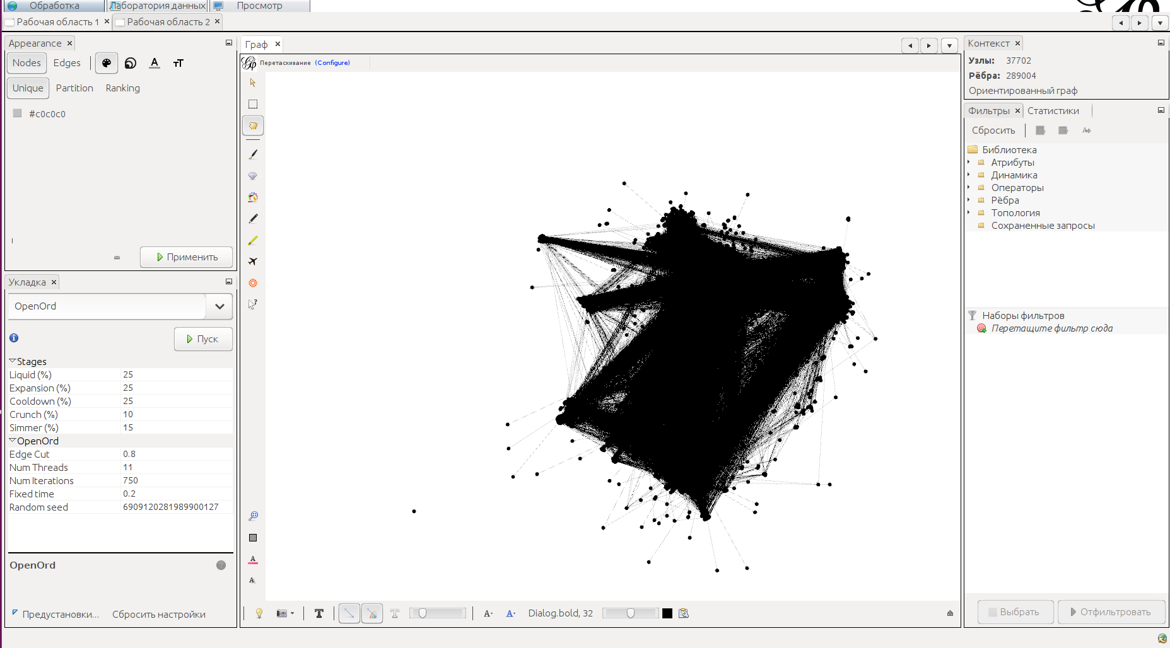

Yifan Hu:

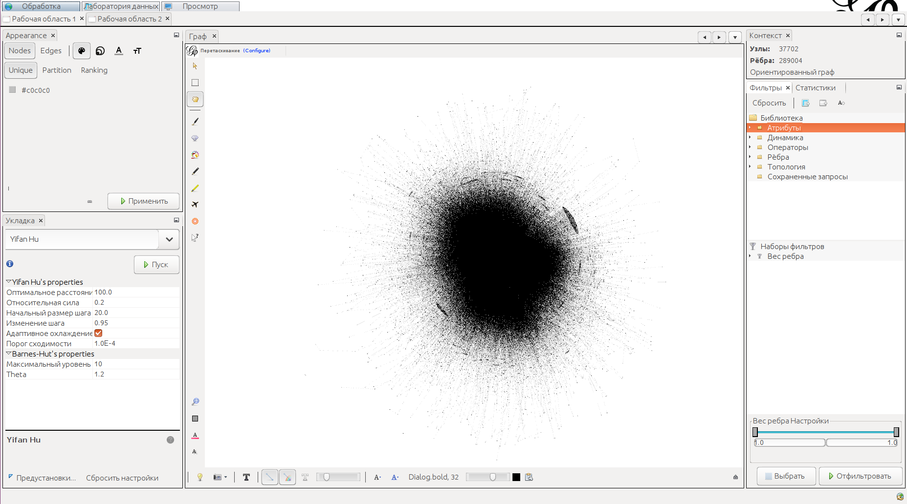

Now we use tools to get statistics

Number of nodes — 37702

Number of edges — 289004

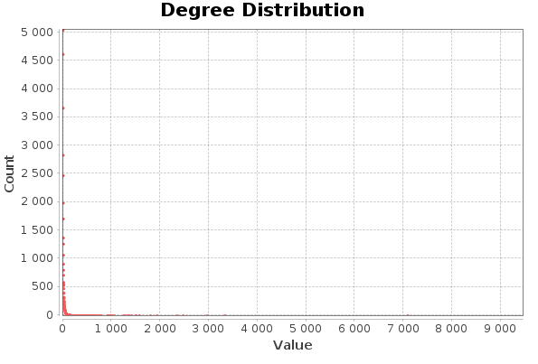

Most vertecies have low degree, average is 7.665

Density of graph is 0.0002

Modularity is 0.451

Number of communities is 22

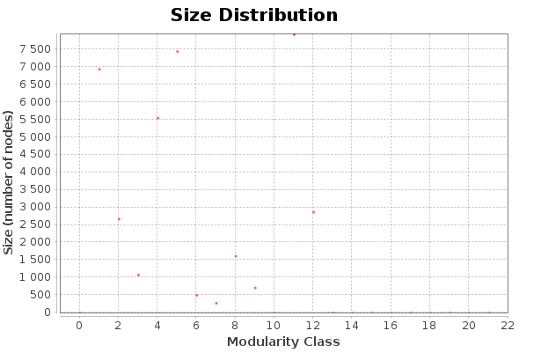

Conclusion:

Averarege number of followers is small (Average degree is 7). Also the graph is too discharged (Density is 0.0002). There are only 22 communities and 4 from them have substantially more members than other.