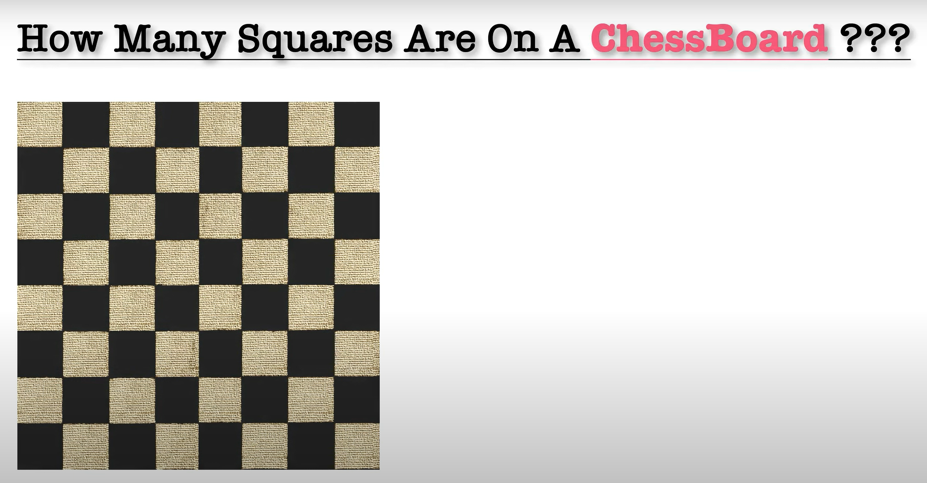

**Solution**

Consider 1x1 squares -> 64

Consider 2x2 squares ->7 in a row,7 in a col ->49

Consider 3x3 square -> 6 in a row , 6 in a col -> 36

We can make a formula for such Qs

|  |  |
| --- | --- |
|  |  |
|  |  |

Here 4 1x1 and 1 2x2 => 5

|  |  |  |
| --- | --- | --- |
|  |  |  |
|  |  |  |
|  |  |  |

9 1x1 4 2x2 1 3x3 => 14

So we can say

n^2 + (n-1) ^2 + …4+1

So for 8 x8 we get 64+49+36+25+16+9+4+1 = 204