<https://www.youtube.com/shorts/9uOsB39DwGM>

Problem->

* 3 boxes one contains only oranges, one contains only apples other contains both
* All are mislabelled
* Only allowed to take out one item from each box and then assign correct labels

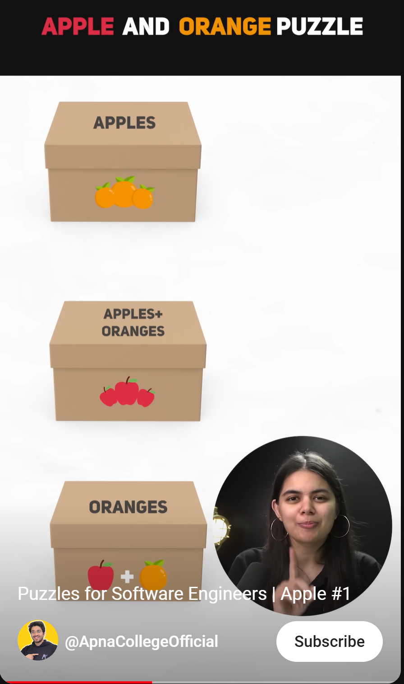

**SOLUTION:**

As we know all boxes are mislabelled, it implies a box cannot be what it is labelled.

So, if a box is labelled apples & oranges -> it will not be apples and oranges

So, if we take an item out of it and it is an apple then box must contain ONLY apples similarly if it is an Orange then box must Contain Oranges ONLY.

For remaining 2 boxes

IF A+O labelled box -> apple

|  |  |
| --- | --- |
| Label | Contains |
| A+O | Apples |
| A | Oranges |
| O | Apples + Oranges |

IF A+O labelled box -> orange

|  |  |
| --- | --- |
| Label | Contains |
| A+O | Oranges |
| A | Apples + Oranges |
| O | Apples |