**Guide to Making a Perfect Peanut Butter and Jelly Sandwich for Dummies**

Step 1:

Decide to make a peanut butter and jelly (PBJ) sandwich.

Step 2:

Choose the supermarket you want to but the ingredients from.

Step 4:

Go to the supermarket.

Step 5:

Decide on the mode of transport to and from the supermarket.

* Own Vehicle
* Public Transport
* Walk

Step 6:

Choose the necessary ingredients required for the PBJ sandwich.

* Choose the type of peanut butter
* Crunchy
* Paste
* Choose the preferred brand of peanut butter spread.
* Choose the flavor of jam/jelly.
* Choose the type of bread
* Wheat
* White

Step 7:

Checkout from the supermarket.

Step 8:

Go back home.

Step 9:

Unpack the items bought at the supermarket and keep everything required for preparing the sandwich.

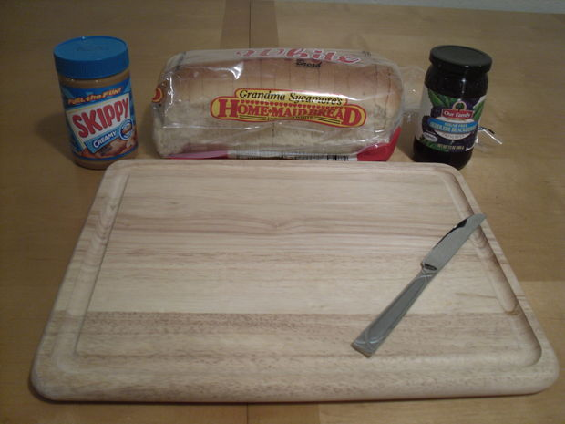

© <http://www.instructables.com/id/How-To-Make-a-Perfect-Peanut-Butter-and-Jelly-Sand/>

10/27/2016

Step 10:

Take two slices of bread.

* Decide whether the bread should be toasted or not toasted.
* Decide whether the sandwich should be made with the crust or without the crust.

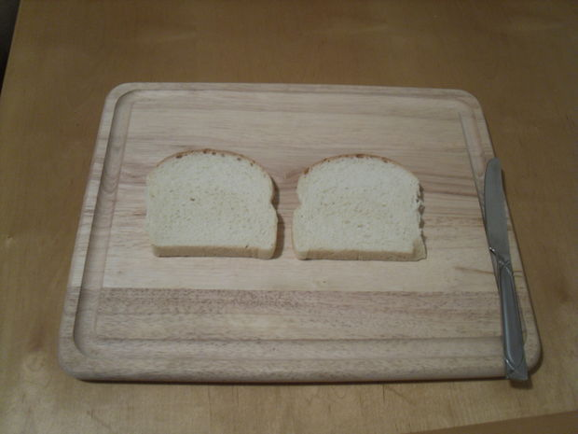

© <http://www.instructables.com/id/How-To-Make-a-Perfect-Peanut-Butter-and-Jelly-Sand/step2/Prepare-the-Bread/>

10/27/2016

Step 11:

Take one of the slices of bread and using the butter knife spread the peanut butter over it.

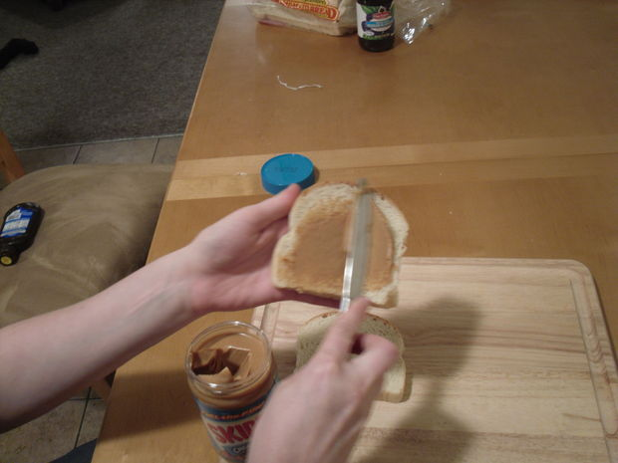

© <http://www.instructables.com/id/How-To-Make-a-Perfect-Peanut-Butter-and-Jelly-Sand/step3/Apply-Peanut-Butter/>

10/27/2016

Step 12:

Take the other slice of bread and using the same or another butter knife spread the jam/jelly over it.

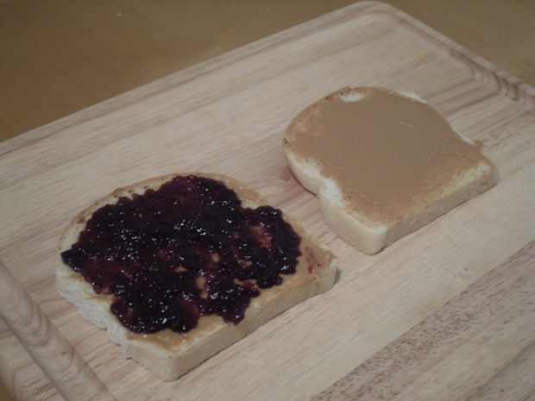

© <http://www.instructables.com/id/How-To-Make-a-Perfect-Peanut-Butter-and-Jelly-Sand/step4/Apply-Jelly/>

10/27/2016

Step 13:

Bring the two slices together and press them gently against each other.

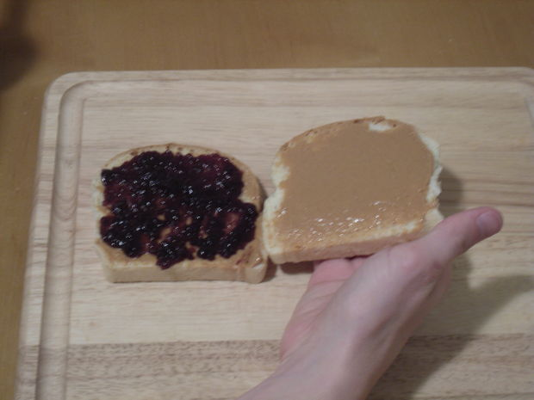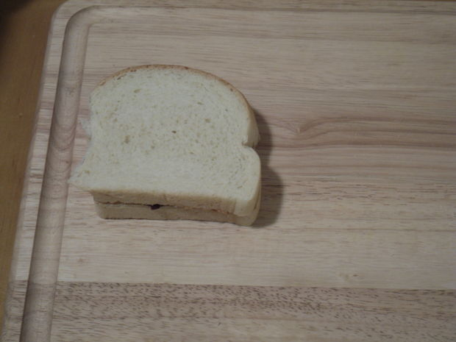

© <http://www.instructables.com/id/How-To-Make-a-Perfect-Peanut-Butter-and-Jelly-Sand/step5/Combine-Both-Slices-of-Bread/>

10/27/2016

Step 14:

* Decide on whether the sandwich needs to be cut.
* If it needs to be cut, how should it be cut
* Diagonally
* Horizontally/Vertically

Step 15:

Take a bite and enjoy the sandwich.

**Word Count: 279**

**FLOWCHART FOR PREPARNG A PEANUT BUTTER AND JELLY SANDWICH**

